State of Louisiana Office Supply Contract – Instructions

Table of Contents
- State Contract Number
- Registering for a New Account
- How to Order
- How to Print Order Details for Credit Card Statements
- Delivery and Minimum Order Charges
- Return Policies
- Contract Discounts
- Account Support
- Office Depot Retail Locations

- Contract Procurement:

The contract was awarded by the Office of State Procurement to ODP Business Solutions, LLC through the State of Louisiana – Contract Number 4400021682.

Office of State Procurement Contact Information
If you have questions for OSP, please email DOA-OSPHELPDESK@la.gov.

- Registering for an Account:
All users will need to register to get an account setup to utilize the State Contract.
Important Note: There are two (2) links below – the first is for state agencies only, and the second is for political subdivisions / quasi agencies. Please use the correct link when registering, as the process and information collected is different.

The link below will guide you through an Online Registration form. After completing the online form, you will receive an email that your registration has been submitted and you will soon receive an email from ODP Business Solutions with your login credentials and additional information.

Click Link Below for State Agencies Only
State of LA User Registration (State Agencies Only)
Click Link Below for Political Subdivisions and Quasi Agencies
State of LA-Political Sub Divs & Quasi Agencies

For support with account setups, email Christy Copeland at christy.copeland@odpbusiness.com or call 225.323.4255

- How to Order:

Once you receive your login credentials, please visit https://www.odpbusiness.com
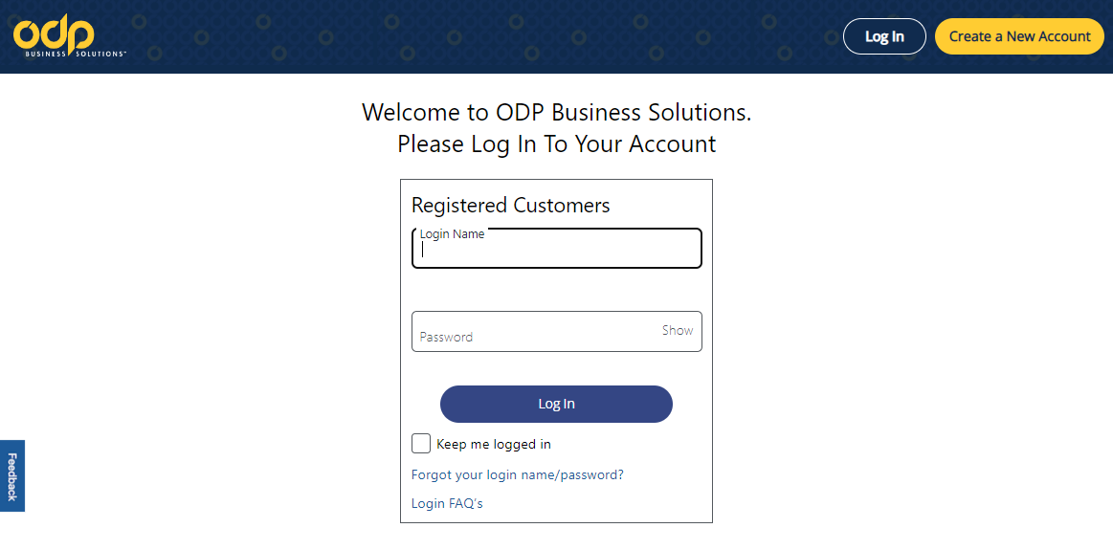

NOTICE: DO NOT ORDER from RETAIL WEBSITE: www.OfficeDepot.com

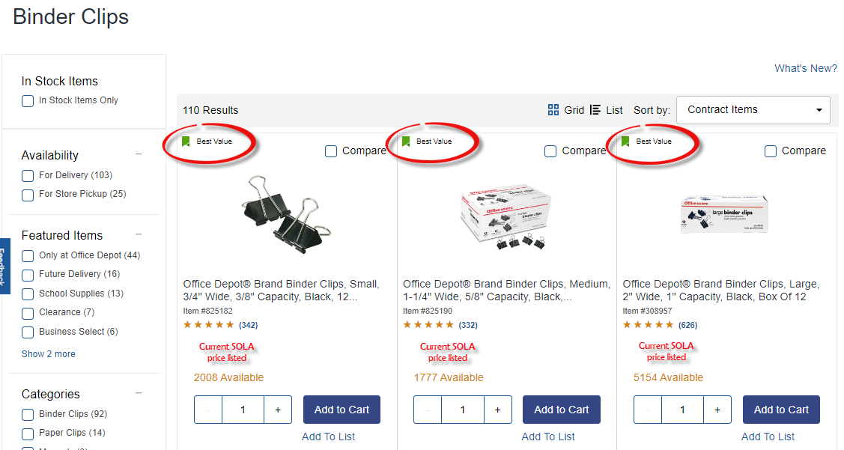
Contract Items will be displayed with a “Best Value” Icon (shown below). Any items without an icon have been priced at a discounted State of Louisiana Rate, from ODP Business Solutions.

- How to Print Order Invoice for Credit Card Statement

ODP Business Solutions bills your credit card, and the credit card company invoices you. Therefore, we are unable to provide a copy of the invoice. However, you can access the order detail online and use it for supporting documentation with your credit card statement.
Instructions: Click on “Orders” in the top toolbar, search for the order number or click on the order number that coincides with the charge on your credit card statement. The order detail will display, then look for the “Print” icon at the top of the order and click to print or save as a PDF.
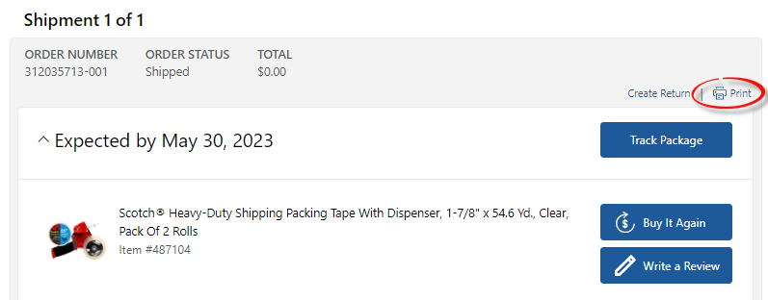

- Delivery Instructions:

Shipping is FOB Destination, with next day or 2-day shipping. If you require special delivery, please reach out to the ODP Business Solutions Account Representative to work with their Delivery team. The minimum order amount is $25.00. All orders below $25 will incur a $5.95 fee. Departments are strongly encouraged to bundle or consolidate orders whenever possible to meet the minimum order amount.

- Returns, Damaged Deliveries, and Backordered Items:

ODP Business Solutions will accept returns up to thirty (30) calendar days after receipt of order. Items must be in the original packaging. Your Original Receipt is required for all store returns or exchanges of technology. There are no restocking fees for returned goods. Returns are credited within 15 business days of receipt.
Exceptions:
- Furniture, Computers and Business Machines with accessories in the original packaging can be returned within 14 days after purchase for a full refund.
- Headsets, microphones, mice, and keyboards cannot be returned.
- Special order and custom-made items (e.g. Stamps) may not be returned unless damaged upon receipt.

- Contracted Catalog Discounts:

Pricing online represents the product category discounts and have been negotiated by the State.

- Vendor Contact Information:

Strategic Support - Customer Service Team:
Contact this group for assistance with order status, delivery issues, backorders, returns, product replacements and questions relating to product information.

Name of Contact: ODP Business Solutions – State of Louisiana Service Team
Phone Number: 1-800-279-1528 (toll free)
Email Address: strategicsupport@odpbusiness.com
Hours: Monday - Friday 8am - 9:30pm CT

Invoicing/Accounts Receivable:
Contact this group for assistance with billing issues, credits, or payments.

Name of Contact: Billing - Customer Service
Phone Number(s) of Contact: 1-888-263-3423
Email Address of Contact: ecsupport@odpbusiness.com

State Contract Representatives:
For help and assistance with user logins, address additions, account administration and special orders.
Name of Contact Person: Amy Cook
Position of Contact: Service Consultant
Phone Number(s) of Contact: 402.671.4192
Email Address of Contact: amy.cook@odpbusiness.com

For overall account support, contract questions, new projects and bids, product and service recommendations, escalations from customer service groups and reporting.

Name of Contact Person: Christy Copeland
Position of Contact: Strategic Account Manager
Phone Number(s) of Contact: 225.323.4255
Email Address of Contact: christy.copeland@odpbusiness.com

- Office Depot Retail Locations within the State of Louisiana:

The below Office Depot retail locations are organized in alphabetical order by city. (updated July 2023)

STORE # | STREET ADDRESS | CITY | ZIP | PHONE NUMBER
349 | 1804-C MACARTHUR DRIVE | ALEXANDRIA | 71301 | (318) 443-5151
259 | 3116 COLLEGE DRIVE | BATON ROUGE | 70808 | (225) 927-0034
2290 | 9001 FLORIDA BLVD, SUITE D | BATON ROUGE | 70815 | (225) 218-8011
2742 | 1651 MILLERVILLE RD | BATON ROUGE | 70816 | (225) 272-8816
2820 | 7540 BLUEBONNET BLVD | BATON ROUGE | 70810 | (225) 763-9696
291 | 2001 AIRLINE DRIVE SUITE 156 | BOSSIER CITY | 71111 | (318) 752-3340
344 | 401 NORTH US HIGHWAY #190 | COVINGTON | 70433 | (985) 893-4142
2612 | 2360 SOUTH RANGE AVE | DENHAM SPRINGS | 70726 | (225) 665-5221
697 | 703 N AIRLINE HWY | GONZALES | 70737 | (225) 647-3800
2111 | 2260 W THOMAS STREET | HAMMOND | 70401 | (985) 542-9770
6493 | 1000 S. CLEARVIEW PKW 1020 | HARAHAN | 70123 | (504) 736-0215
56 | 1500 WEST BANK EXPRESSWAY | HARVEY | 70058 | (504) 368-9731
461 | 3408-B WILLIAMS BLVD | KENNER | 70065 | (504) 466-4422
101 | 4670 JOHNSTON STREET | LAFAYETTE | 70503 | (337) 988-6503
385 | 1879 WEST PINHOOK ROAD | LAFAYETTE | 70508 | (337) 234-9900
2573 | 5700 JOHNSTON STREET | LAFAYETTE | 70503 | (337) 273-2559
2745 | 3215 LOUISIANA AVE #ST 102 | LAFAYETTE | 70501 | (337) 231-5722
266 | 2806 RYAN STREET | LAKE CHARLES | 70601 | (337) 439-7996
2574 | 3150 PRIEN LAKE ROAD | LAKE CHARLES | 70615 | (337) 562-2455
2717 | 1847 N. CAUSEWAY BLVD. | MANDEVILLE | 70471 | (985) 626-7739
55 | 6851 VETERANS MEMORIAL BLVD | METAIRIE | 70003 | (504) 889-6661
124 | 755 VETERANS MEMORIAL BLVD | METAIRIE | 70005 | (504) 833-5545
334 | 2301 LOUISVILLE AVENUE | MONROE | 71201 | (318) 323-9220
551 | 820-F E ADMIRAL DOYLE DR | NEW IBERIA | 70560 | (337) 364-1221
2166 | 1429 ST CHARLES AVE | NEW ORLEANS | 70130 | (504) 561-8846
3283 | 309 N CARROLLTON AVE. SUITE 2 | NEW ORLEANS | 70119 | (504) 206-3157
2092 | 221 N SERVICE ROAD EAST | RUSTON | 71270 | (318) 251-2117
185 | 8210 JEWELLA ROAD | SHREVEPORT | 71108 | (318) 688-5824
446 | 1708 EAST 70TH STREET | SHREVEPORT | 71105 | (318) 524-0005
418 | 1583 GAUSE ROAD | SLIDELL | 70458 | (985) 781-2505
693 | 200 BLANCHARD DRIVE | WEST MONROE | 71291 | (318) 322-1123

We Appreciate Your Business – Thank You!

