Evaluating Proposals – RFP Event Review

What is RFP Event Review? 2

How are evaluation committee members notified of RFP Event Review? 2

Accessing RFP Event Review 3

Navigating the Grading Module 5

Downloading or Printing Proposals 11

Evaluating Proposals 14

# What is RFP Event Review?

* RFP Event Review is a task in LESA used for evaluation committee members to independently evaluate each proposal submitted in response to the RFP.
* The State Procurement Analyst will start the RFP Event Review Task following the Evaluation Kickoff Meeting and once all evaluation committee members have indicated that they do not have a conflict of interest with any proposer.

# How are evaluation committee members notified of RFP Event Review?

* ARIBA (LESA) will send an email to each evaluation committee member notifying them that their review is required.

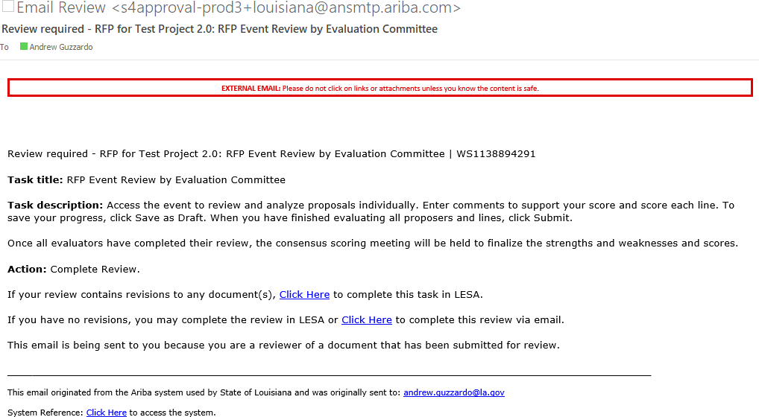

# Accessing RFP Event Review

* + The RFP Event Review task can be accessed in several ways. The two main ways to access the task are 1) through the email notification that was sent; or 2) through the LESA dashboard.

1. Accessing RFP Event Review through email
   * Open the email notification that was sent. Verify that the Task title in the email is ‘RFP Event Review by Evaluation Committee’. Find System Reference at the bottom of the email and select ‘Click Here’.

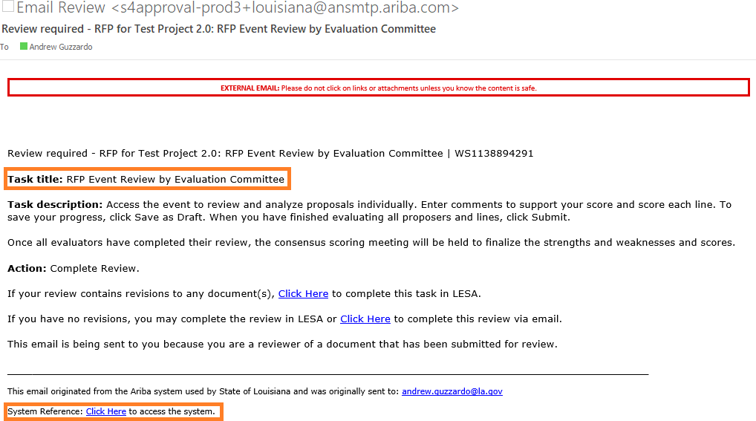

* + You will be prompted to log into LESA. After you log in, LESA will bring you directly to the RFP Event Review task. Find the name of the RFP on the left side of the screen about halfway down the page. Click on the RFP name and then select ‘Grade’.

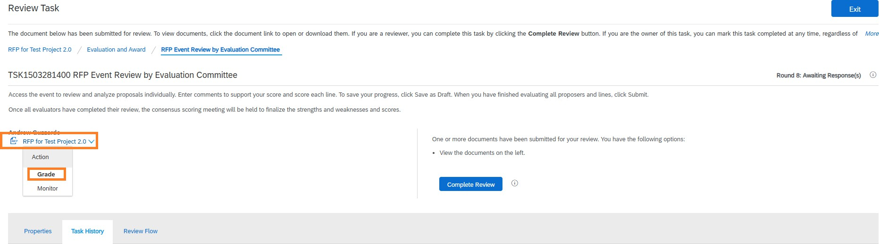

1. Accessing RFP Event Review through LESA dashboard
   * [Log into LESA](http://louisiana.sourcing.ariba.com)[.](http://louisiana.sourcing.ariba.com/) After you log in, LESA will bring you to your dashboard. Locate the ‘Needs Review’ section. Find the task labeled RFP Event Review by Evaluation Committee and select it.

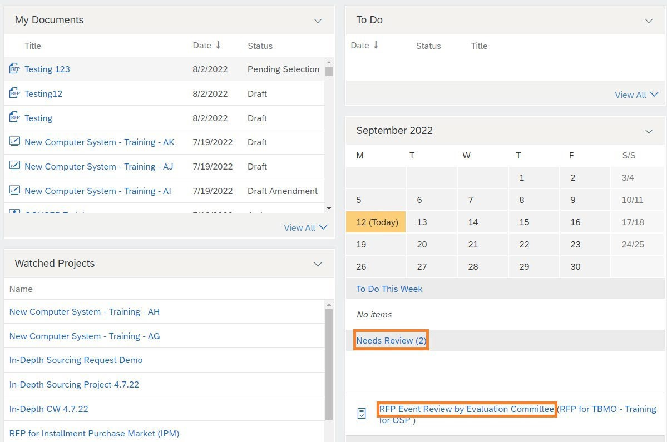

* + LESA will bring you to the RFP Event Review task. Find the name of the RFP on the left side of the screen about halfway down the page. Click on the RFP name and then select ‘Grade’.



# Navigating the Grading Module

* + There are two ways to evaluate proposals in LESA: 1) Grade by Participants; and, 2) Grade by Content. Grade by Participants is the default and will be automatically selected when you enter the grading module.

1. Grade by Participants
   * This is the default method of evaluating proposals. Three proposers are shown at a time.

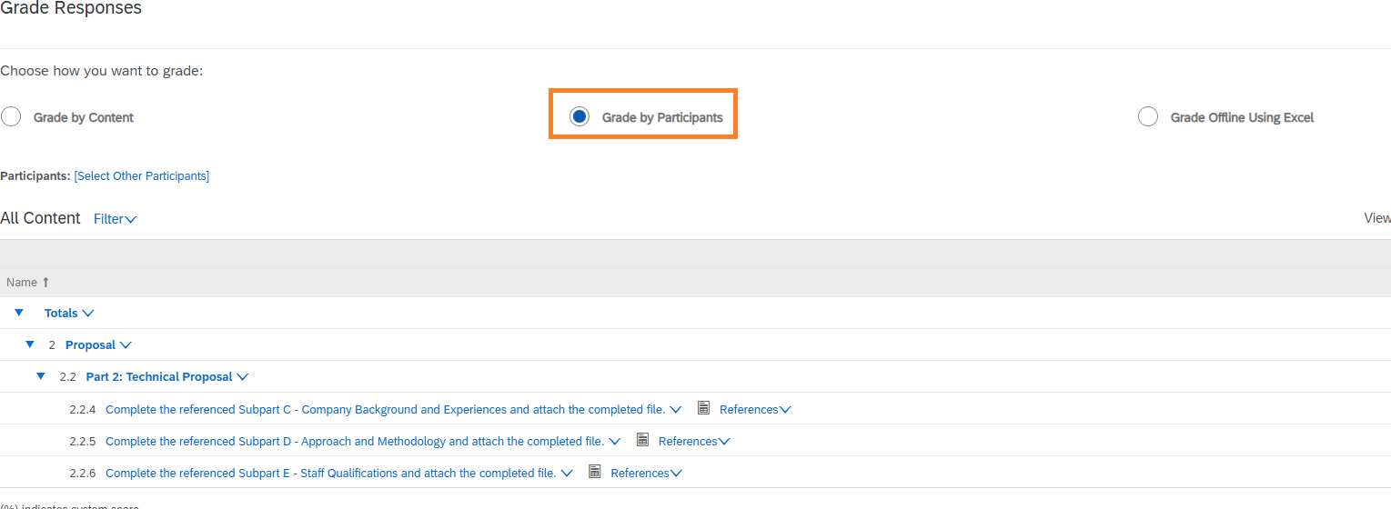

* + Proposer’s names are listed at the top of the table.

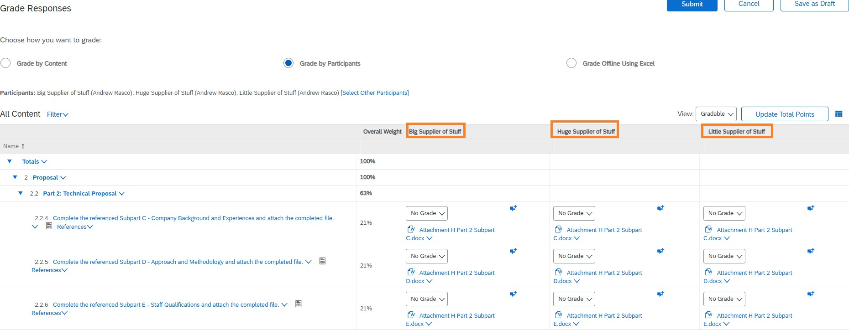

* + Three proposers are shown at a time. If more than three proposers submitted a response to the RFP, you can change the proposers shown by clicking ‘Select other Participants’.

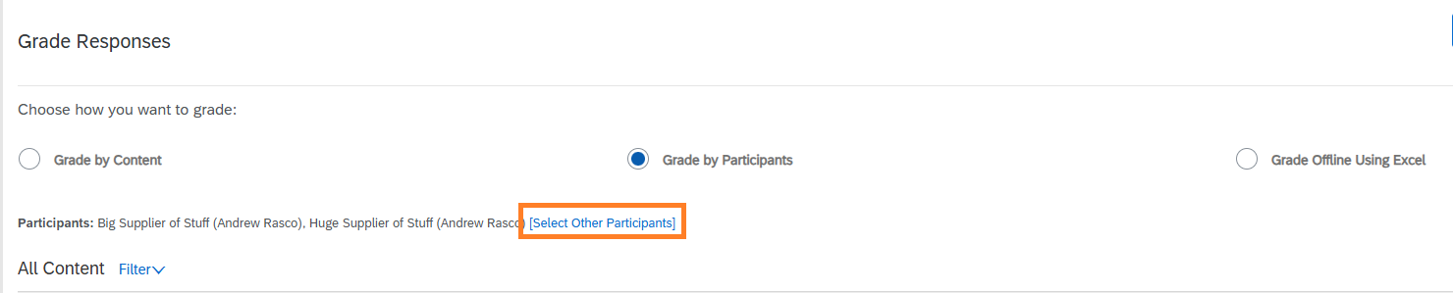

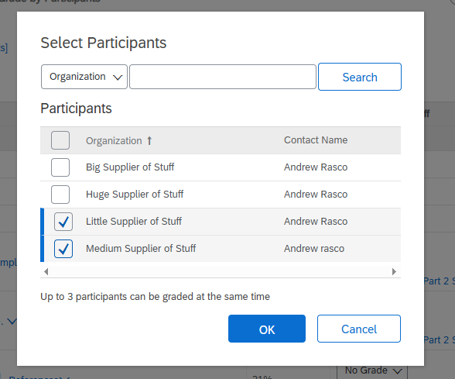

* + Evaluation committee members should download the attached referenced document and review the questions asked of the Proposers. Responses are evaluated against the questions and the RFP Scope of Work, **NOT** compared to the other responses.

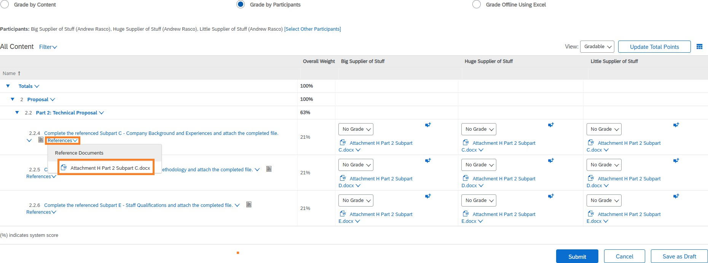

* + - Responses also may be an attachment. To view responses entered as an attachment, select the file name and choose ‘Download this attachment’.

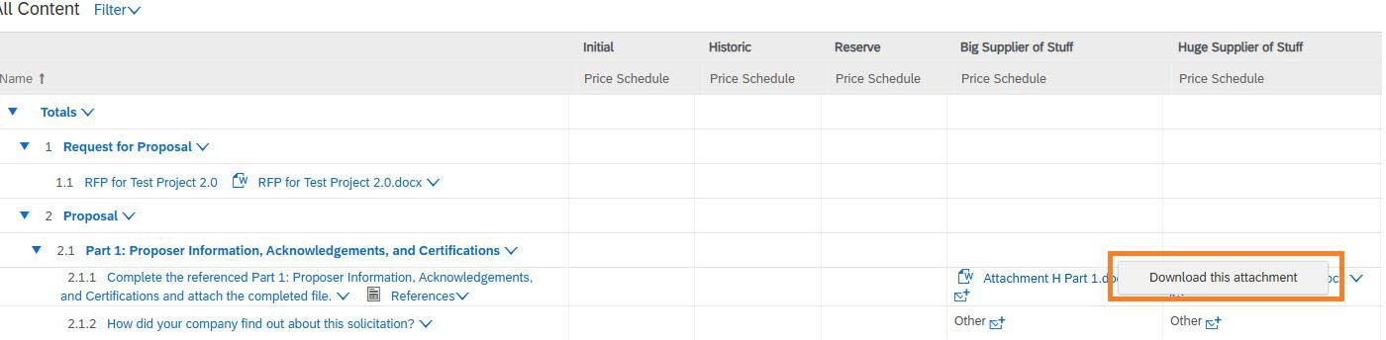

* + - Some responses may be entered as text directly into LESA along with an accompanying attachment. The accompanying attachment can be viewed by clicking the ‘View Comments’ symbol following the text response and then selecting the attachment to download it.

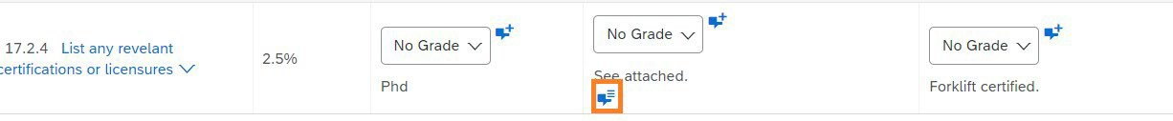

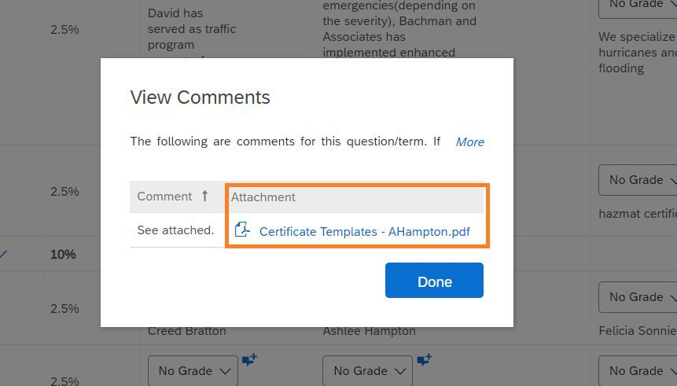

1. Grade by Content
   * Evaluation committee members can change to Grade by Content by selecting the radio button next to Grade by Content.

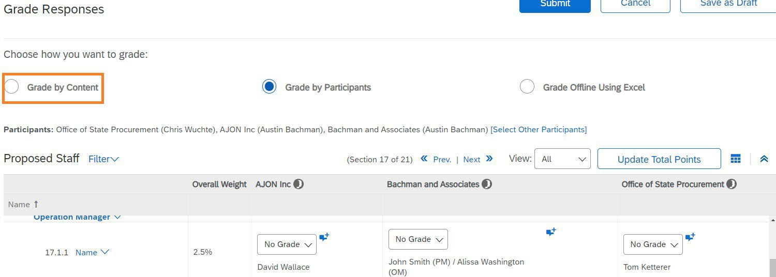

* + This will open a dialogue box asking you to select the content to grade. The ‘Grade’ buttons for gradable proposal content are filled in blue. Make a selection.

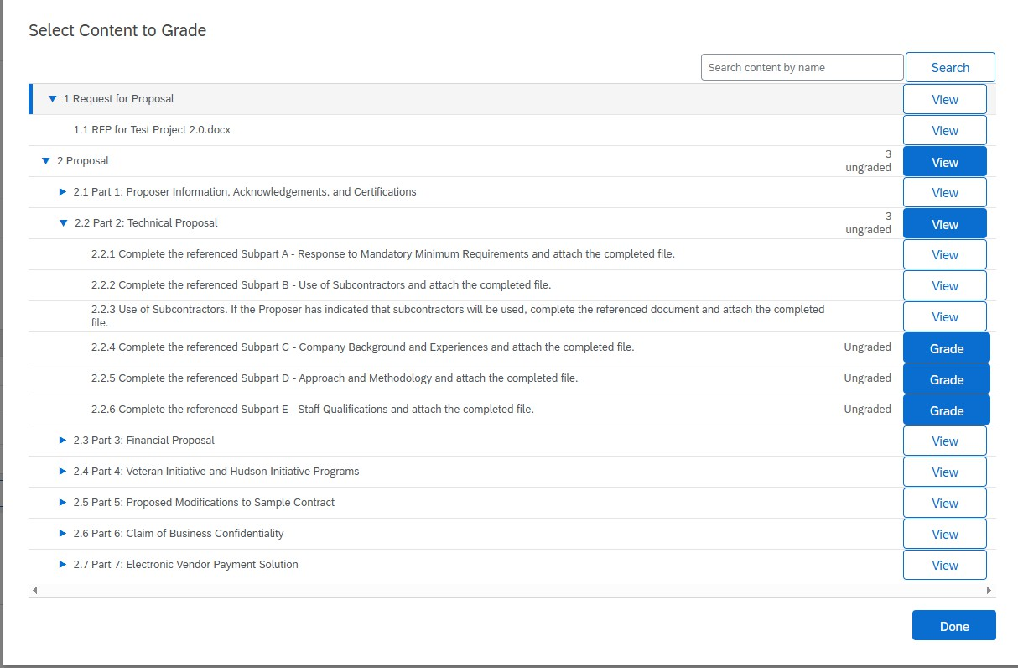

* + You will be brought to the section header. Select either ‘Next Gradable’ or ‘Next Ungraded’.

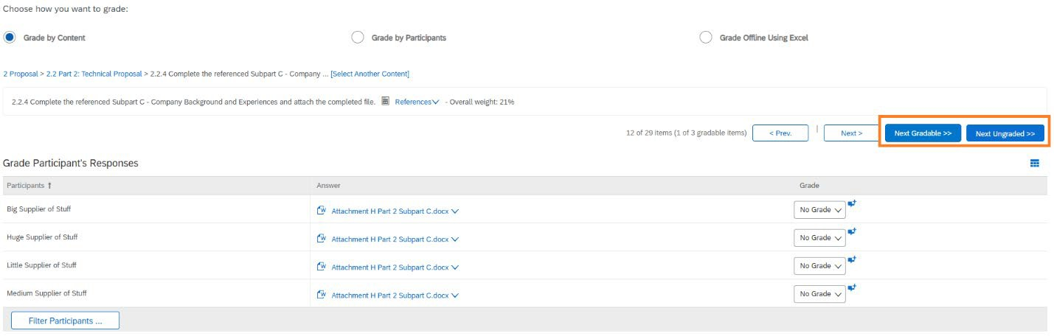

* + The question asked of the Proposers are in the Reference attachment.

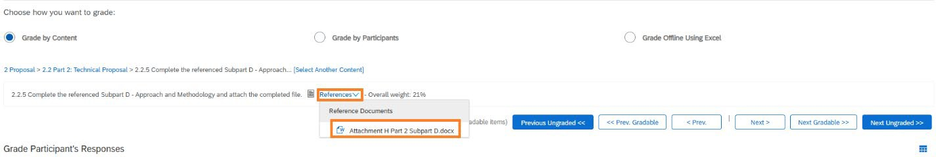

* + Proposal responses are in the second column of the table. Evaluation committee members should download the attachment to review the Proposers response. Responses are evaluated against the question and the RFP Scope of Work, **NOT** compared to the other responses.

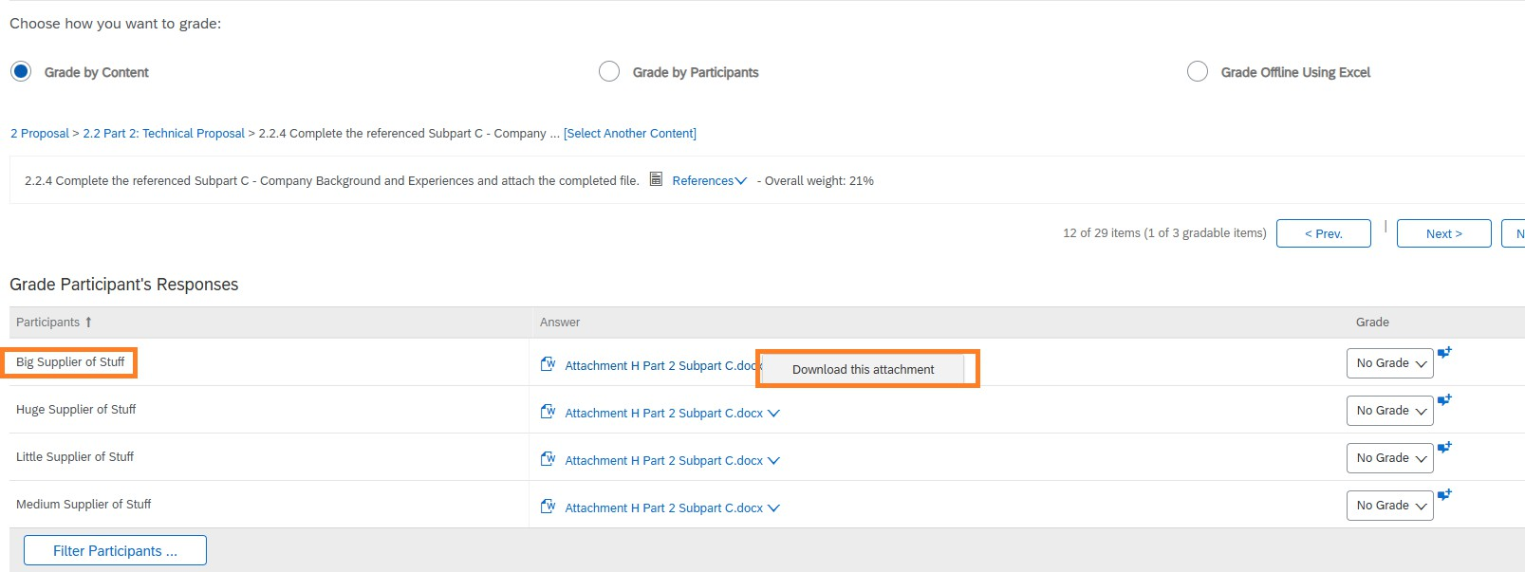

* + Use the buttons to navigate between different questions.

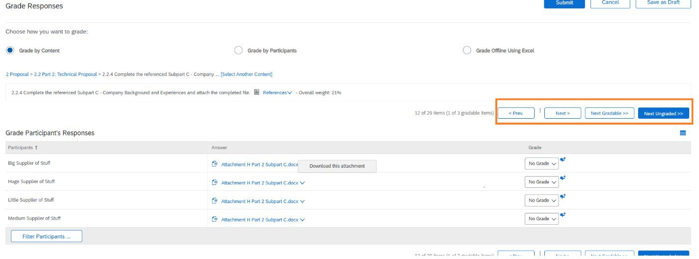

# Downloading or Printing Proposals

* + Evaluation committee members may want to download or print proposals. This can be done by selecting ‘Grade Offline Using Excel’.

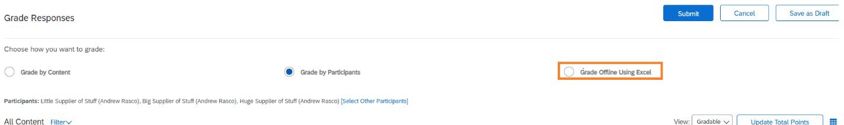

* + Select the proposals you wish to download or print.

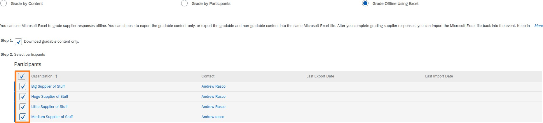

* + To download proposal responses entered as text directly into LESA, select ‘Click here to download your RFP for grading in an Excel spreadsheet’. LESA will export all responses selected into an Excel spreadsheet.

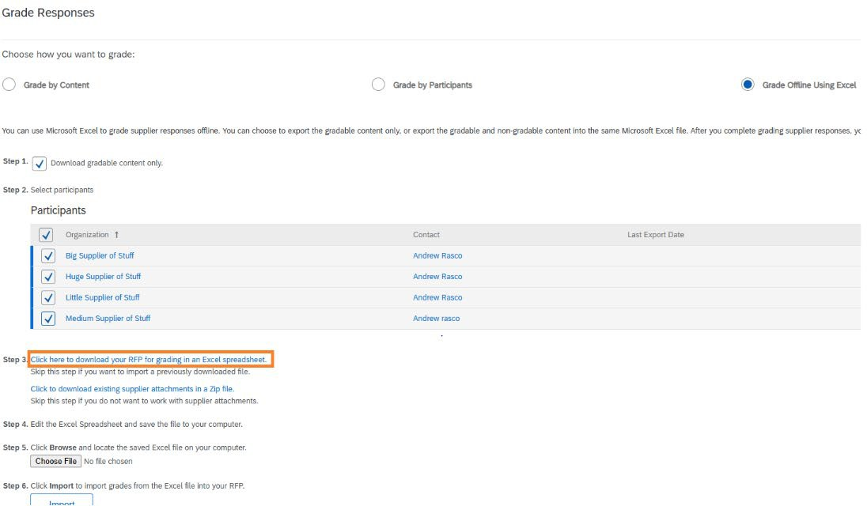

* + Proposals responses will also likely include attachments. To download attachments, select ‘Click to download existing supplier attachments in a Zip file’.

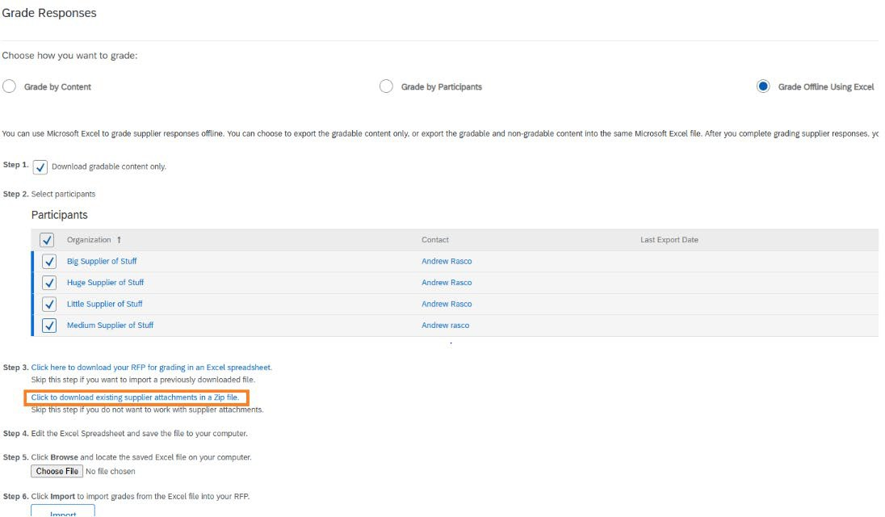

* + On the next screen, select the proposers whose attachments you want to download. Then select the sections you want to download. To download all proposer attachments, select the top box. Alternatively, you can select individual sections.

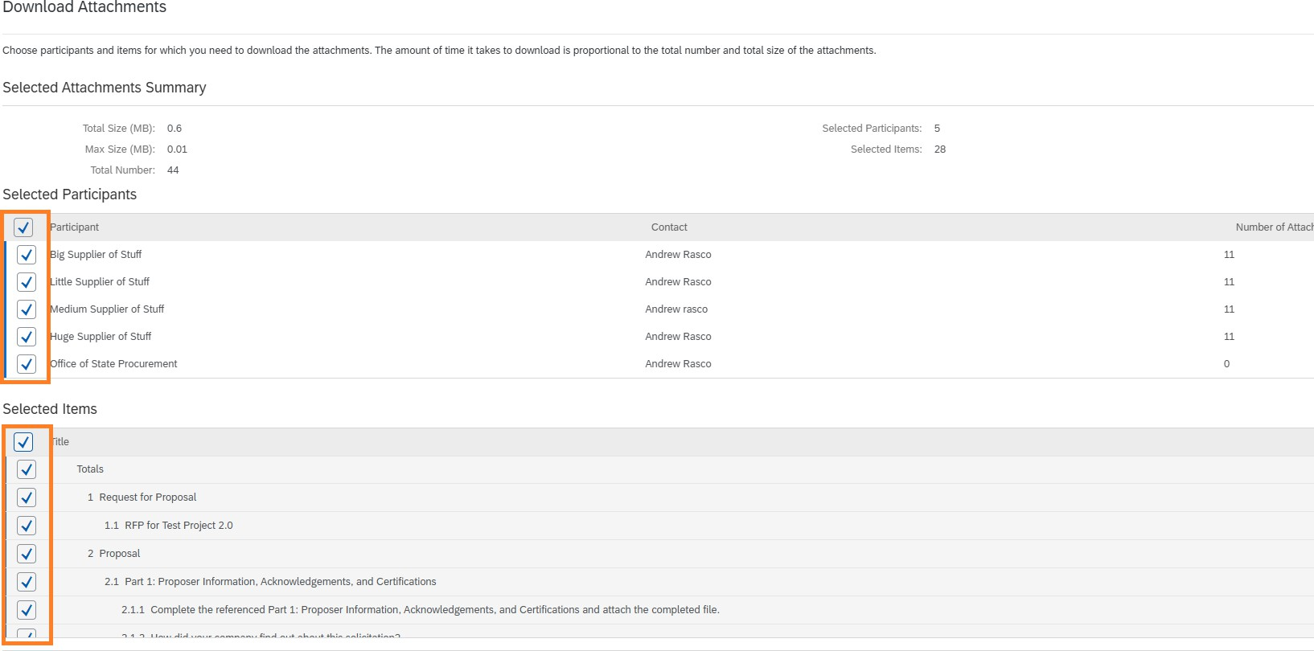

* + The Selected Attachments Summary section towards the top of the page will show how many attachments will be downloaded. Select Download Attachments to download the selected attachments into a Zip file.

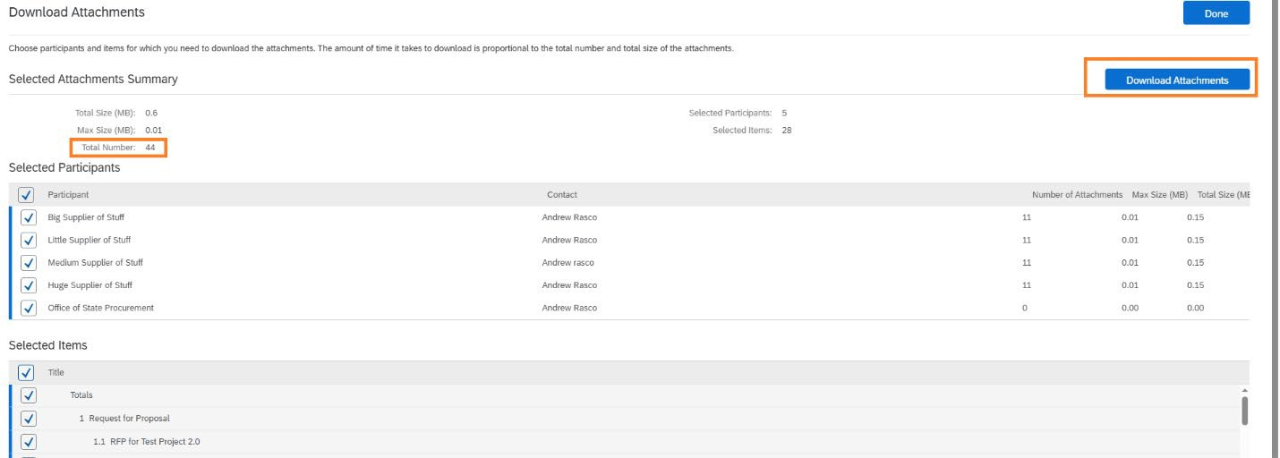

* + When you have finished downloading proposals and attachments, you can exit in several ways. To remain in the grading module, change the radio button to ‘Grade by Content’ or ‘Grade by Participants’. Alternatively, you can select ‘Cancel’ to exit the grading module. Do NOT select ‘Submit’ as this will submit your evaluation, even if you have not yet completed it.

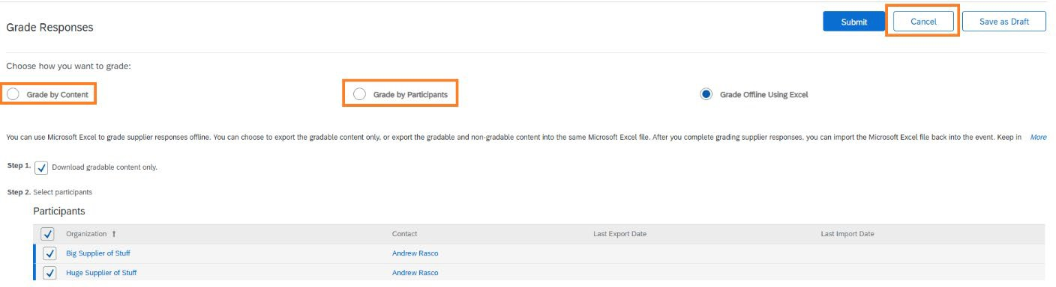

# Evaluating Proposals

* + Evaluation committee members evaluate proposals by reading the response and any attachments for each question. Grades are assigned by selecting the dropdown and selecting a percentage. For guidance, consult the Evaluation Methodology for your RFP.

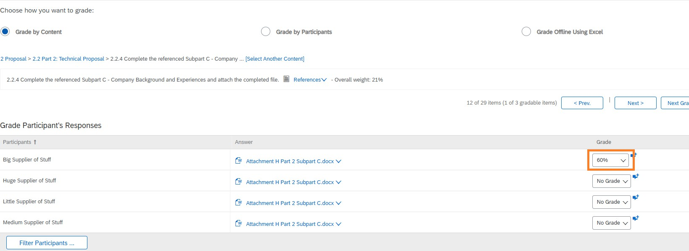

* + Comments should be entered to explain the rationale for your chosen grade. This is done by clicking the ‘Add grading comment and optional attachment’ symbol and entering a

comment.

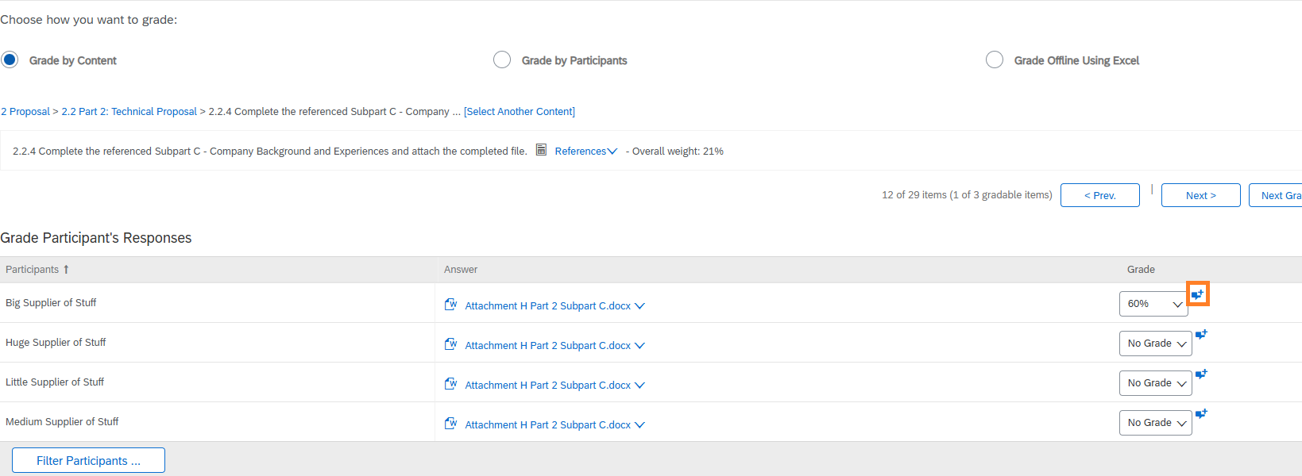

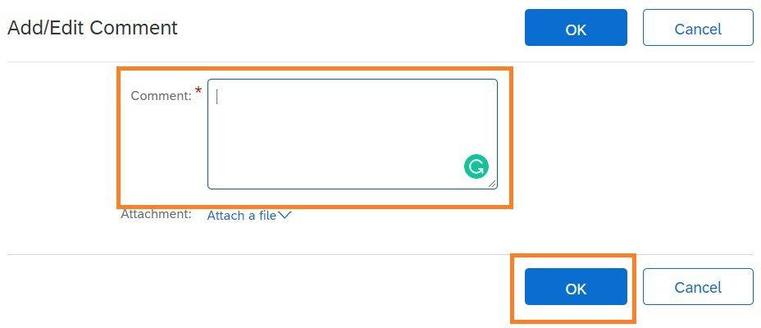

* + If you need a break during evaluation, select ‘Save as Draft’ to save your progress.

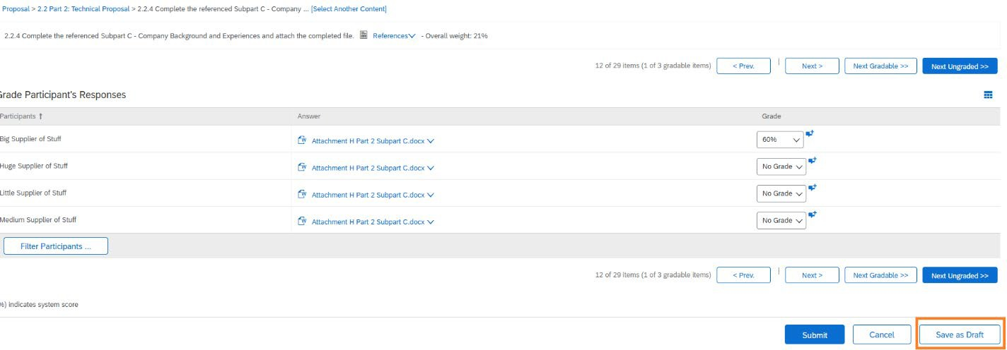

* + A grade must be entered for each response. A comment should be entered for each response. When you have graded all responses, select ‘Submit’ to submit your individual evaluation.

