Purchase Order Email Election

- As the vendor administrator, if you need to update your record, please access by clicking on the ‘PO Email Election’ option in the Detailed Navigation pane:

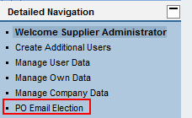

- You will be directed to a page with the option to change your selection:

