Manage Product Categories
- Log in to the vendor portal with your ID (11 digit vendor number that begins with a “V”) and your personal password.

- Click on Manage Product Categories under “Detailed Navigation” on the left and the following screen will appear:

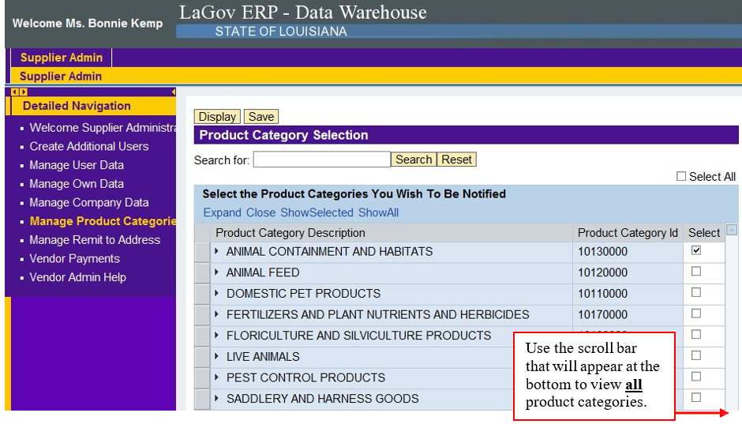
- To add additional product categories, click the appropriate box on the right under the “select” column. To remove a product category from your selection, click the check mark by the appropriate product category and it will deselect it.

NOTE: You may search product categories at this site at the UNSPSC family and class level. If you do not find what you are looking for, you may want to use the detailed search at https://wwwcfprd.doa.louisiana.gov/OSP/LaPAC/vendor/commoditySearch.cfm
Hint: If you use the detailed search and click on the box by “whole word”, it will narrow your search. Example if you enter “ice” it will bring up 4129 hits because it includes words like device, service, etc. If you select whole word, it will narrow your search to 37. When you locate the product or service you are looking for, make a note of the first 4 digits (family code). You will use these to select your product categories.

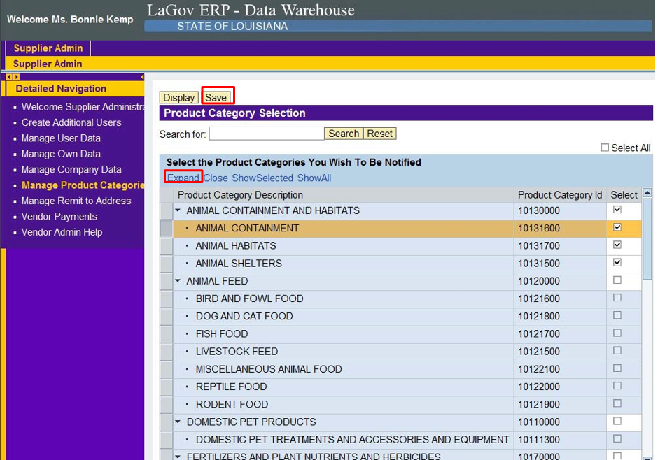

- When you registered at the family level (4 digits), the system automatically selected all classes (6 digits) within that UNSPSC family to send notifications. If you would like to fine tune your selection to only the products that you can provide, you have the option of deleting some of the classes that fall under the family code that you have selected. To do this, click expand (will populate all classes under all families) or click the small black arrow located immediately to the left of the specific family code (will populate classes that fall under only that family). You may then click the check marks on the right that do not interest you and you will no longer receive emails for those particular classes under that family.

- Other options exist on the same line where you clicked “expand”. You may limit your selection to only those product categories that you have selected or you may want to show all available product categories.

- After you have made your changes, click the “save” button at the top of the screen and the following message will appear:

