Part II. Military Justice

Chapter 1. General 1

§101. Authority 1

§102. Purpose 1

§103. Applicability 1

§104. Suggested Improvements 1

§105. Explanation of Abbreviations and Terms 1

§106. Responsibilities 2

§107. Availability of Military Justice Publications 2

§108. Prospective Application of Amendments 3

§109. Construction and Precedence 3

§110. Forms 3

§111. Jurisdictional Alignment of Louisiana Guard Units 3

Chapter 2. Basics of Military Justice 4

§201. The Commander's Role 4

§202. Professional Standards of Conduct 4

§203. Unlawful Command Influence 4

Chapter 3. Investigating and Obtaining Evidence 4

§301. Sources of Information 4

§302. Command Responsibilities 4

§303. Questioning Suspects and Witnesses, Generally 5

§304. LCMJ Article 31 Warning/Right to a Lawyer 5

§305. Written Statements 6

§306. Oral Statements 6

§307. Search and Seizure 6

§308. Authority to Search 7

§309. Safeguarding Evidence, Generally 8

§310. Chain of Custody 8

§311. Marking Evidence 8

§312. Perishable and Unstable Items 9

§313. Flagging Action, Generally 9

§314. Courts of Inquiry 9

Chapter 4. Non-Judicial Punishment 9

§401. Applicability, Generally 9

§402. Prerequisites 9

§403. Persons Who May Be Punished 10

§404. Persons Who May Impose Non-judicial Punishment 10

§405. Policies 11

§406. Authorized Punishments 11

§407. Special Rules and Limitations 11

§408. Initial Notification 12

§409. Demand for Trial by Court-Martial 13

§410. Waiver of Court-Martial and Failure to Either Submit Matters or Demand Hearing 13

§411. Waiver of Court-Martial and Hearing and Submission of Matters 13

§412. Waiver of Court-Martial and Demand for Hearing 13

§413. Hearing Procedures 14

§414. Non-Judicial Punishment Based on Record of Court of Inquiry or Other Investigative Body 14

§415. Specific Punishments 14

§416. Appeals, Generally 15

§417. Who May Act on Appeal 15

§418. Procedure for Submitting Appeal 16

§419. Action by the Imposing Commander on Appeal 16

§419. Action by the Superior Authority on Appeal 16

§420. Action by a Judge Advocate on Appeal 16

§422. Clemency, Generally 16

§423. Suspension 17

§424. Vacation 17

§425. Mitigation 17

§426. Remission 17

§427. Setting Aside and Restoration 18

§428. Summarized Article 15 18

§429. Distribution and Filing of Article 15 and Allied Documents 19

§430. Supplementary Action 20

§431. Reconciliation Log 21

§432. Time for Distribution of Initial DA Form 2627 21

§433. Transfer or Removal of Records of Non-judicial Punishment. 21

§434. Use of Non-judicial Punishment Records 21

§435. Effects of Errors 22

§436. Announcement of Punishment 22

Chapter 5. Pretrial Procedures 29

§501. Report of Offense 29

§502. Commander's Duties before Trial 29

§503. Referral of Offenses to Civilian Authorities 31

§504. Arrest Warrant Procedures 31

§505. Apprehension and Detention by Peace Officers 33

§506. Pretrial Restraint 33

§507. Pretrial Confinement 34

§508. Bail 34

§509. Preparation of the Charge Sheet 34

§510. Preferral and Transmittal of Charges 35

§511. Transmittal of Charges 36

§512. Time Limits 36

§513. Detailing of Military Judge 36

§514. Detailing of Trial Counsel 37

§515. Assignment of Defense Counsel 37

§516. Detailing and Duties of Court Members 37

§517. Subpoenas 38

§518. Expenses 38

§519. Docketing of Trials 38

§520. Continuance Requests 38

§521. Logistical Arrangements 38

§522. Article 32 Investigations 38

§523. Plea Bargains and Pretrial Agreements 39

Chapter 6. Trial Procedures 51

§601. Applicability of Trial Guides 51

§602. Courtroom Procedure Rules 52

§603. Article 39(a) Sessions/Conferences 54

§604. Arraignment 54

§605. Motions 54

§606. Pleas 55

§607. Former Jeopardy, Mistrial, and Withdrawal 56

§608. Contempt 57

§609. Witnesses 57

§610. Stipulations 57

§611. Withdrawal of Stipulations 57

§612. Motion for Finding of Not Guilty 57

§613. Views and Inspections 58

§614. Arguments 58

§615. Objections to Impermissible Argument 59

§616. Sentence 59

Chapter 7. Post-Trial Procedures 63

§701. Report of Result of Trial 63

§702. Deferral of Sentences to Confinement 63

§703. Preparation of Record of Trial 63

§704. Legal Reviews 63

§705. Matters Submitted by the Accused 63

§706. Convening Authority's Action 63

§707. Suspension of Sentences 64

§708. Execution of Sentence Involving Custody 64

§709. Publication of Results 64

§710. Distribution and Filing of Charge Sheet 65

§711. Appeal 65

§712. Fine Payment and Disposition 65

§713. Nonpayment of Fines 65

§714. Vacating Suspensions 66

Chapter 8. Reserved. 74

Chapter 9. Complaints Under Article 138, LCMJ 74

§901. General 74

§902. Explanation of Terms 75

§903. Inappropriate Subject Matter for Article 138 75

§904. Making a Complaint 75

§905. Complaint 76

§906. Legal Advice 76

§907. Action by Person Receiving the Complaint 76

§908. Determination Not Required by The Adjutant General 77

§909. Withdrawal of Complaint 77

§910. Determination Required by the Adjutant General 77

§911. Forwarding Complaint to Governor 78

§912. Military Justice Abbreviations 79

§913. Military Justice Definitions 79

§914. Nonjudicial Punishment Guide—Appendix 85

§915. Summary Courts-Martial Guide—Appendix 89

§917. Request for Arrest Warrant Packet—Appendix 97

**Part III. Benefits**

Chapter 1. National Guard Death and Disability Benefits 101

§101. General Provisions 101

Title 41

MILITARY FORCES OF THE STATE

Part II. Military Justice

Chapter 1. General

§101. Authority

A. U.S. Constitution, Article I, Section 8, clauses 15 and 16; Article II, Section 2, clause 1; Article VI; Amendment X.

B. Title 10, Chapter 47, U.S. Code (UCMJ); Title 32 U.S. Code, Sections 326-333.

C. Manual for Courts-Martial, United States, 2008 (MCM).

D. Army Regulation 27-10, Military Justice.

E. Air Force Manual 111-6, Military Justice.

F. Louisiana Constitution, 1974, Article IV, Section 5(J).

G. Louisiana Revised Statutes 29:2, 39, 136, 242.

AUTHORITY NOTE: Promulgated in accordance with R.S. 29:11(F).

HISTORICAL NOTE: Promulgated in accordance with the Office of the Governor, State Military Department, LR 35:2352 (November 2009).

§102. Purpose

A. This Regulation prescribes policies and procedures pertaining to the administration of military justice within the Louisiana National Guard and implements the Louisiana Code of Military Justice (LCMJ). Its format is designed to be of practical assistance to the commander in his effort to be effective and fair in matters relating to military law. Although even the most routine legal situation may seem confusing initially, the solution will generally prove to be relatively simple. This Regulation presents practical advice about many aspects of military justice and is designed to equip all concerned with the resources necessary to make swift, fair, and effective decisions.

AUTHORITY NOTE: Promulgated in accordance with R.S. 29:11(F).

HISTORICAL NOTE: Promulgated in accordance with the Office of the Governor, State Military Department, LR 35:2352 (November 2009).

§103. Applicability

A. General. This Regulation applies to all persons in the military forces and applies at all places. [LCMJ Article 5.]

B. Extraterritorial Application. Courts Martial and Courts of Inquiry may be convened and held in units of the Louisiana National Guard while those units are serving outside the State, with the same jurisdiction and power as to persons subject to the LCMJ as if the proceedings were held inside the State, and offenses committed outside the State may be tried and punished either inside or outside the State. However, there is no extraterritorial application of the LCMJ to a Louisiana National Guard unit serving overseas in a Title 10, U.S. Code status. Soldiers committing offenses in a Title 10 status must be adjudicated by active duty units through the application of the Uniform Code of Military Justice (UCMJ).

C. Duty Status Limitation. No person may be tried or punished for any offense under LCMJ Articles 77-134 unless the act(s) or omission(s) constituting the offense was committed while he was in a duty status or during a period of time in which he was under lawful order to be in a duty status. (For purposes of Article 112a only, membership is equated with duty status.) Nevertheless, the processing of charges and all proceedings, including trial, may be conducted without regard to duty status of the accused, and is not affected by the place where the military justice action takes place. [LCMJ Article 2.]

AUTHORITY NOTE: Promulgated in accordance with R.S. 29:11(F).

HISTORICAL NOTE: Promulgated in accordance with the Office of the Governor, State Military Department, LR 35:2352 (November 2009).

§104. Suggested Improvements

A. The proponent agency of this Regulation is the Office of the State Judge Advocate. Any questions and/or recommendations for improvements concerning these materials should be directed to Joint Forces Headquarters Louisiana, Consolidated Law Center, 5445 Point Clair Road, Box 28, Carville, LA 70721.

AUTHORITY NOTE: Promulgated in accordance with R.S. 29:11(F).

HISTORICAL NOTE: Promulgated in accordance with the Office of the Governor, State Military Department, LR 35:2352 (November 2009).

§105. Explanation of Abbreviations and Terms

A. General. Abbreviations and special terms used in this Regulation are explained in the Glossary. [See also, LCMJ Article 1, 10 U.S. Code Section 101, 32 U.S. Code Section 101, and Rules for Courts-Martial (R.C.M.) 103 for definitions of terms used therein.] If a term is not adequately explained in this Regulation, it should receive the construction and usage customarily accorded by reference to dictionaries of the English language.

B. Special Rules. Unless otherwise specifically so stated, use of the male pronoun shall be construed to include the female, and use of the term "Servicemember" includes Soldiers and Airmen of the Louisiana National Guard. References to terms peculiar to one branch of military service shall, unless the context specifically indicates a contrary intent, be construed to include the corresponding term(s) for other branch(es) of the military service. Words used in the singular number apply also to the plural; words used in the plural number include the singular. The word "shall" is mandatory, and the word "may" is permissive. The term "Louisiana National Guard" shall include the terms Louisiana Army National Guard, Louisiana Air National Guard Military Department, State Militia, State Military Forces, State Guard, and State Defense Force unless context clearly indicates otherwise. The term "Parish" shall, where applicable, be construed to include the term, "County."

C. Cross-references. References to source materials located elsewhere are designated in [brackets.]

AUTHORITY NOTE: Promulgated in accordance with R.S. 29:11(F).

HISTORICAL NOTE: Promulgated in accordance with the Office of the Governor, State Military Department, LR 35:2352 (November 2009).

§106. Responsibilities

A. State Judge Advocate. The State Judge Advocate (SJA) is responsible for the overall supervision and administration of military justice within the Louisiana National Guard. The State Judge Advocate is also the legal advisor to The Adjutant General (TAG) and the Governor in their capacities as General Courts Martial convening authorities. The SJA supervises all Judge Advocate Legal Services (JALS) in the National Guard. [LCMJ Article 6, 34, 60; R.C.M. 406, 1106.] The SJA or his assistants shall make frequent inspections in the field in supervision of the administration of military justice. [LCMJ Article 6C.] The SJA may publish directives or rules not inconsistent herewith for the conduct of military justice operations.

B. Staff Judge Advocates. Brigade and/or Direct Reporting Unit Staff Judge Advocates are responsible for providing legal advice and services to their respective commands. The Staff Judge Advocate has responsibilities generally corresponding to those discharged by the State Judge Advocate with relation to TAG. Staff Judge Advocates assist the commander by identifying legal problems and participating in making legally acceptable decisions. Staff Judge Advocates supervise Trial Counsel and other Judge Advocates assigned to the DRU and control the duties and responsibilities assigned to the Trial Counsel and other Judge Advocates assigned to the DRU. Additionally, the Staff Judge Advocates supervise all paralegals assigned to the DRU and to Summary Court Martial Convening Authorities (i.e. Battalions) which are attached to the DRU. As such the Staff Judge Advocate is authorized by this regulation to consolidate all paralegals at a DRU law center in order to better provide efficient and timely legal services to the command.

C. Chief of Military Justice. The Chief of Military Justice is responsible for assisting in the professional development and guidance for all LANG Trial Counsel in all facets of military justice actions. The chief will supervise and is responsible for all post-trial matters for Special and General Courts-Martial. He will also provide guidance and assistance on pre-trial matters, especially preparation of convening orders and the selection of panel members.

D. Chief, Trial Defense Service. In order to provide independent trial defense counsel services to the Soldiers and Airmen of the Louisiana National Guard, TAG established Louisiana National Guard Trial Defense Service. (LANG TDS). Chief, LANG TDS shall operate independently from the State Judge Advocate and shall provided separate offices, automation, and support. Chief, LANG TDS shall provide defense counsel services for LANG personnel, whenever required by law or regulation and authorized by the State Judge Advocate. Chief, LANG TDS shall also develop programs and policies to promote the effective and efficient use of defense counsel resources and enhance the professional qualifications of all personnel providing defense services. Chief, LANG TDS is appointed by the State Judge Advocate and certified under LCMJ Article 27b(2) and is the Supervisor of all defense counsel assigned to LANG TDS. Chief, LANG TDS details defense counsel to courts martial and recommends personnel for service in LANG TDS. Chief, LANG TDS may represent soldiers and airmen in courts martial, administrative boards, and other proceedings and act as consulting counsel as required by law and regulations. Chief, LANG TDS may assist the State Judge Advocate and DRU SJA’s with mobilization issues that do not relate to criminal law (ie Wills, Powers of Attorney).

E. Other Assigned Judge Advocate Legal Service (JALS) Personnel. Other assigned personnel of a JALS perform those duties prescribed by their superiors and/or outlined in applicable regulations as supplemented by superior competent authority.

F. Commanders. Commanders at each level are responsible for carrying out the military justice responsibilities outlined in this Regulation and other references. A copy of this Regulation is issued to each unit down to the company/squadron level to be maintained in the units' publications library, and is subject to inspection. It is imperative that commanders familiarize themselves with the contents of these materials. [See also, paragraph 2-3.]

G. Convening Authorities. Convening Authorities are responsible for carrying out those duties outlined in this Regulation and other references. Careful attention will be given to the area of Unlawful Command Influence discussed in Chapter 2.

AUTHORITY NOTE: Promulgated in accordance with R.S. 29:11(F).

HISTORICAL NOTE: Promulgated in accordance with the Office of the Governor, State Military Department, LR 35:2352 (November 2009).

§107. Availability of Military Justice Publications

A. The complete text of the current Manual for Courts-Martial, United States, the Louisiana Code of Military Justice (R.S. 29:101, et seq.), and this Regulation, shall be available electronically to any member of the Louisiana National Guard by accessing the State Judge Advocate’s site Louisiana Knowledge Online (LKO) at http://nglashcbsvitsp1/SiteDirectory/sja/default.aspx printed copies are available upon request through Judge Advocates and the Trial Defense Service.

AUTHORITY NOTE: Promulgated in accordance with R.S. 29:11(F).

HISTORICAL NOTE: Promulgated in accordance with the Office of the Governor, State Military Department, LR 35:2353 (November 2009).

§108. Prospective Application of Amendments

A. All references made to any provisions of the LCMJ, MCM, federal or state statutes, rules, or regulations shall automatically include amendments and additions thereto now or hereafter made.

AUTHORITY NOTE: Promulgated in accordance with R.S. 29:11(F).

HISTORICAL NOTE: Promulgated in accordance with the Office of the Governor, State Military Department, LR 35:2353 (November 2009).

§109. Construction and Precedence

A. Principles of Construction. This Regulation and other military justice source materials shall be construed to secure simplicity in procedure, elimination of unjustifiable expense and delay, and fairness and efficiency in administration to the end that truth may be ascertained and proceedings justly determined.

B. Order of Precedence. Unless express authority or the context clearly indicate otherwise, the following authorities are applicable to the administration of military justice under the LCMJ in the following order of precedence:

1. the LCMJ and other provisions contained in La. Revised Statutes Title 29 [See, e.g. La. R.S. 29:11(F).];

2. the Military Rules of Evidence (M.R.E.) and Rules for Courts-Martial (R.C.M.);

3. Louisiana laws concerning criminal trials and procedures (e.g. La. C.Cr.P., La. C.E., etc);

4. the UCMJ.

C. Special Rules/Secondary Authorities.

1. Louisiana court decisions may be used in interpreting or construing Louisiana authorities (the LCMJ, La. R.S., this Regulation, and other Louisiana laws and rules concerning criminal trials and procedures). Decisions of the U.S. Supreme Court, other federal courts, and the U.S. Court of Military Appeals (U.S.C.M.A.) may be cited in interpreting or construing federal authorities (e.g. M.R.E.., R.C.M., UCMJ, and MCM). Decisions of the Courts of Military Review do not constitute precedent authority, but they may be cited as guidance or persuasive authority.

2. Other active component publications (regulations, pamphlets, etc.) not applicable to the National Guard when not in federal service may be used for guidance in administering military justice, but shall not be regarded as directive, particularly if they are incompatible with the general nature and organization of, or special procedures established or authorized by law for Louisiana National Guard military justice activities.

D. Matters Not Covered. All matters relating to the administration of military justice in the organized militia not otherwise provided for herein shall be decided by the customs and usage of the appropriate force or of the Armed Forces of the United States.

E. Consensual Departure Authorized. Nothing contained in this Regulation or other military justice authority shall prevent departure from any of the procedural requirements prescribed for military justice actions provided that the defendant makes a voluntary, knowledgeable, and intentional declaration on the record of his intention and desire to so depart.

AUTHORITY NOTE: Promulgated in accordance with R.S. 29:11(F).

HISTORICAL NOTE: Promulgated in accordance with the Office of the Governor, State Military Department, LR 35:2353 (November 2009).

§110. Forms

A. Prescribed Forms. Certain forms in use by Louisiana and/or United States military forces are referred to herein. The use of any particular form described in connection with military justice actions is preferred but not mandatory. Variance from the specified forms does not constitute a jurisdictional defect or invalidate any proceeding.

B. Non-prescribed Forms. If a Department of Defense, Army, or Air Force form is available for certain purposes, it may be modified to comply with this Regulation and/or the LCMJ, and may be used for state purposes.

AUTHORITY NOTE: Promulgated in accordance with R.S. 29:11(F).

HISTORICAL NOTE: Promulgated in accordance with the Office of the Governor, State Military Department, LR 35:2354 (November 2009).

§111. Jurisdictional Alignment of Louisiana Guard Units

A. The Adjutant General and Governor are the General Court-martial convening authorities. As such TAG or the Governor may publish a Jurisdictional alignment of units designating the Special Court Martial Convening Authorities and Summary Court-Martial Convening Authorities and the units under the jurisdiction of such authorities. TAG or the Governor may delegate to SPCMCA’s the authority to jurisdictionally align their own subordinate units. This delegation must be in writing.

AUTHORITY NOTE: Promulgated in accordance with R.S. 29:11(F).

HISTORICAL NOTE: Promulgated in accordance with the Office of the Governor, State Military Department, LR 35:2354 (November 2009).

Chapter 2. Basics of Military Justice

§201. The Commander's Role

A. The commander has the primary role in the administration of military justice. He is responsible for both enforcing the law and protecting the rights of the individual servicemember. Generally, the commander is one of the first to learn of conduct of one under his command that might require non-punitive disciplinary measures, non-judicial punishment or court-martial action. The commander's duties are two-fold. First, he has a duty to investigate the circumstances of a possible infraction and secondly, to determine the appropriate action. Factors such as the seriousness of the offense, the intent or lack thereof, the age, experience and any special qualifications of the offender, the past performance and record of the servicemember, and the state of morale and discipline in his unit will influence whether the commander prefers charges by a court-martial or disposes of the matter with non-punitive disciplinary action or non-judicial punishment. The commander has strong powers to exact obedience. But military justice should be restrained and graduated to "fit the crime." The commander should act objectively and calmly, and should never resort to scorn or ridicule. All facts should be collected and carefully considered before acting. The commander's choice of action will depend in part on the nature of the misconduct; it will also depend upon the goal sought. The commander shall consult with his servicing judge advocate.

AUTHORITY NOTE: Promulgated in accordance with R.S. 29:11(F).

HISTORICAL NOTE: Promulgated in accordance with the Office of the Governor, State Military Department, LR 35:2354 (November 2009).

§202. Professional Standards of Conduct

A. The Louisiana Code of Judicial Conduct and Louisiana Rules of Professional Responsibility are applicable to judges and lawyers involved in Louisiana National Guard courts-martial. The Army Rules of Professional Conduct, Army Regulation 27-26 applies to all Army judge advocates and paralegals in the Louisiana National Guard. The Air Force Rules of Professional Conduct, TJS-2 applies to all Air Force judge advocates and paralegals in the Louisiana National Guard. Any allegation of a violation of such rules will be processed in accordance with Army Regulation 27-1 or TJS-2, as applicable.

AUTHORITY NOTE: Promulgated in accordance with R.S. 29:11(F).

HISTORICAL NOTE: Promulgated in accordance with the Office of the Governor, State Military Department, LR 35:2354 (November 2009).

§203. Unlawful Command Influence

A. Convening Authority's Proper Role. The LCMJ permits the convening authority to play a dominant role in the court-martial process before and after trial. Before trial, the convening authority decides whether to convene a court-martial and refers the case to trial. After the trial, the convening authority has broad powers of clemency. But while the convening authority plays a dominant role before and after trial, the LCMJ has provisions to assure the independence of the court-martial during trial.

B. Specific Prohibitions. Superiors may not direct how subordinate commanders’ act on cases over which authority to act has not been withheld or restricted. A superior who believes a specific action (such as imposing non-judicial punishment, referring a case to trial, or ordering pretrial confinement) should be taken may not order the subordinate to take the desired action. Rather, until the accused has been arraigned on a charge, the superior retains authority to order that charge referred to him for disposition; after arraignment, the superior has no authority to take action on the charge. [See LCMJ Article 37, R.C.M. 104]

AUTHORITY NOTE: Promulgated in accordance with R.S. 29:11(F).

HISTORICAL NOTE: Promulgated in accordance with the Office of the Governor, State Military Department, LR 35:2354 (November 2009).

Chapter 3. Investigating and Obtaining Evidence

§301. Sources of Information

A. A commander may receive information from many sources that an offense may have been committed by one of his Servicemembers. For example, the unit commander himself may witness an offense, someone within the unit may report the offense, or a higher headquarters may forward a report for action. When a superior commander asks that a report be investigated and the disposition reported, the request should not be construed or interpreted as a directive to take disciplinary action.

AUTHORITY NOTE: Promulgated in accordance with R.S. 29:11(F).

HISTORICAL NOTE: Promulgated in accordance with the Office of the Governor, State Military Department, LR 35:2355 (November 2009).

§302. Command Responsibilities

A. General. Regardless of how the commander learns of an alleged offense, he must insure that the matter is promptly and adequately investigated.

B. Reporting. Any incident which may generate widespread adverse publicity or which may damage public confidence in the organized militia shall be reported to the Adjutant General through channels.

C. Investigation. The investigation should provide the unit commander with sufficient information to make an intelligent and appropriate disposition of the incident report. The commander may conduct the inquiry himself or he may direct some other competent individual to do it. In serious cases, consideration should be given to use of law enforcement professionals, such as the Military Police or Criminal Investigation Division. The investigator should collect and present all information which may prove or disprove the allegation of misconduct. The investigation should address itself to three primary questions.

1. Was an offense committed?

2. Was a servicemember involved in the offense?

3. What is the character and military record of the suspected servicemember?

D. Impartiality. The investigator must at all times remain impartial. A one-sided investigation may lead to an injustice to the accused and an embarrassment to the command. Usually, the preliminary investigation is informal and consists of interviews with witnesses and review of police reports. The investigation must be thorough enough to provide a firm factual foundation for a determination of what happened and what should be done. This investigation is preliminary in nature and should not be confused with the formal LCMJ Article 32 investigation, which requires sworn charges, nor the procedures for an administrative investigation under AR 15-6.

E. Disposition. Once the preliminary investigation is completed, the unit commander must make his decision. He may:

1. decide to take no action;

2. decide to take non-punitive disciplinary action;

3. decide to impose non-judicial punishment under LCMJ Article 15 (Chapter 4);

4. decide to prefer court-martial charges against the accused (Chapter 5); or

5. refer the case to appropriate civilian authorities (Chapter 5, paragraph 5-3).

AUTHORITY NOTE: Promulgated in accordance with R.S. 29:11(F).

HISTORICAL NOTE: Promulgated in accordance with the Office of the Governor, State Military Department, LR 35:2355 (November 2009).

§303. Questioning Suspects and Witnesses, Generally

A. It is the duty of the unit commander to insure prompt investigation of the circumstances of an alleged crime and to examine the facts relevant to the guilt or innocence of the accused. All necessary witnesses as well as the suspects, should be interviewed. Interviews should be conducted fairly and, because memories fade, as soon as possible. The questioning of any suspect must begin with a warning of his rights under LCMJ Article 31 and his right to counsel. An investigation may be complicated or simple. In either case, the investigator will want to question both the suspect and the witnesses. Not all cases will require formal statements. In the simple case, sufficient facts may be obtained without written statements.

AUTHORITY NOTE: Promulgated in accordance with R.S. 29:11(F).

HISTORICAL NOTE: Promulgated in accordance with the Office of the Governor, State Military Department, LR 35:2355 (November 2009).

§304. LCMJ Article 31 Warning/Right to a Lawyer

NOTE: (DA Form 3881 Rights Warning Procedures/Waiver Certificate, See Figure 5.7).

A. General. Servicemembers suspected of a violation of the LCMJ shall be advised of their Article 31 rights. A confession or admission made by such a suspect who has not been advised of his rights may result in the confession or admission being inadmissible against him court-martial. It is possible that an accused may still be convicted because of other evidence of guilt which is admissible.

1. Procedure. The following procedure must be carefully followed in questioning a suspect to insure that his statements are admissible in court proceedings (DA Form 3881 Rights Warning Procedures/Waiver Certificate, See Figure 5.7):

a. Before asking any questions pertaining to the case, first inform the individual: "You are suspected of committing the following offense(s) which is (are) violation(s) of the Louisiana Code of Military Justice. Before I ask you any questions, you must understand your rights. You have the right to remain silent. Any statement you make may be used as evidence against you in criminal or administrative proceedings. You have the right to consult with a lawyer before being asked any questions and to have the lawyer present with you during questioning. You may hire a civilian lawyer at no cost to the government or a military lawyer will be detailed for you at no cost to you. Even if you decide to answer questions now without having a lawyer present, you may stop answering questions until you consult with a lawyer."

b. After this statement is made, the suspect should be asked if he understands his rights. When the investigator is satisfied that the suspect understands these rights, then the following two questions should be asked:

(a). "Do you want a lawyer?" and

(b). "Do you want to answer any questions or make a statement?"

2. The suspect may indicate that he wishes to waive his rights to remain silent and to consult with a lawyer. He must waive these rights freely, knowingly and intelligently. If he does so, he may then be questioned concerning the offense. If the suspect indicates that he wants to consult with a lawyer, he should not be questioned until a lawyer is present. If the suspect indicates that he does not wish to answer questions, he should not be questioned. In any case, it is essential that the investigator not use a tone of voice or manner which could lead the suspect to believe that he is being threatened or which plays down the importance of the warning. If this is done it may later be held that the suspect's agreement to answer questions was gained by coercion or improper inducement and his statement would be inadmissible in a trial by court-martial. It is advisable to have a disinterested witness present for such advice of rights and suspect statements. The investigator may decide not to question a suspect if other evidence is available (DA Form 3881 Rights Warning Procedures/Waiver Certificate, See Figure 5.7).

B. If the person being interviewed is not suspected of having committed an offense, but is merely a witness to the offense or has knowledge of it, there is no legal requirement to warn him of his rights. In the questioning, the investigator may begin to suspect that the witness was involved in the offense. This may happen when it appears that the witness was actually an accomplice or an accessory to the crime. The investigator should immediately then stop the questioning, inform the witness of the offense of which he is now suspected, and advise him of his rights as indicated above.

AUTHORITY NOTE: Promulgated in accordance with R.S. 29:11(F).

HISTORICAL NOTE: Promulgated in accordance with the Office of the Governor, State Military Department, LR 35:2355 (November 2009).

§305. Written Statements

A. Procedure. The best means for making an accurate and complete record of the information obtained in the investigation is the sworn statement. A sworn statement (affidavit) is a written statement of facts given by a witness or suspect who states under oath or affirmation that the contents of his statement are true. All persons who are detailed to conduct the investigation are authorized by LCMJ Article 136 to administer oaths in conjunction with sworn statements taken in the course of a preliminary investigation. No special form is required to make this sworn statement. If the statement is to be taken from a suspect, DA Form 3881 (Rights Warning Procedures/Waiver Certificate) should be completed and signed by the suspect before taking his statement. A copy of DA Form 3881 is Figure 5-7, which may be used with appropriate changes in the body from "UCMJ" to "LCMJ". [See paragraph 1-10.] After a suspect has signed the DA Form 3881 and waived his rights to remain silent, his statement may be taken on DA Form 2823 (Sworn Statement). DA Form 2823 (Sworn Statement) may also be used for the sworn statement of a witness. Since the witness is not a suspect, this latter form has no provision for a warning of his rights. The language of the witness or suspect should be used throughout the statement even though it may be vulgar, grammatically incorrect, or illogical. This insures that the writing is the witness's statement and not the composition of the investigating officer. The statement may be written in narrative form or story form, in question and answer form, or both. An appropriate oath for completing the sworn statement may be administered as follows:

1. "Do you swear (or affirm) that the statements you have made are the truth, the whole truth and nothing but the truth (so help you God)?"

2. The person administering the oath must sign his own name.

B. Guidelines for Written Statements. Sworn statements should be requested primarily from witnesses who have direct, personal knowledge of the facts. If the information offered was told to a witness by Sergeant A, the investigator should obtain a sworn statement from Sergeant A. Opinions and conclusions, without offering supporting facts, reduce the reliability of a sworn statement. The investigator should attempt to obtain the facts upon which the opinions are based, and encourage the witness to substitute facts for his opinions. The witness should initial the written statement at the beginning and the end of each page, at each erasure and correction, and where otherwise indicated on DA Form 2823. The purpose of initials is to avoid any questions of tampering after the statement has been completed.

AUTHORITY NOTE: Promulgated in accordance with R.S. 29:11(F).

HISTORICAL NOTE: Promulgated in accordance with the Office of the Governor, State Military Department, LR 35:2356 (November 2009).

§306. Oral Statements

A. When a suspect waives his rights under LCMJ Article 31 and his right to counsel, but refuses to sign a statement, the investigator may make a summary of his remarks. This summary or oral statement may be admissible in a trial by courts-martial. The oral statement of a suspect concerning his part in an offense made to a person who is not investigating the case or which was blurted out spontaneously to the investigator before the rights warning was administered may also be admissible in a trial by court-martial. If possible, have critical oral statements witnessed by at least one disinterested individual.

AUTHORITY NOTE: Promulgated in accordance with R.S. 29:11(F).

HISTORICAL NOTE: Promulgated in accordance with the Office of the Governor, State Military Department, LR 35:2356 (November 2009).

§307. Search and Seizure

A. General. A unit commander may lawfully seize the property of a person in his unit; however, that an unlawful search which violates a Servicemember's rights will likely result in seized items being excluded from evidence and therefore inadmissible during a court-martial. Because the law of probable cause is often difficult to apply, Commanders shall consult with a Judge Advocate prior to taking action. This not only avoids unlawful searches and protects the Servicemember's rights, but it also insures that physical evidence will be admissible in a trial by court-martial.

B. Lawful Searches and Seizures. A commander may authorize a search if he is reasonably certain that an offense has been committed and that items connected with the offense will be found in the location he intends to search.

C. Search of Persons, Vehicles, or Residences not located on Military Property. Searches shall not be conducted of Persons, Vehicles, or Residences not located on Military Property. If a commander has a reasonable basis to search a servicemember’s person, vehicle, or residence not located on Military Property, he shall immediately contact his servicing Judge Advocate in order to obtain a civilian search warrant and the assistance of local law enforcement.

D. Search of Government Quarters or Residences located on Military Property. Prior to undertaking a search of Government Quarters or Residences located on Military Property, commanders and investigators shall immediately contact his servicing Judge Advocate in order to obtain a search warrant from a Military Judge.

E. Inspections. Search and seizure requirements do not limit the commander's authority to conduct legitimate inspections including unannounced shakedown inspections. The purpose of an inspection is to promote the health, welfare, preparedness, and safety of the personnel in the unit. For example, the commander may want to insure that his servicemembers have their equipment cleaned, maintained, and properly stored and that they have no dangerous articles such as ammunition carried from the range. The inspection must apply uniformly to all Servicemembers in the area and may extend to an examination of all their belongings kept within their government living area. Although an inspection need not be previously announced, it must have a legitimate purpose and may not be a mere subterfuge or excuse for what is really an unlawful search. The commander who decides to conduct his "inspection" upon hearing of a barracks larceny, and then starts his inspection near the living area of his prime suspect probably will not later convince the military judge that he was "inspecting" rather than "searching." Since an inspection is not based on the commander's belief a crime has been committed, it is not a search. Evidence of criminal conduct discovered during the course of a legitimate inspection may be admitted at a trial by court-martial.

F. Inventories. When a servicemember is AWOL, about to be confined, or detained by civilian authorities, an inventory of the member's personal belongings is required. Evidence obtained as a result of this inventory is admissible in a court-martial. Having a disinterested witness participate in this inventory is advisable.

G. Consent Searches. A person may consent to a search of his person or property, or both, unless control over such property has been given to another. A person may grant consent to search property when the person exercises control over that property. Consent may be limited in any way by the person granting consent, including limitations in terms of time, place, or property, and may be withdrawn at any time [See also para 3-8(C).] The issue of whether or not consent has been granted is a question of fact to be determined after a thorough examination of the circumstances relative to the alleged consent.

H. Searches of Government Property. Government property may be searched unless the person to whom the property is issued or assigned has a reasonable expectation of privacy therein at the time of the search. Under normal circumstances, a person does not have a reasonable expectation of privacy in government property that is not issued for personal use. Wall or floor lockers in living quarters issued for the purpose of storing personal possessions normally are issued for personal use; however, the determination as to whether a person has a reasonable expectation of privacy in government property issued for personal use depends on the facts and circumstances at the time of the search. [See also para 3-8(c).]

I. Searches of Open Fields or Woodlands. A search of open fields or woodlands does not require the issuance of a search warrant or search authorization.

J. Search of Person or Vehicle Located on Military Post, Reservation or Installation. When properly notified, usually by a warning sign posted conspicuously at the post, reservation or installation gate, individuals entering or leaving such post, reservation or installation give implied consent to the search of their persons, possessions, and vehicles and may be so searched. This authority includes Louisiana National Guard armories and facilities, under the provisions of La. R.S. 29:28.1.

K. Canine Searches. If a commander has a reasonable belief that illegal drugs are present in the area under his command, that commander may authorize a canine search of either the barracks or POV's located in that area and any contraband found upon alert of the canine is legal and admissible evidence.

AUTHORITY NOTE: Promulgated in accordance with R.S. 29:11(F).

HISTORICAL NOTE: Promulgated in accordance with the Office of the Governor, State Military Department, LR 35:2356 (November 2009).

§308. Authority to Search

A. A search and seizure is lawful in the following situations:

1. Apprehension. A Servicemember may be searched at the time and place of a lawful apprehension. The purpose of the search is to discover weapons and to prevent the destruction of evidence. The search is limited to the person of the Servicemember and the area within his immediate control. For example, the area within his immediate control may include a nearby open locker within his reach, but not the entire room.

2. Searches Authorized by the Commander

a. Areas subject to search. A commander has authority to conduct or direct a search of any person or property located in a place under his control if there is probable cause to justify the search. Searches of areas outside the commander’s immediate control should be undertaken only after coordination with the proper command authority.

b. Requirement of Probable Cause. Before a commander may authorize a search of a person or area in a place under his control, he must at least have probable cause to believe:

i. a crime is being committed or has been committed;

ii. the person to be searched committed or is involved in the crimes;

iii. the evidence of the crime is now where the commander plans to search; and

iv. the information is credible and the source of the information is reliable.

c. Probable cause to search exists when there is a reasonable belief that a person, property, or evidence sought is located in the place or on the person to be searched. A search authorization may be based upon "hearsay" evidence in whole or in part. There must be more than mere suspicion in the mind of the commander, but absolute proof beyond a shadow of a doubt is not required. In other words, probable cause lies somewhere between suspicion and actual knowledge. The commander must personally conclude, on the basis of information presented to him, that the contraband or evidence of a crime is at that time likely to be in the possession of the individual or on the premises to be searched. The commander's determination that probable cause exists must be reasonable and must be based on facts. It may not be based only on the conclusions of others. It is of no importance that a CID agent, a first sergeant, or an informant is aware of sufficient facts to provide probable cause, unless those facts are given to the only individual who orders or authorizes the search - the commander. The commander must believe that the person furnishing the information is reliable and that he had a sound basis for his information. In case of doubt, the commander should consult a Judge Advocate. DA Form 3745 should be used by the commander when authorizing a search.

d. Delegation of Authority. A unit commander may delegate his authority to search. The delegation of this authority should be limited to those persons whose experience, responsibilities, and temperament will insure a fair and impartial determination of probable cause. Commanders should consult the DRU SJA in order to delegate his authority to search.

3. Consent Searches

a. Probable cause is not required when a person with possession or control of property freely gives his consent to the search of his property. Because consent to the search is a waiver of the constitutional right to be free from unreasonable searches, the government must be able to produce clear and convincing evidence that the consent was voluntary and not a mere submission to authority. In order to establish voluntary consent, it is recommended that the suspect be told:

i. the specific items the search is expected to uncover;

ii. the specific area the search will cover;

iii. that he has a legal right to withhold his consent;

iv. that he cannot be forced to submit to a search unless it is properly authorized; and

v. that any evidence found in the search can be used against him.

b. It is advisable for a commander to have an unbiased and trustworthy witness present when a servicemember consents to a search. Should consent become an issue at the trial, the witness can verify the nature of the consent. If a consent search uncovers evidence of criminal conduct, the evidence will be admissible at trial. It does not matter that the consent was obtained without probable cause.

4. Open View. Evidence of criminal conduct which is in open view or located in a public area, such as a day room, may be seized without consideration of the requirements of consent or probable cause.

5. Search Warrant. Evidence may be seized pursuant to a search warrant issued by a proper magistrate. In the event that a search warrant is deemed necessary, the commander should consult a Judge Advocate.

AUTHORITY NOTE: Promulgated in accordance with R.S. 29:11(F).

HISTORICAL NOTE: Promulgated in accordance with the Office of the Governor, State Military Department, LR 35:2357 (November 2009).

§309. Safeguarding Evidence, Generally

A. Drugs, weapons, clothing, and other items related to an alleged offense are physical evidence of crimes. The unit commander must preserve and safeguard any physical evidence in his custody. Physical evidence should be handled by as few persons as possible since anyone who touches it may be required to appear at the trial. In order to properly safeguard physical evidence, it must be carefully marked to insure the later identification. A chain of custody document must be initiated, such as DA Form 4137, Physical evidence should be turned over to investigating officer as soon as possible.

AUTHORITY NOTE: Promulgated in accordance with R.S. 29:11(F).

HISTORICAL NOTE: Promulgated in accordance with the Office of the Governor, State Military Department, LR 35:2358 (November 2009).

§310. Chain of Custody

A. When an item of physical evidence is introduced at trial, counsel must show that it is the same item that was found at the scene of a crime or otherwise connected with the offense and that the item has not been materially altered. The chain of custody document is a written record listing all persons who have handled an item from the time it was originally identified as evidence until the time of trial. Therefore, secure storage for such evidentiary items is crucial. Coordination with the servicing staff Judge Advocates and, if available, active component CID personnel and/or local law enforcement authorities should prove useful in this regard.

AUTHORITY NOTE: Promulgated in accordance with R.S. 29:11(F).

HISTORICAL NOTE: Promulgated in accordance with the Office of the Governor, State Military Department, LR 35:2358 (November 2009).

§311. Marking Evidence

A. Physical evidence must be marked immediately by the first person who assumes custody to insure that he will be able to identify it at trial. This mark may be placed on the item itself and is usually the person's initials, the date, and time. The chain of custody record should briefly describe the item and the date and place of its discovery. One acceptable method of marking difficult items is with typewriter correction fluid, which will accept pen or pencil markings once dry. If the evidence simply cannot be marked, it should be placed in a sealed container and the container suitably marked and dated.

AUTHORITY NOTE: Promulgated in accordance with R.S. 29:11(F).

HISTORICAL NOTE: Promulgated in accordance with the Office of the Governor, State Military Department, LR 35:2358 (November 2009).

§312. Perishable and Unstable Items

A. Perishable and unstable items of evidence require special attention. They must be photographed or otherwise preserved. Professional assistance is necessary, for example, to preserve a fingerprint or a tire track in the dirt. Military police, CID, and/or local law enforcement officials may be of assistance in this regard. Contact your Judge Advocate if in doubt.

AUTHORITY NOTE: Promulgated in accordance with R.S. 29:11(F).

HISTORICAL NOTE: Promulgated in accordance with the Office of the Governor, State Military Department, LR 35:2359 (November 2009).

§313. Flagging Action, Generally

A. When it appears that action may be initiated which could result in a court-martial, disciplinary action, or elimination proceedings, the commander must initiate flagging action against the servicemember pursuant to AR 600-8-2, (DA Form 286, Suspension of Favorable Actions). This suspends all favorable personnel action. In no case will flagging action be used as a punitive or disciplinary measure.

AUTHORITY NOTE: Promulgated in accordance with R.S. 29:11(F).

HISTORICAL NOTE: Promulgated in accordance with the Office of the Governor, State Military Department, LR 35:2359 (November 2009).

§314. Courts of Inquiry

A. General. A court of inquiry is a formal, fact-finding tribunal authorized by LCMJ Article 135. It may be convened by the Governor to investigate any matter of concern to the Louisiana National Guard whether or not the persons involved have requested such an inquiry.

B. Policy. LANG policy is that a court of inquiry will not be convened to investigate a particular matter to ascertain the facts if there are other satisfactory means available (prescribed by law or regulation or authorized by the customs of the service). Under this policy, it is proper to convene a court of inquiry only when-

1. The matter to be investigated is one of grave importance to the Louisiana National Guard or an individual.

2. The testimony is expected to be so diverse, complicated, conflicting, or difficult to obtain that a court of inquiry can best:

a. procure the pertinent evidence;

b. ascertain the true facts; and/or

c. assist the convening or superior authority in determining what action should be taken.

3. Procedures. The procedures applicable to courts of inquiry shall parallel those prescribed in active component regulations, except as otherwise specifically set forth in LCMJ 135 or necessitated by the peculiar nature of the Louisiana National Guard. [See AR 27-10, Chapter 10.] Counsel appointed to advise a court of inquiry shall advise the president on issues of procedural and substantive law, and the president's ruling on such issues shall be binding on the court and all participants.

AUTHORITY NOTE: Promulgated in accordance with R.S. 29:11(F).

HISTORICAL NOTE: Promulgated in accordance with the Office of the Governor, State Military Department, LR 35:2359 (November 2009).

Chapter 4. Non-Judicial Punishment

§401. Applicability, Generally

A. A commanding officer of the organized militia may impose non-judicial punishment for minor offenses upon military personnel of his command under the provisions of LCMJ Article 15. He should distinguish non-judicial punishment from non-punitive disciplinary measures, such as reprimands, administrative reductions, and corrective training. Non-judicial punishment is a disciplinary measure more serious than the administrative corrective measures, but less serious than trial by court-martial. Non-judicial punishment provides commanders with an essential and prompt means of maintaining good order and discipline and also promotes positive behavior changes in servicemembers without the stigma of a court-martial conviction. It is important to note that non-judicial punishment is imposed to correct misconduct which violates the LCMJ.

AUTHORITY NOTE: Promulgated in accordance with R.S. 29:11(F).

HISTORICAL NOTE: Promulgated in accordance with the Office of the Governor, State Military Department, LR 35:2359 (November 2009).

§402. Prerequisites

A. General. Before taking action under LCMJ Article 15, the commanding officer must satisfy himself that:

1. based on a swiftly conducted, fair, and impartial preliminary factual investigation, the alleged misconduct actually was committed by the accused Servicemember (see Chapter 3);

2. the misconduct was an offense under the Louisiana Code of Military Justice. This can be verified by consulting the "elements of the offense" analysis found under the analogous UCMJ punitive article in Part IV of the most current Manual for Courts Martial;

3. non-judicial punishment is appropriate to the offense in view of the nature and circumstances of the alleged misconduct and the Servicemember's past record. Stated another way, non-punitive measures are simply inadequate or inappropriate, and the violation is of a "minor" nature not warranting court-martial.

B. Minor Offenses. Whether an offense is "minor" depends on several factors: the nature of the offense and the circumstances surrounding its commission, the offender's age, rank, duty assignment, record, and experience. Ordinarily, a "minor offense" would exclude conduct that would warrant a dismissal, bad conduct, or dishonorable discharge or constitute a "felony" under civilian law (i.e. punishable by imprisonment at hard labor if convicted). Generally speaking, the term "minor" does not include offenses involving any greater degree of criminality than is involved in the average offense tried by summary court-martial. However, this rule is flexible, and rests with the commander's discretion. The decision whether an offense is "minor" is a matter of discretion for the commander imposing non-judicial punishment, but non-judicial punishment for an offense other than a minor offense (even though thought by the commander to be "minor") is not a bar to trial by court-martial for the same offense. [See R.C.M. 907(b)(C)(iv).] However, the accused may show at trial that non-judicial punishment was imposed, and if the accused does so, this fact must be considered in determining an appropriate sentence. [See Article 15(f); R.C.M. 1001(c) (B).]

AUTHORITY NOTE: Promulgated in accordance with R.S. 29:11(F).

HISTORICAL NOTE: Promulgated in accordance with the Office of the Governor, State Military Department, LR 35:2359 (November 2009).

§403. Persons Who May Be Punished

A. The Adjutant General reserves disposition authority over all officer and senior noncommissioned officer in the grade of E7 and above offenses. Unit commanders will forward all offenses of officer and senior noncommissioned officer offenses through the DRU commanders to The Adjutant General.

B. Except as provided by subparagraph (a) of this Paragraph, unit commanders may impose non-judicial punishment upon enlisted members of their command. For purposes of Article 15, military personnel are considered to be "of the command" of a commander if they are:

1. assigned to an organization commanded by that commander.

2. affiliated with the command (by attachment, detail, or otherwise) under conditions, either expressed or implied, which indicate that the commander and the commander of the unit to which they are assigned are to exercise administrative or disciplinary authority over them.

3. unit commanders may impose non-judicial punishment upon enlisted members of their command.

C. Of the Command. To determine if an individual is "of the command" of a particular commanding officer, refer first to those written or oral orders or directives that affect the status of the individual. If orders or directives do not expressly confer authority to administer non-judicial punishment to the commander of the unit with which the servicemember is affiliated or present (as when, for example, they contain no provision attaching the servicemember "for disciplinary purposes"), consider all attendant circumstances, such as:

1. the phraseology used in the orders.

2. where the servicemember slept, ate, was paid, performed duty, the duration of the status, and other similar factors.

D. If orders or directives include such terms as "attached for administration of military justice," or simply "attached for administration," the individual so attached will be considered to be of the command of the commander of the unit of attachment for the purpose of Article 15.

AUTHORITY NOTE: Promulgated in accordance with R.S. 29:11(F).

HISTORICAL NOTE: Promulgated in accordance with the Office of the Governor, State Military Department, LR 35:2360 (November 2009).

§404. Persons Who May Impose Non-judicial Punishment

A. General. Non-judicial punishment may be imposed by any commanding officer, provided that a superior commander has not restricted or withheld his authority to impose punishment on certain categories of military personnel or offenses (e.g. officers, senior NCO's, drug offenses, etc.) For special rules, see paragraph 4-7 and Figure 4-1.

B. Delegation. The authority given to a commander under Article 15 is an attribute of command and cannot be delegated except as follows:

1. The Adjutant General may delegate his authority under Article 15 to an Assistant Adjutant General.

2. The authority delegated may only be exercised when the delegate is senior in rank to the person punished. A delegate need not, when acting as a superior authority on an appeal, be senior in rank to the imposing commander.

3. A delegation of authority shall be in writing, and unless limited by its terms, the officer to whom this authority is granted may exercise any power that is possessed by the officer who delegated the authority.

4. Notification that the delegation has been terminated should be made in writing.

AUTHORITY NOTE: Promulgated in accordance with R.S. 29:11(F).

HISTORICAL NOTE: Promulgated in accordance with the Office of the Governor, State Military Department, LR 35:2360 (November 2009).

§405. Policies

A. General. Commanders are responsible for good order and discipline in their commands. Generally, discipline can be maintained through effective leadership including, when necessary, administrative corrective measures. Non-judicial punishment is ordinarily appropriate when administrative corrective measures are inadequate due to the nature of the minor offense or the record of the Servicemember, unless it is clear that only trial by court-martial will meet the needs of justice and discipline. Non-judicial punishment shall be considered on an individual basis.

B. Proportionality. Commanders considering non-judicial punishment should consider the nature of the offense, the record of the Servicemember, the needs for good order and discipline, and the effect of non-judicial punishment on the Servicemember and the Servicemember's record. A commander should employ his power under LCMJ Article 15 in every case in which punishment is deemed necessary and that section applies, unless it is clear that punishment under that section would not meet the ends of justice and discipline. Superior commanders should restrain any tendency of subordinate commanders to resort prematurely or unnecessarily to court-martial jurisdiction for the punishment of offenders. The punitive power under Article 15 must be used judiciously and with restraint. Punishment that is too severe creates resentment and bitterness and frustrates corrective efforts. Conversely, to be effective, the punishment must be adequate and proportional to deter the offender and others from committing the same offenses.

C. Suspension of Article 15. Commanders should consider suspending all or part of any punishment selected under Article 15, particularly in the case of first offenders or when significant extenuating or mitigating matters are present. Suspension provides an incentive to the offender and gives an opportunity to the commander to evaluate the offender during the period of suspension. [See paragraph 4-23 and Figure 4-4.] Additionally, commanders must seriously consider the collateral effects of a reduction in pay grade on the accused before imposing such a penalty.

D. Referral within Chain of Command. Although a superior commander has authority to impose disciplinary punishment upon military subordinates of his command, it is customary for such superior commander to refer any breach of discipline on the part of an enlisted person in grade E-6 or below who is a member of a subordinate unit to the attention of the immediate commander of the offender. If the officer, to whom information concerning a breach of discipline is forwarded, as contemplated in this paragraph, lacks jurisdiction to impose the most appropriate punishment, he should forward the matter to a superior authority. DA Form 5109-R, Request to Superior to Exercise Article 15 Jurisdiction, may be modified and used for these purposes, or the request can be made in memorandum format. [See Figure 4-7.]

E. Personal Consideration Required. A commander who is considering a case for disposition under Article 15 will exercise personal discretion in evaluating each case, both as to whether non-judicial punishment is appropriate, and, if so, as to the nature and amount of punishment appropriate. No superior may direct that a subordinate authority impose non-judicial punishment in a particular case. No superior may issue regulations, orders, or "guides" which suggest to subordinate authorities that certain categories of minor offenses be disposed of by non-judicial punishment instead of by court-martial or administrative corrective measures, or that predetermined kinds or amounts of punishments be imposed for certain classifications of offenses that the subordinate considers appropriate for disposition by non-judicial punishment.

AUTHORITY NOTE: Promulgated in accordance with R.S. 29:11(F).

HISTORICAL NOTE: Promulgated in accordance with the Office of the Governor, State Military Department, LR 35:2360 (November 2009).

§406. Authorized Punishments

A. LCMJ Article 15(B) proscribes the maximum authorized punishments a commander may impose under his non-judicial punishment authority. Figure 4-1 contains a chart outlining permissible Article 15 maximum punishments and the commanders authorized to impose such within the LANG. No additional punishments may be imposed under Article 15.

AUTHORITY NOTE: Promulgated in accordance with R.S. 29:11(F).

HISTORICAL NOTE: Promulgated in accordance with the Office of the Governor, State Military Department, LR 35:2361 (November 2009).

§407. Special Rules and Limitations

A. Combinations of Punishments. With the following exception, punishment authorized under Article 15 may be combined. No two or more of the punishments of arrest in quarters, extra duties, and restriction may be combined to run consecutively in the maximum amount imposable for each. Whenever any of those punishments are combined to run consecutively, there must be an apportionment.

B. Duration of Punishments. A withholding of privileges, a restriction to certain specified limits or the imposition of extra duties, when imposed as non-judicial punishment, may not extend beyond the last day of the training period (MUTA or AT) during which such punishment was imposed. No such limitation applies to fines or forfeitures.

C. Extra Duties Considerations. No extra duties imposed as non-judicial punishment which tend to degrade the grade of the person upon whom they are imposed may be imposed upon non-commissioned officers.

D. Forfeiture of Pay Considerations. Whenever a punishment of forfeiture of pay is imposed under LCMJ Article 15, the forfeiture may apply to pay accruing on or after the date that punishment is imposed and to any pay accrued after that date.

E. Double Punishment Prohibited. When non-judicial punishment has been imposed for an offense, punishment may not again be imposed for the same offense under Article 15.

F. Increase in Punishment Prohibited. Once non-judicial punishment has been imposed, it may not be increased, upon appeal or otherwise.

G. Multiple Punishments Prohibited. When a commander determines that non-judicial punishment is appropriate for a particular servicemember, all known offenses determined to be appropriate for disposition by non-judicial punishment and ready to be considered at that time, including all such offenses arising from a single incident or course of conduct, shall ordinarily be considered together, and not made the basis for multiple punishments.

H. Statute of Limitations. Except as provided in LCMJ Article 43(d), non-judicial punishment may not be imposed for offenses which were committed more than 2 years before the date of imposition. [See LCMJ Article 43(c).]

AUTHORITY NOTE: Promulgated in accordance with R.S. 29:11(F).

HISTORICAL NOTE: Promulgated in accordance with the Office of the Governor, State Military Department, LR 35:2361 (November 2009).

§408. Initial Notification

A. The first steps in an Article 15 proceeding are the commander's oral and written notification to the servicemember. The elements of this step are stated on the DA Form 2627, Record of Proceedings under Article 15, UCMJ. Located at Appendix C is a "Suggested Guide for Conduct of Non-judicial Punishment Proceedings." The initial notification contains the following elements:

1. Statement of Offense. The commander who intends to impose the punishment must inform the member of that intent. The initial notification must include a brief statement of the offense that the commander believes the member has committed, including the specific Article(s) of the LCMJ. The commander shall prepare the charge sheet only with the advice and assistance of a Judge Advocate or a Paralegal. In drafting Item 1 of the DA Form 2627, the paralegal should use the model sample specification forms in Part IV, Punitive Articles, of the Manual for Courts-Martial by selecting the UCMJ Punitive Article which corresponds to the LCMJ Punitive Article under which the accused is being punished. The notice should include a brief summary of the information upon which the allegations are based or a statement that the member may, upon request, examine available statements and evidence.

2. Right to Demand Trial by Court-Martial. Unless the member is attached to or embarked in a vessel, the member has a right to demand court-martial in lieu of the Article 15. If the member has this right, the commander must so advise the individual, covering the following specific facts:

a. the member may demand trial by court-martial in lieu of non-judicial punishment;

b. the maximum punishment which the non-judicial punishment authority may impose by non-judicial punishment;

c. if trial by court-martial is demanded, charges could be referred for trial by summary, special, or general court-martial along with an explanation of the maximum possible punishments those courts-martial may adjudge; that the member may not be tried by summary court-martial over the member's objection; and that at a special or general court-martial the member has the right to be represented by military counsel at no personal expense.

3. Rights under Article 31(b), LCMJ. The commander must inform the member that under Article 31(b), the member has a right to remain silent and that anything said by the individual can be used against him.

4. Right to Consult Counsel or Representative. The commander shall inform the individual of the right to consult counsel or his personal representative concerning the proposed disciplinary action. At the time of the initial notification, the commander shall inform the servicemember of the period of time which the servicemember has to consult with counsel or personal representative and make the necessary decisions on such matters as the right to demand court-martial. The servicemember shall be afforded the opportunity to view the video and complete the survey provided by LANG TDS on State Judge Advocate’s site Louisiana Knowledge Online (LKO) at http://nglashcbsvitsp1/SiteDirectory/sja/default. Unit personnel shall provide a method for the servicemember to view such video if the servicemember does not have the ability to do so. If the servicemember wishes to consult counsel after viewing the video, then unit personnel shall provided him with the contact information for LANG TDS. In no event shall a servicemember be given less that 48 hours, to consult with counsel, if he chooses to do so. The commander must afford the servicemember a reasonable amount of time to consult with counsel. In determining the amount of time afforded to servicemember to consult with counsel, the commander should consider such factors as the gravity of the offense and the availability of counsel. If, after viewing the LANG TDS video, the servicemember chooses not to avail himself to the right to counsel, then the commander may precede with the remainder of the article 15 preceding and does not have to wait a full 48 hours.

5. Right to Informal Public Hearing. The commander must inform the servicemember of the right to fully present evidence, and to be accompanied by a person to speak on his behalf. The commander must also inform the servicemember that, upon request, the hearing will be open to the public unless military exigencies or security interests preclude public disclosure.

6. Maximum Possible Punishments. While the servicemember is not entitled to be informed as to the type or amount of punishment actually contemplated by the commander if he does not demand trial by court-martial, he will in each case be informed of the maximum punishment which may be imposed under Article 15 by the officer who is to impose the punishment, and, if he specifically requests such, he shall be advised of the maximum punishment that could be adjudged by court-martial upon conviction for the offense involved. Figure 4-1 contains a chart outlining permissible Article 15 maximum punishments and the commanders authorized to impose such within the LANG. Figure 6-2 contains a table outlining permissible maximum punishments under courts-martial.

7. Possibility of Counsel. The servicemember will also be told that, if he demands trial, trial could be by SCM, SPCM, or GCM. The servicemember will also be told that he may object to trial by SCM and that at SPCM or GCM he would be entitled to representation by qualified LANG TDS, or by civilian counsel obtained at no government expense.

AUTHORITY NOTE: Promulgated in accordance with R.S. 29:11(F).

HISTORICAL NOTE: Promulgated in accordance with the Office of the Governor, State Military Department, LR 35:2361 (November 2009).

§409. Demand for Trial by Court-Martial

A. Except in the case of a member attached to or embarked in a vessel, no non-judicial punishment under the provisions of LCMJ Article 15 may be imposed upon any member of the Louisiana National Guard if the member has, before the imposition of such punishment, demanded trial by court-martial in lieu of such punishment. In such a case, the Article 15 must terminate, and the commander must then decide whether to prefer court-martial charges and the level of court. The commander need not prefer the charges, but will ordinarily do so.

AUTHORITY NOTE: Promulgated in accordance with R.S. 29:11(F).

HISTORICAL NOTE: Promulgated in accordance with the Office of the Governor, State Military Department, LR 35:2362 (November 2009).

§410. Waiver of Court-Martial and Failure to Either Submit Matters or Demand Hearing

A. If the member waives court-martial and neither submits matters in his own behalf nor demands a hearing, the commander may immediately impose punishment if convinced that a violation has been committed by the member.

§411. Waiver of Court-Martial and Hearing and Submission of Matters

A. If the servicemember waives both court-martial and an Article 15 hearing but submits matters orally or in writing in defense, extenuation, or mitigation, the commander must consider these matters before deciding whether to impose non-judicial punishment. If the matters persuade the commander that the servicemember is not guilty or that there is some other valid reason for not punishing the servicemember, the commander simply terminates the Article 15 proceeding. If, after considering the matters, the commander is still convinced that the servicemember is guilty and that non-judicial punishment is appropriate, the commander proceeds to impose punishment.

AUTHORITY NOTE: Promulgated in accordance with R.S. 29:11(F).

HISTORICAL NOTE: Promulgated in accordance with the Office of the Governor, State Military Department, LR 35:2362 (November 2009).

§412. Waiver of Court-Martial and Demand for Hearing

A. General. If the servicemember waives court-martial but demands an Article 15 hearing, the commander must arrange for and conduct the hearing before deciding whether to impose non-judicial punishment. The commander himself must conduct the hearing except in rare circumstances where it is not feasible for him to do so. In those circumstances, the commander must appoint another officer to conduct the hearing. After conducting the hearing, the appointed officer should submit written recommendations to the commander.

B. Spokesman. During the hearing the servicemember may be represented by a spokesman. The individual need not be an attorney, and the spokesman's participation in the case must be completely voluntary. In addition, no travel fees or other unusual costs will be incurred at government expense to insure the spokesman's presence at the hearing. Neither shall the servicemember's desire to be represented by a spokesman be permitted to cause unreasonable delay in the disposition of his case.

C. Accused Witnesses. The servicemember may indicate the witnesses he desires produced at the hearing. If the witnesses are reasonably available, the commander must arrange for their presence. No witness or transportation fees will be incurred at government expense to insure the witnesses' presence. Reasonably available witnesses include those present for duty at the installation concerned and those whose presence can be arranged without the expenditure of government travel funds and whose attendance at the hearing will not materially delay the proceedings.

D. Evidentiary Considerations. During the hearing, neither the member nor the spokesman may examine or cross-examine witnesses unless the commander allows them to do so. However, the Servicemember or the spokesman may brief the commander on the relevant issues and areas. The commander should explore those issues and areas in questioning the witnesses. The imposing commander is not bound by the formal rules of evidence before courts-martial (except privileges), and may consider any matter, including unsworn statements, that the commander reasonably believes to be relevant to the offense.

E. Punishment Warranted. If the imposing commander decides to impose punishment, ordinarily the commander will announce the punishment to the servicemember. The commander may, if he desires to do so, explain to the servicemember why a particular punishment was imposed.

F. Punishment Not Warranted. If, after evaluation of all pertinent matters, the imposing commander determines that non-judicial punishment is not warranted, the servicemember is notified that the proceedings have been terminated and all copies of DA Form 2627 are destroyed.

G. Appellate Rights. After punishment is imposed the appellate rights and procedures which are available to the servicemember are explained to the servicemember. (Refer to Paragraph 4-16)

H. Subsequent Court-Martial. The imposition and enforcement of disciplinary punishment under LCMJ Article 15 for any act or omission is not a bar to trial by court-martial for a serious crime or offense growing out of the same act or omission, and not properly punishable under LCMJ Article 15. However, the fact that a disciplinary punishment has been enforced may be shown by the accused upon trial, and when so shown shall be considered in determining the measure of punishment to be adjudged in the event of a finding of guilty by court-martial.

AUTHORITY NOTE: Promulgated in accordance with R.S. 29:11(F).

HISTORICAL NOTE: Promulgated in accordance with the Office of the Governor, State Military Department, LR 35:2362 (November 2009).

§413. Hearing Procedures

A. General. Unless the servicemember demands trial by court-martial within the decision period, the imposing commander may proceed with the hearing. Located at Appendix A of this Regulation is a "Suggested Guide for Conduct of Non-judicial Punishment Proceedings." The major functional subdivisions of the hearing consist of the following:

1. consideration of evidence, written or oral, against the servicemember.

2. examination of available evidence by the servicemember.

3. presentation by servicemember of testimony of available witnesses or other matters, in defense, extenuation, and/or mitigation.

4. determination of guilt or innocence by the imposing commander.

5. imposition of punishment or termination of the proceedings;

6. explanation of right to appeal.

B. Not Adversarial Proceedings. Article 15 proceedings, unlike courts-martial, are not adversarial in nature. Thus, no "examination" or "cross-examination" of witnesses is permitted by the servicemember or his spokesperson unless authorized by the imposing commander. The Military Rules of Evidence, other than with respect to privileges, do not apply at non-judicial punishment proceedings. Any relevant matter may be considered, after proper notification to the servicemember of the information against him and relating to the offense(s) alleged and allowing the servicemember opportunity to examine documents or physical objects against him that are being considered by the non-judicial punishment authority.

C. Open/Closed Hearings. Ordinarily, hearings are open. Though the servicemember may request that his hearing be open or closed, that decision rests solely within the discretion of the imposing commander. An "open hearing" is a hearing open to the public, but does not require the commander to hold the proceeding in a location different from that in which he conducts normal business, i.e., the commander's office.

AUTHORITY NOTE: Promulgated in accordance with R.S. 29:11(F).

HISTORICAL NOTE: Promulgated in accordance with the Office of the Governor, State Military Department, LR 35:2363 (November 2009).

§414. Non-Judicial Punishment Based on Record of Court of Inquiry or Other Investigative Body

A. General. Non-judicial punishment may be based on the record of a court of inquiry or other investigative body, in which proceeding the member was accorded the rights of a party. No additional proceeding in the nature of a hearing is required.

B. Procedure. The servicemember shall be informed in writing that non-judicial punishment is being considered based on the record of the proceedings in question, and given the opportunity, if applicable, to refuse non-judicial punishment. If the servicemember does not demand trial by court-martial, the servicemember may submit, in writing, any matter in defense, extenuation, or mitigation, to the officer considering imposing non-judicial punishment, for consideration by that officer to determine whether the member committed the offenses in question, and, if so, to determine an appropriate punishment.

AUTHORITY NOTE: Promulgated in accordance with R.S. 29:11(F).

HISTORICAL NOTE: Promulgated in accordance with the Office of the Governor, State Military Department, LR 35:2363 (November 2009).

§415. Specific Punishments

A. General. Whether to impose punishment and the nature of the punishment are the sole decisions of the imposing commander. However, commanders are encouraged to consult with their NCO's on the appropriate type, duration, and limits of punishment to be imposed. Additionally, as NCO's are often in the best position to observe a servicemember undergoing punishment and evaluate daily performance and attitude, their views on clemency should be given careful consideration.

B. Restriction. Restriction may be imposed with or without suspension from duties. Normally, the limits of the restriction should be announced at the time punishment is imposed. However, the imposing commander, a successor-in-command, and any superior authority may change the specified limits of restriction; e.g., if a servicemember is transferred or assigned duties at another location after imposition and before the term or restriction is completed. The limits of restriction, as changed, will be generally no more restrictive (unless required by military exigencies) than the limits originally imposed. Restrictions during periods other than IDT or AT require that the accused be placed on duty orders.

C. Extra Duties. Extra duties may be required to be performed at anytime and, within the duration of the punishment, for any length of time. Extra duties during periods other than IDT or AT require that the accused be placed on duty orders. Extra duties may include the performance of fatigue duty or of any other military duty. No extra duty may be imposed that:

1. constitutes cruel or unusual punishment or a punishment not sanctioned by the customs of the service (e.g., using the offender as a personal servant);

2. is a duty normally intended as an honor, such as assignment to a guard of honor;

3. is required to be performed in a ridiculous or unnecessarily degrading manner (e.g., an order to clean a barracks floor with a toothbrush);

4. constitutes a safety or health hazard to the offender; or

5. would demean the servicemember's position as a NCO or specialist.

D. Reduction in Grade. The grade from which reduced must be within the promotion authority of the imposing commander or of any officer subordinate to the imposing commander. For the purposes of this Regulation, the imposing commander or any subordinate commander has "promotion authority" within the meaning of Article 15 if the imposing commander has the general authority to appoint to the grade from which reduced or to any higher grade. When a person is reduced in grade as a result of an unsuspended reduction, the date of rank in the grade to which reduced is the date the punishment of reduction was suspended. If the reduction is suspended either on or after the time the punishment was imposed, or is set aside or mitigated to forfeiture, the date of rank in the grade held before the punishment was imposed remains unchanged. If a suspension of the reduction is vacated, the date of rank in the grade to which reduced as a result of the action is the date the punishment was originally imposed, regardless of the date the punishment was suspended or vacated.

E. Effective Date and Execution of Punishments. Reduction and forfeiture of pay, if unsuspended, take effect on the date the commander imposes the punishments. Other punishments, if unsuspended, will take effect and be carried into execution on the date they are imposed, unless the imposing commander prescribes otherwise. In those cases where the execution of the punishment legitimately must be delayed (e.g., the servicemember is hospitalized, placed on quarters, authorized emergency leave or on brief period of TDY or a brief field problem) the execution of the punishment should normally begin immediately thereafter A sentence to forfeiture of pay may be collected from active duty and inactive-duty training pay during subsequent periods of duty. If the servicemember timely files an appeal and specifically requests interruption of the performance of the punishment pending action on his appeal, the request should be granted.

AUTHORITY NOTE: Promulgated in accordance with R.S. 29:11(F).

HISTORICAL NOTE: Promulgated in accordance with the Office of the Governor, State Military Department, LR 35:2364 (November 2009).

§416. Appeals, Generally

A. Timeliness. Only one appeal is permissible under Article 15 proceedings. An appeal not made within a reasonable time may be rejected as untimely by the superior authority. A reasonable time will vary according to the situation; however, an appeal (including all documentary matters) submitted more than five days after the punishment is imposed will be presumed to be untimely unless the superior commander, in his sound discretion for good cause shown, determines it to be timely.

B. Change of Intention. If, at the time of imposition of punishment, the servicemember indicates a desire not to appeal, the superior authority may reject a subsequent election to appeal, even though it is made within the 5 day period.

C. Vacation of Suspended Punishment. Although a suspended punishment may be appealed, no appeal is authorized from the vacation of a suspended punishment. Vacation of a suspended non-judicial punishment is not itself non-judicial punishment and additional action to impose non-judicial punishment for a violation of a punitive article of the code upon which the vacation action is based is not precluded thereby. The accused is entitled to be confronted with the allegations that give rise to the vacation of a suspended punishment. Though no right exists to a full hearing, the accused should, in the absence of extraordinary circumstances, be given the opportunity to consult with a Judge Advocate and to present a written response to the allegations raised by the convening authority. [See Para 4-24 and Figure 4-.8]

AUTHORITY NOTE: Promulgated in accordance with R.S. 29:11(F).

HISTORICAL NOTE: Promulgated in accordance with the Office of the Governor, State Military Department, LR 35:2364 (November 2009).

§417. Who May Act on Appeal

A. General. The authority next superior to the commander will act on an appeal if the servicemember punished is still of the command of that officer at the time of appeal.

B. Next Superior Rule. If the commander has acted under a delegation of authority, the appeal will be acted on by the authority next superior to the delegating officer. If, at the time of appeal, the servicemember is no longer of the imposing commander's command, the authority next superior to the servicemember's present commander (who can impose the same kind and amount of punishment as than imposed or resulting from subsequent modifications) will act on the appeal. The authority "next superior" to an imposing commander is normally the next superior in the chain of command or such other authority as may be designated by competent authority as being next superior for the purposes of Article 15.

AUTHORITY NOTE: Promulgated in accordance with R.S. 29:11(F).

HISTORICAL NOTE: Promulgated in accordance with the Office of the Governor, State Military Department, LR 35:2365 (November 2009).

§418. Procedure for Submitting Appeal

A. All appeals will be made on DA Form 2627 or DA Form 2627-1 and forwarded through the imposing commander (or successor in command, when applicable) to the superior authority. The superior authority will act on the appeal unless otherwise so directed by competent authority. The servicemember may state reasons or attach documents to the appeal for consideration, but is not required to do so.

AUTHORITY NOTE: Promulgated in accordance with R.S. 29:11(F).

HISTORICAL NOTE: Promulgated in accordance with the Office of the Governor, State Military Department, LR 35: 2365 (November 2009).

§419. Action by the Imposing Commander on Appeal

A. General. The imposing commander or successor-in-command may take any action on the appeal with respect to the punishment that the superior authority could take (see paragraph 4-20). If the imposing commander or successor-in-command suspends, mitigates, remits, or sets aside any part of the punishment, this action will be so recorded according to instructions on the DA Form 2627 or 2627-1.

B. Inquiry. If such action (suspension, mitigation, remission or set aside) is taken by the imposing commander, the appealing member (the "appellant") will be so advised and asked to state whether, in view of this action, the appellant wishes to withdraw the appeal. Unless the appeal is voluntarily withdrawn, the appeal will be forwarded to the appropriate superior authority. An officer forwarding the appeal shall attach a detailed report of the incident, any comments he deems appropriate, and the appellant's permanent record.

C. Presumption. Any allegations by the appellant, if unrebutted by the forwarding commander, may be accepted as valid and considered by the reviewing officer.

D. Consulting Legal Counsel Availability. The imposing commander (or successor-in-command) will make available to the servicemember reasonable assistance (legal and otherwise) in preparing the appeal, and will promptly forward the appeal to the appropriate superior authority.

AUTHORITY NOTE: Promulgated in accordance with R.S. 29:11(F).

HISTORICAL NOTE: Promulgated in accordance with the Office of the Governor, State Military Department, LR 35: 2365 (November 2009).

§419. Action by the Superior Authority on Appeal

A. General. The superior authority to which the appeal is made shall refer every such appeal to the Judge Advocate Office of his assigned or detailed Special Courts-Martial Convening Authority for review and comment as to legal sufficiency prior to action. He may conduct an independent inquiry into the case if necessary or desirable. In acting on an appeal, the superior authority may exercise the same powers with respect to the punishment imposed as may be exercised by the imposing commander or the imposing commander's successor-in-command. However, the superior authority cannot change a filing determination. A timely appeal does not terminate merely because a servicemember is discharged from the service. It will be processed expeditiously to completion by the superior authority.

B. Delay. Action by the superior authority on appeal should ordinarily be accomplished within 30 days after imposition of non-judicial punishment.

AUTHORITY NOTE: Promulgated in accordance with R.S. 29:11(F).

HISTORICAL NOTE: Promulgated in accordance with the Office of the Governor, State Military Department, LR 35: 2365 (November 2009).

§420. Action by a Judge Advocate on Appeal

A. General. The Judge Advocate review on Article 15 appeals may be either oral or written. If given orally, that fact and the name of the Judge Advocate who rendered the advice will be recorded on the DA Form 2627, item 8. The Judge Advocate is not limited to an examination of written matters of the record of proceedings, and may make any inquiries that are necessary. An example of the Judge Advocate Review on Appeal is located at Figure 4-6.

B. Inquiry. The Judge Advocate Review shall address the following issues:

i. the appropriateness of the punishment.

ii. whether the proceedings were conducted under law and regulations.

C. Review Standard. Only deviations that substantially affect the proceedings shall give cause for relief.

AUTHORITY NOTE: Promulgated in accordance with R.S. 29:11(F).

HISTORICAL NOTE: Promulgated in accordance with the Office of the Governor, State Military Department, LR 35: 2365 (November 2009).

§422. Clemency, Generally

A. Usefulness. The full effectiveness of non-judicial punishment cannot be realized unless the commander is aware of his powers of "clemency," including the authority to suspend, remit, or set aside punishment if warranted by the circumstances of the case. These powers give the commander an effective means of rehabilitating the offender which are often more valuable than his mere power to punish.

B. Recording Requirement. Any action of suspension, mitigation, remission, or setting aside taken by an authority will be recorded according to published guidance on DA Form 2627-2.

AUTHORITY NOTE: Promulgated in accordance with R.S. 29:11(F).

HISTORICAL NOTE: Promulgated in accordance with the Office of the Governor, State Military Department, LR 35: 2365 (November 2009).

§423. Suspension

A. General. Ordinarily, punishment is suspended to grant a probational period during which a servicemember may show that he deserves a remission of the remaining suspended punishment. An executed punishment of reduction or forfeiture may be suspended only within a period of six months after the date imposed. Suspension of non-judicial punishment may not be for a period longer than six months from the suspension date, and the expiration of the current enlistment or term of service of the servicemember involved automatically terminates the period of suspension. [See Figure 4-8.]

B. Remission. Unless the suspension is sooner vacated, suspended portions of the punishment are remitted, without further action, upon the termination of the period of suspension.

C. Conditions of Probation. Unless otherwise stated, an action suspending a punishment includes a condition that the servicemember not violates any punitive article of the code. The non-judicial punishment authority may specify in writing additional conditions of the suspension. Further misconduct by the servicemember, within the period of the suspension, may be grounds for vacation of the suspended portion of the punishment.

AUTHORITY NOTE: Promulgated in accordance with R.S. 29:11(F).

HISTORICAL NOTE: Promulgated in accordance with the Office of the Governor, State Military Department, LR 35:2366 (November 2009).

§424. Vacation

A. General. A commander may vacate any suspended punishment provided the punishment is of the type and amount the commander could impose and where the commander has determined that the servicemember has committed misconduct (amounting to an offense under the LCMJ) during the suspension period. A suspension may be vacated by any non-judicial punishment authority or commander competent to impose upon the servicemember concerned punishment of the kind and amount involved in the vacation of suspension. [See Para 4-16(c) and   
Figure 4-9.]

B. Procedure. The commander is not bound by the formal rules of evidence before courts-martial, and may consider any matter, including unsworn statements; the commander reasonably believes to be relevant to the misconduct. There is no appeal from a decision to vacate a suspension. Unless the vacation is undertaken prior to the expiration of the stated period of suspension, the suspended punishment is automatically remitted without further action. Misconduct resulting in vacation of a suspended punishment may also be the basis for the imposition of another   
Article 15.

C. Servicemember's Right to Rebut. The commander should, unless impracticable, give the servicemember an opportunity to rebut the information on which the proposed vacation is based. This may be by personal appearance or in writing, at the discretion of the commander. Failure to provide prior notification and/or an opportunity to appear or otherwise respond to the basis of a proposed vacation will not, by itself, render a vacation action void, though it may render the record of non-judicial punishment inadmissible in any subsequent court-martial.

D. Vacation Not Considered NJP. Vacation of a suspended non-judicial punishment is not itself non-judicial punishment and additional action to impose non-judicial punishment for a violation of a punitive article of the code upon which the vacation action is based is not precluded thereby.

AUTHORITY NOTE: Promulgated in accordance with R.S. 29:11(F).

HISTORICAL NOTE: Promulgated in accordance with the Office of the Governor, State Military Department, LR 35:2366 (November 2009).

§425. Mitigation

A. General. Mitigation is a reduction in either the quantity or quality of a punishment. For example, a punishment of $50.00 forfeiture may be reduced to $25.00. The general nature of the punishment remains the same. Mitigation is appropriate when:

1. the recipient has, by the recipient's subsequent good conduct, merited a reduction in the severity of punishment.

2. the punishment imposed was disproportionate to the offense or the offender.

B. Judge Advocate Advice. As the rules for mitigation are somewhat complex, Judge Advocate advice is warranted.

AUTHORITY NOTE: Promulgated in accordance with R.S. 29:11(F).

HISTORICAL NOTE: Promulgated in accordance with the Office of the Governor, State Military Department, LR 35:2366 (November 2009).

§426. Remission

A. This is an action whereby any portion of the unexecuted punishment is canceled. Remission is appropriate under the same circumstances as mitigation. An unsuspended reduction is executed on imposition and thus cannot be remitted, but may be mitigated or set aside. The death, discharge, or separation from the service of the servicemember punished automatically remits any unexecuted punishment.

AUTHORITY NOTE: Promulgated in accordance with R.S. 29:11(F).

HISTORICAL NOTE: Promulgated in accordance with the Office of the Governor, State Military Department, LR 35:2366 (November 2009).

§427. Setting Aside and Restoration

A. Generally. This is an action whereby the punishment or any part or amount, whether executed or unexecuted, is set aside and any rights, privileges, or property affected by the portion of the punishment set aside are restored. Non-judicial punishment is "wholly set aside" when the commander who imposed the punishment, a successor-in-command, or a superior authority sets aside all punishment imposed upon an individual under Article 15. The basis for any set aside action is a determination that, under all the circumstances of the case, the punishment has resulted in a clear injustice. "Clear injustice" means that there exists an unwaived legal or factual error which clearly and affirmatively injured the substantial rights of the servicemember. An example of "clear injustice" would be the discovery of new evidence unquestionably exculpating the servicemember. "Clear injustice" does not include the fact that the servicemember's performance of service has been exemplary subsequent to the punishment or that the punishment may have a future adverse effect on the retention or promotion potential of the servicemember.

B. Proof Required. Normally, the servicemember's uncorroborated sworn statement will not constitute a basis to support the setting aside of punishment.

C. Administrative Errors. In cases where administrative error results in incorrect entries on the Article 15 documents, the appropriate remedy generally is an administrative correction of the form and not a setting aside of the punishment.

D. Timeliness. The power to set aside an executed punishment and to mitigate a reduction in grade to a forfeiture of pay, absent unusual circumstances, will be exercised only within four months after the punishment has been executed. When a commander sets aside any portion of the punishment, he will record the basis for this action upon the form. Any punishment set aside after four months from the date punishment has been executed will be accompanied with a detailed addendum of the unusual circumstances warranting such action.

AUTHORITY NOTE: Promulgated in accordance with R.S. 29:11(F).

HISTORICAL NOTE: Promulgated in accordance with the Office of the Governor, State Military Department, LR 35:2366 (November 2009).

§428. Summarized Article 15

A. General. A summarized Article 15 may be imposed by any commander who may impose a formal Article 15. It should be used for only very minor offenses, and where the preliminary inquiry convinces the commander that any punishment that might be imposed should not exceed the following:

1. 14 days extra duty;

2. 14 days restriction;

3. an oral admonition or reprimand;

4. any combination of these punishments.

B. Procedures. A servicemember offered a summarized Article 15 may request, but does not have a right, to consult with legal counsel provided by the Government before deciding whether to accept the Article 15, he does not have the right to be accompanied by a spokesperson at the hearing, and he normally must decide whether to accept the Article 15 or demand trial by court-martial within 24 hours. Otherwise, he has the same rights under the summarized procedure that he does under the formal procedure.

C. Notification and Explanation of Proceedings. If an imposing commander determines that summarized proceedings are appropriate, the designated subordinate officer or NCO or the commander personally will notify the servicemember of the following:

1. the imposing commander's intent to initiate proceedings under Article 15, LCMJ;

2. the fact that the imposing commander intends to use summarized proceedings and the maximum punishments impossible under these proceedings;

3. the right to remain silent;

4. offense(s) the servicemember has allegedly committed and the Article(s) of the LCMJ violated;

5. the right to demand trial;

6. the right to confront witnesses, examine the evidence, and submit matters in defense, extenuation, and/or mitigation; and

7. the right to appeal.

D. Hearing. Unless the servicemember demands trial by court-martial within the decision period, the imposing commander may proceed with the hearing, which should consist of the following:

1. consideration of evidence, written or oral, against the servicemember;

2. examination of available evidence by the servicemember;

3. presentation by the servicemember of testimony of available witnesses or other matters, in defense, extenuation, and/or mitigation;

4. determination of guilt or innocence by the imposing commander;

5. imposition of punishment or termination of the proceedings; and

6. explanation of right to appeal.

E. Record of Proceedings. DA Form 2627-1 (Summarized Record of Proceedings under Article 15, UCMJ) will be used to record the proceedings, which may be handwritten. An illustrated example of a completed DA Form 2627-1 is shown at Figure 4-5. Except as provided above, the same rules and limitations concerning punishments, appeal, and clemency are applicable to summarized proceedings as in the case of formal proceedings.

F. Filing/Destruction of DA Form 2627-1 The Summarized Article 15 form will be maintained locally in the unit's non-judicial punishment files, and shall be destroyed at the end of two years from the date of imposition of punishment or on the servicemember's transfer from the unit, whichever occurs first. A copy will be provided to the servicemember on a request submitted during the filing period.

AUTHORITY NOTE: Promulgated in accordance with R.S. 29:11(F).

HISTORICAL NOTE: Promulgated in accordance with the Office of the Governor, State Military Department, LR 35:2367 (November 2009).

§429. Distribution and Filing of Article 15 and Allied Documents

A. General. DA Form 2627 will be prepared in an original and five copies. All written statements and other documentary evidence considered by the imposing commander or the next superior authority acting on an appeal will be transmitted with the original. Copies of DA Form 2627 will be transmitted through the SIDPERS (J1) to the Military Personnel Records Jacket (MPRJ) to the MilPay maintaining the servicemember's pay account according to DA Pam 600-8, chapter 8. DA Form 268, Report of Suspension of Favorable Personnel Actions, will be submitted per AR 600-8-2 Standard instructions for distribution and filing of forms for commissioned officers, warrant officers, and enlisted servicemembers are set out below.

B. Original of DA Form 2627

1. Place of filing, E-4 and below. For servicemembers E-4 and below (prior to punishment), the original will be filed locally in unit non-judicial punishment files. Such locally filed originals will be destroyed at the end of 2 years from the date of imposition of punishment or on the servicemember's transfer to another special courts-martial convening authority, whichever occurs first. For these servicemembers, the imposing commander should annotate item 5 of DA Form 2627 as "Not Applicable (N/A)."

2. Place of filing, E-5 and above. For all other servicemembers E-5 and above, the original will be sent to the appropriate custodian for filing in the OMPF (Official Military Personnel File) located in iPERMS (Personnel Electronic Records Management System.)

3. "Performance Fiche" versus "Restricted Fiche"

a. The "performance fiche" is that portion of the OMPF in iPERMS that is routinely used by career managers and selection boards for the purpose of assignment, promotion, and schooling selection. The "restricted fiche" is that portion of the OMPF in iPERMS that contains information not normally viewed by career managers or selection boards except as provided in AR 640-10 or specified in the Secretary of the Army's written instructions to the section board.

b. A commander's decision whether to file a record of non-judicial punishment on the "performance fiche" of a Servicemember's Official Military Personnel File (OMPF) is as important as the decision relating to the imposition of non-judicial punishment itself. In making a filing determination, the imposing commander must weigh carefully the interests of the servicemember's career against those of the Louisiana National Guard to produce and advance only the most qualified personnel for positions of leadership, trust, and responsibility. In this regard, the imposing commander should consider the servicemember's age, grade, total service (with particular attention to the servicemember's recent performance and past misconduct), and the fact that the filing decision is final, except for those cases where the servicemember has more than one record of non-judicial punishment directed for filing in the "restricted fiche." (See (c) below). However, the interests of the Louisiana National Guard are compelling when the record of non-judicial punishment reflects unmitigated moral turpitude or lack of integrity, patterns of misconduct, or evidence of serious character deficiency or substantial breach of military discipline. In such cases, the record should be filed in the "performance fiche."

c. The decision to file the original DA Form 2627 on the "performance fiche" or the "restricted fiche" in the OMPF in iPERMS will be determined by the imposing commander at the time punishment is imposed. The filing decision of the imposing commander is final subject only to review when a previous DA Form 2627 that has not been wholly set aside is discovered to have been previously filed in the "restricted fiche". Records directed for filing in the "restricted fiche" will be redirected to the "performance fiche" if the servicemember has other records of non-judicial punishment reflecting misconduct in the grade E-5 or higher that have not been wholly set aside recorded in the "restricted fiche."

C. Copy One of DA Form 2627

1. Performance Fiche. For those Article 15's directed for filing on the "performance fiche" of the OMPF, the appropriate custodian must file in iPERMS. Copy one will be filed in the permanent section of the iPERMS unless the original Article 15 is transferred from the "performance fiche" to the "restricted fiche" of the OMPF. In this case, copy one will be withdrawn from the iPERMS and destroyed.

2. Restricted Fiche. For those Article 15's directed for filing on the "restricted fiche" of the OMPF, this copy will be filed in the unit personnel files and destroyed at the expiration of 2 years from the date of the punishment or on the servicemember's transfer, whichever occurs first. [See also DA Pam 600-8; chap 9, for use and preparation of DA Form 4187, Personnel Action.]

3. Servicemembers E-4 and Below. For servicemembers in grades E-4 and below, copy one will be destroyed. [See also DA Pam 600-8; chap 9, for use and preparation of DA Form 4187, Personnel Action.]

D. Copies Two and Three of DA Form 2627

1. Unsuspended Pay and/or Forfeiture of Pay Sentences. Copies two and three for use as substantiating documents will be forwarded to the MilPay and SIDPERS (J1) that services the MPRJ if the punishment includes an unsuspended reduction and/or forfeiture of pay. If the punishment includes an unsuspended forfeiture of pay, the unit will forward to the MilPay that maintains the servicemember's pay account.

2. Other Punishments. If all punishments affecting pay are suspended by the imposing commander, copies two and three will be retained by the unit where the punishment was imposed and destroyed on expiration of the period of suspension, unless forwarded for supplementary action in accordance with paragraph If the punishment, suspended or unsuspended, does not include reduction or forfeiture of pay, these copies will be destroyed. If a punishment affecting pay is suspended by superior authority acting on an appeal, copy two will be retained by the unit where the punishment was imposed. It will be destroyed when the period of suspension expires unless forwarded for supplementary action in accordance with paragraph if punishment includes only a reduction, copy three will be forwarded to the SIDPERS (J1) servicing the MPRJ. If the punishment includes a reduction and forfeiture or only forfeiture, copy three will be forwarded through the SIDPERS (J1) servicing the MPRJ to the MilPay office maintaining the servicemember's pay account for use as a substantiating document according to AR 37-104-3.

E. Copy Four of DA Form 2626

1. General. Immediately after imposition of punishment, copy four will be annotated in the left-hand corner of the title block sequentially in the order the Article 15 was given during the calendar year; i.e., 91-1, 91-2, etc. On the Reconciliation Log [See paragraph 4-31], and the appropriate information will be entered in it. Thereafter, copy four will be used according to and below.

2. Cases Involving an Appeal

a. On the date punishment is imposed, if item 7 is not completed or blocks b and c are initialed, and item 7 is signed by the servicemember and the punishment includes an unsuspended reduction or unsuspended forfeiture of pay, copy four of DA Form 2627 will be marked "APPEAL PENDING" in the right-hand margin.

b. Copy four will be sent to SIDPERS (J1) and to MilPay. On receipt, the local SIDPERS (J1) and the will check that proper action has been taken on unsuspended reductions and forfeitures of pay.

c. Upon receipt SIDPERS (J1)'s receipt of the copies of DA Form 2627 forwarded by the unit copy four will be returned directly to the imposing commander. Copy four will be destroyed after all periods of suspension of punishment affecting pay have expired.

d. If punishments affecting pay are suspended, copy four will not be transmitted to the SIDPERS (J1) and MilPay. It will be destroyed after all periods of suspended punishments affecting pay have expired.

e. If there are no punishments affecting pay, copy four will not be transmitted to the SIDPERS (J1) and MilPay and will be destroyed after the entry is made in the Reconciliation Log.

3. Cases Not Involving an Appeal

a. Where there is no appeal and the punishment imposed includes an unsuspended reduction or unsuspended forfeiture of pay, copy four will not be marked "APPEAL PENDING." If the punishment imposed includes only an unsuspended reduction, copy four will be forwarded with copies two and three to the SIDPERS (J1).

b. If punishments affecting pay are suspended, copy four will not be transmitted to the SIDPERS (J1) and/or MilPay and will be destroyed after all periods of suspended punishments affecting pay have expired.

c. Copy Five of DA Form 2626. Hand deliver to the servicemember punished.

F. Allied Documents. Allied documents will be transmitted for administrative convenience with the original DA Form 2627 for filing on the restricted fiche of the OMPF [See paragraph 4-34.]

AUTHORITY NOTE: Promulgated in accordance with R.S. 29:11(F).

HISTORICAL NOTE: Promulgated in accordance with the Office of the Governor, State Military Department, LR 35:2367 (November 2009).

§430. Supplementary Action

A. Supplementary Action. Any action taken by an appropriate authority to suspend, vacate, mitigate, remit, or set aside a punishment (except punishment imposed under summarized proceedings, (para 4-28) after action has been taken on an appeal or DA Form 2627 has been distributed according to paragraph 4-29.

B. Recording. Supplementary action will be recorded on DA Form 2627-2, Record of Supplementary Action under Article 15.

C. Distribution and Filing

1. Original. The original will be forwarded to the appropriate custodian of the OMPF as provided in the preceding paragraph. This copy will be filed in the same OMPF fiche location as the DA Form 2627 that initially imposed the punishment. The imposing commander's filing determination on the initial DA Form 2627 will be annotated on the DA Form 2627-2.

2. Copy One. Copy one will be forwarded to the SIDPERS (J1) to be filed in the servicemember's MPRJ when the imposing commander directs filing on the performance fiche of the OMPF. This copy will be destroyed along with copy one of the initial DA Form 2627 if the original DA Form is transferred from the performance to the restricted fiche. In cases of filing on the restricted fiche of the OMPF, copy one will be filed in the unit personnel files.

3. Copies Two and Three. If the action affects a reduction, copy two (and copy two of the initial DA Form 2627, if maintained by the unit) will be forwarded to the SIDPERS (J1). If the action affects a forfeiture copy three will be forwarded to the MilPay which maintains the servicemember's pay account.

4. Copy Four. Copy four will be annotated with the same sequence number as the initial copy four. If the action affects a reduction, it will be forwarded to the SIDPERS (J1) servicing the MPRJ which will annotate it as indicated below. If the action affects forfeiture, it will be forwarded to the MilPay which maintains the servicemember's pay account which will annotate as indicated below. Either the SIDPERS (J1), finance, or both will see that the following is annotated in the left-hand margin and returned to the unit to verify the entry of subsequent actions in the Reconciliation Log.

5. Copy Five. Hand deliver to servicemember punished.

AUTHORITY NOTE: Promulgated in accordance with R.S. 29:11(F).

HISTORICAL NOTE: Promulgated in accordance with the Office of the Governor, State Military Department, LR 35:2369 (November 2009).

§431. Reconciliation Log

A. Imposing commanders will ensure that punishments imposed under the provisions of Article 15 are executed. Punishments of reduction and forfeiture of pay may be monitored by the mandatory use of the Reconciliation Log, DA Form 5110-R (Article 15 Reconciliation Log), showing the punishment and date imposed. Reconciliation Log, DA Form 5110-R may be locally reproduced. To properly use DA Form 5110-R, copy four of all DA Forms 2627 must be sequentially numbered and the required data entered in the DA Form 5110-R. These entries are to be compared with copy four of the DA Form 2627 that was returned to the unit by the SIDPERS (J1) and/or MilPay which maintains the servicemember's pay account. Sequential numbers on the DA Form 5110-R will correspond to the number noted on copy four. After information is verified on the DA Form 5110-R from copy four, this copy will be retained until the expiration of any period of suspension of punishments affecting pay.

AUTHORITY NOTE: Promulgated in accordance with R.S. 29:11(F).

HISTORICAL NOTE: Promulgated in accordance with the Office of the Governor, State Military Department, LR 35:2369 (November 2009).

§432. Time for Distribution of Initial DA Form 2627

A. Distribution will be made IAW paragraph 4-27 after the punished servicemember indicates in item 7 that there will not be an appeal. If the servicemember appeals, the DA Form 2627, minus copy four (if it has been forwarded as an "APPEAL PENDING" copy), will be forwarded to the superior authority and distributed after completion of item 10. Completion of this item shows that the servicemember acknowledges notification of action on the appeal. If item 10 cannot be completed because the servicemember is not reasonably available or due to military exigencies, a statement signed by the imposing commander stating that the punished servicemember was informed in writing of the disposition of the appeal and why it was not possible to have item 10 completed will be placed in item 11 before distribution is made. When the servicemember appeals the punishment, an "APPEAL PENDING" copy will be distributed as prescribed in paragraph 4-29E. If the servicemember fails to complete or sign item 7, an explanation of the failure will be provided by the imposing commander in item 11 and distribution will be made as prescribed. A servicemember's refusal to declare whether or not he desires to appeal may be presumed to indicate an intention not to appeal.

AUTHORITY NOTE: Promulgated in accordance with R.S. 29:11(F).

HISTORICAL NOTE: Promulgated in accordance with the Office of the Governor, State Military Department, LR 35:2369 (November 2009).

§433. Transfer or Removal of Records of Non-judicial Punishment.

A. Except as specifically addressed herein, applicable provisions of active component publications shall govern the transfer or removal of records of non-judicial punishment. [See also, AR 27-10, Chapter 3.]

AUTHORITY NOTE: Promulgated in accordance with R.S. 29:11(F).

HISTORICAL NOTE: Promulgated in accordance with the Office of the Governor, State Military Department, LR 35:2370 (November 2009).

§434. Use of Non-judicial Punishment Records

A. General. Records of proceedings and supplementary action under Article 15 recorded on DA Forms 2627 and 2627-2, previously or hereafter administered, may be used as directed by competent authority. Allied documentation transmitted with the original or copies of DA Forms 2627 and 2627-2, where filed with any of these forms, shall be considered to be maintained separately for the purpose of determining the admissibility of the original or copies of DA Forms 2627 or 2627-2 at courts-martial or administrative proceedings.

B. Admissibility. A record of non-judicial punishment or a duplicate as defined in M.R.E. 1001, not otherwise inadmissible, is a record of completed actions and may be admitted at courts-martial or administrative proceedings from any file in which it is properly maintained by regulation. A record or non-judicial punishment, otherwise properly filed, will not be inadmissible merely because the wrong copy was maintained in a file. It may be considered for use at courts-martial or administrative proceedings independently of any written statements or other documentary evidence considered by an imposing commander, a successor, or a superior authority.

AUTHORITY NOTE: Promulgated in accordance with R.S. 29:11(F).

HISTORICAL NOTE: Promulgated in accordance with the Office of the Governor, State Military Department, LR 35:2370 (November 2009).

§435. Effects of Errors

A. Failure to comply with any of the procedural provisions relative to non-judicial punishment shall not invalidate a punishment imposed unless the error materially prejudiced a substantial right of the punished servicemember.

AUTHORITY NOTE: Promulgated in accordance with R.S. 29:11(F).

HISTORICAL NOTE: Promulgated in accordance with the Office of the Governor, State Military Department, LR 35:2370 (November 2009).

§436. Announcement of Punishment

A. General. In order to be effective, the military justice system must not only function properly, but it must also appear to function properly. For this reason, the commander will announce the disposition of all cases involving non-judicial punishment of personnel in grade of E-4 and below. The punishment may be announced at the next unit formation after punishment is imposed or, if appealed, after the decision on the appeal. It also may be posted on the unit bulletin board. The purpose of announcing the results of punishments is to preclude perceptions of unfairness of punishment and to deter similar misconduct by other servicemembers. An inconsistent or arbitrary policy should be avoided regarding the announcement of punishment that might result in the appearance of vindictiveness or favoritism.

B. Grades E5 and above. In the cases of personnel in grade E-5 and above, any announcement of Article 15 disposition is discretionary with the commander imposing the punishment. The commander must consider the impact on unit morale and the impairment to job or leadership effectiveness of the individual concerned. In deciding whether to announce punishment of servicemembers in the grade of E5 or above, the following should be considered:

1. the nature of the offense;

2. the individual's military record and duty position;

3. the deterrent effect;

4. the impact on unit morale or mission;

5. the impact on the victim (if any);

6. the impact on the leadership effectiveness of the individual concerned.

C. Article 15 Maximum Punishments Table (Figure 4-1)

Formal1 Article 15 Maximum Punishments Chart

| **Commander Imposing  Article 15** | **Upon Servicemember Ranks** | **Reduction In Rank2** | **Fine** | **Forfeiture of Pay** | **Admonition or Reprimand** | **Restriction** | **Extra Duty** | **Arrest In Quarters** |
| --- | --- | --- | --- | --- | --- | --- | --- | --- |
| Company / Detachment Commander  (O3 or below) | E-1 to E-4 | One Pay Grade | None | $50 | Yes | 14 days3 | 14 days3 | None |
| E-5 to E-7 | None | None | $50 | Yes | 14 days3 | 14 days3 | None |
| Battalion / Squadron Commander  (O4 or O5) | E-1 to E-4 | To lowest or any intermediate grade | $25 | $100 | Yes | 14 days3 | 14 days3 | None |
| E-5 to E-6 | Not more than one grade6 | $25 | $100 | Yes | 14 days3 | 14 days3 | None |
| E-7* | None | $25 | $100 | Yes | 14 days3 | 14 days3 | None |
| DRU Commander / SPCMCA  (O5 or O6) | E-7 to E-8* | Not more than one grade6 | $25 | $100 | Yes | 14 days3 | 14 days3 | None |
| E-9* | None | $25 | $100 | Yes | 14 days3 | 14 days3 | None |
| TAG or Designee | E-9* | Not more than one grade6 | $25 | $100 | Yes | 14 days3 | 14 days3 | None |
| Officers (Commissioned and Warrant)* | None | $100 | $100 | Yes4 | 15 days5 | None | 15 days5 |

Notes:

Summarized Article 15s carry maximum authorized punishments not exceeding any combination of: 14 days extra duties; restriction; oral admonition or reprimand.

Commanders may only demote from a grade within the commanders’ promotion authority. Enlisted members above E-4 may not be reduced more than one grade.

Restrictions and extra duties must be performed while Servicemember is on duty status. They may be combined to run concurrently, but the combination may not exceed the maximum imposable for extra duty.

Admonitions and/or reprimands given to officers as NJP must be administered in writing.

Arrest in quarters may not be imposed in combination with restriction for officers.

Only TAG can reduce an E-9. Only TAG or an O6 DRU CDR (with TAG release of disposition) can reduce an E-7 or E-8. Only TAG, a DRU CDR, or an O5 BN CDR can reduce an E-5 or an E-6.

* TAG retains the authority to dispose of any and all allegations of misconduct involving officers and senior non-commissioned officers in the rank of E-7 and above. Subordinate commanders must transmit the allegations along with their recommendations through their servicing Judge Advocate to JFHQ-LA-SJA for review by TAG.

D. Reserved For Future Publication (Figure 4-2)

E. Formal Article 15 (Figure 4-3)

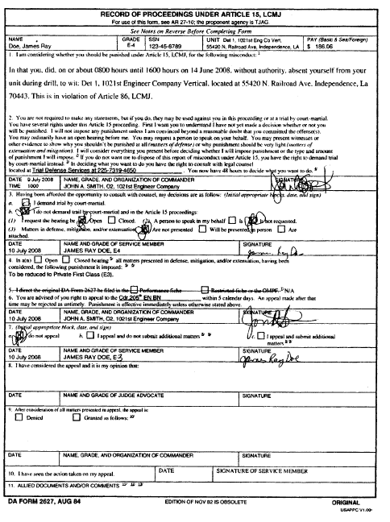

F. Record of Supplementary Action under Article 15 with continuation page (Figure 4-4)

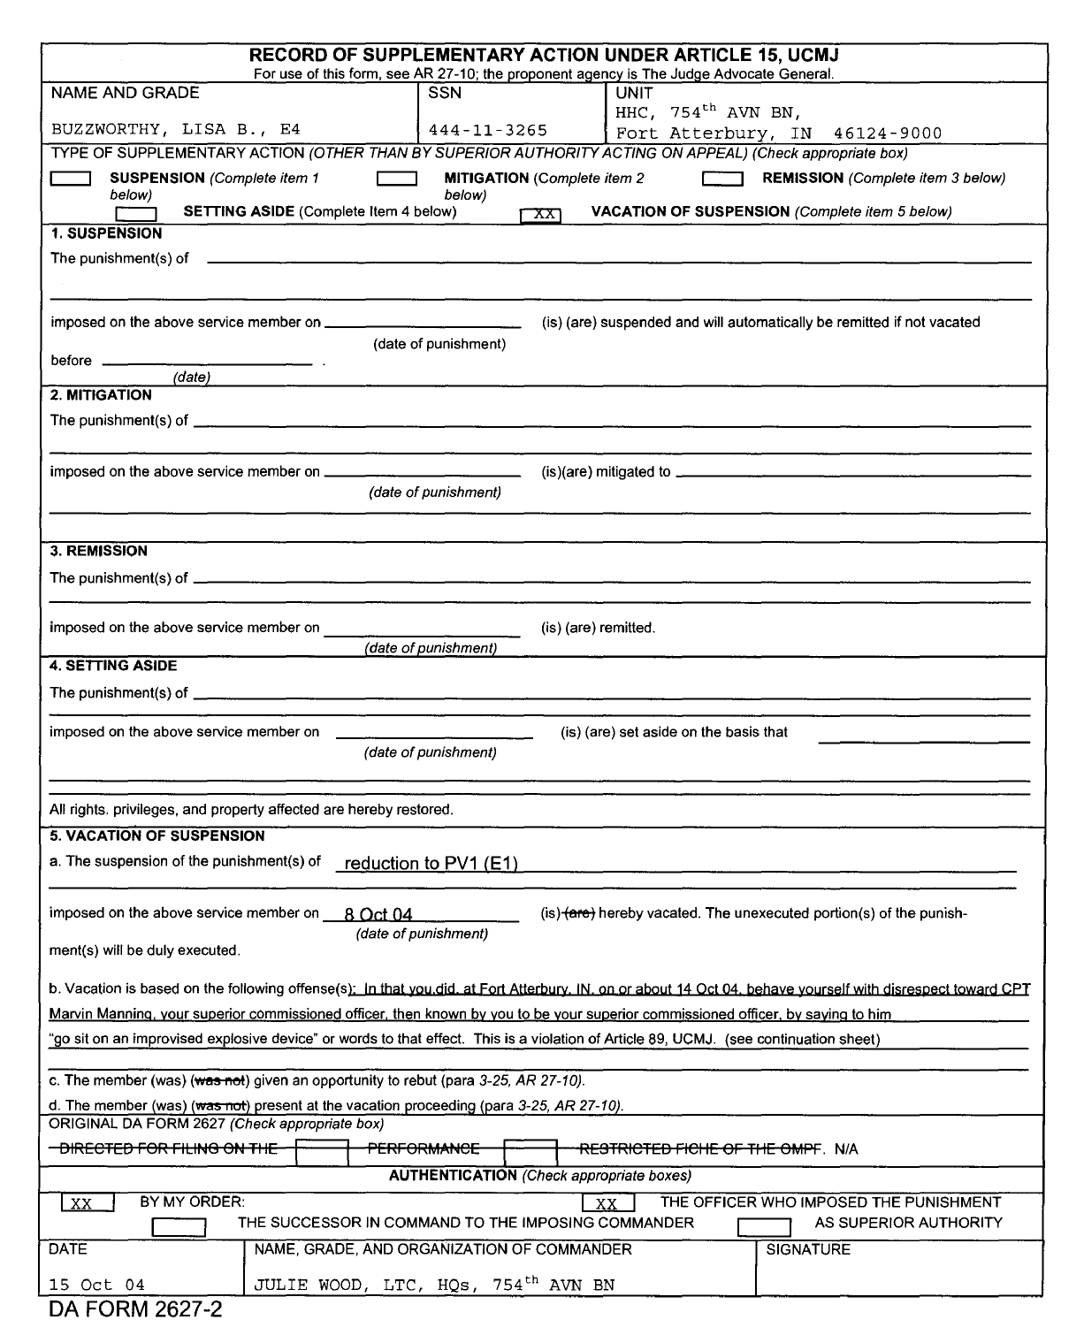

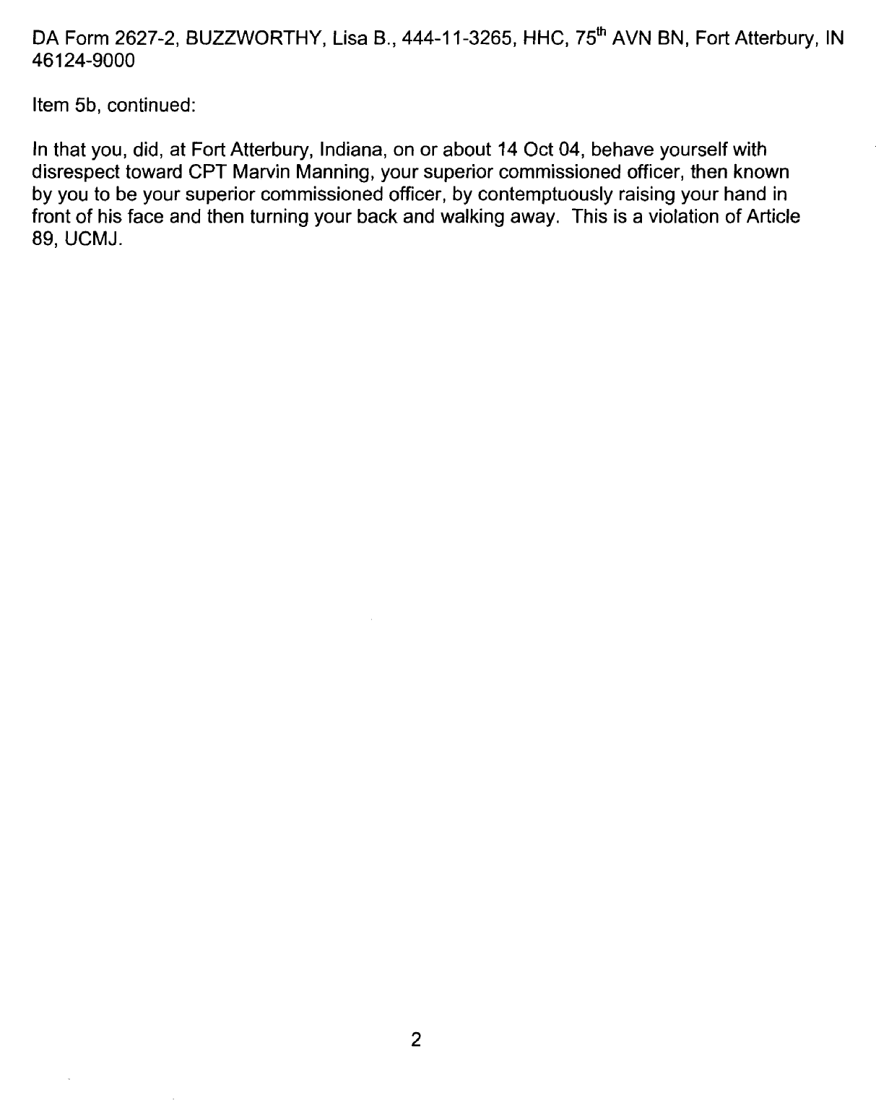

G. Summarized Article 15 (Figure 4-5)

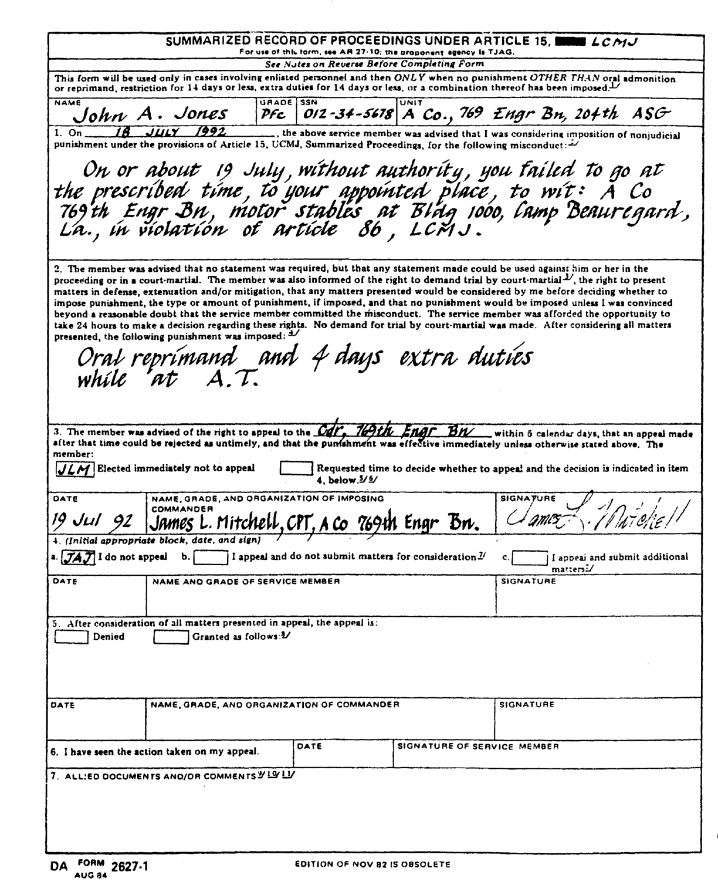

H. Judge Advocate Review of Article 15 (Figure 4-6)

LANG-XXX  
DATE

MEMORANDUM FOR [Commander]

SUBJECT: Legal Sufficiency Review of Article 15, SGT JOHN DOE, XXX-XX-XXXX

ISSUE: Presented for decision is appeal of Article 15 administered to above named individual.

BACKGROUND AND DISCUSSION:

a. On 10 July 2006, LTC HARD CHARGER imposed Article 15 punishment on SGT JOHN DOE. Punishment imposed was reduction two (2) pay grades, fine of $25.00, and 2 days extra duties, to be performed during upcoming AT.

b. SGT DOE is appealing the Article 15 and has submitted additional matters. He is specifically contesting the amount of the extra duties.

RECOMMENDATION: Review of the attached evidence indicates that the punishment is within the range of appropriateness and the proceedings were properly conducted under the current law and regulations. It should be noted that extra duties, to be lawful, must be performed while Servicemember is on duty status. Accordingly, I recommend denial of the appeal.

[SIGNATURE BLOCK]

I. Request to Superior to Exercise Article 15 Jurisdiction (Figure 4-7)

LANG-XXX  
DATE

MEMORANDUM FOR CDR, [Appropriate Command Level Unit]

SUBJECT: Request for Action UP LCMJ Article 15

The enclosed report indicates that on or about 5 May 1992 at North Fort Polk, LA, SGT John Q. Public,

123-45-6789, a member of this unit, was absent without leave. This act is punishable under LCMJ Article

I recommend you exercise your non-judicial punishment authority in the disposition of this case.

[SIGNATURE BLOCK]

NOTES: No recommendation may be made as to the kind or amount of punishment to be imposed this memorandum form may be used in lieu of DA Form 5109-K See paragraph 4-5(d).

J. Sample Endorsements for Remission. Mitigation. Suspension or Setting Aside of NJP (Figure 4-8)

LANG-XXX  
DATE

MEMORANDUM FOR

On ____, 19_, (I) (my predecessor in command) (the Commander, ____) imposed non-judicial punishment on you, consisting of ____. (No part of the punishment) The time punishment) that portion of the punishment relating to ____) was suspended. (You have requested action be taken to remit [the punishment] [the unserved portion of the punishment] [that portion of the punishment relating to 1).

I hereby remit (the punishment) (the unserved portion of the punishment) (the portion of the punishment relating to _____) effective (immediately) 19J.

OR

I hereby mitigate (the punishment) (so much of the punishment as relates to portion of the punishment relating to _____) to _______.) (the unserved portion of the punishment)

OR

I hereby suspend (the punishment) (the unserved portion of the punishment) (the portion of the

punishment relating to ____) until ____, 19_, at which time, unless the suspension is sooner vacated, it will be remitted.

OR

2. I hereby set aside (the punishment) (the unserved portion of the punishment) (the unserved portion of the punishment relating to ]. All rights, privileges, and property of which you have been deprived by (that portion of) the sentence set aside will be restored.

NOTE: If the action taken results in eliminating or suspending a reduction which was previously in effect, a paragraph in substantially the following form should be added

Your date of rank as (Private First Class) is ____

[SIGNATURE BLOCK]

K. Sample Endorsement for Revocation of Suspension of NJP (Figure 4-9)

LANG-XXX  
DATE

MEMORANDUM FOR

On ____, 19, (I) (my predecessor in command) (the Commander, imposed non-judicial punishment on you, consisting of ____. The portion of the punishment relating to ____ was suspended.

I hereby revoke the suspension of that portion of the punishment relating to ____, effective

(immediately).

You are expected to ____ [here set out any special and necessary instructions as to how you expect the member to carry out the punishment ordered into effect.]

[SIGNATURE BLOCK]

AUTHORITY NOTE: Promulgated in accordance with R.S. 29:11(F).

HISTORICAL NOTE: Promulgated in accordance with the Office of the Governor, State Military Department, LR 35:2370 (November 2009).

Chapter 5. Pretrial Procedures

§501. Report of Offense

A. There are a number of ways a commander can become aware of a criminal act committed by a servicemember, including personal observation, receipt of a report or complaint from an individual within or without the command, or receipt of a formal report from a law enforcement agency, including the military police or Criminal Investigation Command. This information may be incomplete and may require further investigation. Chapter 3 deals with the subject of Investigating and Obtaining Evidence. Any person may report an offense that is a violation of law. Ordinarily, any military authority who receives a report of an offense shall forward as soon as practicable the report and any accompanying information to the immediate commander of the suspect. However, competent authority superior to that commander may direct otherwise. [R.C.M.301(b).]

AUTHORITY NOTE: Promulgated in accordance with R.S. 29:11(F).

HISTORICAL NOTE: Promulgated in accordance with the Office of the Governor, State Military Department, LR 35:2376 (November 2009).

§502. Commander's Duties before Trial

A. General. Upon receiving a DD Form 458, Charge Sheet with its allied papers, a commander with authority to convene courts-martial must examine the file and decide which of the options available he will exercise. If he should decide to refer the case to trial, he incurs certain additional duties. While a commander must have a good understanding of the military justice system and his role in that system, he must never hesitate to consult with the SJA or trial counsel if any questions arise concerning the proper disposition of a case.

B. Insure there is a Case. One of the most frustrating experiences a commander can face is to charge an individual and send him to trial only to have the Military Judge or First Circuit Court of Appeal, or other appellate court, dismiss the case for failure of the specification to state an offense. Part IV of the Manual for Courts-Martial, United States, shall be consulted for discussions and descriptions of the crimes which constitute offenses under the LCMJ. The MCM also includes a discussion of the proof which is required to sustain a conviction for each offense. The "elements of the offense" are those facts which must be proved beyond a reasonable doubt in order to sustain a conviction. The adequacy of the specification should always be checked by the trial counsel before the case is referred to trial. In the event an offense is not alleged, the convening authority should return the DD Form 458, Charge Sheet to the accuser for correction. In the event such action is necessary, it should be expedited to insure that the accused is not denied his right to a speedy trial.

C. Insure the Evidence Supports the Allegations. It is also essential to insure that there is sufficient competent evidence to support the allegations in the charges. In processing charges, it is not necessary for a commander to await the results of a Criminal Investigation Division (CID) Laboratory analysis before he forwards the DD Form 458, Charge Sheet. If a servicemember has been found with marijuana in his possession and the company commander desires to charge him with a violation of Article 112a, LCMJ, he may begin processing the DD Form 458, Charge Sheet and send it forward even though the lab analysis has not been completed.

D. Consider the Individual Servicemember. In addition, the commander and the convening authority must inquire into the background of the individual offender before he can make an intelligent decision as how to dispose of the charges. There may be factors in the servicemember's background or adjustment to his unit which, in part, caused or contributed to commission of the offense. Such factors should be considered by the convening authority.

E. Disposition of Charges. There are several options available to the commander when processing military justice actions among the options are:

1. Dismissal. A commander may dismiss charges that have been preferred. A decision to dismiss a charge does not bar other disposition of the offense, such as administrative action or Article 15 punishment by the same commander, or preferral or repreferral of a charge by the same or a superior commander. Charges are ordinarily dismissed by lining out and initialing the deleted specification. When all charges and specifications are dismissed, the accused and the accuser should ordinarily be informed. A charge should be dismissed when it fails to state an offense, when it is unsupported by available evidence, or when there are other sound reasons why trial by court-martial is not appropriate on the charge. If an accused has already refused Article 15 punishment, but later requests that the Article 15 be reoffered, charges are usually dismissed after Article 15 punishment is imposed.

2. Returning Charges to Subordinate Authority. Instead of dismissing charges or taking other action, a commander may return the charges to a subordinate commander for whatever action the subordinate deems appropriate. This might occur if the commander did not think the offense was as serious as did the subordinate commander. When returning charges to a subordinate commander, the superior commander may not normally direct that the subordinate dispose of the charges in any particular way. Normally the superior commander should only indicate that the subordinate commander dispose of the charges by a means within the subordinate's authority. Otherwise, an issue of "unlawful command influence" may result.

3. Referring Charges to Trial. When an accused's prior record, the seriousness of the offense, and the needs for justice and discipline indicate that a trial by court-martial is warranted, the convening authority may dispose of the charge by referring it for trial by court-martial. The referral of a case to trial is accomplished by completing part V of the DD Form 458, Charge Sheet, authenticated by the signature of an adjutant under the command line of the convening authority. Factors to consider in this analysis include:

a. the charges should be referred to the lowest court which can adjudge an appropriate punishment [See Figure 4-1 for Table of Maximum Punishments];

b. consistent with the needs of discipline and justice, there should be relative uniformity (or proportionality) in the treatment of military justice violations;

c. a commander should also analyze the type of offense before him, and determine whether the offense is one where there is an identifiable victim involved (e.g. larceny), or whether it is a crime where no identifiable victim is involved (e.g. AWOL). In conjunction with this, he should look to see what injury or threat, if any, was inflicted upon the victim and, if so, whether the offender has made meaningful steps toward restitution;

d. an inquiry should be made to determine what evidence, if any, there is of premeditation, reflection, conspiracy, and the relative culpability among multiple offenders;

e. in deciding upon his action or recommendation, a commander should take into account the character and age of the accused as well as his previous military and civilian history. The offender's prior military and civilian record is, or course, only one factor among many that must be considered by a commander;

f. additionally, an offender's mental state should be considered along with any problems the servicemember may have. The convening authority should also consider any signs the individual has shown toward rehabilitation. If the individual has performed well since the commission of the offense and there seems to be rehabilitation potential present, then perhaps a referral to a lower level court-martial might be appropriate;

g. the recommendations of subordinates should be given their due weight since they are closest to the situation and most likely know the facts and probable repercussions of a military justice violation within the unit. Such reliance should be tempered by caution, however, in that the subordinate is also plagued with having the troublemaker in his unit

h. the previous disposition of similar offenses within the same command should also be considered, the administration of military justice should be even-handed in order to appear fair. If one servicemember is given an Article 15 for an offense and another servicemember is given a SPCM for the same offense under identical circumstances, the servicemembers may perceive the system as unfair. Still, each case must be evaluated individually, and there will often be factors that point toward the need for different treatment of servicemembers guilty of substantially similar wrongdoing.

i. Forwarding Charges to Superior Authority. The commander may feel that his power is inadequate to handle the case. If that is the case, then he must forward the file to a superior authority who’s judicial or non-judicial powers are greater than his. For example, if a SCM convening authority believes that a punitive discharge is appropriate, he will have to forward the file through channels to the SPCMCA, the next highest authority who can convene a SPCM, the lowest court capable of adjudging a punitive discharge. [See Figure 5-1, Transmittal of Court-Martial Charges.]

4. Judge Advocate Advice. No charges shall be referred to a SPCM or GCM before the convening authority has consulted directly with the appropriate judge advocate or his representative for advice with regard to the investigation, disposition of the case, and guidance in procedural matters. [See Figure 5-2 for example of Judge Advocate Pretrial Advice.]

AUTHORITY NOTE: Promulgated in accordance with R.S. 29:11(F).

HISTORICAL NOTE: Promulgated in accordance with the Office of the Governor, State Military Department, LR 35:2376 (November 2009).

§503. Referral of Offenses to Civilian Authorities

A. Evaluation of the Offense. Upon receipt of information that a servicemember of the command is suspected of committing an offense, the immediate Commander must make or cause to be made a preliminary inquiry into the suspected offense(s). [R.C.M. 303.] Upon determining that an offense has been committed, one of the issues that the Commander must decide is whether the conduct constituting the offense is characterized as a "felony," a "misdemeanor," a "dual" offense, a "purely civilian offense", or a "purely military offense." These terms are defined below and/or in the GLOSSARY to this Regulation. Commanders should consult with the servicing Staff Judge Advocate if in doubt on this evaluation.

B. "Dual" Offenses.

1. General. This would involve conduct that violates both civilian and military laws. Examples would include assault, battery, theft, drunk driving, riot, damage to property, disturbing the peace, and larceny.

2. Felonies. If the "dual" offense is a felony under the laws of Louisiana, federal law, or laws of another state where the incident occurred, [See GLOSSARY for definition] the commander must, at the earliest opportunity, consult with the Office of the Staff Judge Advocate regarding the advisability of referral to the proper civilian authorities in the Parish (or County) where the offense occurred. Many of the offenses defined as felonies under Louisiana law that are prohibited under the UCMJ are omitted from the LCMJ (e.g. Article 118 under the UCMJ defines and prohibits murder; this is omitted in the LCMJ, though homicide is defined and prohibited under general Louisiana laws applicable to all persons within the State. [See R.S. 14:29 et seq.] In the absence of extraordinary circumstances, each such case should be promptly referred to the appropriate civilian agency. When civilian felony charges have been filed against a servicemember, he shall be surrendered to civilian authorities.

3. Misdemeanors. If an offense against both civilian and military law is determined to involve a misdemeanor, [See GLOSSARY for definition] the commander should exercise discretion over his option of referring the matter to appropriate civil authorities or retaining the matter for disposition pursuant to courts-martial, non-judicial punishment, or non-punitive disciplinary sanctions. If circumstances permit, SJA advice should be sought.

C. Purely "Civilian" Offenses. Criminal conduct over which the LANG has no jurisdiction falls into this category. An example may be a crime committed in a non-duty status, not on a military facility, and when the victim has no service connection. Neither courts-martial nor commanders exercising non-judicial punishment shall have jurisdiction over purely civilian offenses, however a civilian conviction may afford basis for administrative action.

D. Purely "Military" Offenses. This is conduct that has no counterpart in the civilian law. Examples of purely military offenses are absence without leave (AWOL), missing movement, and disrespect to a superior commissioned officer. The commander's evaluation over how to deal with such offenses is not restricted by considerations of referral to civilian prospective agencies.

E. Policy. When the offense is punishable under the LCMJ and the State Criminal Code, the matter should ordinarily be referred to civilian authorities for disposition unless the interests of the Louisiana National Guard are better served by utilization of military administrative, non-judicial, or courts-martial procedures. Trial and punishment by civil authorities does not preclude trial and additional punishment by court-martial for any purely military offense related to a servicemember's commission of a referred offense, however caution and Judge Advocate advice should be obtained in such circumstances. A commander may re-evaluate any decision on referral should the appropriate civil authorities decline prosecution or fail to demonstrate an intention to timely initiate appropriate actions toward prosecution and/or punishment. [See LCMJ Article 14.]

F. Report to Superior Commander. If a case is referred to appropriate civilian authorities, the commander shall make an immediate report through operational channels to TAG. When the determination is made to precede within the LANG Military Justice system, the commander should complete the investigation (Chapter 3) in a timely manner to determine if there is probable cause that the accused committed the offense.

AUTHORITY NOTE: Promulgated in accordance with R.S. 29:11(F).

HISTORICAL NOTE: Promulgated in accordance with the Office of the Governor, State Military Department, LR 35:2378 (November 2009).

§504. Arrest Warrant Procedures

A. Definitions

*Apprehension*—the taking of a person into custody. [LCMJ Article 7(A)]

*Detention*—the imposition of custody by competent authority, pending disposition of offenses for a period of longer than 8 hours. For purposes of this Regulation, the term “detention” shall be synonymous with “arrest” and “arrest warrant” under LCMJ Articles 8 and 9.

B. Grounds for Apprehension and Detention—a person subject to the LCMJ may be apprehended and detained only for an offense triable by court-martial upon probable cause to apprehend and when a properly executed arrest warrant is issued. Probable cause to apprehend exists when there are reasonable grounds to believe that an offense under the LCMJ has been or is being committed and the person to be apprehended committed or is committing the offense. Receipt of the sworn Charge Sheet (DD Form 458) is considered probable cause for the issuance of an arrest warrant.

C. Apprehension by Military Authorities. If probable cause exists to apprehend a servicemember who is located on property under control of the Louisiana National Guard, then persons authorized under LCMJ Articles 7 and 8 may apprehend persons for which, while in a duty status, there is probable cause to believe that an offense has been committed and those who take part in quarrels, frays, or disorders. An arrest warrant shall not be necessary to apprehend servicemembers located on military property or installations.

D. Apprehension by Civilian Law Enforcement

1. Apprehension of all servicemembers who are located outside of military installations or military property shall be conducted under the arrest warrant procedures under LCMJ Article 8 in accordance with this Regulation. Any apprehension conducted outside of military installations and property shall be conducted by civilian law enforcement agencies which have jurisdiction over the location where the accused may be found. In order to make an apprehension, a law enforcement officer may use such physical force as in reasonably justifiable and authorized for the officer to exercise under the laws of this state.

2. Upon making the apprehension, the officer shall take the offender without due delay before the officer directing the apprehension in the arrest warrant. If circumstances require that the accused must be detained prior to being taken to the apprehension authority, he may be placed in a confinement facility, but for no more than 8 hours and he may not be placed in the general population of such facility.

3. If circumstances are such that it is clear that the accused will not be released to his commander within 8 hours of apprehension, then the accused shall be released and given a written order to appear before the court martial on a certain time and date. The order shall provide a warning to the accused that failure to appear will result in another arrest warrant being issued and additional charges brought against him under the LCMJ.

4. Overnight detention or pre-trial confinement is not authorized and, in such circumstance, the arresting authority will release the accused to his unit as expeditiously as possible. Overnight pre-trial confinement pursuant to an arrest warrant shall not be authorized unless approved by the State Judge Advocate.

E. Arrest Warrant Procedure. Arrest warrants may be initiated by the SCMCA (i.e. the Battalion Commander) when, based upon his/her judgment and discretion, all other methods have failed to secure the presence of the accused for trial by court martial.

1. Before an arrest warrant will be approved, the unit must certify that all reasonable efforts to secure the presence of the accused have been exhausted and arrest is the last available means to secure the presence of the accused. Reasonable efforts include, but are not limited to telephone contact, personal contact, AWOL Recovery Team efforts and the like. All specific details of these attempts to contact the accused should be fully set forth in the DA Form 3744 (Affidavit Supporting Request for Authority to Search and Seize or Apprehend. All reasons given by the accused should be listed in the Affidavit, along with the details of the actions taken by the unit to address the accused’s concerns.

2. AWOL Recovery Teams. AWOL Recovery Teams usually consist of two or more soldiers who travel to the home of a servicemember who is Absent Without Leave from a required drill or other assembly and attempt to convince the servicemember to voluntarily attend the required assembly. AWOL Recovery Teams are not authorized to involuntarily take the servicemember from his or her home to the assembly. Members of an AWOL Recovery team should include responsible and mature non-commissioned officers or officers. An AWOL Recovery Team which involuntarily secures a servicemember’s presence at drill or other assembly violates this Regulation and may expose themselves to civil litigation pursuant to 28 U.S.C. 1983. If the servicemember refuses to return to drill or other assembly, the AWOL Recovery Team will leave, return to the armory. The unit then may request a warrant for the arrest of the AWOL servicemember. The DA Form 3744 (Affidavit Supporting Request for Authority to Search and Seize or Apprehend) and warrant application will describe the actions of the AWOL Recovery Team and the information learned by their activity.

3. Even after the warrant request is initiated, the unit shall continue to make calls and visits, and send letters to try to recover the servicemember if the Battalion Commander has not otherwise excused the servicemember from service.

4. A warrant for arrest must be completed in its entirety to include a copy of the completed charge sheet with required signatures for referral of the charges to a court-martial. A request for an Arrest Warrant [See Appendix G for Arrest Warrant Requirements] must include the following items:

a. warrant checklist;

b. request for warrant signed or endorsed by the battalion commander. In the request, give a summary of the servicemember’s overall performance and answer the following questions.

i. Has the accused been deployed to Operation Iraqi Freedom or Operation Enduring Freedom?

ii. Has the accused experienced any extenuating circumstances or hardship recently or since the unsatisfactory participation?

iii. What specific actions has the unit taken to secure the presence of the accused including a description of all personal contact by the members of the unit?

iv. A characterization of the accused service.

c. DD Form 458, Charge Sheet

d. Arrest Warrant

e. Written Order to Report

f. DA Form 3744, Affidavit Supporting Request for Authority to Search and Seize or Apprehend. Include all elements of “who, what, where, when and why”.

g. DRU Judge Advocate Legal Review and Recommendation

5. All arrest warrants shall be approved by the Adjutant General prior to execution. The Adjutant General, in writing, may delegate approval authority for arrest warrants. In order to secure approval, all requests for arrest warrants shall be:

a. sent through the Battalion Commander for recommendation and guidance;

b. sent to the DRU Judge Advocate for legal review. The DRU Judge Advocate or Paralegal will send to the State Judge Advocate for legal review and TAG decision;

c. the Arrest and confinement of any soldier shall be reported by the chain of command directly to the Adjutant General.

6. Written Authorization. A written arrest warrant [Figure 5-3] shall be executed by the authority ordering apprehension and/or detention. The warrant shall:

a. specify the name of the person to be apprehended;

b. specify the nature of the LCMJ offense violated;

c. state the date when issued;

d. state that it is in the name of the governor, be signed and bear the title of the person having authority to issue the order;

e. command any civilian law enforcement officer to arrest the person for whom the order was issued and to bring the person before the commanding officer issuing the order or superior authority (whose address and phone number shall be identified), or deliver the person apprehended to a civil jail to be held for delivery to military authorities;

f. state an amount of bail that may be posted by the soldier to secure his release, which shall not exceed:

i. Summary Court-Martial - $500.00;

ii. Special Court-Martial - $1,000.00;

iii. General Court-Martial - $2,500.00.

F. Use of Force. Any person authorized to make an apprehension is justified in using only such nondeadly force that such person reasonably believes is necessary to defend himself or a third person from what he reasonably believes to be the use or imminent use of physical force while making or attempting to make an arrest or while preventing or attempting to prevent an escape. Use of deadly force is prohibited except when a person authorized to apprehend reasonably believes such force is necessary for self-defense or for the defense of another person for the use or imminent use of deadly physical force by the person apprehended or to be apprehended.

G. Report of Apprehension. Any person who apprehends an alleged offender shall immediately cause a report to the offender’s commander or superior authority, providing the commander or superior authority with the name of the prisoner, the time and place of confinement, if any, and the name of the person who ordered or authorized the apprehension. A similar report shall be made to the staff judge advocate serving the organization.

AUTHORITY NOTE: Promulgated in accordance with R.S. 29:11(F).

HISTORICAL NOTE: Promulgated in accordance with the Office of the Governor, State Military Department, LR 35:2379 (November 2009).

§505. Apprehension and Detention by Peace Officers

A. Authority to Apprehend. Any peace officer having authority to apprehend offenders under the laws of the state may apprehend and detain an offender under the LCMJ.

B. Apprehension Procedures. A peace officer may apprehend and detain a person subject to the LCMJ:

1. for any court-martial offense committed in the presence of the peace officer, if the peace officer has probable cause to believe the person apprehended committed it, or

2. when the peace officer is notified by telegraph, telephone, radio, facsimile machine, or other mode of communication by a commissioned officer or by military law enforcement officials, or by another peace officer, that there exists a duly issued order for the apprehension of the person by a commanding officer to whose authority the person is subject, or by a military court.

C. Notice to Servicemember. The peace officer shall inform the person to be apprehended of the peace officer's authority and reason for the apprehension.

AUTHORITY NOTE: Promulgated in accordance with R.S. 29:11(F).

HISTORICAL NOTE: Promulgated in accordance with the Office of the Governor, State Military Department, LR 35:2380 (November 2009).

§506. Pretrial Restraint

A. General. Pretrial restraint is moral or physical restraint on a Servicemember's liberty which may be imposed before and during disposition of offenses. Pretrial restraint may consist of conditions on liberty, restriction in lieu of arrest, arrest, or confinement.

B. Conditions on Liberty. Conditions on liberty are imposed by orders directing a person to do or refrain from doing specified acts. Such conditions may be imposed in conjunction with other forms of restraint or separately.

C. Restriction in Lieu of Arrest. Restriction in lieu of arrest is the restraint of a person by oral or written orders directing the person to remain within specified limits; a restricted person shall, unless otherwise directed, perform full military duties while restricted.

D. Arrest. Arrest is the restraint of a person by oral or written order not imposed as punishment, directing the person to remain within specified limits; a person in the status of arrest may not be required to perform military duties such as commanding or supervising personnel, serving as guard, or bearing arms. The status of arrest automatically ends when the Servicemember is placed, by the authority of the person who ordered the arrest or a superior authority, on duty inconsistent with the status of arrest. Arrest shall not prevent requiring the Servicemember arrested to do ordinary cleaning policing, or to take part in routine training and duties.

E. Confinement. Pretrial confinement is physical restraint, imposed by order of competent authority, depriving a person of freedom pending disposition of offenses for a period of longer than 24 hours. This should be distinguished from detention, discussed in Paragraphs 5-4. Pretrial confinement will not be used except in accordance with Paragraphs 5-7.

AUTHORITY NOTE: Promulgated in accordance with R.S. 29:11(F).

HISTORICAL NOTE: Promulgated in accordance with the Office of the Governor, State Military Department, LR 35:2380 (November 2009).

§507. Pretrial Confinement

A. Pre-trial confinement is not authorized. In the case of arrest pursuant to a warrant approved by the Adjutant General, the arresting authority will release the accused to the unit as expeditiously as possible. Overnight pre-trial confinement pursuant to the execution of National Guard warrants is not authorized unless approved by an exception to policy by the State Judge Advocate. In no case will a member of the National Guard be placed in the general population of any confinement facility.

B. Lesser Forms of Restraint. Less serious forms of restraint must always be utilized. The commander shall consider whether the servicemember could safely remain in the unit, at liberty or under some form of restriction, or conditions of liberty.

AUTHORITY NOTE: Promulgated in accordance with R.S. 29:11(F).

HISTORICAL NOTE: Promulgated in accordance with the Office of the Governor, State Military Department, LR 35:2381 (November 2009).

§508. Bail

A. General. Any person in confinement charged with or convicted of an offense under the LCMJ is entitled to bail pending finality of the sentence. The order fixing the amount of bail shall be in writing, specify the amount of the bail, and designate the officer(s) authorized to accept the bail, and must be signed by the convening authority. [Figure 5-3.] Any person in confinement on a charge under the LCMJ may invoke the supervisory jurisdiction of a military judge on the claim that the convening authority has improperly refused bail or for a reduction of bail. The amount of such bail shall be fixed by the convening authority that ordered the confinement, and shall not exceed the following limits:

1. Summary Court-Martial—$500.00;

2. Special Court-Martial—$1000.00;

3. General Court-Martial—$2500.00.

B. Factors in Determining Bail Amount. The amount of bail shall be such as in the judgment of the convening authority will insure the presence of the accused before the proper court-martial, having regard to:

1. the seriousness of the offense charged;

2. the weight of the evidence against the defendant;

3. the previous criminal record, if any, of the defendant;

4. the ability of the defendant to give bail; and

5. any other circumstances affecting the probability of the defendant's appearance.

C. Procedures. The qualifications of sureties, the bail undertaking, the various types of bail authorized, the rights of surety, the surrender or arrest of the accused, and the exoneration of the surety, shall be governed by the provisions of Articles 323 to 343 inclusive of the Louisiana Code of Criminal Procedure. Proceedings relating to the forfeiture of bail and the collection thereof shall be conducted by the appropriate district attorney under the provisions of LA R.S. 15:85 to LA R.S. 15:89 inclusive, before the district court of the district in which the court-martial proceeding was held. Bail bond forms are located at Figures 5-5 and 5-6.

AUTHORITY NOTE: Promulgated in accordance with R.S. 29:11(F).

HISTORICAL NOTE: Promulgated in accordance with the Office of the Governor, State Military Department, LR 35:2381 (November 2009).

§509. Preparation of the Charge Sheet

A. General. In preparing charges for trial by courts-martial, the unit commander will use the current DD Form 458, Charge Sheet. Detailed instructions for completing the Charge Sheet may be found at R.C.M. 307 and at Figure 5-8 of this Regulation. An example of a completed Charge Sheet is located at Figure 5-7 any person subject to the LCMJ may prefer charges, but trial counsel should always draft or review charges before they are preferred. While the unit commander is responsible for the preparation of the Charge Sheet, there is no legal requirement that he do it personally. He should, however, supervise its prompt and proper preparation and forwarding. Once the charge and specification has been prepared and signed under oath, it is a public record, and other than minor administrative changes, should not be altered, except upon the advice of a judge advocate. For minor administrative or typographical corrections, the officer making same should initial in the margin the correction.

B. Timeliness. When the Unit Commander has made the decision to prefer court-martial charges and to recommend trial by courts-martial, he should promptly dispose of the matter. It is longstanding military policy, both in the active forces and in the National Guard that military justice be given priority.

C. Personal Data. Section I of the Charge Sheet is personal data concerning the accused. This information is generally found in the accused's personnel file. The unit commander should have reviewed this personnel file before making his decision on disposition of the offense during his preliminary investigation. The accused's "grade or rank" (Block 3) is his military title (such as PFC) and his "pay grade" (Block 4) is his numerical designation (such as E-3). The initial date of the accused's current service is the date of his latest enlistment (Block 6). Paragraph 7 "Pay per Month" is the normal MUTA-4 pay which the accused would receive for one month to be inserted in the "basic" block. Louisiana National Servicemembers do not receive "sea or foreign duty pay". Block 8, entitled "nature of restraint of accused" should show all types of restraint imposed, and block 9 should show the corresponding duration (inclusive dates) of the restraint and any changes.

D. Charges and Specifications

1. General. Section II of the Charge Sheet is the section for charges and specifications. This is the most important part of the Charge Sheet. The "charge" indicates the section of the Louisiana Code of Military Justice violated. Since DD Form 458, Charge Sheet, is a federal form, the reference in Section II to a "violation of the UCMJ, Article __" should be changed to "violation of the Louisiana Code of Military Justice, Article __." The "specification," which is under the charge, must be written so that it clearly advises the accused of the date, time, place and circumstances of the alleged offense against him. The specification states the facts and circumstances which constitute a violation of the particular section of the LCMJ alleged to be violated. Neither the misdesignation of an article nor the failure to designate any article is ordinarily material so long as the specification alleges an offense over which courts-martial have jurisdiction. If there is only one charge, it is not numbered. When there is more than one charge, each is numbered with a Roman numeral. [R.C.M. 307(c).]

2. Elements of the Offense. Part IV of the Manual for Courts-Martial, United States, lists each essential element of all equivalent punitive Articles in the LCMJ. It is imperative that commanders familiarize themselves with the contents of these materials. The Unit Commander should refer to one of these references for a discussion of "proof" and an outline of the "elements of the offense." This will help the Commander to recognize criminal conduct and in drafting a clear, complete specification. When the specification is written, the Commander should be able to find each of the discussed "elements" in the specification.

3. Legal Advice. The unit commander should not alter the words in a model specification without legal advice from a Judge Advocate. If he, or his legal clerk, has any questions in the selection or drafting of a specification, he should contact the Staff Judge Advocate of his Direct Reporting Unit.

AUTHORITY NOTE: Promulgated in accordance with R.S. 29:11(F).

HISTORICAL NOTE: Promulgated in accordance with the Office of the Governor, State Military Department, LR 35:2381 (November 2009).

§510. Preferral and Transmittal of Charges

A. Preferral. Section III of the Charge Sheet is the preferral of charges. The person who believes that the specifications are true signs in block 11d as the accuser. The reference in the affidavit to the "Uniform Code of Military Justice" should be changed to read "Louisiana Code of Military Justice" by deleting the word "Uniform" and substituting in its place the word "Louisiana. While any person subject to the Louisiana Code of Military Justice may be an accuser, it is customary for the Unit Commander to sign as the accuser. A superior authority may not order anyone to act as accuser. The signing of the Charge Sheet by the accuser must be done in the presence of a commissioned officer serving in the capacity of Adjutant, Assistant Adjutant, acting Adjutant, or Personnel Adjutant. [See LCMJ Article 136.] Each unit is authorized to detail in writing an officer in the capacity of acting Adjutant for the purpose of taking such oaths.

B. Informing the Accused. After charges have been preferred, the accused's commanding officer or his designated representative will inform the accused of the charges preferred against him, and will sign the certificate confirming such that is located at the top of page two of the Charge Sheet. This individual shall also advise the accused regarding his right to consult with legal counsel pursuant to LCMJ Article 20. When, because of the unavailability of the accused, this notice cannot be accomplished by reading the charges to him, a letter notifying him of the charges mailed by first class mail to the accused at his address as shown on the unit alert roster will suffice, but the certificate will be amended to reflect that the accused was informed of the charges by mail.

C. Receipt by the Summary Court-Martial Convening Authority. The unit commander next will have all copies of the Charge Sheet and related papers promptly sent to the commander exercising summary court-martial jurisdiction over his unit. This is normally the battalion or squadron commander. The summary court-martial authority or his representative (preferably the S-1) will indicate the time the sworn charges were received and sign the receipt of charges on Page two, Section IV.

D. Referral of Charges for Trial by Courts-Martial. If the convening authority decides to refer the case to trial by court-martial, the appropriate block in Section V of the Charge Sheet should be completed. Ordinarily in the Louisiana National Guard, such referral will be to a summary court-martial and the Charge Sheet should be delivered to the summary court officer, with the convening authority retaining a copy for his records. In lieu of referring the charges for disposition by court-martial, the convening authority may impose non-judicial punishment on the accused, or, if he determines that neither judicial nor non-judicial action is indicated, he may dismiss the charges. The convening authority, in any case, should advise the unit Commander who initiated the charges of his decision.

E. Service of Charges. Section V of the Charge Sheet also contains in the last item the service of the charges. In summary courts-martial, the most common type of court-martial held in the Louisiana National Guard, this service will ordinarily be accomplished by the summary court officer. If the charges have been referred to a special or general court-martial, the service will be accomplished by the trial counsel or at his direction. If, at time of preparation of the Charge Sheet, the accused is present at either at a unit training assembly or annual training, a copy of the Charge Sheet, and a copy of Notice of Court Martial, [See Figure 6-1] will be furnished the accused by the summary court officer or other official who will then sign the certificate which is the last item on page two of the Charge Sheet. At times other than annual training or unit training assemblies, the summary court officer will either serve the accused personally or mail a copy of the Charge Sheet and any Notice of Trial to the accused by first class mail to his home address as shown on the Unit Alert Rosters. A copy will also be furnished to any attorney of record representing the accused whose whereabouts are known or may reasonably be ascertained. A certificate of such service along with the date thereof shall be made part of the record. Service may be waived in writing by either the accused or his counsel. Unless waived, the delay for service of the charges upon the accused or his counsel must be accomplished not later than:

1. five days before trial for GCM;

2. three days before trial for SPCM;

3. 24 hours before trial for SCM. [See, generally, LCMJ Article 35; R.C.M. 602.]

AUTHORITY NOTE: Promulgated in accordance with R.S. 29:11(F).

HISTORICAL NOTE: Promulgated in accordance with the Office of the Governor, State Military Department, LR 35:2382 (November 2009).

§511. Transmittal of Charges

A. General. In addition to the Charge Sheet, often other documents must be prepared and forwarded by the accused's commander. [See Figures 5-1 and 6-1.] A copy of each such record should be retained by the unit for its files.

B. Minor Offenses. When charges are submitted with a view to trial by summary court-martial or non-judicial punishment action, they need not be forwarded by a formal letter of transmittal, but should be accompanied by evidence of previous court martial convictions (DD Form 493) and of previous non-judicial punishments of the accused ant sufficient information about the circumstances, including an informal summary of the expected evidence, to enable the commander receiving them to make an intelligent disposition of the case without an additional investigation.

C. Serious Offenses. When charges are submitted with a view to trial by special or general court-martial, they will be forwarded by a letter of transmittal signed personally by the forwarding officer. The letter will include, or carry as enclosures, the following:

1. A summary of the evidence expected from each witness or other source. The signature of each witness to the summary of his testimony will be obtained unless the procurement of the signature(s) is not possible or would unduly delay the forwarding of the charges;

2. Copies of all reasonably available documentary evidence. Originals should not be forwarded with the Charge Sheet and letter of transmittal. The original documentary evidence should be properly marked, preserved, and referred to in the charges or the letter of transmittal with a statement as to where it may be found.

3. Evidence of admissible previous convictions by court-martial and non-judicial punishments, which, in the case of enlisted persons, is usually in the form of an attested copy of the pertinent entries in the accused's personnel records.

4. Explanation of any unusual features of the case, including such matters as the character of the accused's military service before the offense charged and his record before entry into the military service, if known.

5. Specific recommendation as to the disposition of the charges.

6. Certification that Judge Advocate advice has been obtained in the matter if the transmittal recommends a special or general court-martial.

AUTHORITY NOTE: Promulgated in accordance with R.S. 29:11(F).

HISTORICAL NOTE: Promulgated in accordance with the Office of the Governor, State Military Department, LR 35:2383 (November 2009).

§512. Time Limits

A. General. The prompt disposition of charges is essential to our system of military justice. An unexplained delay in the processing of charges at any stage may result in dismissal of the charges. When a decision concerning a delay is brought up at trial, the burden is on the government to justify the delay, to show that it was not intentional nor due to an oppressive design or neglect on the part of the National Guard. The period of time for which the government is accountable starts to run when the accused is placed in restraint or when charges have been preferred. The following are guidelines for avoiding unreasonable delays in the processing of the court-martial charges:

1. promptly send all court-martial files to higher headquarters;

2. investigate an incident immediately after it happens;

3. do not allow a case to remain in a unit because of the pressure of other duties;

4. if the accused is placed in pre-trial confinement, he will be served with a copy of the charges and taken into military custody or brought before the court for trial not later than 24 hours after the commencement of his pre-trial confinement. Exception to this policy may only be granted by the State Judge Advocate or his designated representative.

AUTHORITY NOTE: Promulgated in accordance with R.S. 29:11(F).

HISTORICAL NOTE: Promulgated in accordance with the Office of the Governor, State Military Department, LR 35:2383 (November 2009).

§513. Detailing of Military Judge

A. In accordance with Article 26 of the LCMJ the authority convening the General or Special Court Martial shall detail a Military Judge thereto. A Military Judge will be made available to the convening authority by the State Judge Advocate. The written documentation detailing the military judge may be included in the court-martial convening order. [See Figure 5-12] Nothing in this regulation precludes the detail of a military judge from another armed service to preside over courts-martial.

AUTHORITY NOTE: Promulgated in accordance with R.S. 29:11(F).

HISTORICAL NOTE: Promulgated in accordance with the Office of the Governor, State Military Department, LR 35:2383 (November 2009).

§514. Detailing of Trial Counsel

A. Trial Counsel will be made available to the convening authority by the State Judge Advocate or the DRU SJA. The order detailing trial counsel will be in writing, and will be announced orally on the record during the court-martial, and will indicate by whom the trial counsel was detailed. The written documentation detailing the trial counsel may be included in the court-martial convening order.

AUTHORITY NOTE: Promulgated in accordance with R.S. 29:11(F).

HISTORICAL NOTE: Promulgated in accordance with the Office of the Governor, State Military Department, LR 35:2383 (November 2009).

§515. Assignment of Defense Counsel

A. Chief, LANG TDS will make available to GCMCA’s and SPCMCA’s military trial defense counsel for detail to all Special and General Courts Martial. The name of the military trial defense counsel will appear on the convening order and announced orally at the court martial.

AUTHORITY NOTE: Promulgated in accordance with R.S. 29:11(F).

HISTORICAL NOTE: Promulgated in accordance with the Office of the Governor, State Military Department, LR 35:2383 (November 2009).

§516. Detailing and Duties of Court Members

A. The convening authority shall detail qualified persons as members for courts-martial. He may detail as members of general and special courts-martial persons under his command or others made available by another commander even if those persons are members of an armed force different from that of the convening authority or accused.

B. Qualifications. The members detailed to a court-martial shall be those persons who in the opinion of the convening authority are best qualified for the duty by reason of their age, education, training, experience, length of service, and judicial temperament. Each member shall be a member of the Louisiana National Guard and shall be:

1. a commissioned officer;

2. a warrant officer, except when the accused is a commissioned officer; or

3. an enlisted person if the accused is an enlisted person and has made a timely request under R.C.M. 503(a)(2).

C. Enlisted Members. An enlisted accused may, before assembly, request orally on the record or in writing that enlisted persons serve as members of the general or special court-martial to which that accused’s case has been or will be referred. If such a request has been made, an enlisted accused may not be tried by a court-martial the membership of which does not include enlisted members in a number comprising at least one-third of the total number of members unless eligible enlisted members cannot be obtained because of physical conditions or military exigencies. If the appropriate number of enlisted members cannot be obtained, the court-martial may be assembled, and the trial may proceed without them, but the convening authority shall make a detailed written explanation why enlisted members could not be obtained which must be appended to the record of trial.

D. Duties. The members of a court-martial shall determine whether the accused is proved guilty and, if necessary, adjudge a proper sentence, based on the evidence and in accordance with the instructions of the military judge. Each member has an equal voice and vote with other members in deliberating upon and deciding all matters submitted to them, except as otherwise specifically provided in these rules. No member may use rank or position to influence another member. No member of a court-martial may have access to or use in any open or closed session this Regulation, the Manual for Courts-Martial, reports of decided cases, or any other reference material, except for instructions or other documents provided by the military judge.

E. President. The president of a court-martial shall be the detailed member senior in rank then serving. He shall have the same duties as other members and shall also preside over closed sessions of the members of the court-martial during their deliberations and speak for the members of the court-martial when announcing the decision of the members or requesting instructions from the military judge.

F. Changes of Members

1. Before assembly. Before the court-martial is assembled, the convening authority may change the members of the court-martial without showing cause. The convening authority may delegate authority to excuse individual members to the State Judge Advocate or legal officer or other principal assistant to the convening authority. Before the court-martial is assembled, the convening authority’s delegate may excuse members without cause shown; however, no more than one-third of the total number of members detailed by the convening authority may be excused by his delegate in any one court-martial. After assembly, the convening authority’s delegate may not excuse members.

2. After assembly. After assembly, no member may be excused, except:

a. by the convening authority for good cause shown on the record;

b. by the military judge for good cause shown on the record;

c. as a result of a challenge under R.C.M. 912.

3. New Members. New members may be detailed after assembly only when, as a result of excusals under this Paragraph, the number of members of the court-martial is reduced below six, or the number of enlisted members, when the accused has made a timely written request for enlisted members, is reduced below one-third of the total membership.

AUTHORITY NOTE: Promulgated in accordance with R.S. 29:11(F).

HISTORICAL NOTE: Promulgated in accordance with the Office of the Governor, State Military Department, LR 35:2383 (November 2009).

§517. Subpoenas

A. Convening Authority's Responsibility. The Convening Authority is responsible for assuring that witnesses sought by both government and defense are timely subpoenaed. Requests for subpoenas shall be made at the earliest practicable time to allow ample time for service. Unless otherwise directed, 30 days prior to scheduled trial is considered reasonable. [See Paragraph 4-8, Figures 5-2, 6-1 and 6-2.]

B. Civilian Witnesses. Civilian personnel will not be ordered to appear as witnesses at any SCM or SPCM unless prior approval has been obtained from the SJA or his designee.

AUTHORITY NOTE: Promulgated in accordance with R.S. 29:11(F).

HISTORICAL NOTE: Promulgated in accordance with the Office of the Governor, State Military Department, LR 35:2384 (November 2009).

§518. Expenses

A. General. The expenses of a court-martial other than pay and allowances of members and counsel detailed to the court will generally be paid with State funds.

B. Expenses of Witnesses. Subpoenas or other process issued to witnesses will be served as provided by LCMJ Article 46. The process will be accompanied by a letter explaining the penalty for failure to obey the process as outlined in LCMJ Article 47. The letter will also advise the witness of any statutory entitlement to expenses and the procedure for collecting payment. If state funds are to be used for payment of these expenses, the issuing authority will coordinate with the Office of the State Judge Advocate prior to issuing the process and letter.

C. Expenses of Court Reporters and Interpreters. Court reporters and interpreters may be employed when required by the LCMJ or when directed by TAG. A court reporter will not be provided in a non-judicial punishment proceeding or a summary court-martial. Scheduling and compensation of such court reporters and interpreters shall be coordinated by the Office of the State Judge Advocate.

D. Government Transportation. Government transportation will be utilized by counsel and members detailed to the court-marital unless not available. Travel Orders will be issued as appropriate.

AUTHORITY NOTE: Promulgated in accordance with R.S. 29:11(F).

HISTORICAL NOTE: Promulgated in accordance with the Office of the Governor, State Military Department, LR 35:2384 (November 2009).

§519. Docketing of Trials

A. The Convening Authority's SJA shall review all requests for SPCM or GCM and, if approved by the Convening Authority, the SJA shall contact the Military Judge to arrange for arraignment and trial. te (SJA) by the quickest means available to announce this decision. The LANG TDS shall provide the name of the designated military defense counsel (DC). The State Judge Advocate shall provide the name of the designated Military Judge (MJ), and a case number. The Convening Authority’s SJA will then contact the DC and coordinate a tentative trial date. Thereafter, the Convening Authority’s SJA shall contact the MJ for final selection of a trial date. The Convening Authority's SJA shall advise the MJ whether a court reporter's presence is specifically sought for the case. The MJ shall advise the State Judge Advocate of the final trial date selected, whether a court reporter will be required, and any other matters of special interest and significance. Appropriate notices of trial and subpoenas shall be timely dispatched after coordination with all parties. [See Figures 6-1, 6-2]

AUTHORITY NOTE: Promulgated in accordance with R.S. 29:11(F).

HISTORICAL NOTE: Promulgated in accordance with the Office of the Governor, State Military Department, LR 35:2385 (November 2009).

§520. Continuance Requests

A. Requests for the continuance of regularly scheduled courts-martial are matters within the discretion of the assigned military judge. Requests based on failure to timely take appropriate action (e.g. witness subpoena requests) shall be looked on with disfavor, and shall be granted only in cases where a substantial and demonstrable prejudice is likely to result there from.

AUTHORITY NOTE: Promulgated in accordance with R.S. 29:11(F).

HISTORICAL NOTE: Promulgated in accordance with the Office of the Governor, State Military Department, LR 35:2385 (November 2009).

§521. Logistical Arrangements

A. The Convening Authority's SJA shall be responsible for conduct of the entire case, including summoning of all witnesses and production of documentary evidence, arranging for a courtroom facility, coordinating requests for court reporters with Office of State Judge Advocate, and coordination of trial details with the military judge.

AUTHORITY NOTE: Promulgated in accordance with R.S. 29:11(F).

HISTORICAL NOTE: Promulgated in accordance with the Office of the Governor, State Military Department, LR 35:2385 (November 2009).

§522. Article 32 Investigations

A. The conduct of an LCMJ Article 32 Investigation shall be considered the principal or primary duty of the Investigating Officer (IO) until completed. The officer directing the investigation shall provide adequate clerical and staff assistance to the IO. Officers designated to conduct LCMJ Article 32 investigations shall consult with the Trial Counsel prior to undertaking their duties, and shall follow published guidance (active component and otherwise) concerning such tasks.

AUTHORITY NOTE: Promulgated in accordance with R.S. 29:11(F).

HISTORICAL NOTE: Promulgated in accordance with the Office of the Governor, State Military Department, LR 35:2385 (November 2009).

§523. Plea Bargains and Pretrial Agreements

A. The convening authority may properly agree to refer charges to a certain type of court-martial, withdraw one or more charges or specifications from the court-martial, have trial counsel present no evidence as to one or more specifications, and/or take specified action on the sentence adjudged by the court-martial as set forth in R.C.M. 705. [See example at Figure 5-10.]

B. Transmittal of Court-Martial Charges (Figure 5-1)

UNIT HEADING

LANG-XXX July 5, 2008

MEMORANDUM FOR: Commander, 256th Infantry Brigade (M), 1806 Surrey St., Lafayette, LA 70508

SUBJECT: Referral of Charges to Court-Martial

Forwarded herewith are sworn court-martial charges for appropriate disposition.

Summaries of expected testimony and documentary evidence upon which the charges are based, if any, are enclosed.

The following material witnesses are expected to be available at the time of the trial:

(List Rank(s), Name(s), and Address (es)

There is evidence of _____ (list number, if any) of admissible previous court-martial conviction(s) of the accused. A duly authenticated extract copy of the accused's military records of previous conviction s showing such conviction(s), if any, is enclosed.

The character of the accused's military service prior to the offense(s) charged has been (excellent) (good) (fair) (unsatisfactory).

I recommend trial by (Summary) (Special) (General) Court-Martial, and further recommend that the Servicemember (be) (not be) retained in the Louisiana National Guard. [If applicable: The accused was offered and declined Summary Court-Martial for the charge.]

HARD CHARGER

MAJ, IN, LANG

Commanding

C. Judge Advocate Pretrial Advice (Figure 5-2)

UNIT HEADING

LANG-xxx DATE

MEMORANDUM FOR: Commander, 256th Infantry Brigade (M), 1806 Surrey St., Lafayette, LA 70508

SUBJECT: Advice on Disposition of Court-Martial Charges UP R.C.M. 406

1. ACCUSED: SSG JOHN DOE, 000-00-0000, Co A, 199th SPT BN, 256th INF BDE.

PERSONAL DATA: The accused's records indicate no prior court-martial convictions or non-judicial punishment.

DOB/AGE:8 Dec 56 (35)

RACE: White

TIME IN SVC:15 yrs, 1 mo.

CIV EDUCATION: HS Graduate

MIL EDUCATION: Advanced Course

ETS:21 Feb 94

MARITAL STATUS: Married

DEPENDENTS: 2

PRETRIAL CONF. None

CHARGES:

Disrespect [LCMJ Article 89]

Dereliction [LCMJ Article 92]

LEGAL CONCLUSIONS: After reviewing the attached charges and allied papers, I have reached the following conclusions:

Each charge/specification alleges an offense under the LCMJ;

The allegations in each charge/specification are warranted by the evidence;

There is court-martial jurisdiction over the accused and all charged offenses.

RECOMMENDATIONS: Company and Battalion Commanders recommend trial by Special Court-Martial. I concur in recommendation of Special Court-Martial.

LEGAL EAGLE

LTC, JA

Staff Judge Advocate

Attachments

(Charge Sheet)

(Allied Papers)

D. Arrest Warrant/Pretrial Confinement Order (Figure 5-3)

STATE OF LOUISIANA

Military Department

WARRANT FOR ARREST

TO ALL PEACE OFFICERS OF THE STATE OF LOUISIANA AND PROVOST MARSHALLS OF THE ARMED FORCES OF THE STATE OR FEDERAL GOVERNMENT, GREETINGS:

Pursuant to Articles 7 through 14 of the Louisiana Code of Military Justice (LA Revised Statutes 29:107 through 114), and considering the attached affidavit supporting a determination that probable cause exists to believe that an offense under the LCMJ was committed by the Servicemember named herein, YOU ARE HEREBY DIRECTED TO ARREST:

Name, Rank, Social Security Number, Address

whose description is as follows: Race: Weight: Height: DOB: Hair: Eyes:

and bring said person either before me, the undersigned authority at Address of unit

immediately, or, alternatively, to deliver said person to Name of Parish Jail or to the most appropriate detention facility within your jurisdiction for the purpose of answering to the State of Louisiana for an offense against the laws of said State, as follows: State LCMJ Article(s) from Charge Sheet as sworn to in writing before me. The accused may be fingerprinted and photographed if required by your agency, and while in your custody, the said individual shall be subject to the same treatment as other persons so restrained under the laws of the State of Louisiana. The accused may be released in to the custody of the Louisiana National Guard or admitted to bail in the amount of $500.00 and given written notice to report within 24 hours to his National Guard unit at the address below. This warrant shall expire six months from the date of issuance, and authorized detention SHALL NOT EXCEED EIGHT HOURS from the time of arrest. Upon release the arresting authority shall deliver the attached written direct order to report to the unit before 1600 the following working day. Immediately after the accused is in custody, and again when he is released, you are required under LA R.S. 29:111(c) to notify his National Guard unit by calling the following persons:

Name and Rank __ Daytime Phone No. ___ After Hours Phone No.

1.

2.

By authority of the Governor of the State of Louisiana, I affix my official signature, this ________ day of _______________________, 2008.

__________________________________________________

(Typed Name & Rank of Convening Authority (“CA”) (CA’s Signature)

__________

(Military Unit and Location)

E. Affidavit in Support of Arrest Warrant (Figure 5-4)

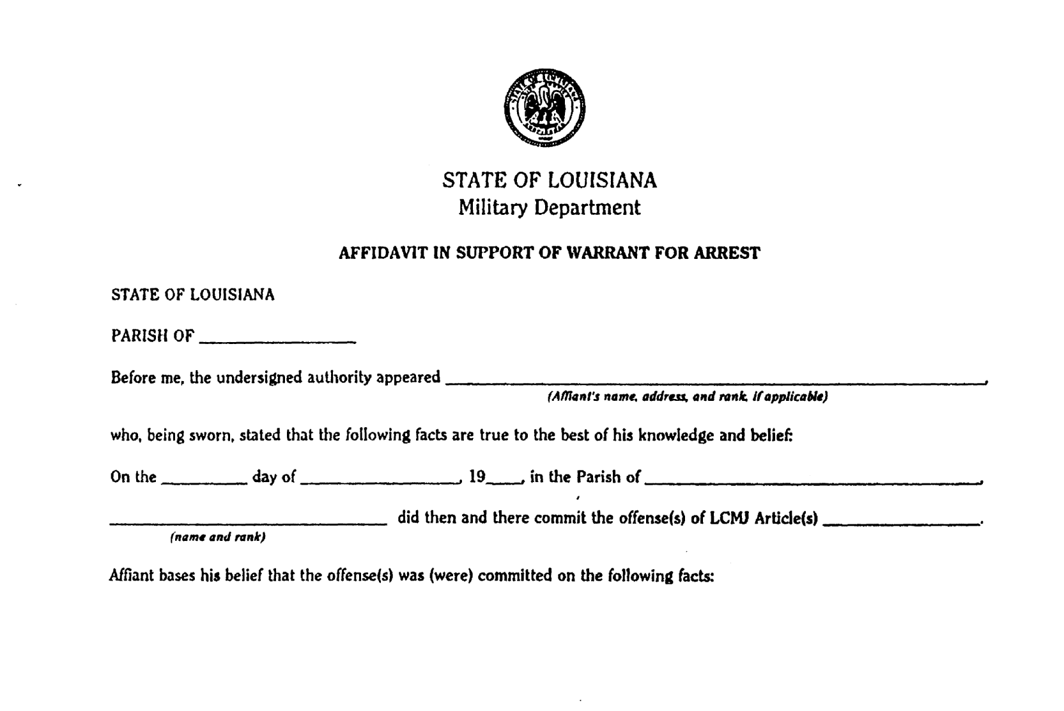

F. Surety Appearance Bond (Figure 5-6)

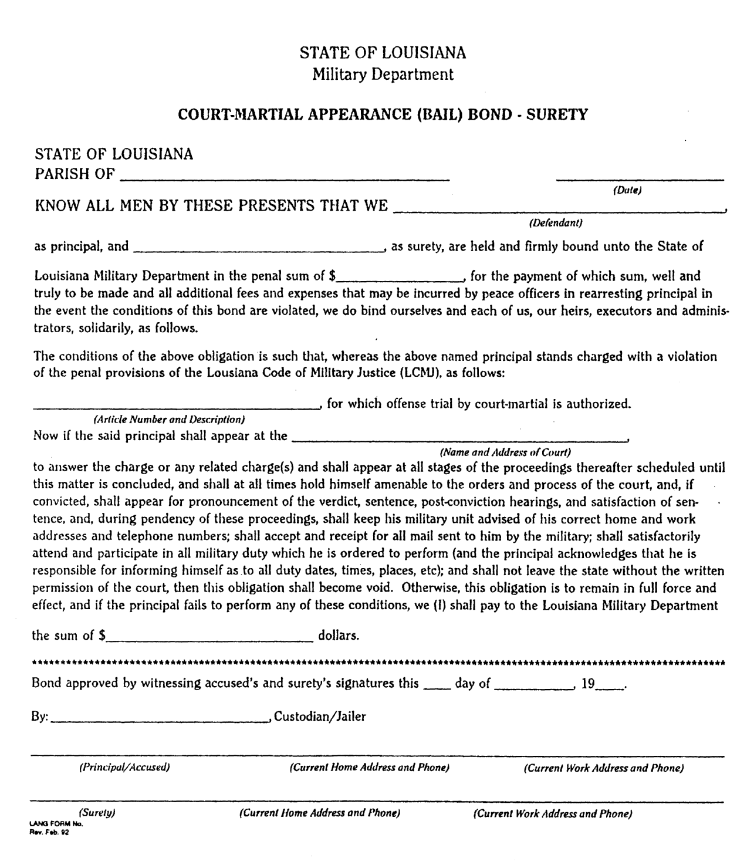

G. Surety Appearance Bond Cash (Figure 5-7)

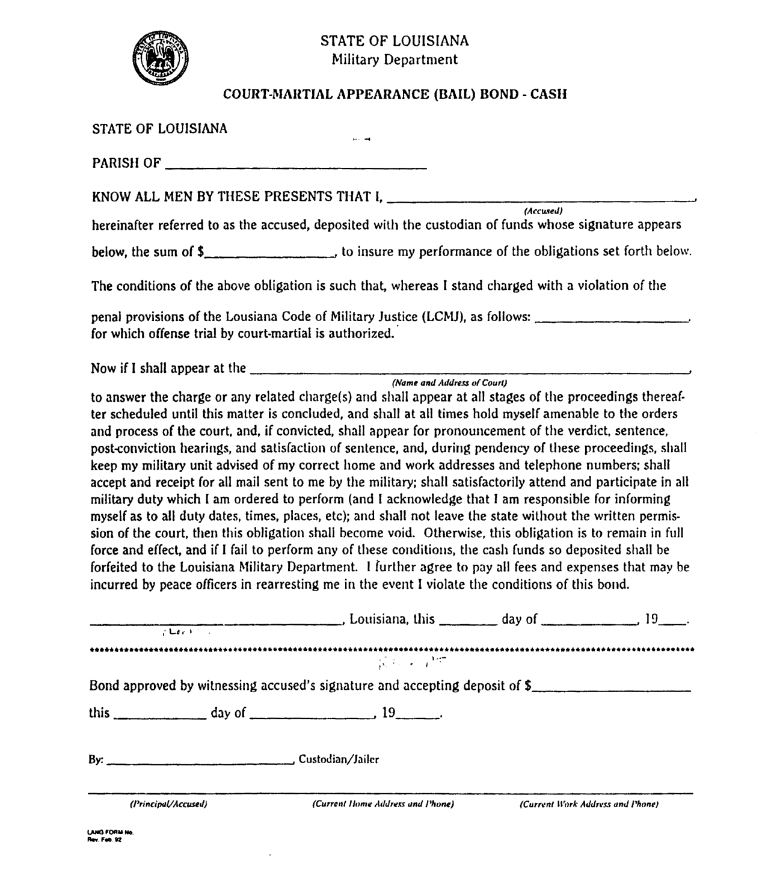

H. SCM Rights Notification/Waiver Statement

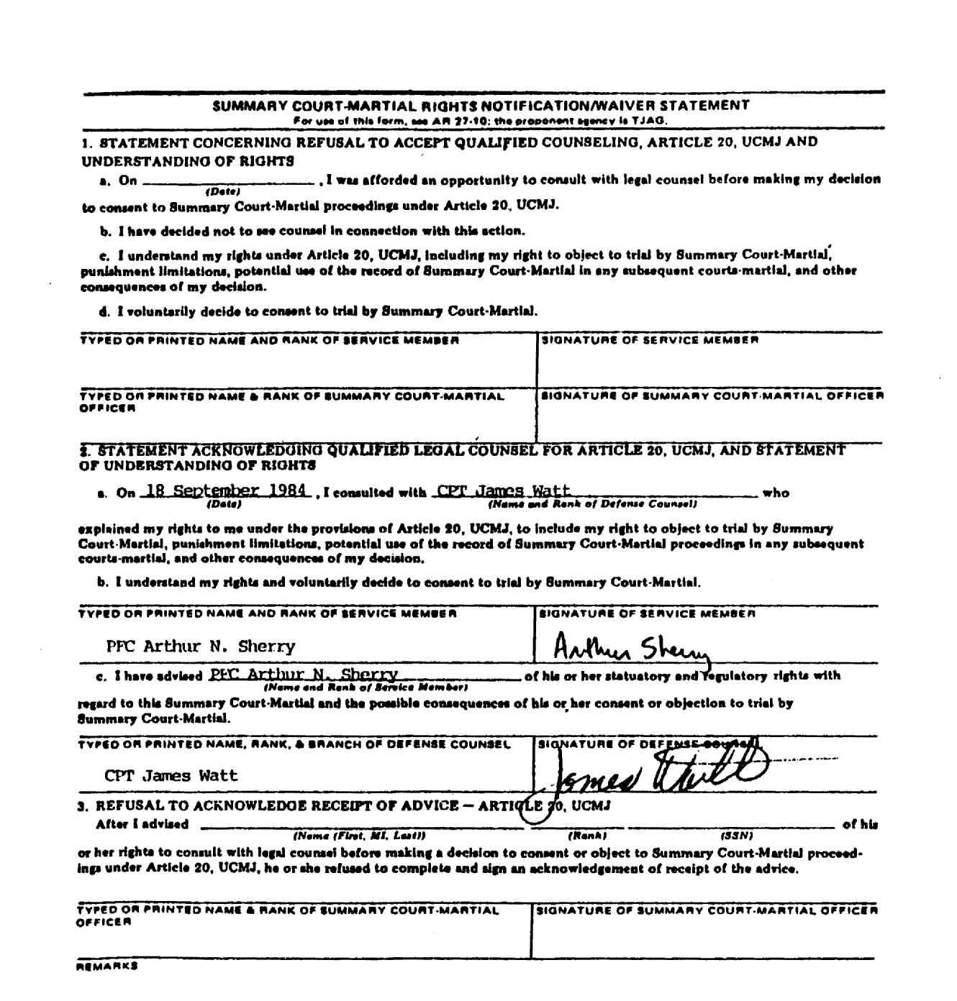

I. Charge Sheet (Figure 5-9)

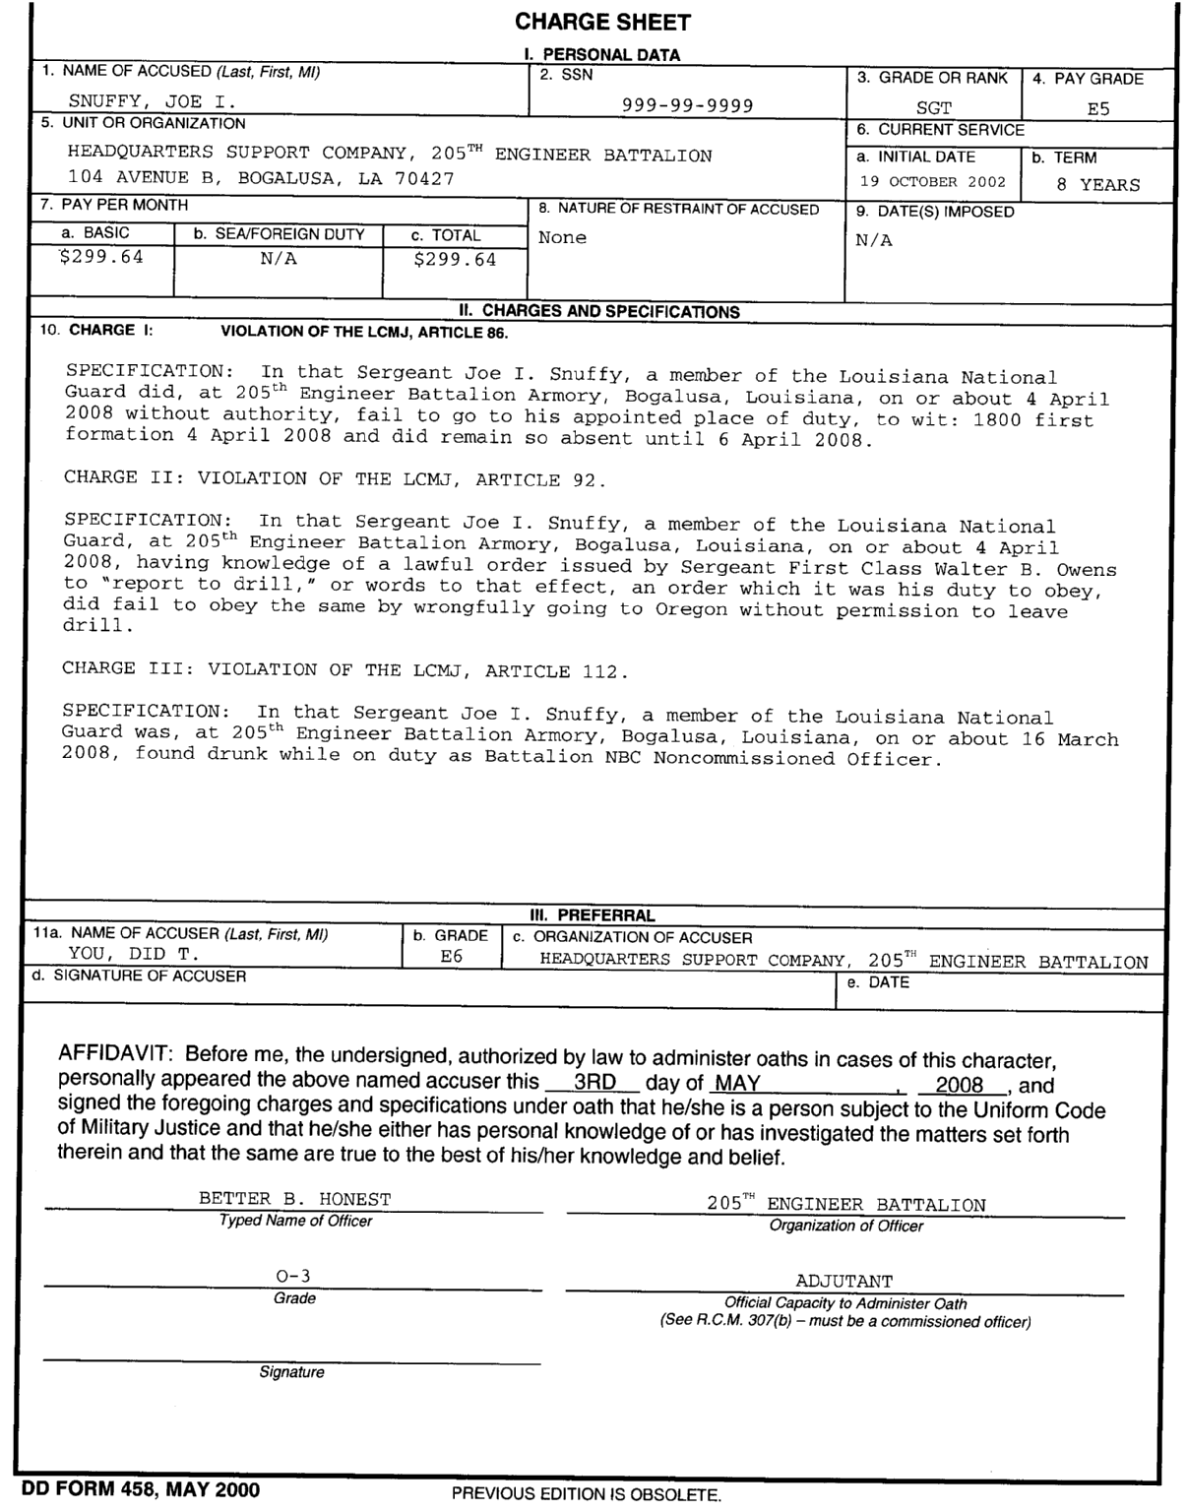

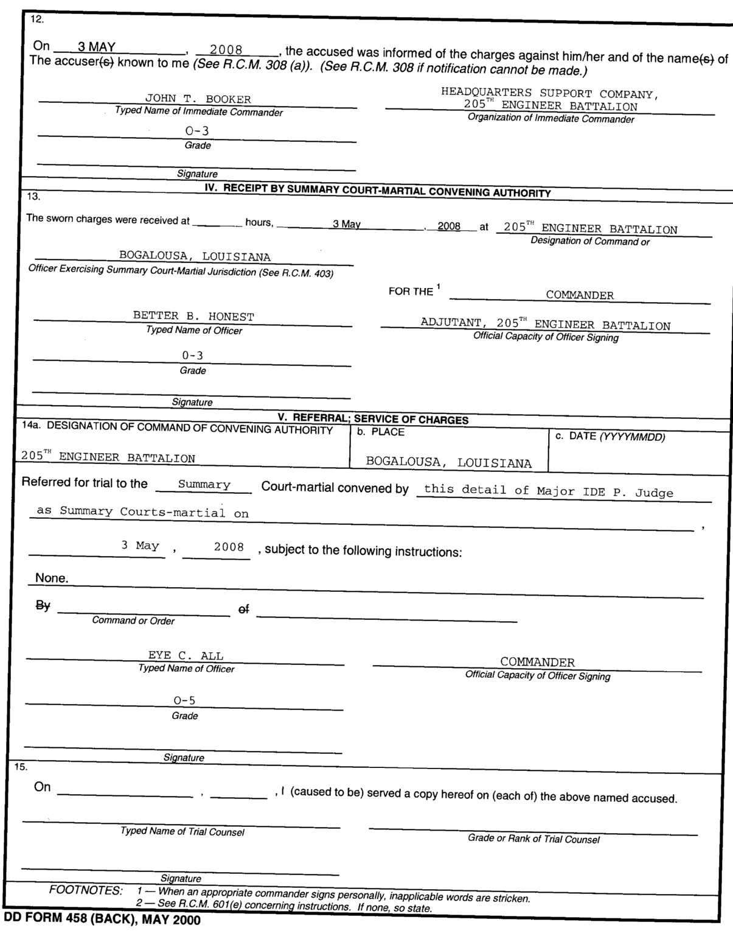

J. Charge Sheet Completion Explanation Item   
(Figure 5-10)

Item 1 Enter last name, first name, and middle initial of accused.

Item 2 Enter Social Security Account Number of accused.

Item 3 See AR 600-200, Table 1-1, for proper rank/grade designations. Example: PFC; SFC.

Item 4 Enter numerical pay grade designation of officer or enlisted member, as appropriate. Example: E-4; E-1.

Item 5 Enter complete military address of unit to which the individual is assigned.

Item 6 Enter initial date and term of current enlistment.

Item 7 Enter amount of base pay for one inactive duty training period. Louisiana National Servicemembers do not receive "sea or foreign duty pay."

Item 8 Enter nature of any restraint imposed upon the accused at the time the charge sheet is prepared. Example: Arrest in Quarters; Confinement. If no restraint is imposed, enter NONE.

Item 9 Enter the date that restraint in Item 8 was imposed. If no restraint is imposed, enter N/A.

Item 10 Change "UCMJ" to "LCMJ." Each violation of a different section of the LCMJ requires a separate charge. Charges, if more than one, are numbered by Roman numerals. Examples: I; II; III; IV, etc. If only one charge is made, it need not be numbered. In the blank space following the word "Article," enter the appropriate section of the LCMJ. Each specification under a charge is numbered with Arabic numerals. Example: 1; 2; 3; 4, etc. If only one specification is shown under a charge, it need not be numbered. Do not use abbreviations or SSAN of the accused in any specification. Specifications will be free of typographical errors. Consult Part IV of the Manual for Courts-Martial, United States, for sample specifications. Do not alter the words in a model specification without advice from the servicing staff judge advocate.

Item 11 For "preferral of charges," enter name, grade, and organization of accuser. While it is customary for the unit commander to sign as accuser, any person subject to the LCMJ may be an accuser, though that individual may not thereafter refer the charges to a GCM or SPCM. [See LCMJ Article 30.] Signing for the accuser is not authorized, and rubber stamp signatures are not authorized. Charges must be sworn in all cases, with the accuser signing the charge sheet in the presence of the servicing staff judge advocate, his assistant, or one of the individuals so authorized to administer oaths for military justice purposes. [See LCMJ Article 136.] No accused may be tried on unsworn charges over his objection. Only a commissioned officer may swear the accuser to the charges. [LCMJ Article 136.]

Item 12 Enter date accused was notified of the charges. Enter name, grade, and organization of person informing accused of the charges. If possible, the accused's commander should make this notification personally. If personal notice is not possible, a letter notifying the accused should be mailed using first class postage, and the charge sheet should be noted to so reflect. The one notifying the accused of the charges should also complete the DA Form 5111-R, Summary Court-martial Rights Notification/Waiver Statement. [See Figure 5-6.]

Item 13 The unit commander then forwards the charge sheet to the Summary Court-martial Convening Authority, usually the battalion or squadron commander. The time and date on which the charges are received by the SCM Convening Authority is critical as it begins the statute of limitations clock running. [LCMJ Article 43.]

Item 14 The appropriate convening authority's decision on the level of court-martial is entered in this blank.

Item 15 Enter record of service of the charge sheet upon the accused. The Summary Court-martial Officer normally serves SCM process. It is Trial Counsel's responsibility to insure that timely service is made for SPCM and GCM. Service may be accomplished either by personal deliver or first class mail.

See R.C.M. 307 for further guidance. All blocks of Charge Sheet must carry an entry, and all changes, corrections, additions, and deletions must be initialed by the person who makes them.

K. Pretrial Agreement (Figure 5-11)

STATE OF LOUISIANA SPECIAL COURT-MARTIAL NO.____

versus

PRIVATE E-1 JOHN DOE

256TH INFANTRY BRIGADE (M)

LOUISIANA ARMY NATIONAL GUARD

OFFER TO PLEAD GUILTY

I, Private E-1 John Doe, the accused in a Special Court-Martial now pending, have had an opportunity to examine the charges preferred against me, the investigating officer's report, and the statements and documents attached thereto; and after consulting with my defense counsel, CPT _____, and being fully advised that I have a legal and moral right to plead not guilty to the Charge and Specification under which I am about to be tried, to wit:

Charge: Violation of the Louisiana Code of Military Justice, Article 86, containing one specification of AWOL from 4-11 July, 1992.

I offer to plead guilty to the Charge and the Specification, provided that the convening authority will not approve any sentence in excess of the sentence attached hereto as Appendix I.

In offering the above agreement, I declare that:

I agree upon acceptance of this offer to enter into a written stipulation with the trial counsel of the facts and circumstances surrounding the offenses and further agree that this stipulation may be used to inform the court-martial of matters pertinent to an appropriate finding and/or sentence. I am satisfied with the defense counsel who has been detailed to defend me. This offer to plead guilty originated with me and no person or persons have made any attempt to force or coerce me into making this offer to plead guilty. My defense counsel has advised me of the meaning and effect of my guilty plea and I understand the meaning and effect thereof. I understand that I may request a withdrawal of this plea at any time before sentence is announced and the military judge determines whether the request should be granted. I understand this offer and agreement and the fact that I have agreed to enter into the stipulation of fact as set out above. If my plea is not accepted, this offer to stipulate is null and void. I further understand that this agreement will be automatically canceled upon the happening of any of the following events:

Failure of agreement with the trial counsel on the contents of the stipulation of fact;

The withdrawal by either party from the agreement prior to trial;

The modification at any time of the agreed stipulation of fact without consent of trial counsel or myself; The changing of my plea by anyone during the trial from guilty to not guilty; or, The refusal of the Military Judge to accept my plea of guilty.

_________________________ _____________________________

DEFENSE COUNSEL ACCUSED

The foregoing is (accepted) (not accepted).

_____, Louisiana, this ___ day of _____, 19__.

___________________________

COMMANDER

L. Pretrial Agreement, Continued (Figure 5-12)

*On a separate sheet, the sentencing limitation language should be typed, substantially as follows:*

APPENDIX I

I, Private E-1 John Doe, offer to plead guilty to the Charge and Specification herein provided the convening authority will not approve a sentence in excess of a fine of not more than $75.00 and confinement of not more than 60 days.

_____, Louisiana, this ___ day of _____, 19__.

_________________________ ___________________________

DEFENSE COUNSEL ACCUSED

The foregoing is (accepted) (not accepted).

___________________________

COMMANDER

M. Court Martial Convening Order (Figure 5-13)

UNIT HEADING

LANG-xxx DATE

SPECIAL COURT-MARTIAL CONVENING ORDER 08-XX

1. All prior orders, as pertains to a Special Court-Martial are hereby rescinded.

2. A Special Court-Martial is hereby convened. It may proceed to try such person(s) as may be properly brought before it. LAARNG Judge Advocates are appointed with the approval of the State Judge Advocate. The Court will be constituted as follows:

MILITARY JUDGE

COL WILLIAM R. JUSTICE, Louisiana State Guard, certified in accordance with LCMJ Article 26(b) and previously sworn in accordance with LCMJ Article 42(a).

TRIAL COUNSEL

MAJ JOE BROWN, JA, HHC 225TH EN BDE, LAARNG, is detailed as TRIAL COUNSEL, certified in accordance with LCMJ Article 27(c) and previously sworn in accordance with LCMJ Article 42(c).

DEFENSE COUNSEL

CPT BLEEDING HEART, JA, Joint Forces Headquarters, Trial Defense Service, LAARNG, is detailed as DEFENSE COUNSEL, certified in accordance with LCMJ Article 27(c) and previously sworn in accordance with LCMJ Article 42(c).

SPECIAL COURT-MARTIAL CONVENING ORDER 08-XX

DATE

MEMBERS

RANK NAME UNIT NAME

COL ADAM, JOHN ROGER JFHQ-LA(-)

COL BOAT, JAMES ERNEST JFHQ-LA(-)

MSG BROCH, TED ANTHONY JFHQ-LA(-)

MSG COOK, JOSEPH GREG HHC, 225TH EN BDE

LTC CHARLES, JERRY SCOTT HHC, 225TH EN BDE

MSG DANGLE, DENISE MARIE JFHQ-LA(-)

MSG GENNERY, DONNA JEAN JFHQ-LA(-)

1SG GOLF, JEFFERY BLAKE 926 MOBILITY AUG CO (MAC)

CSM HUBERT, FRANKLIN RAY HSC 527 EN BN

COL JONES, JORDAN TODD 61ST TROOP COMMAND

SFC LANDRY, LEROY 61ST TROOP COMMAND

CPT MACFLUFF, AARON JFHQ-LA(-)

MSG MCGIBB, ROBIN KENDALL JFHQ-LA(-)

SFC MCNOOFUNHOUSER, NATASHA HHC 256TH INF BDE (IBCT)

1SG NUGENT, ROBERT EUGENE DET 1, 199TH REG (LDR)

1SG PARTINES, GREGORY ALFRED 812TH MED CO (AIR AMBL)

LTC PINGER, LADENNA MAYEUR JFHQ-LA(-)

1SG ROUGH, DANNY ALFRED 843(-) HORIZONTAL EN CO

1SG RALGER, JOHN MARTIN CO C (MED), 199TH SPT BN

MAJ RASSHOUSE, TINA DRACINE JFHQ-LA(-)

MSG RAINS, MELODY ANN JFHQ-LA(-)

MSG SALIVASTER, DENNIS JOYAUS HHD 139 SUPPORT GROUP (REG)

CPT ST. THOMAS, JOHN GREGORY 769 EN BN

LTC TALLWOOD, VINCENT DOUGLAS HHD 139 SUPPORT GROUP (REG)

SGM TOILRER, PAT RAY JFHQ-LA(-)

MSG VICTOR, JAMES MICHAEL HHC 225TH EN BDE

SGM WILLIAMS, GREG ALLEN JFHQ-LA(-)

BY ORDER OF THE COMMANDER:

BENNETT LANDRENEAU

MG, LANG

Commanding

AUTHORITY NOTE: Promulgated in accordance with R.S. 29:11(F).

HISTORICAL NOTE: Promulgated in accordance with the Office of the Governor, State Military Department, LR 35:2385 (November 2009).

Chapter 6. Trial Procedures

§601. Applicability of Trial Guides

A. Court-Martial Trial Guides. A guide for the conduct of Summary Courts-Martial is located in Appendix B of this Regulation. The Military Judge’s Benchbook, DA Pam 27-9, shall be consulted as a guide for Special and General Courts-Martial. The benchbook contains scripts for GCMs and SPCMs. Trial procedures shall conform generally to the Guide applicable to the level of court-martial being conducted.

B. Deviation Not Necessarily Reversible Error. Deviation from the suggested script language shall not constitute reversible error unless a substantial right of the accused is thereby violated.

AUTHORITY NOTE: Promulgated in accordance with R.S. 29:11(F).

HISTORICAL NOTE: Promulgated in accordance with the Office of the Governor, State Military Department, LR 35:2396 (November 2009).

§602. Courtroom Procedure Rules

A. Pursuant to LCMJ Article 36, and unless otherwise specifically stated by the military judge or other competent authority, the following rules of courtroom procedures shall apply to all non-judicial punishment proceedings and courts-martial conducted under the LCMJ.

1. Decorum of Courtroom

Rule 1. As a traditional mark of respect for the dignity of the military judicial system, as represented by the military judge, all persons in the courtroom, without regard to grade, will rise when the military judge enters or leaves.

Rule 2. The military judge, either at a Section 39(a) session or at the time of assembling the court, should make known any special rules relating to conduct which the accused, counsel, witnesses, members of the court, and others in the courtroom will be expected to follow which are not set forth in the Rules for Courts-Martial, Part II of the Manual for Courts-Martial, United States, these rules, and the Louisiana Code of Military Justice.

Rule 3. Except as otherwise provided by the military judge, all military personnel who participate in the trial, including court members, counsel, the accused, the reporter, the bailiff, guards, and witnesses, shall appear in appropriate service uniform. Unless a court-martial is conducted in the field the uniform shall be Class A. Military witness who are called unexpectedly may be permitted to appear in other than service uniform to avoid undue delay.

Rule 4. The military judge should be attired in a judicial robe during open sessions of the trial of a case with members. In other cases he should appear in appropriate service uniform.

Rule 5. Spectators are encouraged to attend trials and shall be permitted to observe any trial unless otherwise ordered by the trial judge. Spectators may enter and leave the courtroom during open sessions of court, subject to the rules established by the military judge, but they will not be permitted to disturb or interrupt court proceedings by their conduct.

Rule 6. It is improper for a spectator to demonstrate agreement or disagreement with testimony or other events at trial, whether verbally, by facial expressions, shaking or nodding of the head, or by any other conduct. Spectators who violate this rule may be ordered from the courtroom by the military judge. All counsel are responsible for advising their clients, witnesses, and acquaintances of such persons who are in attendance, of the demeanor required of them while the court is in session.

Rule 7. Smoking will not be permitted in the courtroom during open sessions of the court, and may be permitted by the military judge at other times only if smoking is permitted in the room when it is not being utilized as a courtroom. Food and beverages, other than water, will not be permitted in the courtroom, except with the prior express permission of the military judge.

Rule 8. Photographs, sound recordings designed for public release, and radio and television broadcasts shall not be made in or from the courtroom during sessions of the trial except with prior approval of the military judge.

2. Conduct of Counsel

Rule 9. Counsel owes a duty both to his client and to the court. Counsel shall assist the military judge in maintaining throughout the trial a quiet and dignified atmosphere in keeping with the highest traditions of judicial proceedings in the military services. All counsel are responsible for knowing and observing the proper relationship and decorum that must exist between themselves and the military judge.

Rule 10. Unless otherwise authorized or directed by the military judge, counsel shall stand when addressing the military judge or court members.

Rule 11. While the accused is present or the court is in session, counsel should refrain from any familiarity among themselves or with the military judge, members of the court or witnesses. Direct colloquy, argument or hostility between counsel serves no proper purpose in the trial and shall not be permitted.

Rule 12. Counsel should conduct the questioning of witnesses and arguments to the court at a reasonable distance from the witness or court. At the discretion of the military judge, counsel may be required to question witnesses and present arguments from a lectern, the counsel table, or other prescribed place. Except to present an exhibit, counsel should not approach a witness without asking permission of the military judge; nor should he position himself so as to block the view between witnesses and the other participants in the trial.

Rule 13. During argument of counsel, opposing counsel shall remain seated at the counsel table. Counsel shall not walk about, talk to others, or otherwise conduct himself so as to divert the attention of the court or any member.

Rule 14. Except with the permission of the military judge, only one counsel for each side (or, if there are multiple accused, one counsel for each accused) may examine any one witness or address the court on any particular issue or motion.

Rule 15. When counsel initially enters an objection, he shall state only the objection and the basis for it. Before proceeding to argue an objection, counsel will request permission of the military judge and ascertain whether argument will be entertained in open or in an out-of-court session. Although argument identifying legal issues and presenting authorities is ordinarily appropriate, an objection or argument for the purpose of making a speech, recapitulating testimony, or attempting to guide a witness is prohibited.

Rule 16. After the military judge has announced his decision on an objection, counsel shall not make further comment or argument except with the express permission of the military judge.

Rule 17. All requests for rereading of questions or answers shall be addressed to the military judge.

Rule 18. The military judge may initiate the voir dire examination by referring to the charge against the accused and putting to the members’ questions touching upon their qualifications, including impartiality, to serve as members of the court. The military judge shall permit such additional questions, oral or written, as he deems reasonable and proper.

Rule 19. Counsel shall confine their opening statements to what they expect the evidence to prove. Counsel will not use the opening statement to argue the case or to instruct as to the law.

Rule 20. In closing argument, counsel may make reasonable comment on the evidence and may draw such inferences from the evidence as will support his theory of the case, but he shall not assert his personal belief in the justice of his cause or in the guilt or innocence of the accused; nor may he personally vouch for the credibility or lack of credibility of witnesses.

3. Witnesses

Rule 21. All witnesses will be treated with fairness and consideration; they will not be unnecessarily crowded, shouted at, ridiculed, humiliated, or otherwise abused.

Rule 22. A military witness should not salute the military judge or the president of the court. In a trial by members, the accused will salute and report to the president when he stands to receive the findings or sentence. Counsel should insure that witnesses they present understand the physical setup of the courtroom, where they should go, and what they should do.

Rule 23. The court will cooperate with commanders, senior staff officers, doctors and other professional witnesses and may accommodate them by permitting them to appear and testify out of order. Counsel should discuss such arrangements in advance with opposing counsel and the military judge.

Rule 24. Each counsel should make arrangements before each session to insure that his witnesses will be immediately available when called.

4. Exhibits

Rule 25. Exhibits intended to be used or introduced at trial should be marked "For Identification" prior to trial. Prosecution exhibits will be marked consecutively with Arabic numerals and defense exhibits with capital letters. When referring to an exhibit while questioning a witness or addressing the court, counsel shall specify the exhibit number or letter.

Rule 26. Counsel tendering an exhibit shall have sufficient copies made for the military judge and all opposing counsel. Proposed prosecution exhibits should be shown to the defense counsel before trial. Defense counsel may do likewise, but are not required to do so.

Rule 27. If an item of evidence cannot be included in the record of trial for any reason, counsel offering it should arrange to have a suitable substitute provided. Such a substitute shall include an accurate and detailed description, either pictorially or written, as to the exhibit's size, shape, weight, substance, color, and other relevant physical characteristics.

Rule 28. If a copy of a document is to be substituted in the record of trial for a document that was offered into evidence, only a permanent type copy may be used.

5. Support Trial Personnel

Rule 29. A bailiff should be present at every trial to announce the opening and closing of the court, to obtain witnesses as they are called to testify, to ask everyone to rise when the military judge enters or leaves the courtroom, and to take care of administrative errands during the trial. The trial counsel is responsible for briefing the bailiff as to his duties. If a bailiff is not present, the trial counsel or an assistant will perform the bailiff's duties.

Rule 30. Unless otherwise directed by the military judge, guards, if necessary, shall not be permitted inside the bar of the courtroom.

6. Docketing and Other Procedural Matters

Rule 31. Each military judge should maintain his calendar in a manner which will make efficient use of available time and provide for expeditious scheduling of trials when requested by the commands which he services.

Rule 32. When a number of uncontested cases are pending in a single area, such cases should be consolidated for trial at a continuous session of the court.

Rule 33. When a military judge is named to a case, the trial counsel will advise the military judge of the general nature of the charges. As preparation for the trial continues, he will keep the judge informed of the estimated duration of the trial, whether it will be by judge alone, and whether it will be contested. Counsel for both sides shall prepare for trial as expeditiously as possible and will arrange with the military judge for a firm trial date. Alternatively, in areas where the caseload justifies doing so, the military judge may schedule periodic pretrial sessions to conduct arraignments, enter pleas, hear motions, and set dates for future hearings and trials.

Rule 34. Counsel shall be prepared to dispose of all motions at one LCMJ Article 39(a) session. As soon as practicable after being detailed to serve, a defense counsel who wishes to present motions or other pleadings will prepare and furnish to the trial counsel, copy to the military judge, a Motions and Hearings Checklist, in substantially the form shown at the end of these rules, accompanied by the motions or other pleadings presented. He will indicate thereon those issues he wishes to litigate at a LCMJ Article 39(a) session, specifying whether the hearing will involve argument only, or also presentation of evidence. As soon as counsels have determined that a preliminary hearing is necessary, they will arrange a hearing date with the military judge. Motions or other pleadings which are required to be considered at a preliminary hearing which are not presented in accordance with this rule will not be entertained at a preliminary hearing or during trial except for good cause shown and with permission of the military judge. If the convening authority can provide the relief sought by counsel, thus making a preliminary hearing unnecessary, a timely application therefore should be made to him. Only those matters which are contested by the parties or which are not fully satisfied by the trial counsel or convening authority will be scheduled for preliminary hearing.

Rule 35. If defense counsel anticipates moving for dismissal of any charge on the basis that the accused has been denied his right to a speedy trial, counsel for both sides should endeavor, prior to trial, to enter into and prepare a stipulation of fact as to the chronology of events. In any case in which trial counsel anticipates that defense counsel may raise an issue of denial of speedy trial, trial counsel shall prepare a chronology of events in the case, even if defense counsel is not willing to stipulate to such facts. In such case, trial counsel should also be prepared to present evidence to prove the pre-trial events. If a motion or other issue involves only a dispute between the parties as to an issue of law or ultimate question of fact, and not as to the underlying facts, counsel should endeavor to enter into and prepare, prior to trial, a stipulation of fact or a stipulation of expected testimony covering those matters. Counsel may enter into such a stipulation for the limited purpose of obtaining a ruling on a motion or other pleading.

Rule 36. In a trial with members, if either counsel desires any specialized instructions, including any summarization of the evidence or any instructions not contained in appropriate service publications (for example, as are contained in the Military Judge's Benchbook, DA Pam 27-9), he should submit such instructions to the military judge in writing prior to commencement of the Section 39(a) instructions conference. If either counsel desires a modification of a standard instruction from appropriate service publications, he should also submit his proposed modification in writing prior to commencement of the Section 39(a) instructions conference.

Rule 37. The military judge may enter special findings even though not requested to do so by counsel for either side. Such findings should not merely repeat what is available elsewhere in the record of trial, but should be limited to those special findings of fact and conclusions of law which were made by the military judge as the basis for his general findings of guilt or innocence or his disposition of important motions. If counsel for either side desires special findings, he should not only make a request therefore, but he should also submit proposed special findings to the military judge in writing, including when appropriate citations of legal authority.

AUTHORITY NOTE: Promulgated in accordance with R.S. 29:11(F).

HISTORICAL NOTE: Promulgated in accordance with the Office of the Governor, State Military Department, LR 35:2397 (November 2009).

§603. Article 39(a) Sessions/Conferences

A. General. An "LCMJ Article 39(a) Session" empowers the military judge to call the court-martial into session for consideration of any matters not requiring the presence of court members. It applies to both pre-trial and post-trial issues.

B. Purposes. The following illustrative general purposes may prompt an Article 39(a) Session:

1. Hearing and determining motions raising defenses or objections that are capable or determination without trial of the issues raised by a plea of not guilty.

2. Hearing and ruling upon any of the following matters under the LCMJ even though the matter may be appropriate for later consideration by the members:

a. unlawful command influence [See LCMJ Article 37];

b. verification and qualification of counsel [See LCMJ Article 38];

c. continuances [See LCMJ Article 40];

d. challenges or disqualification of counsel [See LCMJ Article 41];

e. statute of limitations [See LCMJ Article 43];

f. former jeopardy [See LCMJ Article 44];

g. correction or reconsideration of pleas [See LCMJ Article 45];

h. issuing process for witnesses or evidence [See LCMJ Article 46];

i. contempt [See LCMJ Article 48];

j. authorizing depositions [See LCMJ Article 49.]

k. holding arraignments and receiving pleas of the accused and entry of findings of guilt thereupon.

l. performing any other procedural function of the military judge not requiring the presence of the court members, to include, particularly, resolution of questions of trial procedure, the accused's choice of counsel and forum, admissibility of evidence, and motions for appropriate relief. [See, R.C.M. 803 discussion.]

AUTHORITY NOTE: Promulgated in accordance with R.S. 29:11(F).

HISTORICAL NOTE: Promulgated in accordance with the Office of the Governor, State Military Department, LR 35:2399 (November 2009).

§604. Arraignment

A. The arraignment normally occurs during an Article 39(a) session. [See R.C.M. 904.] In the arraignment, the trial counsel informs the accused of the specific charges and the military judge asks the accused how he desires to plead. The accused may waive reading of the charges and specifications. The plea itself is not part of the arraignment. The accused may be validly arraigned only on charges and amendments thereto which have been properly referred to the arraigning court-martial for trial. After arraignment, no additional charges may be referred to the same trial without the consent of the accused.

AUTHORITY NOTE: Promulgated in accordance with R.S. 29:11(F).

HISTORICAL NOTE: Promulgated in accordance with the Office of the Governor, State Military Department, LR 35:2399 (November 2009).

§605. Motions

A. General. A motion is a request to the military judge for some particular relief, as set forth in R.C.M. 905- 907. Motions may be oral, or in the discretion of the military judge, in writing. Motion practice is primarily the province of the defense counsel.

B. Kinds of Motions. The three functional kinds of motions are "motions to dismiss," "motions for appropriate relief" and "motions to suppress." Another kind of motion similar to a motion to suppress is a motion in limine.

1. A Motion to Dismiss is a request to terminate further proceedings as to one or more charges and specifications on grounds capable of determination without trial of the general issue of guilt. Grounds, which include both "waivable" and "nonwaivable" bases, include statute of limitations, speedy trial, former jeopardy, pardon, immunity, constructive condonation of desertion, and prior punishment under LCMJ Articles 13 or 15 for the same offense, if it is a "minor offense." "Nonwaivable" grounds include lack of jurisdiction and failure of a specification to state an offense. "Waivable" grounds for motion to dismiss must be made before final adjournment of the court-martial.

2. A Motion for Appropriate Relief is designed to remedy defects of form or substance that require corrective action short of dismissal. It is made to cure a defect which impedes the party from properly preparing for trial or conducting his case. R.C.M. 906(a) lists 14 non-exclusive, different grounds for the motion for appropriate relief.

3. A Motion to Suppress may be directed to a confession or admission by an accused, evidence obtained from a search or seizure or believed to belong to the accused, and/or prior eyewitness identification of the accused. Once properly notified by trial counsel that such evidence exists, the accused must ordinarily make the motion to suppress the evidence before entering pleas. Absent good cause, the military judge must conduct a hearing and make a ruling on a motion to suppress before requiring entry of a plea.

4. A Motion in Limine is similar to a motion to suppress in that it requests a preliminary ruling on admissibility of evidence which must be ruled on prior to the offering of the matter into evidence. The motion may be made by either side before or during trial.

C. Burden/Standard of Proof. The general rule is that where factual matters must be resolved in order to decide a motion, the burden of persuasion is generally upon the moving party, who must prove the matter by a "preponderance of evidence" (unless another standard, such as "clear and convincing evidence" is specifically required.) [See, e.g., Mil R. Evid. 313(b), regarding examination to locate weapon/contraband.]

1. Motion to Dismiss. Exception to general rule above applies to Motions based on lack of jurisdiction, denial of speedy trial, or running of statute of limitations, all of which place the burden on the government.

2. Motion for Appropriate Relief. The general rule placing the burden on the moving party by a "preponderance of evidence" applies.

3. Motion to Suppress. Exception to the general rule above in that the prosecution has the burden of demonstrating by a "preponderance of the evidence" (unless a different standard is specifically prescribed) that the offered evidence is properly admissible. [See M.R.E.. 311(e), 321(d).]

4. Motion in Limine. The burden of proof is on the proponent of the evidence.

D. Time for Filing. The general rule is that any defense, objection, or request which is capable of determination without the trial of the general issue of guilt may be raised before trial. The following motions must be raised before a plea is entered:

1. defenses or objections based on defects (other than jurisdictional defects) in the preferral, forwarding, investigation, or referral of charges (e.g. unsworn charges, inadequate Article 32 investigation, and inadequate pretrial advice.) [See R.C.M. 307, 401-7, 601-4, 905(b)(Discussion).];

2. defenses or objections based on defects in the charges and specifications (other than failure to show jurisdiction or to charge an offense, which objections shall be resolved by the military judge at any time during the pendency of the proceedings.);

3. motions to suppress admissibility of confessions, admissions, evidence obtained from unlawful searches and seizures, and eyewitness identification. [See M.R.E.. 304, 311, 321.] Challenges to admissibility of evidence on other grounds may be raised by objection at trial or by motion in limine;

4. motions for discovery under R.C.M. 701 or for production of witnesses or evidence;

5. motions for severance of charges or accused;

6. objections based on denial of request for individual military counsel or for retention of detailed defense counsel when individual military counsel has been granted.

E. Military Judge's Essential Findings. When factual issues are involved in determining a motion, the military judge is obliged to state his essential findings on the record. Such findings should contain a statement of the factual findings and essential legal findings which support the decision on the motion.

AUTHORITY NOTE: Promulgated in accordance with R.S. 29:11(F).

HISTORICAL NOTE: Promulgated in accordance with the Office of the Governor, State Military Department, LR 35:2399 (November 2009).

§606. Pleas

A. Types of Pleas and Their Effect

1. Not Guilty Plea. Such a plea places all matters in issue and requires the prosecution to prove the accused's guilt beyond a reasonable doubt. If an accused fails or refuses to plead, or makes an irregular plea, the military judge shall enter a plea of not guilty for the accused.

2. Guilty Plea. A plea of guilty, if accepted by the military judge, admits the accused's guilt and relieves the prosecution of the burden of proving guilt beyond all reasonable doubt. Before the plea is accepted, the accused must admit every essential element of the offense. [See R.C.M. 910(E) discussion.] The military judge must make a searching and detailed inquiry of the accused to determine if the accused understands the plea, that it is entered into voluntarily, and that the accused, is, in fact guilty. [See R.C.M. 910(c).]

3. Guilty by Exceptions or Guilty with Exceptions and Substitutions. These types of pleas "except out" certain language from the charged specification and/or substitutes words in the specification, thereby entering a plea to an offense included in the offense charged. The result is to plead not guilty to the charged offense but guilty to a different, and often lesser included offense. For example, if the charged offense were robbery and the guilty plea by exceptions and substitutions was to the lesser included offense of wrongful appropriation, the defense counsel would state:

4. "Your honor, the accused, _____, pleads to the specification: guilty, except the words, 'by means of force and violence steal from the person of _____ against his will,' substituting therefore the words 'wrongfully appropriate,' to the excepted words not guilty, to the substituted words guilty to the charge, not guilty, but guilty of a violation of Article 121."

5. A plea of guilty to a lesser included offense does not bar the prosecution from proceeding of the offense as charged and the prosecution need not prove the elements of the lesser offense admitted in the plea. The military judge must make a guilty plea inquiry into the plea of guilty by exceptions and substitutions.

6. Mixed Pleas. An accused may enter plea(s) of guilty to some specifications, guilty by exceptions and substitutions to others, and/or not guilty to other specifications. After a guilty plea inquiry and acceptance by the military judge of any guilty pleas, the prosecution may attempt to prove the remaining offenses. If the accused pleads guilty to some but not all of the specifications, the accused's admission of an element in one specification does not relieve the Government from the burden of proving the same element in the remaining, contested specifications. Thus, admissions implicit in a guilty plea to one offense cannot be used as evidence to support the findings of guilty of an essential element of a separate and different offense.

7. Conditional Pleas. With the approval of the military judge and the consent of the government, an accused may enter a conditional plea of guilty, reserving in writing the right, on further review or appeal, to review of the adverse determination of any specified pretrial motion. The specified grounds preserved for appeal must be actually litigated at the trial court level. If the accused prevails on further review or appeal, he is allowed to withdraw the guilty plea. The conditional plea enables the accused to preserve his appeal and also saves the government the time and expense of a trial on the merits. Conditional pleas are not normally granted unless the motion is capable of full pretrial litigation. When the pretrial motion requires trial on the merits for a full development of the underlying factual issues or the motion is not "case dispositive," the conditional plea is normally denied.

B. Guilty Plea Inquiry. The guilty plea or "providence inquiry" is a dialogue between the military judge and the accused. It is made on the record to assure the military judge that the accused personally understands the meaning and effect of his plea and that an adequate factual basis exists for acceptance of an admission of guilt. The components of the guilty plea inquiry, listed in RCM 910(c) are:

1. The nature of the offense to which the plea is offered, the maximum possible penalty and any mandatory minimum penalty.

2. The right to representation by counsel.

3. The rights to confrontation and cross-examination of one’s accusers, right against compulsory self-incrimination, right to trial of the facts by court-martial.

4. The factual basis for the plea.

5. The plea agreement inquiry.

C. Refusal to Accept Guilty Plea. The military judge will refuse to accept an accused's plea of guilty and enter a not guilty plea in the following situations:

1. The accused enters an "irregular" plea, such as a plea of guilty while denying criminality, or "guilty but insane," or "guilty to the charge but not guilty to the specification," or "nolo contendere".

2. There are substantial, irreconcilable inconsistencies between the plea and statements of the accused or the evidence. The military judge shall make inquiry to negate any defenses raised by the accused, and may call witnesses to resolve any such potential defense.

3. The accused enters an "improvident" plea (i.e. without understanding its meaning)

4. The accused refuses to enter a plea.

D. Withdrawal of Guilty Plea. Prior to acceptance of a guilty plea by the military judge, the accused has an absolute right to withdraw a guilty plea and enter a plea of not guilty or guilty to a lesser included offense. After acceptance of the plea, but before the sentence is announced, an accused can request permission from the military judge to withdraw a guilty plea. The military judge should ordinarily grant such a request if it is shown that the guilty plea was induced by fraud, mistake, imposition, misrepresentation, or misapprehension of the accused of his legal rights.

AUTHORITY NOTE: Promulgated in accordance with R.S. 29:11(F).

HISTORICAL NOTE: Promulgated in accordance with the Office of the Governor, State Military Department, LR 35:2400 (November 2009).

§607. Former Jeopardy, Mistrial, and Withdrawal

A. Former Jeopardy. A proceeding terminated by the government after evidence is introduced on the merits, without fault of the accused, is a trial. No person may, without his consent, be tried a second time for the same offense. Former jeopardy does not apply to offenses under civilian law, but the authority to try an accused for the same acts which constitute an offense under the LCMJ may be limited by regulation. [See LCMJ Article 44a and R.C.M. 907(b)(C).]

B. Mistrial. A declaration of mistrial may be ordered by the military judge when such action is manifestly necessary in the interest of justice to prevent unfairness. Mistrial is a drastic remedy and should be employed only when manifestly necessary to preserve the ends of justice. For instance, an error in admitting evidence can ordinarily be cured by striking the testimony or evidence and/or by a curative instruction to disregard. A mistrial may be granted either as to findings of some or all charges or only as to the sentence. The military judge shall inquire into the views of the parties prior to such declaration. A declaration of mistrial shall not prevent trial by another court-martial on the affected charges and specifications except when the mistrial was declared after jeopardy attached and before findings, and the declaration was an abuse of discretion and without the consent of the accused and/or the direct result of intentional prosecutorial misconduct designed to necessitate a mistrial. [See R.C.M. 915(a)-(c).]

C. Withdrawal of Charges. The convening authority or a superior competent authority may, for any reason, cause any charges or specifications to be withdrawn from a court-martial at any time before findings are announced. Charges that have been withdrawn from a court-martial may be referred to another court-martial unless the withdrawal was for an improper reason. Charges withdrawn after the introduction of evidence on the general issue of guilt may be referred to another court-martial only if the withdrawal was necessitated by urgent and unforeseen military necessity. Withdrawal before trial proceedings begin carries the presumption of regularity; however the reason for withdrawal should be made part of the record. [See R.C.M. 604.]

AUTHORITY NOTE: Promulgated in accordance with R.S. 29:11(F).

HISTORICAL NOTE: Promulgated in accordance with the Office of the Governor, State Military Department, LR 35:2401 (November 2009).

§608. Contempt

A. Any level of court-martial has the power to punish for contempt "...any person who uses any menacing word sign, or gesture in its presence, or who disturbs its proceedings by any riot or disorder." The punishment for such conduct may not exceed confinement for 30 days or a fine of one hundred dollars ($100) or both. The convening authority approves or disapproves all or part of the sentence, with no further review or appeal. Any confinement will begin when adjudged unless it is deferred, suspended, or disapproved by the convening authority. Any fine adjudged does not become effective until ordered executory by the convening authority. [See LCMJ Article 48 and R.C.M. 809.]

AUTHORITY NOTE: Promulgated in accordance with R.S. 29:11(F).

HISTORICAL NOTE: Promulgated in accordance with the Office of the Governor, State Military Department, LR 35:2401 (November 2009).

§609. Witnesses

A. During the case in chief, the counsel and court may call witnesses to testify. The party calling the witness conducts direct examination followed by cross-examination of the witness by the opposing party. Redirect and recross-examination are conducted as necessary, followed by any questioning by the military judge and members. The military judge has the discretion to limit the number of redirect and recross-examinations. [See R.C.M. 913 and M.R.E.. 611 and 614.]

AUTHORITY NOTE: Promulgated in accordance with R.S. 29:11(F).

HISTORICAL NOTE: Promulgated in accordance with the Office of the Governor, State Military Department, LR 35:2401 (November 2009).

§610. Stipulations

A. General. A "stipulation" is an agreement between the parties. There are two common types of stipulations, "stipulation of fact" and "stipulation of expected testimony." Stipulations may be made orally or in writing. The military judge rules on the admissibility of the stipulation, and should ordinarily inquire to insure that the accused understands the right not to stipulate, understands the stipulation, and consents to it. [See R.C.M. 811.]

B. Stipulation of Fact. The parties may stipulate that a certain facts exists or does not exist. Once accepted, a stipulation of fact, in whatever form, is binding on the court-martial and may not be contradicted by the parties.

C. Stipulation of Expected Testimony. The parties may also stipulate that, if a witness were present, he would testify in a specified manner or that, if an original document were introduce, the document's contents would include certain information. Unlike a stipulation of fact, the parties are free to contradict, attack, or explain the evidence presented in this manner.

D. "Confessional Stipulation". The accused may, after a plea of not guilty, enter into a stipulation that amounts to a confession. Such a stipulation is subject to the same constraint as a guilty plea, and the military judge must ascertain that:

1. the accused understands the right not to so stipulate;

2. the stipulation will not be accepted without the accused's consent;

3. the accused understands the contents and effect of the stipulation;

4. the accused, after consulting with counsel, consents to the stipulation; and

5. whether there are any agreements between the parties in connection with the stipulation, and, if so, the terms thereof.

AUTHORITY NOTE: Promulgated in accordance with R.S. 29:11(F).

HISTORICAL NOTE: Promulgated in accordance with the Office of the Governor, State Military Department, LR 35:2402 (November 2009).

§611. Withdrawal of Stipulations

A. A party may withdraw from an agreement to stipulate or from a stipulation at any time before the stipulation is accepted. After a stipulation has been accepted by the military judge, he may permit withdrawal. If a party withdraws from an agreement to stipulate or from a stipulation, the opposing party may be entitled to a continuance to obtain proof of the matters which were to have been stipulated. If there is withdrawal of a stipulation previously accepted, the stipulation must be disregarded by the court-martial, and an instruction to that effect should be given.

AUTHORITY NOTE: Promulgated in accordance with R.S. 29:11(F).

HISTORICAL NOTE: Promulgated in accordance with the Office of the Governor, State Military Department, LR 35:2402 (November 2009).

§612. Motion for Finding of Not Guilty

A. General. A motion for finding of not guilty is a procedural device whereby the defense may test the sufficiency of the government's case. The motion may also be raised sua sponte by the military judge. The motion may be made at the conclusion of the government's case or at the conclusion of the defense's case, but must be made before the announcement of the findings on the general issue of guilt. The motion must specifically indicate where the government's evidence is insufficient and the military judge should give the parties an opportunity to be heard before ruling on the motion. The military judge should ordinarily allow the trial counsel to reopen the government's case as to the insufficiency specified in the motion if any such further evidence is reasonably available. [See R.C.M. 917.]

B. Test and Effect of Ruling. The test for granting the motion is whether there is some evidence, which together with all reasonable inferences and applicable presumptions, could reasonably tend to establish every essential element of the offense charged. The evidence is viewed in the light most favorable to the government and without evaluating the credibility of witnesses. The military judge may grant the motion as to part of a specification, as long as a lesser offense charged is alleged in the portion of the specification as to which the motion is not granted. A ruling granting a motion for a finding of not guilty is an acquittal and is final when announced; it may not be reconsidered by the military judge. A ruling which denies a motion for finding of not guilty may be reconsidered at any time prior to announcement of findings.

AUTHORITY NOTE: Promulgated in accordance with R.S. 29:11(F).

HISTORICAL NOTE: Promulgated in accordance with the Office of the Governor, State Military Department, LR 35:2402 (November 2009).

§613. Views and Inspections

A. In extraordinary circumstances, the military judge may, as a matter of discretion, permit the court-martial to view or inspect the premises or a place, or an article, or object. Such a view or inspection shall take place only in the presence of all parties, the members (if any) and the military judge. A person familiar with the scene may be designated by the military judge to escort the court-martial. Such a person shall perform the duties of escort under oath. The escort shall not testify, but may point out particular features prescribed by the military judge. Any statement made at the view or inspection by an escort, party, military judge, or any member shall be made part of the record. The fact that a view or inspection has been made does not necessarily preclude the introduction in evidence of photographs, diagrams, maps, or sketches or the place or item viewed, if these are otherwise admissible. [See R.C.M. 913(c).]

AUTHORITY NOTE: Promulgated in accordance with R.S. 29:11(F).

HISTORICAL NOTE: Promulgated in accordance with the Office of the Governor, State Military Department, LR 35:2402 (November 2009).

§614. Arguments

A. Types of Arguments

1. Opening Statements. The trial counsel may make an opening statement immediately before presenting the case in chief, and defense counsel may make an opening statement either after trial counsel or after the prosecution has rested its case. [See R.C.M. 913(b).]

2. Motions. Before action is taken on a contested motion, each side has the opportunity to present evidence and make an argument. The military judge, in his discretion, may limit or refuse to hear arguments which are trivial, mere repetition, or designed as a delay tactic. [See R.C.M. 905(h).]

3. Evidentiary objections and any others questions or matters presented to the Court for decision during the course of the court-martial.

4. Closing Arguments on Findings [R.C.M. 919] and Sentencings [R.C.M. 1001(g).]

B. Permissible Argument

1. Counsel may make reasonable comment on the evidence and may draw such inferences from the evidence as will support his theory of the case. [R.C.M. 919(b).]

2. Counsel may comment on the testimony, conduct, motives, and evidence of malice of the witnesses.

3. Counsel may argue as though the testimony of his witnesses conclusively established the facts related by them. Comments may be direct and forceful so long as they are fair and not unfairly prejudicial.

4. Counsel may argue that deterrence of others should be considered in adjudging a sentence, but may not argue this to the exclusion of all other sentencing factors.

5. Counsel may argue for the maximum sentence, or may argue for a specific sentence which is less than the maximum authorized by law.

6. Both trial and defense counsel may properly argue for a sentence they know cannot approved as a result of a pretrial agreement.

C. Impermissible Argument

1. Facts that are not properly before the court as evidence or have no foundation in the record. However, it is permissible to argue the ordinary experience of mankind, facts of contemporary history, and other matters which are common knowledge.

2. Misstatement of facts which are in evidence.

3. Personal belief of counsel.

4. Comment on the accused's failure to testify. Trial counsel may not characterize the evidence as "uncontroverted," where the accused is the only person who could have contradicted that evidence. However, trial counsel may properly review the available evidence and note that the trier of fact must decide the case based on the evidence presented.

5. Comment on effect of outcome of the case on "civilian-military" relations.

6. Placing court members in shoes of victim or victims' relatives.

7. Implication that a particular sentence is the view of the convening authority.

AUTHORITY NOTE: Promulgated in accordance with R.S. 29:11(F).

HISTORICAL NOTE: Promulgated in accordance with the Office of the Governor, State Military Department, LR 35:2403 (November 2009).

§615. Objections to Impermissible Argument

A. It is not necessary for counsel to interrupt opposing counsel's argument in order to preserve an assignment of errors. An error is preserved for appeal so long as the objection is made before the military judge begins his instructions to members or, if none, renders his verdict.

AUTHORITY NOTE: Promulgated in accordance with R.S. 29:11(F).

HISTORICAL NOTE: Promulgated in accordance with the Office of the Governor, State Military Department, LR 35:2403 (November 2009).

§616. Sentence

A. General. When the court returns a finding of not guilty, the accused is acquitted and the proceedings terminate. When the court returns a finding of guilty, the court-martial proceeds to the sentencing phase. During the sentencing phase, the trial counsel has the first opportunity to present the "case in aggravation." Then the defense counsel has an opportunity to present a "case in extenuation and mitigation." Thereafter, counsel for both sides present their case in rebuttal and surrebuttal as appropriate. At the conclusion of the evidence and counsel arguments, the military judge announces the sentence (or, in a case with members, instructs members who then deliberate, vote, and announce their sentence).

B. The Case in Aggravation. The trial counsel's case in aggravation consists of matters which the sentencing authority may consider in arriving at an appropriate sentence. These matters can be presented by the trial counsel, and can be considered by the sentencing authority, regardless of what defense counsel decides to present during the case in extenuation and mitigation. The government's right to present presentencing evidence is the same in a contested case as it is in a guilty plea case. The M.R.E.. are not relaxed for the government during the case in aggravation, which necessitates that data must be properly authenticated and satisfy the requirements regarding hearsay testimony, if applicable. The case in aggravation consists of five enumerated categories of information:

1. Service data relating to the accused taken from the charge sheet concerning the accused's pay, time in service, and prior restraint. This information should be verified for accuracy with defense counsel. This may be read orally into the record. [See R.C.M. 1001(b).]

2. Previous convictions, military or civilian. Unless stipulated, documentary evidence used to prove a conviction must be properly authenticated. Courts-martial result in a "conviction" once sentence is adjudged in the case. To determine whether a civilian adjudication has resulted in a criminal conviction, refer to the law of the civilian jurisdiction where the proceeding took place. A juvenile adjudication is not a conviction for these purposes. The conviction must antedate the commencement of the presentencing proceeding in which it is offered; however, with the exception of SCM convictions, there is no requirement that the conviction be "final" to be admissible. [See R.C.M. 1001(b)(A).]

3. Personal data and character of prior service of the accused. Trial counsel may present to the military judge copies of any personnel records that reflect the past military efficiency, conduct, performance, and history of the accused, prepared and maintained according to departmental regulations. [See R.C.M. 1001(b).]

4. Matters in aggravation. The trial counsel may present evidence directly related to the circumstances surrounding the offense and evidence concerning the repercussions of the offense. It must be in a form admissible under the M.R.E.. (e.g. relevant, non hearsay, properly authenticated, etc.) and must satisfy the balancing test of M.R.E.. 403 (i.e. probative value outweighs prejudicial effect). [See R.C.M. 1001(b).]

5. Opinion evidence of rehabilitative potential and past duty performance. Any opinion testimony should be based on personal observation, but may also be based on reports and other information provided by subordinates. The government cannot use this as an opportunity to influence the court to punish the accused by imposing a punitive discharge. Also, the trial counsel cannot explore specific incidents of misconduct during direct examination, but if defense counsel "opens the door" by inquiring specific instances of conduct during cross-examination, redirect examination on that subject is appropriate. The military judge has broad discretion in limiting collateral inquiries into specific instances of conduct.

C. The Case in Extenuation and Mitigation. Matters in extenuation are those matters which serve to explain the circumstances surrounding the commission of an offense. Mitigation evidence relates to the accused's character and those aspects or the individual which indicate that sentence leniency is warranted. [See R.C.M. 1001(c).] The rules of evidence are generally relaxed for the defense presentation of the case in extenuation and mitigation. The military judge has discretion in relaxing the rules of evidence, but should not admit any evidence that is irrelevant or has no indicia of reliability. The military judge should personally advise the accused of the right to present matters in extenuation and mitigation including the rights of allocution. [See R.C.M. 1001(a).] The accused may make a sworn statement, an unsworn statement, both, or remain silent. If the accused makes a sworn statement he may be cross-examined. His unsworn statement is not subject to cross-examination, but may be rebutted by the government by independent evidence.

D. Other Factors Which May Be Considered on Sentencing.

1. Plea of Guilty. It is appropriate to consider that a guilty plea usually saves the government time, effort, and expense.

2. Time Spent in Pretrial Confinement. The accused is entitled to credit for time served in pretrial confinement. [See R.C.M. 305(k).]

3. The Accused's False Testimony on the Merits. The court-martial may consider the accused's mendacity as bearing on rehabilitative potential during sentencing if it concludes that the accused willfully lied about a material matter.

4. The Accused's Absence from Trial. If the accused is tried in absentia, the sentencing authority may consider the accused voluntary absence as an indication of rehabilitative potential.

5. Administrative Consequences of a Sentence. Command policies and directives regarding the disposition of offenders or directives impacting on the military corrections system are not appropriate sentencing factors, however, the sentencing authority may consider that a punitive discharge deprives an individual of substantially all benefits administered by the Department of Veterans' Affairs.

6. Purposes of Sentencing. The sentencing authority must consider that the principal reasons for adjudging a sentence are:

a. protection of society from the wrongdoer;

b. punishment of the wrongdoer;

c. rehabilitation of the wrongdoer;

d. preservation of good order and discipline in the military; and,

e. deterrence of the wrongdoer and those who know of his crime and sentence from committing the same or similar offenses.

E. Permissible Punishments by Courts-Martial. See Figure 6-2.

F. Reconsideration of Sentence. The sentencing authority may reconsider a sentence with a view towards decreasing it anytime before the record of trial is authenticated. [R.C.M. 1009(b).]

G. Defective or Illegal Sentence. After sentence is announced, the military judge can seek a clarification of the ambiguity or illegality of a sentence any time prior to adjournment. [R.C.M. 1009(c)(B).] After the case is adjourned, the military judge may initiate a reconsideration proceeding but only with a view to clarifying or decreasing the sentence; the convening authority can order a proceeding to seek clarification; or the convening authority can approve the lowest legal, unambiguous sentence adjudged. [R.C.M. 1009(c).]

H. Suspension of Sentences. The military judge, summary court martial officer, or the convening authority may suspend execution of any sentence. [LCMJ Article 71(B).] No penalty or sentence may be suspended beyond a reasonable period. The suspension period cannot extend beyond the expiration of an enlisted accused's present term of service, and is subject to the following maximum periods:

1. 12 months for a SCM;

2. 18 months for a SPCM;

3. 24 months for a GCM.

I. Sample Notice of Court-Martial (Accused) (Figure 6-1)

[UNIT HEADING]

LANG-BDE-SJA DATE

MEMORANDUM FOR: SPC JOHN DOE, 400-00-0000, 1234 Elm Street, Anywhere, LA 70000

SUBJECT: Notice of Court-Martial

You are hereby furnished a copy of the charge sheet for which a Special Court-Martial was ordered on this date.

You are directed to appear at the Special Court-Martial entitled STATE OF LOUISIANA versus SPC JOHN DOE to be conducted at 1000 hours, 21 Sep 91, in the 199th Support Battalion Armory located at Alexandria, Louisiana. You are ordered to appear at 0800 on that date in Class A uniform. FAILURE TO APPEAR WILL RESULT IN ISSUANCE OF A BENCH WARRANT FOR YOUR ARREST.

CPT HUNT DOWNER has been appointed as your military defense counsel and will be present at your court-martial. It is your responsibility to contact CPT DOWNER as soon as possible during normal business hours at (504) 876-5432. You have a right to retain civilian counsel of your own choosing and at your own expense if you so elect. If you intend to be represented by a civilian counsel, you should make arrangements to have that attorney present with you at the court-martial. CPT DOWNER will be present to assist you regardless of your decision concerning hiring civilian counsel.

If you have witnesses in your defense, you must immediately provide the full name(s), home and work address(es) to your defense counsel so that subpoenas may issue. Your failure to take immediate action in this regard will not be grounds for a postponement of your Court-Martial. It will not be necessary for your witnesses to appear in Class A uniform.

Any questions concerning the content of this notice may be directed to the undersigned at (318) 765-4321.

GLENN GREMILLION

CPT, JA

Trial Counsel

CF: Military Judge

Staff Judge Advocate, 256th Bde

Defense Counsel

Office of the State Judge Advocate

S-1, 199th Support Battalion

NOTE: This Notice, which may be tailored to meet existing conditions and requirements, should be hand-delivered or, if that is not possible, mailed CERTIFIED MAIL, RETURN RECEIPT REQUESTED

J. Court Martial Maximum Punishment Table   
(Figure 6/2)

1. This table reflects recent changes in Louisiana law that became effective on 1 JUL 07.

|  |
| --- |
| **General Court-Martial (LCMJ Article 18)** |
| A fine of not more than one thousand dollars ($1,000.00); |
| Forfeiture of pay and allowances; |
| A reprimand; |
| Dismissal, bad conduct, or dishonorable discharge; |
| Reduction of a noncommissioned officer to the ranks; |
| Confinement of not more than two years; or |
| Any combination of these punishments. |
| **Special Court-Martial (LCMJ Article 19)** |
| A fine of not more than $200; |
| Forfeiture of pay and allowances; |
| A reprimand; |
| Bad conduct discharge or dishonorable discharge; |
| Reduction of a noncommissioned officer to the ranks; |
| Confinement of not more than 12 months; |
| Any combination of these punishments. |
| **Summary Court-Martial (LCMJ Article 20)** |
| Confinement of not more than one week; |
| Reduction of enlisted personnel to the lowest grade; |
| A fine of not more than one hundred dollars ($100.00); |
| Forfeiture of up to one month pay and allowances; |
| A reprimand; or |
| Any combination of these punishments. |

K. Sample Notice of Court-Martial (Participants) (Figure 6-3)

[UNIT HEADING]

LANG-BDE-SJA DATE

MEMORANDUM FOR: CPT Courageous, 123 Main Street, Houma, LA 70360

SUBJECT: Notice of Court-Martial

A Special Court-Martial entitled STATE OF LOUISIANA versus SPC JOHN DOE to be conducted at 1000 hours, 21 Sep 2008, in the 199th Support Battalion Armory located at Alexandria, Louisiana. A copy of the Charge Sheet and allied documents are attached.

You have been appointed as defense counsel for SPC DOE by the Commander, Headquarters, 256th Infantry Brigade (M), by Convening Order Number 08-1, dated 12 January, 2008. You are ordered to report on said date at 0800 hours to perform such duty as the Court-Martial may direct. The uniform of the day is Class A.

Witness subpoena information (full names, home and work addresses) should be telephonically furnished to the undersigned as soon as possible, but in no case less than 20 days before the scheduled Court-Martial.

Any questions concerning the content of this notice may be directed to the undersigned at (318) 765-4321.

GLENN GREMILLION

CPT, JA, LANG

Trial Counsel

CF: Military Judge

Staff Judge Advocate, 256th Bde

Office of the State Judge Advocate

S-1, 199th Support Battalion

[NOTE: The contents of this letter may be revised as necessary for other Court-Martial participants.]

AUTHORITY NOTE: Promulgated in accordance with R.S. 29:11(F).

HISTORICAL NOTE: Promulgated in accordance with the Office of the Governor, State Military Department, LR 35:2403 (November 2009).

Chapter 7. Post-Trial Procedures

§701. Report of Result of Trial

A. After final adjournment of the court-martial in a case, the trial counsel shall promptly notify the accused’s immediate commander, the convening authority or the convening authority’s designee, and, if appropriate, the officer in charge of the confinement facility, of the findings and sentence. R.C.M. 1101.

AUTHORITY NOTE: Promulgated in accordance with R.S. 29:11(F).

HISTORICAL NOTE: Promulgated in accordance with the Office of the Governor, State Military Department, LR 35:2406 (November 2009).

§702. Deferral of Sentences to Confinement

A. Sentences to confinement are deferred until the sentence has been approved and ordered executed by the convening authority unless he denies deferral of confinement in writing. Denial of deferral of confinement should ordinarily be accomplished prior to announcement of sentence; however, the convening authority may, for cause deemed good and sufficient by him, deny deferral and order the accused into confinement after announcement of sentence and before he approves the sentence and orders it executed.

AUTHORITY NOTE: Promulgated in accordance with R.S. 29:11(F).

HISTORICAL NOTE: Promulgated in accordance with the Office of the Governor, State Military Department, LR 35:2406 (November 2009).

§703. Preparation of Record of Trial

A. Each general, special, and summary court-martial shall keep a separate record of the proceedings in each case brought before it. The record of each general and special court-martial shall include a verbatim written transcript of all sessions except sessions closed for deliberations and voting when confinement, forfeitures of pay, or a punitive discharge has been adjudged. When a verbatim transcript is not required under this Paragraph, a summarized report of the court-martial proceedings may be prepared instead of a verbatim transcript. The Record of Trial will be properly prepared Trial Counsel. A copy of the complete Record of Trial will be forwarded to the convening authority. The original Record of Trial will be forwarded to and maintained by the Office of the State Judge Advocate.

AUTHORITY NOTE: Promulgated in accordance with R.S. 29:11(F).

HISTORICAL NOTE: Promulgated in accordance with the Office of the Governor, State Military Department, LR 35:2406 (November 2009).

§704. Legal Reviews

A. Upon conclusion of a court-martial, the military judge forwards the court-martial file to the appropriate staff judge advocate, who prepares a written legal review for the convening authority. For an example, see Figure 7-7. If the approved sentence of a SPCM includes a dishonorable discharge, the State Judge Advocate will also review the record, after the SPCMCA's SJA's review and before the convening authority's action. All GCM's will also be reviewed by the State Judge Advocate.

AUTHORITY NOTE: Promulgated in accordance with R.S. 29:11(F).

HISTORICAL NOTE: Promulgated in accordance with the Office of the Governor, State Military Department, LR 35:2407 (November 2009).

§705. Matters Submitted by the Accused

A. After a general or special court-martial, the accused may submit matters under R.C.M. 1105 within the later of 10 days after a copy of the authenticated record of trial or, if applicable, the recommendation of the staff judge advocate or legal officer, or an addendum to the recommendation containing new matter is served on the accused, whichever is later. An accused in a summary court-martial may submit matters under R.C.M. 1105 within 7 days after the sentence is announced. If, within the 7 or 10-day period, the accused shows that additional time is required for the accused to submit such matters, the convening authority or that authority’s staff judge advocate may, for good cause, extend the 7 or 10-day period for not more than 20 additional days; however, only the convening authority may deny a request for such an extension.

AUTHORITY NOTE: Promulgated in accordance with R.S. 29:11(F).

HISTORICAL NOTE: Promulgated in accordance with the Office of the Governor, State Military Department, LR 35:2407 (November 2009).

§706. Convening Authority's Action

A. General. Upon completion of the legal review(s), the convening authority takes action on the case.

1. He may approve all or part of the adjudged sentence or for any or no reason disapprove the findings and sentence.

2. He may approve only findings of guilty and the sentence or part or amount of the sentence that he finds correct in law and fact and that he in his discretion determines should be approved (unless he indicates otherwise, approval of the sentence is approval of the findings).

3. If he approves any part of the adjudged sentence which has not been executed, he may order the approved sentence executed, or he may suspend the sentence. Exception: The record of trial of all general courts-martial and all special courts-martial in which the approved sentence includes dishonorable discharge must be reviewed by the State Judge Advocate General, after the convening authority's approval but before the sentence is ordered executed.

4. If the convening authority disapproves the findings and sentence, he may order a rehearing, except where there is a lack of evidence of guilt in the record to support the findings. When he disapproves the findings and sentence, he will state the reasons for disapproval. If he disapproves the findings and sentence and does not order a rehearing, he will dismiss the charges.

B. Concurrent or Consecutive Sentences. Unless otherwise specifically so designated by the military judge or court members, if a sentence to confinement is adjudged on two or more separate and distinct offenses, the convening authority may order the periods of confinement into execution consecutively (one punishment starts after the other has been served) or concurrently (the punishments are served at the same time).

C. Dismissal, Bad Conduct, or Dishonorable Discharge. If the adjudged sentence includes dismissal, bad conduct discharge, or dishonorable discharge and total forfeiture of all pay and allowances, and if the convening authority disapproves the dismissal, bad conduct discharge, or dishonorable discharge, he must mitigate the adjudged forfeitures. In doing so, he is bound by the same limitations which exist on the power of a court-martial to adjudge forfeitures.

AUTHORITY NOTE: Promulgated in accordance with R.S. 29:11(F).

HISTORICAL NOTE: Promulgated in accordance with the Office of the Governor, State Military Department, LR 35:2407 (November 2009).

§707. Suspension of Sentences

A. General. The military judge, summary court-martial officer, or the convening authority may suspend execution of any sentence. [LCMJ Article 71(B).] No penalty or sentence may be suspended beyond a reasonable period.

B. Partial Suspension of Sentence. The military judge, summary court-martial officer, or convening authority may suspend any part or amount of any sentence which has not previously been paid or served. For example, an accused who has been sentenced to 7 days' confinement could be ordered into confinement for 3 days and the remaining 4 days suspended; or an accused who has been sentenced to a $25 fine could be ordered to pay $10 and payment of the remaining $15 suspended.

C. Length of Suspension Term. A court-martial sentence may be suspended by the military judge or convening authority for a reasonable period of time. The suspension period cannot extend beyond the expiration of an enlisted accused's present term of service, and is subject to the following maximum periods:

1. NJP—6 months;

2. SCM—12 months;

3. SPCM—18 months;

4. GCM—24 months.

D. Procedure. If the military judge or convening authority does suspend the sentence, the terms of the suspension shall be stated on a document entitled, Conditions of Suspended Sentence, [See Figure 7-5] and the convening authority may include any additional terms the accused may have agreed to in a pretrial agreement (for example, to make restitution). To avoid any misunderstanding or dispute regarding what the terms of suspension are, it is important to obtain the probationer's written acknowledgement of receipt of such terms. If a pretrial agreement was entered into, it will contain the probationer's signature and should set out all terms of suspension. However, if a pretrial agreement does not set out the terms of suspension, the convening authority shall:

1. specify in writing the terms of the suspension;

2. cause a copy of the terms to be served in person on the probationer (do not serve them by mail), and;

3. cause a receipt to be secured from the probationer for service of the terms of the suspension.

AUTHORITY NOTE: Promulgated in accordance with R.S. 29:11(F).

HISTORICAL NOTE: Promulgated in accordance with the Office of the Governor, State Military Department, LR 35:2407 (November 2009).

§708. Execution of Sentence Involving Custody

A. General. Sentences of confinement adjudged by military courts shall be served in the Dabadie Correctional Center at Camp Beauregard, Louisiana. When special circumstances require confinement at another facility, placement of military prisoners in such other facilities may be approved by the Adjutant General or the State Judge Advocate.

B. Order of Commitment. If the convening authority approves any portion of a court-martial sentence that includes confinement and does not suspend that confinement, he will issue an Order of Commitment, if confinement has not been deferred. [See Figure 7-3.] The convening authority may allow the convicted accused to serve his sentence to confinement on some basis other than "straight-time" (for example, by allowing service on weekends or participation in a work-release program), in which case he should make the appropriate arrangements with confinement authorities prior to issuing the Order of Commitment. Any such arrangements are set out in that portion of the Order of Commitment following the words "Special Instructions". The interests of the State of Louisiana and the convicted accused are usually best served by making arrangements through defense counsel for the convicted accused to voluntarily surrender to begin service of sentence, rather than by causing service of the Order of Commitment without prior notice to the convicted accused. Any special medical and/or dental needs of military prisoners should be made known on the Order of Commitment.

AUTHORITY NOTE: Promulgated in accordance with R.S. 29:11(F).

HISTORICAL NOTE: Promulgated in accordance with the Office of the Governor, State Military Department, LR 35:2408 (November 2009).

§709. Publication of Results

A. Upon completion of his action, the convening authority publishes a Promulgating Order setting forth the results of the trial and his actions. R.C.M. 1114 governs the content and use of Promulgating Orders. Figure 7-4 is a sample Promulgating Order. Consult the Judge Advocate and/or appropriate service regulations to adapt this sample to the case.

AUTHORITY NOTE: Promulgated in accordance with R.S. 29:11(F).

HISTORICAL NOTE: Promulgated in accordance with the Office of the Governor, State Military Department, LR 35:2408 (November 2009).

§710. Distribution and Filing of Charge Sheet

A. When the convening authority has completed his action as outlined above, the original Charge Sheet with all exhibits attached is filed in accordance with instructions promulgated by active component publications as the record of trial. The convening authority forwards a complete and legible copy of the package to the accused, defense counsel and the reviewing staff judge advocate.

AUTHORITY NOTE: Promulgated in accordance with R.S. 29:11(F).

HISTORICAL NOTE: Promulgated in accordance with the Office of the Governor, State Military Department, LR 35:2408 (November 2009).

§711. Appeal

A. As provided for in LCMJ Article 66, the First Circuit Court of Appeal shall have appellate jurisdiction over appeal of all LANG courts-martial, excluding summary courts-martial. Once an accused has been provided with notice of final action in a court-martial by the convening authority, he shall have sixty days in which to file a notice of appeal with the military judge and the convening authority. After an accused files a notice of appeal, the trial counsel who prosecuted the court-martial, shall lodge the record of trial, after certification by the military judge, with the Court. Consult LCMJ Article 66 for relevant brief filing deadlines.

B. Once the court acts on the case, the record is returned to the trial counsel, who notifies the state judge advocate and the convening authority of the court’s decision. The convening authority will then take further action based on the court’s decision. A supplemental promulgating order may be issued to supplement or amend the original court-martial promulgating order.

AUTHORITY NOTE: Promulgated in accordance with R.S. 29:11(F).

HISTORICAL NOTE: Promulgated in accordance with the Office of the Governor, State Military Department, LR 35:2408 (November 2009).

§712. Fine Payment and Disposition

A. Fines are due when assessed, unless a reasonable delay for payment (normally not to exceed 30 days) is fixed by the military judge or the convening authority. Within 5 days after a fine is paid, the money shall be remitted to Office of the State Judge Advocate. The State Judge Advocate shall then transmit the fine to the comptroller of the State Military Department where it shall be deposited in the State Treasury.

AUTHORITY NOTE: Promulgated in accordance with R.S. 29:11(F).

HISTORICAL NOTE: Promulgated in accordance with the Office of the Governor, State Military Department, LR 35:2408 (November 2009).

§713. Nonpayment of Fines

A. General. Subject to the limitations set out below, when the sentence of a court-martial includes a fine which is not paid in full within the time allowed by the convening authority after being ordered executed, the convening authority may issue an Order of Commitment, directing law enforcement officers to arrest the accused and confine him for 1 day for every $1.00 of the fine which remains unpaid. [See LCMJ Article 21.]

B. Nonpayment Because of Indigency. Confinement may not be ordered executed for failure to pay a fine if the accused has made good faith efforts to pay but cannot because of indigency, unless the convening authority determines, after giving the accused notice and opportunity to respond, that no other punishment is adequate to meet the State's interest in appropriate punishment. The burden is on the accused to establish his good faith attempts to pay and his inability to do so because of indigency. If the convening authority intends to order confinement in lieu of an unpaid court-martial fine, he shall give written notification of such intent to the accused, delivered in person or by certified mail, return receipt requested, in a postage and fees paid envelope deposited in an office of the United States Postal Service, addressed to the accused at his address as shown on the records of the unit. Receipt of notice sent by mail is presumed seven days following date of deposit. If the accused requests additional time to consult with counsel prior to responding, the convening authority should grant a reasonable amount of additional time so that the accused has the opportunity to prepare and present a meaningful response. If the accused fails or refuses to accept personal delivery, or if the notice by mail is returned undelivered, or if the accused does not respond by the time set, the convening authority may proceed summarily. After receiving the accused's response, the convening authority must consult the servicing judge advocate. If, after consultation with the servicing judge advocate, the convening authority finds either that the accused has not demonstrated that he has made good faith efforts to pay the fine, or that the accused has not demonstrated that his failure to do so is because of indigency, he may order confinement executed. If vacation of suspension of a sentence to confinement is also ordered, the convening authority will issue an Order of Commitment [Figure 7-3] in the appropriate amount of days; the convening authority may order the two periods of confinement to run concurrently or consecutively. If, after consultation with the servicing judge advocate, the convening authority finds that the accused has demonstrated that he has made good faith efforts to pay the fine, and that his failure to do so is because of indigency, the convening authority may not order confinement; he will recall and modify his earlier action approving the fine, either by granting additional time to pay the fine (if the accused has demonstrated a likelihood of future ability to pay, or can only pay in installments), by remitting the fine, or by modifying approval of the fine to approval of forfeitures in the same or a lesser amount (in doing so, he is not bound by the limitations to adjudge forfeitures which exist on a court-martial. The convening authority must satisfy himself that he has all relevant information before him prior to making his findings. If he deems it necessary, he may appoint a court of inquiry under Section 135, or he may request that a military judge be detailed to conduct a hearing into the matter.

AUTHORITY NOTE: Promulgated in accordance with R.S. 29:11(F).

HISTORICAL NOTE: Promulgated in accordance with the Office of the Governor, State Military Department, LR 35:2408 (November 2009).

§714. Vacating Suspensions

A. General. Subject to the limitations of the preceding paragraph, if during the period of suspension the convening authority receives information that the probationer may have violated any term of that suspension, he may, after consulting with the appropriate judge advocate, begin proceedings to consider whether the suspension will be vacated (terminated).

Notice Requirement. The procedure is initiated by written notification to the probationer, delivered in person or by certified mail, return receipt requested, in a postage and fees paid envelope deposited in an office of the United States Postal Service, addressed to the probationer at his address as shown on the records of the unit. If the probationer fails or refuses to accept personal delivery, or if the notice by mail is returned undelivered, the convening authority may proceed summarily. Receipt of notice sent by mail as set out above is presumed seven days following date of deposit.

B. Requests for Continuance. If the accused requests additional time to consult with counsel or to gather additional information prior to responding, the convening authority should grant a reasonable amount of additional time so that the accused may have the opportunity to prepare and present a meaningful response.

C. Hearing Procedures. The convening authority must satisfy himself that he has the facts of the matter before him prior to deciding whether to vacate the suspension. If he deems it necessary, he may appoint an investigating officer and/or consult with his servicing staff judge advocate. After carefully and thoroughly considering all information before him, the convening authority must determine what disposition to make of the alleged violation of suspension. He may:

1. continue the accused on suspension;

2. vacate the suspension, remit any part or amount of the unexecuted part of the sentence, and order the remainder of the sentence into execution (if the vacation is based on failure to pay a fine); or

3. he may vacate the suspension and order the unexecuted portion of the sentence into execution. In addition, he may initiate court-martial charges or non-judicial punishment for the act constituting the alleged violation of suspension, if such act also is a violation of the Code.

D. Written Orders. If the convening authority vacates the suspension, an appropriate order is published [See Figure 7-6] and, if confinement is ordered executed, he issues an Order of Commitment [See Figure 7-3.]

E. SCM Record of Trial (Figure 7-1)

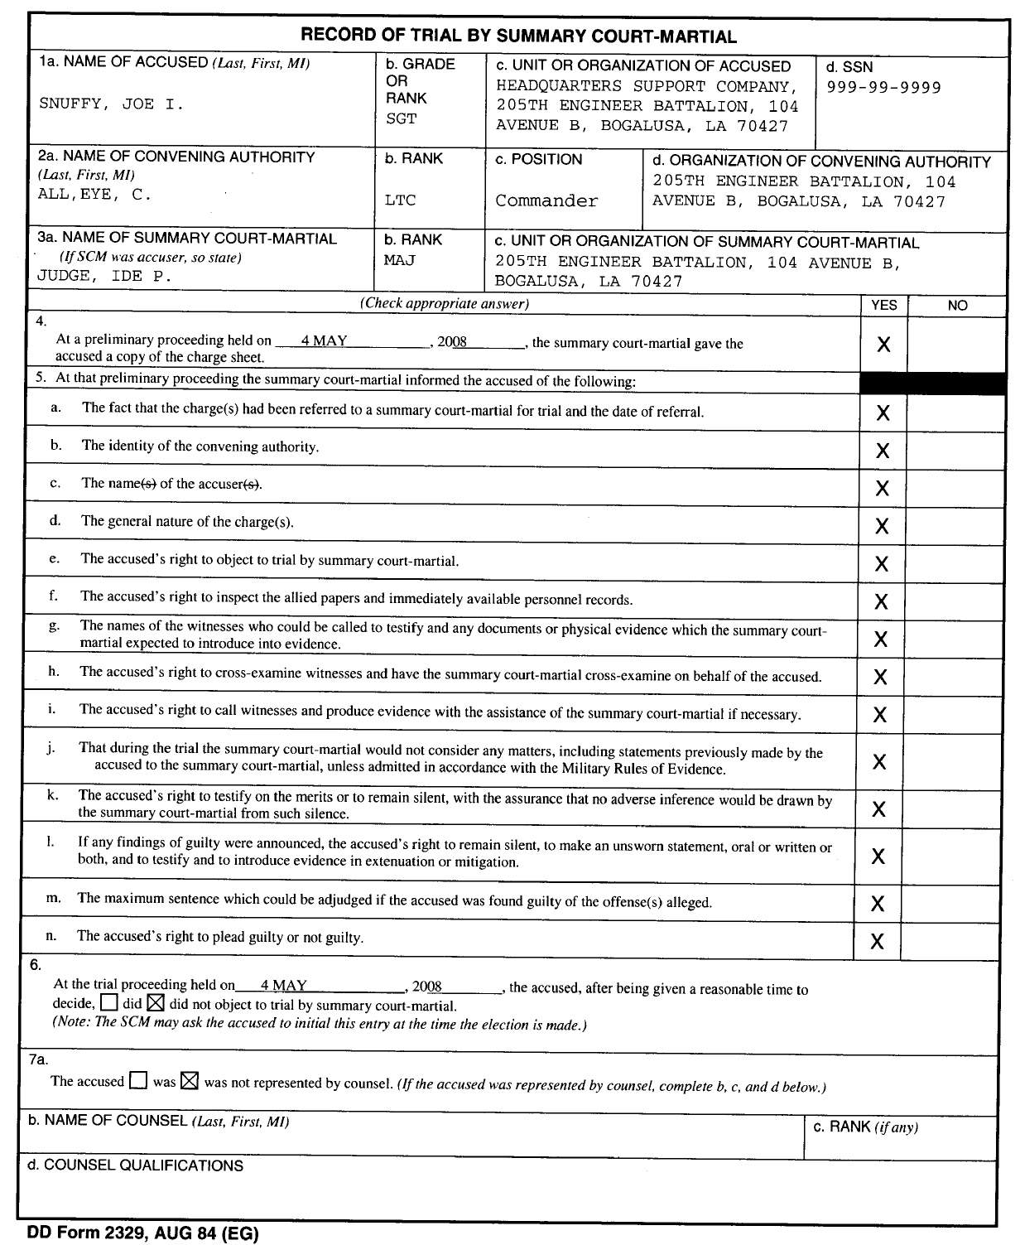

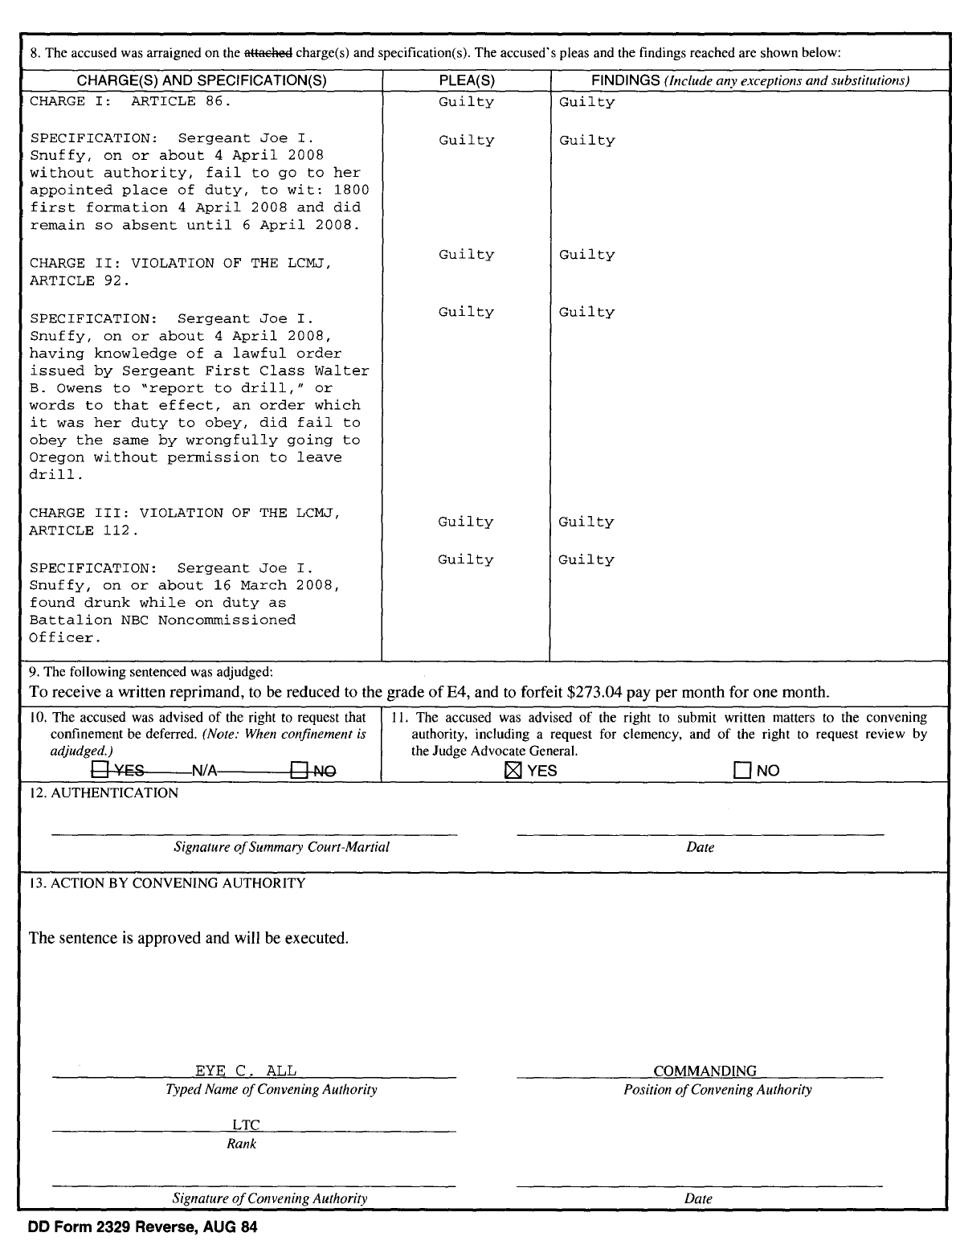

F. Report of Result of Trial (Figure 7-2)

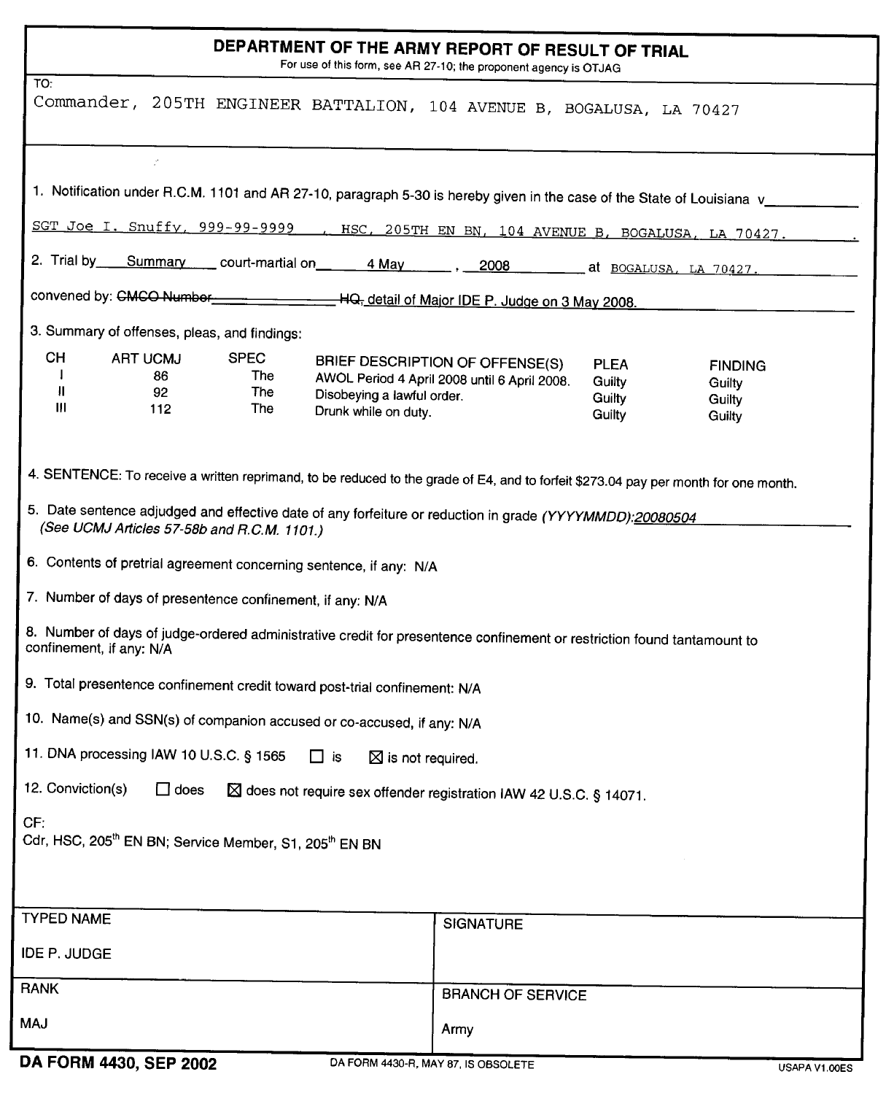

G. Order of Commitment Pursuant to Court-Martial (Figure 7-3)

DEPARTMENTS OF THE ARMY AND AIR FORCE



UNIT HEADING

UNIT ADDRESS

LANG- 4 May 2008

ORDER OF COMMITMENT PURSUANT TO COURT-MARTIAL

TO: Warden, Dabadie Correctional Facility, Camp Beauregard, Louisiana

The defendant, SGT JOE I. SNUFFY, XXX-XX-9999, HEADQUARTERS SUPPORT COMPANY, 205TH ENGINEER BATTALION, has been convicted of violating one specifications of Louisiana Code of Military Justice Article 86 (AWOL), one specification of the Louisiana Code of Military Justice Article 92, (DISOBEYING A LAWFUL ORDER), AND one specification of the Louisiana Code of Military Justice Article 112, (DRUNK WHILE ON DUTY) by a Louisiana National Guard Summary Court-Martial convened by the commander of the 205th Engineer Battalion, LTC Eye C. All.

Therefore, pursuant to Louisiana Code of Military Justice Articles 11 and 58 (La. Revised Statutes 29:111 and 158), the sentence of this Court-Martial, and the action of the convening authority in this matter:

YOU ARE DIRECTED TO COMMIT TO CONFINEMENT FORTHWITH THE ABOVE-NAMED MEMBER OF THE LOUISIANA NATIONAL GUARD AND TO KEEP SAID PERSON IN YOUR CUSTODY FOR THE FOLLOWING PERIODS OF COMMITMENT:

23 May 2008 through no later than 0800 on 30 May 2008

While committed, the said individual shall be subject to the same discipline and treatment as other persons so confined and/or committed under the laws of the State of Louisiana.

When the above-named individual has been released, you are requested to notify the following representative of the Louisiana National Guard:

SFC Readiness NCO (985) 999-9999

By authority of the Governor of the State of Louisiana, I affix my official signature, this 4th day of February, 2008.

EYE C. ALL

LTC, EN, LANG

Commanding

H. Promulgating Order (Figure 7-4)

[UNIT HEADING]

LANG-SJA DATE

SPECIAL COURT-MARTIAL ORDER NUMBER 08-01

Private (E2) John Doe, 000-00-0000, Company A, 199th Support Battalion, 256th Infantry Brigade (M), Lafayette, Louisiana, was arraigned at Fort Polk, LA, on the following offenses at a special court-martial convened by the Commanding General, 256th Inf. Bde.

Charge I. Article 86. Plea: Guilty Finding: Guilty

Specification 1: Unauthorized absence from unit from 25 June 1993 to 27 June 1993. Plea: Guilty. Finding: Guilty

Specification 2: Failure to repair on 24 June 1993. Plea: None entered. Dismissed on motion of defense for failure to state an offense.

Charge II. Article 91. Plea: Not Guilty. Finding: Not Guilty.

Specification: Disrespect to superior noncommissioned officer on 24 June 1993 by saying to him, "Stick it in your ear." Plea: Not Guilty. Finding: Guilty.

Charge III. Article 112a. Plea: Guilty. Finding: Guilty

Specification 1: Wrongful possession of 150 grams of marijuana on 24 June 1993. Plea: Guilty. Finding: Guilty

Specification 2: Wrongful use of marijuana while on duty as a sentinel on 23 June 1993. Plea: Guilty. Finding: Guilty.

SENTENCE

Sentence was adjudged on 8 July 1993. A fine of $100.00, forfeiture of all pay and allowances, Dishonorable discharge, reduction to the lowest enlisted grade, and confinement of 6 months.

ACTION

The sentence is approved and will be executed.

[SIGNATURE BLOCK]

I. Conditions of Suspension of Sentence (Figure 7-5)

UNIT HEADING]

LANG-XXX DATE

FROM: (Individual Concerned,

Name, Grade, Organization)_____________________________________

TO: (Convening Authority,

Court-Martial No.______________________________________________

I hereby accept suspension of any sentence imposed against me in the subject court-martial. I have had advice and assistance of my Defense Counsel in preparing this Request. I hereby agree to abide by the following terms and conditions of suspension:

I will at all times keep my military unit advised of my home and work address(es) and telephone number(s).

I will accept and receipt for all mail sent to me by the military.

I will pay any fine imposed against me by this court-martial which has been approved, within a period of ten (10) days from approval thereof, unless such period of time is extended by the convening authority.

I will commit no violation of the Louisiana Code of Military Justice during the period of suspension.

I specifically agree to satisfactorily attend and participate in all military duty to which I am ordered and I agree and understand that it is my responsibility to inform myself of and comply with all duty dates, times, places, proper uniform, and standards of appearance and conduct.

I understand that my failure to fulfill any of the above conditions can result in vacation of my suspension and imposition of the sentence imposed.

Signature blocks for Accused and Defense Counsel (with dates)

Home/Work address/phone for Accused

"Received and Filed" Signature for Military Judge

and convening authority representative (with dates)

J. Notification Regarding Vacation of Suspension (Figure 7-6)

[UNIT HEADING]

TO: _________________, Accused

FROM: _______________, Convening Authority

SUBJECT: Court-Martial [or Article 15] Number _________

On ________, I [or my predecessor in office] suspended execution on that portion of the sentence of the subject court-martial [Article 15] that called for you to___________________________________________________________________________

______________________________________________________________________________________________________

In doing so, certain conditions of suspension were imposed on you. I have received information that you may have violated the following terms of your suspension:

_____ To keep your unit commander advised of your home and work address(es) and home and work phone number(s) at all times.

_____ To accept and receipt for all mail sent to you by the military.

_____ To pay the fine imposed against you.

_____ To commit no violation of the LCMJ.

Specifically, I have been told that you

__________________________________________________________________________________________________________________________________________________________________________________________________________________________________________________________________________________________________________________

You are required to reply in writing to me concerning this matter. Your written response must be received at this headquarters no later than _____ hours on ________________.

You may, in lieu of a response to the allegations, request a reasonable amount of additional time to consult with defense counsel prior to responding to the allegations. Your response to the allegations will then be required at the expiration of that additional time, if additional time is granted.

In the event this or any other response required of you is not received by the time set, I will act on this matter without further notice to you.

[SIGNATURE BLOCK]

CF: Servicing SJA

Trial Counsel

Defense Counsel

K. SJA’s Review for Legal Sufficiency (Figure 7-7)

[UNIT HEADING]

LANG-EN-SJA 1 July 2008

MEMORANDUM FOR: Commander, 225th Engineer Brigade

SUBJECT: Legal Sufficiency Review of Special Court-martial, SPC JOHN DOE, XXX-XX-XXXX

STATEMENT OF FACTS: SPC John Doe was accused of unlawfully wearing the Purple Heart Ribbon.

STATEMENT OF LAW: SPC John Doe was charged under Article 134, Louisiana Code of Military Justice. The elements are that the accused wore certain insignia on his uniform, the accused was not authorized to wear the insignia on his uniform, the wearing was wrongful, and the conduct of the accused was prejudice of the good order and discipline of the armed forces or brought discredit to the armed forces.

STATEMENT RELATING LAW TO FACTS: SPC John Doe admitted, under oath, that he wore the insignia without authorization in violation of the Louisiana Code of Military Justice Article 134.

RECOMMENDATION: The convening authority approve the findings and sentence as adjudged.

POC is the undersigned at (225) 555-1212.

JOHN B. DUNLAP, III

COL, JA, LANG

State Judge Advocate

AUTHORITY NOTE: Promulgated in accordance with R.S. 29:11(F).

HISTORICAL NOTE: Promulgated in accordance with the Office of the Governor, State Military Department, LR 35:2409 (November 2009).

Chapter 8. Reserved.

Chapter 9. Complaints Under Article 138, LCMJ

§901. General

A. Purpose. This chapter establishes procedures for the preparation, submission, and disposition of complaints made pursuant to Article 138, LCMJ by a member of the Louisiana National Guard against a commanding officer.

B. Applicability. This chapter applies to all members of the Louisiana National Guard as defined in LCMJ Article 1.

C. Resolution of Complaints. LANG policy is to resolve complaints at the lowest level of command and to provide adequate administrative procedures for such resolution. Article 138, LCMJ, is one of several methods available. It provides for consideration at three successive levels. The first attempt to resolve a perceived wrong must be between the servicemember and the commanding officer whom the servicemember believes committed the wrong. If conventional measures are unsuccessful, the servicemember may submit a request for redress under Article 138. Every reasonable measure should be taken to resolve complaints at this lowest level. The principal responsibility for acting on Article 138 complaints lies with the Adjutant General (TAG).

D. Right to Complain. A member of the Louisiana National Guard has a statutory right to submit an Article 138 complaint. Commanders will not restrict the submission of such complaints or retaliate against a member for submitting a complaint.

E. Complaint to be Forwarded. Every complaint will be expeditiously forwarded to the the Adjutant General unless voluntarily withdrawn by the complainant.

F. Complainant Not a Participant. A servicemember who submits an Article 138 complaint does not have a right to participate in any ensuing procedures under this regulation. However, the servicemember may be asked to testify, provide additional information, or otherwise assist in resolving the complaint.

G. Presumption of Regularity. If the available evidence does not establish the validity of a complaint, despite vigorous, good faith investigative efforts to do so, a commanding officer is presumed to have acted properly.

H. Processing Complaints Through Command Channels. Complaints are processed in the chain of command. Area jurisdiction and attachments and assignments for LCMJ or other administrative purposes do not affect the processing of Article 138 complaints. When forwarding a complaint to the Adjutant General, intermediate commanders may deviate from strict adherence to command channels if such deviation will facilitate action on the complaint. However, no commander who has a direct interest in the complaint will be bypassed.

AUTHORITY NOTE: Promulgated in accordance with R.S. 29:11(F).

HISTORICAL NOTE: Promulgated in accordance with the Office of the Governor, State Military Department, LR 35:2416 (November 2009).

§902. Explanation of Terms

A. The terms, "complainant," "complaint," "request for redress," "respondent," "superior commissioned officer," and "wrong" are explained in the Glossary.

AUTHORITY NOTE: Promulgated in accordance with R.S. 29:11(F).

HISTORICAL NOTE: Promulgated in accordance with the Office of the Governor, State Military Department, LR 35:2416 (November 2009).

§903. Inappropriate Subject Matter for Article 138

A. General. The procedures prescribed in this chapter are intended to ensure that an adequate official channel for redress is available to every servicemember who believes the servicemember's commanding officer has wronged the servicemember. For many adverse actions, however, there are other, more specific channels and procedures to ensure the servicemember has an adequate opportunity and forum to be heard. Those specific procedures usually are more effective and efficient for resolving such matters, and Article 138 procedures should neither substitute for nor duplicate them. Generally, an action is an inappropriate subject for resolution under Article 138 procedures when:

1. review is specifically provided by the LCMJ or the action is otherwise reviewable by a court authorized by the LCMJ or by a military judge or military magistrate;

2. it is taken pursuant to the recommendation of a board authorized by LANG regulation at which the complainant was substantially afforded the rights or a respondent [See Chapter 5, AR 15-6.];

3. LANG regulations specifically authorize an administrative appeal;

4. it is a commander's recommendation or initiation of an action included in, or above.

B. Examples. Examples of actions for which Article 138 is inappropriate include:

1. matters relating to court-martial, non-judicial punishment, confinement, and similar actions taken pursuant to the LCMJ, the MCM, or military criminal law regulations;

2. officer or enlisted elimination actions [AR 635-100; AR 635-200.];

3. MOS reclassification board actions [AR 635-200.];

4. withdrawals of flying status [AR 600-107;

5. appeals from findings of pecuniary or financial liability [See AR 37-103, AR 735-5 for examples.];

6. appeals from administrative reductions in enlisted grades [AR 600-200.];

7. appeals from officer evaluation reports [AR 623-105] or enlisted evaluation reports [AR 600-205.];

8. filing of adverse information (e.g. administrative reprimand) in official personnel records [AR 600-37.].

C. Referral to Alternate Channels. When TAG receives an Article 138 complaint apparently involving an adverse action for which more specific channels and appropriate procedures are available, the officer will act on it as prescribed by regulation. [See AR 27-10, paragraph 20-11.] A decision to leave the matter to be processed in those alternate channels and to so advise the complainant constitutes "proper measures for redressing the wrong complained of" within the meaning of Article 138.

AUTHORITY NOTE: Promulgated in accordance with R.S. 29:11(F).

HISTORICAL NOTE: Promulgated in accordance with the Office of the Governor, State Military Department, LR 35:2417 (November 2009).

§904. Making a Complaint

A. Complainant's Request for Redress. Before submitting a complaint under Article 138, a member of the Louisiana National Guard must make a written request for redress of the wrong to the commanding officer the member believes has wronged the member. The request for redress.

1. Generally should be prepared in the format shown in Figure 9-1.

2. Must clearly identify the commanding officer against whom it is made, the date and nature of the alleged wrong and, if possible, the specific redress desired.

3. Will be submitted through command channels to the commanding officer who is alleged to have committed the wrong.

C. Response by the Commanding Officer. A commanding officer receiving a request for redress submitted under this regulation will respond, in writing, within 60 days from receipt. If a final response within 60 days is not possible, an interim response will be provided that indicates the estimated date of a final response.

AUTHORITY NOTE: Promulgated in accordance with R.S. 29:11(F).

HISTORICAL NOTE: Promulgated in accordance with the Office of the Governor, State Military Department, LR 35:2417 (November 2009).

§905. Complaint

A. General. A member of the Louisiana National Guard may submit an Article 138 complaint for any act or omission by the member's commanding officer which the member believes to be a wrong and for which the member has requested redress and been refused. A member who, through no fault of the member's own, has not received a final or interim response within 60 days may elect to treat that fact as a refusal of his request for redress.

B. Form of Complaint. Figure 9-1 contains sample format for Article 138 complaints. The complaint should:

1. be typed or legibly written and signed by the complainant.

2. identify the complainant as a member of the Louisiana National Guard subject to the LCMJ;

3. identify the complainant's current military organization and address;

4. identify the complainant's military organization at the time of the alleged wrong;

5. identify the commanding officer whose act or omission is complained of;

6. indicate the date a written request for redress was submitted to that commanding officer and either that:

a. the request was refused, in whose or in part, and the date thereof; or

b. a final interim or response was not received within 60 days;

7. include a statement that it is a complaint submitted under the provisions of Article 138 and this regulation;

8. clearly and concisely describe the specific wrong complained of. When not readily apparent, state the reason the complainant considers it a wrong;

9. state the specific redress the complainant seeks. Unless it is readily apparent, state the reason the complainant considers that redress appropriate;

10. Have attached to it:

a. the complainant's request to the complainant's commanding officer for redress and the commanding officer's response, if any;

b. any supporting information or documents the complainant desires to be considered.

C. Timeframe for Submitting Complaint. The complainant will deliver the complaint to his immediate superior commissioned officer within 90 days of the date of the complainant's discovery of the wrong, excluding any period during which the request for redress was in the hands of the respondent. If the complainant corrects and resubmits the complaint after TAG has returned it as deficient, the days the complaint was in military channels between submission by and return to the complainant will also be excluded in computing the 90-day period.

D. Withdrawal. The complainant may withdraw the complaint at any time before final action is taken by TAG. If a complaint is withdrawn, it must be a completely voluntary act on the part of the complainant. Prior to receipt by the TAG, the complaint may be withdrawn by an oral request of the complainant. After receipt by the TAG, the complainant must submit a written request to the officer in possession of the complaint.

AUTHORITY NOTE: Promulgated in accordance with R.S. 29:11(F).

HISTORICAL NOTE: Promulgated in accordance with the Office of the Governor, State Military Department, LR 35:2417 (November 2009).

§906. Legal Advice

A. Complainant. A member who desires to submit an Article 138 complaint may:

1. a member who desires to submit an Article 138 complaint may consult a Judge Advocate assigned to member of LANG TDS for advice and assistance in drafting the complaint. The member also should be advised of any other laws or regulations under which he may proceed to seek redress. In connection with Article 138 complaints, LANG TDS will be provided only for such consultation and advice, but not to represent the member in any ensuing Article 138 proceedings;

2. consult or retain other legal counsel at no expense to the Government. Such counsel may attend any proceedings under this regulation which are open to other members of the public, but may not participate in them.

B. Respondent. A commanding officer who receives a request for redress or against whom an Article 138 complaint is submitted may obtain necessary legal advice from the commanding officer's servicing Judge Advocate.

C. TAG. The TAG shall obtain a review for legal sufficiency from the State Judge Advocate prior to notifying the complainant of action taken on the complaint.

AUTHORITY NOTE: Promulgated in accordance with R.S. 29:11(F).

HISTORICAL NOTE: Promulgated in accordance with the Office of the Governor, State Military Department, LR 35:2418 (November 2009).

§907. Action by Person Receiving the Complaint

A. A superior commissioned officer who receives an Article 138 complaint will promptly forward it to the Adjutant General. The person receiving the complaint, or through whom it is forwarded, may add pertinent material to the file or grant any redress within that person's authority. If either action is taken it will be noted in the transmittal.

AUTHORITY NOTE: Promulgated in accordance with R.S. 29:11(F).

HISTORICAL NOTE: Promulgated in accordance with the Office of the Governor, State Military Department, LR 35:2418 (November 2009).

§908. Determination Not Required by The Adjutant General

A. Deficient Complaint. If a complaint does not substantially meet the requirements of Article 138, as implemented by this Chapter, no determination as to the merits of the complaint is required. Unless the deficiency is waived [See b. below], such a complaint will be returned to the complainant with a written explanation of the deficiency and, if correctable, how it may be corrected. Neither the deficient complaint nor the TAG's action on the complaint should be forwarded to the Governor.

B. Waivable Deficiencies. The TAG may waive the following deficiencies when he considers it necessary in the interest of fairness, based upon good cause, and appropriately so noted in the correspondence forwarding the complaint.

1. The complaint was not delivered to the complainant's superior commissioned officer within 90 days of the date of discovery of the wrong.

2. Redress has not been requested and refused.

3. The complaint is repetitive in that it is substantially the same as a previous complaint by the same complainant on which official action has already been taken.

C. Nonwaivable Deficiencies. The following deficiencies may not be waived by the TAG:

1. The complainant was not a member of the Louisiana National Guard and subject to the LCMJ when the complaint was delivered to his superior commissioned officer.

2. The wrong complained of was not a discretionary act or omission, or it was not by the complainant's commanding officer, or it was not under color of Federal or State military authority, or it did not adversely affect the complainant personally.

3. The complaint does not adequately identify a respondent or the wrong complained of.

AUTHORITY NOTE: Promulgated in accordance with R.S. 29:11(F).

HISTORICAL NOTE: Promulgated in accordance with the Office of the Governor, State Military Department, LR 35:2418 (November 2009).

§909. Withdrawal of Complaint

A. Once a voluntary request for withdrawal has been received, no further action will be taken under this Chapter. This does not preclude other appropriate action to resolve any matters raised by the complaint.

AUTHORITY NOTE: Promulgated in accordance with R.S. 29:11(F).

HISTORICAL NOTE: Promulgated in accordance with the Office of the Governor, State Military Department, LR 35:2418 (November 2009).

§910. Determination Required by the Adjutant General

A. Except where the TAG's determination is not required on the Article 138 complaint under the preceding paragraphs, the TAG will take the following actions.

1. Examination into the Complaint. The TAG will examine into the complaint. Except as provided below, the nature and method of the examination is discretionary. The examination may be delegated, but not to a person subordinate to the respondent in the chain of command nor, except for good cause explained in the correspondence forwarding the complaint, to a person junior in rank to the respondent. Examinations so delegated will be conducted in accordance with AR 15-6 and will include a specific recommendation regarding the appropriateness of the redress requested and of any other corrective action.

2. Nature and Extent of Examination. Unless the TAG believes that established channels for redressing the alleged wrong would be inadequate in the particular case, the examination will be limited to determining whether the other channels are, in fact, available for resolving the alleged wrong. Specific findings will be made as to whether the act or omission complained of was:

a. in violation of law or regulation;

b. beyond the legitimate authority of the respondent;

c. arbitrary, capricious, or an abuse of discretion;

d. materially unfair.

3. Action on the Complaint. The TAG must act personally on the Article 138 complaint. This authority may not be delegated. After examination into the complaint is completed, TAG will take the first of the following actions which applies to the particular complaint:

a. If the alleged wrong is of an inappropriate subject matter for an Article 138 complaint [See paragraph 9-3], unless the TAG believes that established channels for redressing the alleged wrong would be inadequate in the particular case, such commanding officer will advise the complainant that:

i. the alleged wrong already is being considered in other official channels, if that is the case; or

ii. a more appropriate official channel is available to redress the alleged wrong. TAG will specify that channel, any applicable regulation under which the complainant may proceed, and any DA or DAF assistance available to the complainant in using that channel.

iii. determine the merits of the complaint and of the redress requested. If no redress is appropriate, the TAG will deny the redress. The TAG will grant whatever redress is appropriate and is within such his authority to provide.

b. TAG will notify the complainant in writing of the action taken on the complaint.

4. Action by TAG. Before final disposition by TAG, each Article 138 file will be reviewed by the State Judge Advocate (or that officer's designee) for legal sufficiency. The SJA may, in that officer's discretion, return the file for additional information or investigation or for other action.

AUTHORITY NOTE: Promulgated in accordance with R.S. 29:11(F).

HISTORICAL NOTE: Promulgated in accordance with the Office of the Governor, State Military Department, LR 35:2418 (November 2009).

§911. Forwarding Complaint to Governor

A. Upon completion of action on the complaint, TAG will forward a summary of the complaint and the action taken to the Governor, as required by LCMJ Article 138.

B. Complaint (Figure 9-1)

[UNIT HEADING]

LANG-xxx Date

MEMORANDUM FOR Commander, HHC, 199th Support Battalion, 5500

Coliseum Blvd, Alexandria, LA 71303-3707

SUBJECT: Request for Redress (LCMJ Article 138)

On 7 July, 1992 you announced that all members of the unit were encouraged, but not required to join in a work project on the following day, 8 July, 1992, which a domestic action activity was involving cleaning public areas in Leesville, LA. As I had previously made plans for that day, I elected not to participate. Thereafter, you turned down my request for special leave to participate in my cousin's wedding scheduled for 14 July, 1992.

I think your refusal to approve my leave is unreasonable and is in retaliation for my absence from the voluntary domestic action program described above. I consider this a wrong within the meaning of Article 138, LCMJ and LAARNG Reg 27-10, Chapter 11.

As redress, I request approval of my leave request.

JOHN Q. SERVICEMEMBER

SGT, HHC

199th Support Battalion

AUTHORITY NOTE: Promulgated in accordance with R.S. 29:11(F).

HISTORICAL NOTE: Promulgated in accordance with the Office of the Governor, State Military Department, LR 35:2419 (November 2009)

.

§912. Military Justice Abbreviations

A. The following abbreviations shall apply throughout this regulation unless otherwise expressly provided.

AD—active duty

AR—Army Regulation

ARNG―Army National Guard

AT―annual training

AWOL―absent without leave

BCD―bad conduct discharge

CID―Criminal Investigation Division

DA―Department of Army, District Attorney

DAF―Department of Air Force

DD—Dishonorable Discharge

DOD—Department of Defense

DRU―direct reporting unit

ETS―expiration term of service

F & AO―(MilPay)

GCM―General Court-Martial

GCMCA―General Court-Martial Convening Authority

IO―investigating officer

JA―judge advocate

JAGC―Judge Advocate Generals' Corps

LA ANG―Louisiana Air National Guard

LAARNG―Louisiana Army National Guard

LCMJ―Louisiana Code of Military Justice (R.S. 29:101-242)

MCM—Manual for Courts-Martial, United States, as amended

M.R.E.―Military Rules of Evidence, contained within the MCM

MOS―Military Occupational Specialty

MPRJ―Military Personnel Records Jacket

MUTA―Multiple Unit Training Assembly

NCO―noncommissioned officer

NGB―National Guard Bureau

NJP―non-judicial punishment under LCMJ Article 15

OMPF―official military personnel file

OTH―other than honorable (discharge)

R.C.M.―rules for courts-martial, contained within   
the MCM

SCM―summary court-martial

SJA―the state judge advocate

SPCM―special court-martial

SPCMCA―special court-martial convening authority

TAG―the Adjutant General of the State of Louisiana

TJAG―the Judge Advocate General of the U.S. Army

UCMJ―Uniform Code of Military Justice (10 U.S. Code, Chapter 47)

U.S.C.―United States Code

AUTHORITY NOTE: Promulgated in accordance with R.S. 29:11(F).

HISTORICAL NOTE: Promulgated in accordance with the Office of the Governor, State Military Department, LR 35:2420 (November 2009).

§913. Military Justice Definitions

A. The following definitions shall apply throughout this regulation unless otherwise expressly provided.

*Abet*―to encourage, incite, or aid another to commit a crime. [LCMJ Article 77.]

*Accessory After the Fact*―any person subject to the LCMJ who, knowing that an offense punishable by the Code has been committed, receives, comforts, or assists the offender in order to hinder or prevent his apprehension, trial or punishment. [LCMJ Article 78.]

*Accused*―one who is charged with an offense under the LCMJ. Synonymous with "Defendant."

*Accuser*―any person who signs and swears to charges, any person who directs that charges nominally be signed and sworn to by another, and any other person who has an interest other than official interest in the prosecution of the accused.

*Act*―includes a failure or omission to perform a legal duty.

*Actual Knowledge*―a state wherein the person in fact knows of the existence of an order, regulation, fact, etc., in question.

*Additional Charges*―new and separate charges preferred while other preferred charges are still pending against the same accused.

*Adjutant General*―a general officer appointed by the Governor to act as the Adjutant General of the Louisiana Military Forces pursuant to R.S. 29:10. Abbreviated as TAG.

*Admission*―a self-incriminatory statement falling short of a complete acknowledgement of guilt. See also, "Confession."

*Admonition*―a warning or reminder given to an offender that a specific act is considered to be misconduct; given to deter repetition and to advise the offender of the consequences that may flow from a recurrence of that misconduct. May be oral or written, but usually oral.

*Affirmation*―see *Oath.*

*Aider and Abettor*―one who shares the criminal intent or purpose of the perpetrator, and hence is liable as a principal. [LCMJ Article 77.]

*Allegation*―the assertion, declaration, or statement of a party in a pleading of what he expects to prove.

*Allege*―to assert or state in a pleading; to plead in a specification.

*Appeal*―a complaint to a superior court of an injustice done or error committed by an inferior court whose judgment or decision the court above is called upon to correct or reverse.

*Appellant*―one who brings an appeal.

*Apprehension*―the taking of a person into temporary custody upon a reasonable belief that the person apprehended has committed an offense under the LCMJ. [See LCMJ Article 7(A) and definitions of Arrest and Detention.]

*Arraignment*―the reading of the charges and specifications to the accused or the waiver of their reading coupled with the accused's plea thereto.

*Arrest*―the moral restraint of a person by an order, not imposed as a punishment for an offense, directing him to remain within certain specified limits. [See LCMJ Article 9(A) and definitions of Apprehension and Detention.]

*Arrest in Quarters*―a moral restraint limiting an officer's liberty, imposed as a non-judicial punishment by the governor, TAG, or a designee. [See LCMJ Article 15.]

*Article 15*―see "Non-judicial Punishment."

*Article 32 Investigation*―a formal investigation that must precede the referral of any charge to a general court-martial. See LCMJ Article 32.

*Article 39(a) Session*―a session of a general or special courts-martial called by the military judge, to dispose of matters not amounting to trial of the accused. [LCMJ Article 39.]

*Assault*―an attempt or offer with unlawful force or violence to do bodily harm to another, whether or not the attempt or offer is consummated. [LCMJ Article 128.]

*Attempt*―an act, or acts, done with a specific intent to commit an offense under the LCMJ, amounting to more than mere preparation, and tending, but failing to effect the commission of such offense.

*Bad Conduct Discharge*―one of two types of punitive discharges that may be awarded an enlisted person under a GCM or SPCM, designed as a punishment for bad conduct. Also called a "BCD." [LCMJ Articles 18 and 19.]

*Battery*―an unlawful and intentional or culpably negligent application of force to the person of another by a material agency used directly or indirectly. [LCMJ Article 128.]

*Challenge*―a formal objection to a member of a court or the military judge continuing as such in subsequent proceedings. May be either a challenge for cause - objections based on a fact or circumstance which disqualifies the person challenged from further participation in the proceedings, or peremptory challenge - an objection permitted without a showing of grounds or basis, except that the military judge cannot be peremptorily challenged.

*Charge*―a formal statement of the LCMJ article(s) which the accused is charged with having violated.

*Charge and Specification*―a description in writing of the offense(s) which the accused is alleged to have committed; each specification, together with the charge under which it is placed, constitutes a separate accusation.

*Circumstantial Evidence*―evidence which tends directly to prove or disprove not a fact in issue, but a fact or circumstance from which, either alone or in connection with other facts, a court may, according to the common experience of mankind, reasonably infer the existence or nonexistence of another fact which is in the issue; sometimes called indirect evidence.

*Clear Injustice*―existence of unwaived legal or factual error which clearly and affirmatively injured the substantial rights of a Servicemember (e.g., discovery of new evidence unquestionably exculpating a convicted Servicemember). See also, "Setting Aside and Restoration."

*Command*―an organization having a commander who is regarded by superior authority as the individual chiefly responsible for maintenance of discipline therein. Includes companies and batteries, numbered units and detachments, battalions, brigades, service schools, squadrons, wings, groups, flights, and area commands. For example, an infantry company, whether or not separated or detached, is considered to be a command. An infantry platoon, however, which is part of a company and is not separate or detached, is not a command. If the platoon were located in an armory separate from the main company's armory, the platoon normally would be considered a separate, detached command. An order. Any demanding of another to do an act towards commission of a crime. [LCMJ Article 77.]

*Commander or Commanding Officer*―includes any commissioned officer who by virtue of rank and assignment exercises primary command over a military organization. Primary command authority does not include staff officers. However, for purposes of administration of military justice under LCMJ, all assistant adjutants general serving in the federally-recognized grade of brigadier general or above are considered commanding officers. For LCMJ Article 138 purposes, this includes an officer in the complainant's chain of command, up to and including the first officer exercising special court-martial jurisdiction over the complainant. A commanding officer against whom an Article 138 complaint has been lodged as referred to in this regulation is called the "respondent," (not to be confused with the identical term used in connection with administrative board proceedings under AR 15-6).

*Commissioned Officer*―an officer who holds a commission issued by the President of the United States or the Governor of the State of Louisiana.

*Common Trial*―a trial in which two or more persons are charged with the commission of an offense or offenses which, although not jointly committed, were committed at the same time and place and are provable by the same evidence.

*Complainant*―under LCMJ Article 138, a member of the Louisiana National Guard who has submitted an Article 138 complaint as referred to in Chapter 9 of this regulation. In civilian criminal law, a complainant refers to anyone who has reported a crime.

*Concurrent Jurisdiction*―jurisdiction which is possessed over the same parties or subject matter at the same time by two or more separate tribunals. [See Paragraph 5-3 regarding referral to civilian authorities.]

*Conditional Guilty Plea*―a plea of guilty that reserves in writing the right to appeal adverse determinations of pretrial motions.

*Conditions on Liberty*―a form of pretrial restraint; orders directing a person to do or refrain from doing certain acts.

*Confession*―an acknowledgement of guilt of an offense. See also, "Admission."

*Confinement*―the physical restraint of a person, imposed by either oral or written orders of competent authority, depriving him of freedom. [LCMJ Article 9(A).]

*Confinement Facility*―facility for the confinement of military prisoners. It applies to transient confinement facilities, installation confinement facilities, area confinement facilities and hospitalized prisoner wards.

*Conspiracy*―a combination of two or more persons who have agreed to accomplish, by concerted action, an unlawful purpose or some purpose not in itself unlawful but accomplished by unlawful means, and the doing of some act by one or more of the conspirators to effect the object of that agreement. [LCMJ Article 81.]

*Constructive Knowledge*―knowledge which may be found to have existed because the regulation, notice, fact or directive, etc., at issue was of so notorious a nature, or was so conspicuously posted or distributed, that the accused ought to have known of its existence; knowledge is constructive when it is shown that the accused would in the ordinary course of events, or by the exercise of ordinary care, have secured knowledge of the order, notice or movement, etc.

*Court Members*―persons designated to serve upon courts-martials for purposes of adjudication as addressed in LCMJ Article 25.

*Convening Authority*―the officer having the authority to convene a court-martial and/or his successor(s) in command.

*Convening Order*―the document by which a court-martial is created, which specifies the type of court and lists the time and place of meeting, the names of the members (if any), trial and defense counsel, the military judge, and, when appropriate, the authority by which the court is created.

*Convicted*―adjudicated guilty after a guilty plea or after trial on the merits.

*Copy*―an accurate representation, however made. When necessary and feasible, includes a copy by handwriting.

*Counseling*―actions designed to advise subordinates of their errors and specific ways to improve. Directly or indirectly advising or encouraging another to commit an offense. [LCMJ Article 77.]

*Court-Martial*―a military tribunal composed of one or more eligible members of the armed forces (the number depending on the type of court), the functions of which are to decide whether a person subject to military law has committed a violation of the LCMJ, and, if so, to adjudge an appropriate punishment therefore. Includes:

a. the military judge and members of a general court-martial;

b. the military judge when a session of a special court-martial is conducted;

c. the summary court-martial officer. [LCMJ Articles 18-20.]

*Court-Martial Orders*―either a "Convening Order" or a "Promulgating Order." See respective definitions.

*Court of Inquiry*―the most formal fact-finding body convened in the Military Department, governed by LCMJ Article 135.

*Credibility*―worthiness of belief.

*Culpable*―deserving blame.

*Custody*―that restraint of free movement which is imposed by lawful apprehension.

*Custom*―a practice which: has been long continued; is certain or uniform; is compulsory, consistent, general, and known; and is not in opposition to the terms and provisions of a statute or lawful regulation or order.

*Dangerous Weapon*―a weapon used in a manner likely to produce death or grievous bodily harm.

*Days*―when a period of time is expressed in a number of days, the period shall be in calendar days, unless otherwise specified. Unless otherwise specified, the date on which the period begins shall not count, but the date on which the period ends shall count as one day.

*Defendant*―see *Accused.*

*Defense Counsel*―a commissioned officer of the Louisiana National Guard, certified and detailed by the SJA to represent an accused at a special/general courts-martial. Such military counsel will be provided to the accused without expense. The term may also refer to "Individual Civilian Counsel" retained by an accused to defend him.

*Deferment of Confinement*―a postponement of the running and service of a sentence to confinement.

*Deposition*―the testimony of a witness taken out of court, reduced to writing, under oath or affirmation, before a person empowered to administer oaths, in answer to interrogatories (questions) and cross- interrogatories submitted by the party desiring the deposition and the opposite party, or based on oral examination by counsel for accused and the prosecution.

*Design*―specifically intended; inferred from conduct so shockingly and grossly devoid of care as to leave room for no reasonable inference but that the result was contemplated as a probable result of the course of conduct followed.

*Destroyed*―not completely demolished or annihilated, but only sufficiently injured to be useless for the purpose for which it was intended. [LCMJ Article 108.]

*Detail*―order to a person to perform a specific temporary duty.

*Detention*―the imposition of custody by competent authority, pending disposition of offense(s) for a period no longer than 24 hours. [See LCMJ Article 7(A) and 9(A) and definitions of Apprehension and Arrest.]

*Discharge*―complete severance from all military status gained by the enlistment or induction concerned.

*Dishonorable Discharge*―the most severe punitive discharge, reserved for those who should be separated under conditions of dishonor, after having been convicted of offenses usually recognized by the civil law as felonies, or of offenses of military nature requiring severe punishment.

*Dominion*―control of property; possession of property with the ability to exercise control over it.

*Dual Offense*―conduct that constitutes an offense punishable under both civilian criminal laws and the LCMJ.

*Due Process*―a course of legal proceedings according to those rules and principles which have been established in our system of jurisprudence for the enforcement and protection of private rights, such as exercise of the powers of the government as the settled maxims of law permit and sanction, and under such safeguards for the protection of individual rights as those maxims prescribe.

*Duty Status*―duty in the National Guard under an order issued by authority of law, and includes travel to and from such duty. [LCMJ Article 1.]

*Elements*―the essential ingredients of an offense; the acts or omissions which form the basis of any particular offense. Listed in the LCMJ, Annotated (Yellow Tab of Louisiana Military Justice Law Manual) Part IV of the Manual for Courts-Martial.

*Enlisted Member*―a person in an enlisted grade. LCMJ Article 1.

*Evidence*―information admissible before a court of law which tends to prove or disprove any matter in question or to influence belief respecting it.

*Exigent Circumstances*―circumstances calling for immediate action or remedy, as in imperative need to search when no time exists to obtain a search warrant. [See M.R.E.. 315(g), 316(d)(4)(B), and R.C.M. 302(e)(B).]

*Felony*―under Louisiana law, an offense punishable by death or imprisonment at hard labor [La. C.Cr.P. Article 933; See also, R.S. 14:2, and the definition of Misdemeanor.]

*Financial Liability*―personal, joint, or corporate statutory obligation to reimburse the Louisiana Military Department or the U.S. Government for Government property lost, damaged, or destroyed because of negligence or misconduct, including wrongful appropriation. [See AR 735-5.]

*Fine*―punishment that makes the accused liable to the State of Louisiana for a specified amount of money.

*Forfeiture of Pay*―punishment that deprives the accused of all or part of his future pay.

*Formal Proceedings*―non-judicial Punishment proceedings that are accompanied by the full procedural and substantive requirements of LCMJ Article 15, this Regulation, and other published guidance.

*Former Jeopardy*―the rule of law that no person shall be tried for the same offense by the same sovereign a second time without his consent. Known also as "double jeopardy." [LCMJ Article 44.]

*General Court-Martial*―a military tribunal comprised of (copy from LCMJ) whose function is to decide whether a member subject to the LCMJ has committed a violation of that Code and, if so, to adjudge punishment therefore. Also known as "GCM."

*Grade*―a step or degree, in a graduated scale of office or military rank that is established and designated as a grade by law or regulation. LCMJ Article 1.

*Inference*―a deduction based upon reason from a fact or facts proved.

*Judge Advocate*―a commissioned officer of the Judge Advocate General's Corps of the U.S. Army, Air Force, Navy, Marine Corps, or Coast Guard.

*Jurisdiction*―the power of a court to hear and decide a case and to impose any appropriate and lawful punishment.

*Knowingly*―with knowledge; consciously, intelligently.

*Lesser Included Offense*―an offense necessarily included in the offense charged; an offense containing some, but not all, of the elements of the offense charged, so that, if one or more of the elements of the offense charged is not proved, the evidence may still support a finding of guilty of the included offense.

*Magistrate*―a Judge Advocate empowered to perform judicial functions such as issuing search warrants. Also includes a U.S. Magistrate as defined in 28 U.S.C. Article 631 and following.

*Matter in Aggravation*―any circumstance attending the commission of a crime which increases its enormity.

*Matter in Extenuation*―any circumstance serving to explain the commission of the offense, including the reasons that actuated the accused, but not extending to a legal justification.

*Members*―the members of a court-martial are the voting members detained by the convening authority. As used in this regulation, "member" also may refer to a Servicemember, Servicemember, Soldier or Airman.

*Mental Responsibility*―the concept that a person is not responsible for criminal conduct if at the time of such conduct as a result of a mental disease or defect he lacks substantial capacity either to appreciate the criminality of his conduct or to conform his conduct to the requirements of law.

*Military Court*―a court-martial or court of inquiry.

*Military Judge*―a Judge Advocate who has been certified by TJAG or the SJA as qualified to preside over GCM's and/or SPCM's in accordance with LCMJ Article 26. LCMJ Article 1.

*Misdemeanor*―offense other than a felony, including ordinance violation that provides a penal sanction [La. C.Cr.P. Article 933.]

*Mistrial*―the situation existing when it becomes apparent that either party cannot receive a fair and impartial hearing before the sitting tribunal.

*Mitigation*―a reduction in either the quantity or quality of a punishment appropriate because of an accused's subsequent good conduct or disproportionateness of an original sentence.

*Motion to Dismiss*―a motion raising any defense or objection in bar or trial.

*National Guard*―the Louisiana Army and Air National Guard.

*Neglect*―omission or failure to do an act or perform a duty due to want of due care or attention.

*Negligence*―the omission to do something which a reasonable person, guided by those ordinary considerations which ordinarily regulate human affairs, would do, or the doing of something which a reasonable and prudent person would not do; the absence of due care; the legal standard that defines what would have been done by a reasonable, prudent person in the same or similar circumstances; as used in the LCMJ, the failure to exercise the care, prudence, or attention to duties which the interests of the Government require to be exercised by a prudent and reasonable person under the circumstances.

*Non-Judicial Punishment*―also known as "Article 15." Disciplinary punishment levied under LCMJ Article 15 for minor offenses, without the intervention of a court-martial. See Chapter 4.

*Oath*―a solemn declaration to testify truthfully, administered in a form calculated to awaken the conscience and impress the mind with the duty to so do. Includes "Affirmation."

*On Duty*―as used in LCMJ Article 112, the exercise of duties of routine or detain in garrison, at a station, or in the field. Does not relate to those periods when, no duty being required of them by order regulations, officers and enlisted persons occupy the status of leisure known as "off duty" or on "liberty."

*Party*―the accused and any defense or associate or assistant defense counsel and agents of the defense counsel when acting on behalf of the accused with respect to the court-martial in question. Any trial or assistant trial counsel representing the government, and any agents of the trial counsel with respect to the court-martial in question.

*Performance Fiche*―that portion of the Official Military Personnel File (OMPF) that is routinely used by career managers and selection boards for the purpose of assignment, promotion, and schooling selection. See also Restricted Fiche.

*Pleading*―the written formal indictment by which an accused is charged with an offense; in military law, the pleadings are called charges and specifications.

*Possession*―physical control over an item of property.

*Preferral*―the act of signing and swearing to court-martial charges.

*Presumption*―a justifiable inference; a well-recognized example of the use of circumstantial evidence, the weight or effect of which should be measured only in terms of its logical value.

*Principal*―one who aids, abets, counsels, commands, or procures another to commit an offense which is subsequently perpetrated in consequence of such counsel, command or procuring, whether he is present or absent at the commission of the offense; The perpetrator of an offense. [LCMJ Article 78.]

*Private Dwelling*―a servicemember's dwelling, on or off military premises, such as a single family house or apartment. The quarters may be owned, leased, rented by the servicemember, or assigned, and may be occupies on a temporary or permanent basis. It does not include living areas in military barracks, aircraft, vehicles, tents, bunkers, field encampments, and similar places, whether or not subdivided into individual units.

*Probable Cause*―prerequisite for a valid search and seizure or arrest. It consists of reliable facts indicating to a reasonable person the probability that a crime has been committed and the person in question committed it or that evidence of a crime is located in the place to be searched.

*Procedural Law*―the rules of pleading and practice by which rights are accorded and enforced.

*Promulgating Orders*―an order issued by the Convening Authority publishing the result of a court-martial and the convening authority's action and any later action taken of the case. Not required for Summary Courts-Martial.

*Punitive Articles*―LCMJ Articles 77 through 134, which generally tract the corresponding UCMJ Articles and state how they may define the conduct made criminal.

*Punitive Discharge*―a Bad Conduct Discharge (BCD) or a Dishonorable Discharge (DD) from military service.

*Rank*―the order of precedence among members of the Louisiana National Guard. LCMJ Article 1.

*Redress*―under LCMJ Article 138, authorized action by any officer in the complainant's chain of command to effect the revocation of a previous official action or otherwise to restore to the complainant any rights, privileges, property, or status lost as a result of a wrong.

*Referral of Charges*―the order of a convening authority that charges against an accused will be tried by a specified court-martial.

*Remission*―the cancellation of any portion of the unexecuted punishment.

*Reprimand*―an act of formal censure that reproves or rebukes an offender for misconduct; a reproof, rebuke, censure, strong criticism, or "chewing out" for failing to comply with the established standard. May be oral or written, but usually written.

*Request for Redress*―under LCMJ Article 138, the complainant's written request directed to the commanding officer whom he believes has committed the wrong. See Paragraph 9-4.

*Respondent*―the one against whom an Administrative Discharge Board action has been initiated. Under LCMJ Article 138, a commanding officer against whom an Article 138 complaint has been made.

*Restricted Fiche*―that portion of the Official Military Personnel File (OMPF) that contains information not normally viewed by career managers or selection boards except as provided in AR 640-10 or specified in the Secretary of Army's written instructions to the selection board. See also Performance Fiche.

*Restriction in Lieu of Arrest*―moral restraint, less severe than arrest, imposed upon a person by oral or written orders, limiting him or her to specified areas of a military command, with the further provision that he or she will participate in all military duties and activities of the organization while under such restriction.

*Revision*―a procedure to correct an apparent error or omission or improper or inconsistent action of a court-martial with respect to a finding or a sentence.

*Self-Incrimination*―the giving of evidence against oneself which tends to establish guilt of an offense.

*Separation*―an all-inclusive term applied to personnel actions resulting from release from active duty, discharge, retirement, dropped from the rolls, release from military control or personnel without a military status or death.

*Setting Aside and Restoration*―action in which the punishment or any part or amount, whether executed or unexecuted, is set aside and any rights, privileges, or property affected by the portion of the punishment set aside are restored based on finding of "clear injustice."

*Special Court-Martial*―a military tribunal comprised of (copy from LCMJ) whose function is to decide whether a member subject to the LCMJ has committed a violation of that Code and, if so, to adjudge punishment therefore. Also known as "SPCM."

*Specification*―a formal statement of specific acts and circumstances relied upon as constituting the offense charged. See also, Charge.

*State*―the State of Louisiana. LCMJ Article 1(13).

*State Judge Advocate*―the Judge Advocate responsible for supervising the administration of military justice in the Louisiana National Guard, and designated as the principal legal advisor to TAG. Also known as "SJA."

*State Military Forces*―the National Guard of the State, as defined in 32 U.S.C. Section 101 , , and any other military forces organized under the laws of the state, when not in a status subjecting them to jurisdiction under Chapter 47 of Title 10, U.S.C. (LCMJ Article 1).

*Statute of Limitations*―the rule of law which establishes the time within which an accused must be charged with an offense. Synonymous with Prescription.

*Substantive Law*―that portion of the body of law which contains rights and duties and regulations of the government, as distinguished from Procedural Law, which is that part containing the rules and remedies by which the substantive law is administered.

*Superior Commissioned Officer*―a commissioned officer superior in rank or command. [LCMJ Article 1.] Under LCMJ Article 138, a commissioned officer in the complainant's current chain of command that is senior to the complainant in grade, rank, or position. [See paragraph 9-5.]

*Supplementary Action*―in Non-judicial Punishment proceedings, any action taken by an appropriate authority to suspend, vacate, mitigate, remit, or set aside a punishment (except punishment imposed under summarized proceedings after action has been taken on an appeal or DA Form 2627 has been distributed.

*Suspension*―to hold a punishment in abeyance and not put it into effect for a specified period of time, resulting in a probationary period during which time the Servicemember may demonstrate his good conduct and efficiency.

*Trial on the Merits*―trial on the issue of guilt or innocence.

*Usage*―a general habit, mode, or course of procedure.

*Unlawful Command Influence*―improper attempts by the convening authority to affect the outcome of a court-martial. Each commander is vested by law with the authority and sole discretion to take - or decline to take - action under the LCMJ in cases arising in his command, unless a superior commander has restricted or withheld the authority to act. Any unauthorized interference by superior authority with the free and independent exercise of this power is called "unlawful command influence" and is itself punishable under the Code.

*Vacation of Suspension*―termination of a period of probation under a suspended sentence so that a Servicemember's original punishment may be effectuated.

*Willful*―deliberate, voluntary, and intentional, as distinguished from acts committed through inadvertence, accident, or ordinary negligence.

*Wrong*―under LCMJ Article 138, a discretionary act or omission by a commanding officer, under color of Federal or State military authority, which adversely affects the complainant personally and which is:

a. in violation of law or regulation;

b. beyond the legitimate authority of that commanding officer;

c. arbitrary, capricious, or an abuse of discretion; or

d. materially unfair.

*Wrongful*―contrary to law, regulation, lawful order or custom.

AUTHORITY NOTE: Promulgated in accordance with R.S. 29:11(F).

HISTORICAL NOTE: Promulgated in accordance with the Office of the Governor, State Military Department, LR 35:2420 (November 2009).

§914. Nonjudicial Punishment Guide—Appendix

[General Note to Commander: This guide is designed to ensure that the proceedings comply with all legal requirements. It contemplates a three-step process, conducted in the presence of the member, consisting of notification, hearing (that may be omitted if the member admits guilt), and imposition of punishment (if the findings result in a determination of guilt). It is not the purpose of this guide to answer all questions which may arise during an Article 15 proceedings. When this guide, Chapter 5 of the LAARNG Regulation 27-10/LA ANG Regulation 111-1, Chapter 3 of AR 27-10, and other legal materials available fail to provide sufficient information concerning law or procedure, the administering Commander should seek advice on these matters from a judge advocate. The SCM should examine the format for record of trial located at Figures 7-1 and 7-2 of LAARNG Regulation 27-10/LA ANG Regulation 11It may be useful as a checklist during the proceedings to ensure proper preparation after trial. The Commander should become familiar with this guide before using it. Instructions for the Commander are contained in brackets, and should not be read aloud. Language in parentheses reflects optional or alternative language. The Commander should read the appropriate language aloud].

Section 1 - Notification

[If the notification of punishment is to be accomplished by other than the imposing commander, the procedures under this provision should be appropriately modified (see note 10d, below)].

CO: As your commander, I have disciplinary powers under Article 15 of the LCMJ. I have received a report that you violated the Louisiana Code, and I am now considering imposing nonjudicial punishment. This is not a formal trial like a court-martial. As a record of these proceedings I will use DA Form 2627. I now hand you this form. Read items 1 and 2. Item 1 states the offense(s) you are reported to have committed and item 2 lists the rights you have in these proceedings. Under the provisions of Article 31 of the LCMJ, you are not required to make any statement or provide any information concerning the alleged offense(s). If you do, it may be used against you in these proceedings or in a trial by court-martial. You have the right to consult with a lawyer as stated in item 2.

[Note 1. Wait for the member to read items 1 and 2 of DA Form 2627. Allow him or her to retain copy five of the form until the proceedings are finished and you have either imposed punishment or decided not to impose it].

CO: Do you understand item 1? Do you understand the offense(s) you are reported to have committed?

Member: (Yes) (No)

[Note 2. If the member does not understand the offense(s), explain the offense(s) to him. Reference may be made to the LCMJ and to Part IV of the Manual for Courts-Martial, United States, and Annotated which contains an explanation of each of the punitive articles together with the essential factual elements necessary to constitute the offense].

CO: Do you understand item 2? Do you have any questions about your rights in these proceedings?

Member: (Yes) (No)

[Note 3. If the member does not understand his or her rights, explain them in greater detail. If the member asks a question you cannot answer, recess the proceedings. You can probably find the answer in one of the following sources:

Article 15, LCMJ; Paragraph 3-4 of LAARNG Reg 27-10/LA ANG Reg 111-1;

Part V, MCM. If you cannot find the answer in one of those sources, contact your servicing Staff Judge Advocate Office.].

CO: There are some decisions you have to make: You have to decide whether you want to demand trial by court-martial. If you demand a court-martial these proceedings will stop. I would then have to decide whether to initiate court-martial proceedings against you. If you were to be tried by court-martial for the offense(s) alleged against you, you could be tried by summary court-martial, special court-martial, or general court-martial. If you were to be tried by special or general court-martial, you would be able to be represented by a military lawyer appointed at no expense to you or by a civilian lawyer of your choosing at no expense to the government.

If you do not demand trial by court-martial, you must then decide whether you want to present witnesses or submit other evidence in "defense," "extenuation," and/or "mitigation." Your decision not to demand trial by court-martial will not be considered as an admission that you committed the offense(s); you can still submit evidence in your behalf.

Evidence in "defense" are facts showing that you did not commit the offense(s) stated in item 1. Even if you cannot present any evidence in "defense," you can still present evidence in "extenuation" or "mitigation."

Evidence in "extenuation" are circumstances surrounding the offense, showing that the offense was not very serious.

Evidence in "mitigation" are facts about you, showing that you are a good Servicemember and that you deserve light punishment.

You can make a statement and request to have a spokesperson appear with you and speak on your behalf. I will interview any available witnesses and consider any evidence you think I should examine.

Finally, you must decide whether you wish to request that the proceedings be open to the public. Do you understand the decisions you have to make?

Member: (Yes) (No)

CO: If you do not demand trial by court-martial and after you have presented your evidence, I am convinced that you committed the offense, I could then punish you. The maximum punishment I could impose on you under Article 15 would be as follows:

[Note 4. Maximum punishments under LCMJ Article 15 varies depending on the level of command imposing punishment and the rank of the member being punished. A ready reference maximum punishments chart is located in LAARNG Reg 27-10/LAANG Reg 11Explain to the member each punishment which could be imposed in his individual case. It is not necessary for you to read the following statute, however, understand that LCMJ Article 15 authorizes the imposition of any one or more of the following punishments:

Upon officers in his command:

Restriction to certain specified limits, with or without suspension from duty, for not more than fifteen consecutive days;

A fine of not more than one hundred dollars ($100.00);

If imposed by the governor, the adjutant general, or an officer of a general or flag rank in command;

Arrest in quarters for not more than fifteen consecutive days;

Forfeiture of pay of not more than one hundred dollars ($100.00);

Upon other military personnel of his command:

Forfeiture of pay of not more than fifty dollars ($50.00);

Reduction to the next inferior pay grade, if the grade from which demoted is within the promotion authority of the officer imposing the reduction or any officer subordinate to the one who imposes the reduction;

Extra duties, including fatigue or other duties, for not more than fourteen (14) consecutive days;

Restriction to certain specified limits, with or without suspension from duty, for not more than fourteen (14) consecutive days;

If imposed by an officer of the grade of major or lieutenant commander, or above (otherwise known as a "Field Grade Article 15"):

Forfeiture of pay of not more than one hundred dollars ($100.00);

Reduction to the lowest or any intermediate pay grade, if the grade from which demoted is within the promotion authority of the officer imposing the reduction or any officer subordinate to the one who imposes the reduction, but an enlisted member in a pay grade above E-4 may not be reduced more than two pay grades;

Extra duties, including fatigue or other duties, for not more than fourteen (14) consecutive days;

Restriction to certain specified limits, with or without suspension from duty, for not more than fourteen (14) consecutive days;

A fine of not more than twenty-five dollars ($25.00)]."

CO: You should compare this punishment with the punishment you could receive in a court-martial.

[Note 5. If the member requests to be informed of the maximum court-martial sentence(s), you may advise him that the maximum possible punishments for courts-martial under the LCMJ are as follows:

Summary Courts-Martial (LCMJ Article 20):

Confinement of not more than one week;

Reduction of enlisted personnel to the lowest pay grade;

A fine of not more than $100 per single offense or, in lieu thereof, confinement of not more than 1 day for each dollar of said fine;

Forfeiture of up to one month pay and allowances;

A reprimand;

Any combination of these punishments.

Special Courts-Martial (LCMJ Article 19):

A fine of not more than $200 per single offense, or, in lieu thereof, confinement of not more than 1 day for each dollar of said fine;

Forfeiture of pay and allowances;

A reprimand;

Bad conduct or dishonorable discharge;

Reduction of a noncommissioned officer to the ranks;

Confinement of not more than twelve months; or

Any combination of these punishments.

General Courts-Martial (LCMJ Article 18):

A fine of not more than $1,000 per single offense, or, in lieu thereof, confinement of not more than 1 day for each dollar of said fine;

Forfeiture of pay and allowances;

A reprimand;

Dismissal, bad conduct, or dishonorable discharge;

Reduction of a noncommissioned officer to the ranks;

Confinement of not more than two years; or

Any combination of these punishments.

[You should not inform the member of the particular punishment you may consider imposing until all the evidence has been considered].

CO: As item 2 points out, you have a right to talk to an attorney before you make your decisions. A military lawyer whom you can talk to free of charge is located at _____. Would you like to talk to an attorney before you make your decisions?

Member: (Yes) (No)

[Note 6. If the member desires to talk to an attorney, arrange through the servicing Judge Advocate Office for the consultation to take place. The member should be encouraged to consult the attorney promptly. Inform the member that consultation with an attorney may be by telephone. The member should be advised that he or she is to notify you if any difficulty is encountered in this undertaking].

CO: You now have 48 hours (or 15 days, if in an IDT status) to think about what you should do in this case. You may advise me of your decision at any time within the aforementioned period. If you do not make a timely demand for trial or if you refuse to sign that part of DA Form 2627 indicating your decision on these matters, I can continue with these Article 15 proceedings even without your consent. Do you understand?

Member: (Yes) (No)

CO: You are now dismissed.

[Note 7. At this point, the proceedings should be recessed unless the Servicemember affirmatively indicates that he or she has made a decision and does not want additional time or to consult with an attorney. In the event the member does not make a decision within the specified time or refuses to complete or sign item 3 of DA Form 2627, the imposing commander may continue the proceedings. In such instances, the Servicemember will be informed that failure to complete and sign item 3 may be treated as a voluntary withdrawal of any oral demand for trial. If the Servicemember persists in his refusal and punishment is imposed, in addition to recording the punishment, the following entry will be made in item 4, DA Form 2627: "Advised of his rights, the Servicemember (did not demand trial during the decision period) (refused to (complete)(sign) item 3.)" When you resume the proceedings, begin at item 3, DA Form 2627].

CO: Do you demand trial by court-martial?

Member: (Yes) (No)

[Note 8. If the answer is yes, continue as follows:]

CO: Initial block a, sign and date item 3. Because you have demanded trial by court-martial, these proceedings will stop. I now must decide whether to initiate court-martial proceedings against you. I will notify you when I have reached a decision. You are dismissed.

[Note 9. If the answer is no, continue as follows:]

CO: An open hearing means that the proceeding is open to the public. If the hearing is closed, only you, I, designated members of the chain of command, available witnesses and a spokesperson, if designated, will be present. Do you request an open hearing?

Member: (Yes) (No)

CO: Do you wish to be accompanied by a spokesperson?

Member: (Yes) (No)

CO: Initial block 3b and indicating your decision. Do you want to submit any evidence showing that you did not commit the offense(s), or explaining why you committed the offenses(s), or any other information about yourself that you would like me to know?

Do you wish to have any witnesses testify, including witnesses who would testify about your good past military record or character?

Member: (Yes) (No)

CO: Now initial block 3b indicating your decision, and sign and date the form in the space provided under that item.

[Note 10. a. Wait until the member initials the blocks and signs and dates the form. If the answers to all the questions are no, you may proceed to impose punishment.

If the answer regarding witnesses and evidence is yes, and the member is prepared to present his or her evidence immediately, proceed as follows. Consider the evidence presented. If the evidence persuades you that you should not punish the member, terminate the proceedings, inform the member, and destroy all copies of DA Form 2627. If you are convinced beyond a reasonable doubt that the member committed the offense(s), and deserves punishment, proceed to impose punishment as appropriate.

If the member needs additional time to gather his or her evidence, give the member a reasonable period of time to gather the evidence. Tell the member when the proceedings will resume and recess the proceedings. A reasonable period of time for these purposes would ordinarily be until the following MUTA during IDT periods and would vary depending on circumstances during AT periods. Consult your servicing Judge Advocate if you have questions on this subject.

If someone else conducted the notification proceedings, the imposing commander should conduct the remainder of the proceedings. When you resume the proceedings, consider the member's evidence. Insure that the member has the opportunity he or she deserves to present any evidence. Ask the member, "Do you have any further evidence to present?"

If the evidence persuades you that you should not punish the member, terminate the proceedings, inform the member of your decision, and destroy all copies of DA Form 2627. If you are still convinced that the member committed the offense(s) and deserves to be punished, impose punishment as appropriate].

Section 2 - Imposition of Punishment

CO: I have considered all the evidence. I am convinced that you committed the offense(s) of ____________. I impose the following punishment(s): _____________ [Announce punishment.]

[Note 11. After you have imposed punishment, complete items 4, 5, and 6 of DA Form 2627, and sign the blank below item 6].

Section 3 - Appellate Advice

[Note 12. Hand the DA Form 2627 to the member]

CO: Read item 4 which lists the punishment I have just imposed on you. Now read item 6 which points out that you have a right to appeal this punishment to (title and organization of next superior authority under Article 15e). You can appeal if you believe that you should not have been punished at all, or that the punishment is too severe. Any appeal should be submitted within 5 calendar days, excluding today. An appeal submitted after that time may be rejected. Even if you appeal, the punishment is effective today (unless the imposing commander sets another date). Once you submit your appeal, it must be acted upon by (title and organization of next superior) within 5 calendar days, excluding the day of submission. Otherwise, any punishment involving deprivation of liberty (restriction or extra duties), at your request, will be interrupted pending the decision on the appeal. Do you understand your right to appeal?

Member: (Yes) (No)

CO: Do you desire to appeal?

Member: (Yes) (No)

[Note 13. If the answer is yes, go to Note 15. If the answer is no, continue as follows:]

CO: If you do not want to appeal, initial block a in item 7 and sign the blank below item 7.

[Note 14. Now give the member detailed orders as to how you want him or her to carry out the punishments].

CO: You are dismissed.

[Note 15. If the answer is yes, continue as follows:]

CO: Do you want to submit any additional matters to be considered in an appeal?

Member: (Yes) (No)

[Note 16. If the answer is yes, go to Note 17. If the answer is no, continue as follows:]

CO: Initial block b in item 7 and sign the blank below item 7. I will notify you when I learn what action has been taken on your appeal. You are dismissed.

[Note 17. If the answer is yes, continue as follows:]

CO: If you intend to appeal and do not have the additional matters with you, item 7 will not be completed until after you have obtained all the additional material you wish to have considered on appeal. When you have obtained this material, return with it by ______________(specify a date 5 calendar days from the date punishment is imposed) and complete item 7, by initialing the box and signing the blank below. After you complete item 7, I will send the DA Form 2627 and the additional matters you submit to (title and organization of next superior authority). Remember that the punishment will not be delayed (unless the imposing commander sets another date). Do you understand?

Member: (Yes) (No)

CO: You are dismissed.

AUTHORITY NOTE: Promulgated in accordance with R.S. 29:11(F).

HISTORICAL NOTE: Promulgated in accordance with the Office of the Governor, State Military Department, LR 35:2425 (November 2009).

§915. Summary Courts-Martial Guide—Appendix

ADMINISTRATION OF MILITARY JUSTICE

SUMMARY COURTS-MARTIAL GUIDE

Preliminary Proceedings

Identity of SCM Officer

SCM:

I am _________________________________________ have been detailed to conduct a summary court-martial by Summary Court-Martial Convening Order Number __________, Headquarters, _________________, dated ___________________.

Referral of charges to trial

SCM:

Charges against you have been referred to me for trial by summary court-martial___________________________, Commander,_______________________________________ on _____________________.

Note 1. Hand copy of charge sheet to the accused.

I suggest that you keep this copy of the charge sheet and refer to it during the trial. The charges are signed by ________________________________, a person subject to the Louisiana Code of Military Justice, as accuser, and are properly sworn to before a commissioned officer of the armed forces authorized to administer oaths. The charges allege, in general,

Violation of Article________, _______________________

_______________________________________________

_______________________________________________

Violation of Article________, _______________________

_______________________________________________

_______________________________________________

Violation of Article________, _______________________

_______________________________________________

_______________________________________________

Violation of Article________, _______________________

_______________________________________________

_______________________________________________

I am now going to tell you about certain rights you have in this trial. You should carefully consider each explanation because you will soon have to decide whether to object to trial by summary court-martial. Until I have completed my explanation, do not say anything except to answer the specific questions which I ask you. Do you understand that?

ACCUSED:

No or Yes, Sir.

Duties of SCM

SCM:

As summary court-martial officer, it is my duty to obtain and examine all the evidence concerning any offense(s) to which you plead not guilty, and to thoroughly and impartially inquire into both sides of the matter. I will call witnesses for the prosecution and question them, and I will help you in cross-examining those witnesses. I will help you obtain evidence and present the defense. This means that one of my duties is to help you present your side of the case. You may also represent yourself, and if you do, it is my duty to help you. You are presumed to be innocent until your guilt has been proved by legal and competent evidence beyond a reasonable doubt. If you are found guilty of an offense, it is also my duty to consider matters which might affect the sentence, and then to adjudge an appropriate sentence. Do you understand that?

ACC:

No or Yes, Sir.

Right to object to SCM

SCM:

You have the absolute right to object to trial by summary court-martial.

If you object the appropriate authority will decide how to dispose of the case. The charges may be referred to a special or general court-martial, or they may be dismissed, or the offenses charged may be disposed of by nonjudicial punishment [if not previously offered and refused] or by the imposition of non-punitive administrative measures. [See R.C.M. 306.]

Do you understand that?

ACC:

No or Yes, Sir.

Right to inspect allied papers and personal records

SCM:

You may inspect the allied papers and personnel records.

Hand those documents which are available to the accused for examination in your presence. You may have time to examine these if you wish.

Witnesses and other evidence for the government

SCM:

The following witnesses will probably appear and testify against you:

__________________________________________________

__________________________________________________

__________________________________________________

__________________________________________________

The following documents and physical evidence will probably be introduced:

__________________________________________________

__________________________________________________

__________________________________________________

__________________________________________________

Right to cross-examine

After these witnesses have testified in response to my questions, you may cross-examine them. If you prefer, I will do this for you after you inform me of the matters about which you want the witness to be questioned.

Do you understand that?

ACC:

No or Yes, Sir.

Right to present evidence

SCM:

You also have the right to call witnesses and present other evidence.

This evidence may concern any or all of the charges. (I have arranged to have the following witnesses for you present at the trial.) I will arrange for the attendance of other witnesses and the production of other evidence requested by you. I will help you in any way possible. Do you understand that?

ACC:

No or Yes, Sir.

Evidence to be considered

SCM:

In deciding this case, I will consider only evidence introduced during the trial. I will not consider any other information, including any statements you have made to me, which is not introduced in accordance with the Military Rules of Evidence during the court-martial. Do you understand that?

ACC:

No or Yes, Sir.

Right to remain silent

SCM:

You have the absolute right during this trial to choose not to testify and to say nothing at all about the offense(s) with which you are charged. If you do not testify, I will not hold it against you in any way. I will not consider it as an admission that you are guilty. If you remain silent, I am not permitted to question you about the offense(s).

Right to testify concerning the offense(s)

However, if you choose, you may be sworn and testify as a witness concerning the offense(s) charged against you. If you do that, I will consider your testimony just like the testimony of any other witness.

SCM:

If you decide to testify, you may limit your testimony to any particular offense charged against you and not testify concerning any other offense(s) charged against you. If you do this, I may question you about the whole subject of the offense about which you testify, but I may not question you about any offense(s) concerning which you do not testify. Do you understand that?

ACC:

No or Yes, Sir.

Right to testify, remain silent make an unsworn statement in extenuation and mitigation

SCM:

In addition, if you are found guilty of an offense, you will have the right to testify under oath concerning matters regarding an appropriate sentence. You may, however, remain silent, and I will not hold your silence against you in any way. You may, if you wish, make an unsworn statement about such matters. This statement may be oral, in writing, or both. If you testify, I may cross-examine you. If you make an unsworn statement, however, I am not permitted to question you about it, but I may receive evidence to contradict anything contained in the statement. Do you understand that?

ACC:

No or Yes, Sir.

Maximum Punishment

SCM:

If I find you guilty (of the offense) (of any of the offenses charged), the maximum sentence which I am authorized to impose is:

Confinement of not more than one week;

Reduction of enlisted personnel to the lowest grade;

A fine of not more than $100.00 or, in lieu thereof, confinement for not more than one day for each dollar of the authorized fine or combination thereof;

Forfeiture of up to one month pay and allowances;

A reprimand;

Any combination of these punishments.

SCM:

Do you understand the maximum punishment which this court-martial is authorized to adjudge?

ACC:

No or Yes, Sir.

Plea Options

SCM:

You may plead not guilty or guilty to each offense with which you are charged. You have an absolute right to plead not guilty and to require that your guilt be proved beyond a reasonable doubt before you can be found guilty. You have the right to plead not guilty even if you believe you are guilty. Do you understand that?

ACC:

No or Yes, Sir.

SCM:

If you believe you are guilty of an offense, you may, but are not required to, plead guilty to that offense. If you plead guilty to an offense, you are admitting that you committed that offense, and this court-martial could find you guilty of that offense without hearing any evidence, and could sentence you to the maximum penalty I explained to you before. Do you understand that?

ACC:

No or Yes, Sir.

SCM:

Do you need more time to consider whether to object to trial by summary court-martial or to prepare for trial?

ACC:

No or Yes, Sir.

SCM:

[If time is requested or otherwise appropriate.] We will convene the court-martial at _____. When we convene, I will ask you whether you object to trial by summary court-martial. If you do not object, I will then ask for your pleas to the charge(s) and specification(s), and for you to make any motions you may have.

Trial Procedure

Convene

SCM:

This summary court-martial is now in session.

Objection or consent to trial by SCM

SCM:

Do you object to trial by summary court-martial?

ACC:

No or Yes, Sir.

[Note 4. If there is an objection, adjourn the court-martial and return the file to the convening authority. If the accused does not object, proceed as follows. The accused may be asked to initial the notation on the record of trial that the accused did or did not object to trial by summary court-martial. This is not required, however.]

Reading of the charges

SCM: Look at the charge sheet. Have you read the charge(s) and specification(s)?

ACC:

No or Yes, Sir.

SCM:

Do you want me to read them to you?

ACC:

No or Yes, Sir.

[If accused requests, read the charge(s) and specification(s).]

Arraignment

SCM:

Before you plead to the offenses, if you have any motion to dismiss (the) (any) charge or specification, or for other relief, you should make it now.

ACC:

No or Yes, Sir.

[Note 5. Motions. If the accused makes a motion to dismiss or to grant other relief, or such a motion is raised by the summary court-martial, do not proceed with the trial until the motions have been decided. See R.C.M. 905-907, and R.C.M. 1304(b)(2)(c). After any motions have been disposed of and if termination of the trial has not resulted, have the accused enter pleas and proceed as indicated below.]

Pleas

ACC:

I plead: _____.

[Note 6. If the accused refuses to plead to any offense charged, enter pleas of not guilty. If the accused refuses to enter any plea, evidence must be presented to establish that the accused is the person named in the specification(s) and is subject to court-martial jurisdiction. See R.C.M. 202, 1301(c).]

[Note 7. If the accused pleads not guilty to all offenses charged, proceed to the section entitled "Procedures-Not Guilty Pleas."]

[Note 8. If the accused pleads guilty to one or more offenses, proceed as follows.]

Procedures - guilty pleas

SCM

I will now explain the meaning and effect of your pleas, and question you so that I can be sure you understand. Refer to the charge(s) and specification(s). I will not accept your pleas of guilty unless you understand their meaning and effect. You are legally and morally entitled to plead not guilty even though you believe you are guilty, and to require that your guilt be proved beyond a reasonable doubt. A plea of guilty is the strongest form of proof known to the law. On your pleas of guilty alone, without receiving any evidence, I can find you guilty of the offense(s) to which you have pleaded guilty. I will not accept your pleas unless you realize that by your pleas you admit every element of the offense(s) to which you have pleaded guilty, and that you are pleading guilty because you really are guilty. If you are not convinced that you are in fact guilty, you should not allow anything to influence you to plead guilty. Do you understand that?

ACC:

No or Yes, Sir.

SCM:

Do you have any questions?

ACC:

No or Yes, Sir.

SCM:

By your pleas of guilty you give up three very important rights. (You keep these rights with respect to any offense(s) to which you have pleaded not guilty.) The rights which you give up when you plead guilty are:

First, the right against self-incrimination. This means you give up the right to say nothing at all about (this) (these) offense(s) to which you have pleaded guilty. In a few minutes I will ask you questions about (this) (these) offense(s), and you will have to answer my questions for me to accept your pleas of guilty.

Second, the right to a trial of the facts by this court-martial. This means you give up the right to have me decide whether you are guilty based upon the evidence which would be presented.

Third, the right to be confronted by and to cross-examine any witnesses against you. This means you give up the right to have any witnesses against you appear, be sworn and testify, and to cross-examine them under oath.

Do you understand these rights?

ACC:

No or Yes, Sir.

SCM:

Do you understand that by pleading guilty you give up these rights?

ACC:

No or Yes, Sir.

SCM:

On your pleas of guilty alone you could be sentenced to the maximum sentence allowed.

[Note 9. Re-read the appropriate sentencing section above unless the summary court-martial is a rehearing or new or other trial, in which case see R.C.M. 810(d).]

SCM:

Do you have any questions about the sentence which could be imposed as a result of your pleas of guilty?

ACC:

No or Yes, Sir.

SCM:

Has anyone made any threat or tried in any other way to force you to plead guilty?

ACC:

No or Yes, Sir.

Pretrial Agreement

SCM:

Are you pleading guilty because of any promises or understandings between you and the convening authority or anyone else?

ACC:

No or Yes, Sir.

[Note 10. If the accused answers yes, the summary court-martial must inquire into the terms of such promises or understandings in accordance with Paragraph 7-21 of this Regulation. See also Note 27 of Appendix C, (SPCM Guide) and R.C.M. 910.]

SCM:

The following elements state what would have to be proved beyond a reasonable doubt before the court-martial could find you guilty if you had pleaded not guilty. As I read each of these elements to you, ask yourself whether each is true and whether you want to admit that each is true, and then be prepared to discuss each of these elements with me when I have finished.

The elements of the offense(s) which your pleas of guilty admit are

Article ____________:

Article ____________:

Article ____________:

[Note 12. Read the elements of the offense(s) from the appropriate punitive article in the LCMJ Annotated..]

SCM:

Do you understand each of the elements of the offense(s)?

ACC:

No or Yes, Sir.

SCM:

Do you believe, and admit, that taken together these elements correctly describe what you did?

ACC:

No or Yes, Sir.

[Note 13. The summary court-martial should now question the accused about the circumstances of the offense(s) to which the accused has pleaded guilty. The accused will be placed under oath for this purpose. See oath below. The purpose of these questions is to develop the circumstances in the accused's own words, so that the summary court-martial may determine whether each element of the offense(s) is established.]

Oath to accused for guilty plea inquiry

SCM:

Do you (swear) (affirm) that the statements you are about to make shall be the truth, the whole truth, and nothing but the truth (so help you God)?

ACC:

No or Yes, Sir.

SCM:

Do you have any questions about the meaning and effect of your pleas of guilty?

ACC:

No or Yes, Sir.

SCM:

Do you believe that you understand the meaning and effect of your pleas of guilty?

ACC:

No or Yes, Sir.

[Note 14. Determination of Providence of Pleas of Guilty. Pleas of guilty may not be accepted unless the summary court-martial finds that they are made voluntarily and with understanding of their meaning and effect, and that the accused has knowingly, intelligently, and consciously waived the rights against self-incrimination, to a trial of the facts by a court-martial, and to be confronted by the witnesses. Pleas of guilty may be improvident when the accused makes statements at any time during the trial which indicate that there may be a defense to the offense(s), or which are otherwise inconsistent with an admission of guilt. If the accused makes such statements and persists in them after questioning, then the summary court-martial must reject the accused's guilty pleas and enter pleas of not guilty for the accused. Turn to the section entitled "Procedures-Not Guilty Pleas" and continue as indicated. If (the) (any of the) accused's pleas of guilty are found provident, the summary court-martial should announce findings as follows.]

Acceptance of guilty pleas

SCM:

I find that the pleas of guilty are made voluntarily and with understanding of their meaning and effect. I further specifically find that you have knowingly, intelligently, and consciously waived your rights against self-incrimination, to a trial of the facts by a court-martial, and to be confronted by the witnesses against you. Accordingly, I find the pleas are provident, and I accept them. However, you may ask to take back your guilty pleas at any time before the sentence is announced. If you have a sound reason for your request, I will grant it. Do you understand that?

ACC:

No or Yes, Sir.

[Note 15. If no pleas of not guilty remain, go to note 24. If the accused has changed pleas of guilty to not guilty, if the summary court-martial has entered pleas of not guilty to any charge(s) and specification(s), or if the accused has pleaded not guilty to any of the offenses or pleaded guilty to a lesser included offense, proceed as follows.]

Procedures – Not guilty pleas

Witnesses for the accused

SCM:

If there are witnesses you would like to call to testify for you, give me the name, rank, and organization or address of each, and the reason you think they should be here, and I will arrange to have them present if their testimony would be material. Do you want to call witnesses?

ACC:

No or Yes, Sir.

Presentation of Evidence

[Note 16. The summary court-martial should estimate the length of the case and arrange for the attendance of witnesses. The prosecution evidence should be presented before evidence for the defense.]

Calling witnesses

SCM:

I call as a witness _____.

Witness oath

SCM:

[To the witness, both standing] Raise your right hand.

Do you swear (or affirm) that the evidence you shall give in the case now in hearing shall be the truth, the whole truth, and nothing but the truth,(so help you God)? [Do not use the phrase, "so help you God," if the witness prefers to affirm.]

WIT:

No or Yes, Sir.

SCM:

Be seated. State your full name, rank organization, and armed force ([or if a civilian witness] full name, address, and occupation.)

[Note 17. The summary court-martial should question each witness concerning the alleged offense(s). After direct examination of each witness, the accused must be given an opportunity to cross-examine. If the accused declines to cross-examine the witness, the summary court-martial should ask any questions that it feels the accused should have asked. If cross-examination occurs, the summary court-martial may ask questions on redirect examination and the accused may ask further questions in recross-examination.]

[Note 18. After each witness has testified, instruct the witness as follows.]

SCM:

Do not discuss this case with anyone except the accused, counsel, or myself until after the trial is over. Should anyone else attempt to discuss this case with you, refuse to do so and report the attempt to me immediately. Do you understand that?

WITNESS:

YES or NO Sir

SCM:

[To the witness] You are excused.

[Note 19. Recalling witnesses. Witnesses may be recalled if necessary. A witness who is recalled is still under oath and should be so reminded.]

[Note 20. After all witnesses against the accused have been called and any other evidence has been presented, the summary court-martial will announce the following.]

SCM:

That completes the evidence against you. I will now consider the evidence in your favor.

[Note 21. Presentation of Defense Case. Witnesses for the accused should now be called to testify and other evidence should be presented. Before the defense case is terminated the summary court-martial should ask the accused if there are other matters the accused wants presented. If the accused has not testified, the summary court-martial should remind the accused of the right to testify or to remain silent.]

Closing argument

SCM:

I have now heard all of the evidence. You may make an argument on this evidence before I decide whether you are guilty or not guilty.

Deliberation and Findings

[Note 22. The court-martial should normally close for deliberations. If the summary court-martial decides to close, proceed as follows.]

SCM:

The court-martial is closed so that I may review the evidence. Wait outside the courtroom until I recall you.

[Note 23. The summary court-martial should review the evidence and applicable law. It must acquit the accused unless it is convinced beyond a reasonable doubt by the evidence it has received in court in the presence of the accused that each element of the alleged offense(s) has been proved beyond a reasonable doubt. See R.C.M. 918. It may not consider any facts which were not admitted into evidence, such as a confession or admission of the accused which was excluded because it was taken in violation of M.R.E.. 304.]

[Note 24. Announcing the findings. The summary court-martial should recall the accused, who will stand before the court-martial when findings are announced. All findings including any findings of guilty resulting from guilty pleas, should be announced at this time. The attached Findings form should be used and signed then read aloud when announcing findings.]

[Note 26. Procedure if total acquittal. If the accused has been found not guilty of all charges and specifications, adjourn the court-martial, excuse the accused, complete the record of trial, and return the charge sheet, personnel records, allied papers, and record of trial to the convening authority.]

Sentencing

[Note 27. Procedure if any findings of guilty. If the accused has been found guilty of any offense, proceed as follows.]

Presentence Procedure

SCM:

I will now receive information in order to decide on an appropriate sentence. Look at the information concerning you on the front page of the charge sheet. Is it correct?

ACC:

No or Yes, Sir.

[Note 28. If the accused alleges that any of the information is incorrect, the summary court-martial must determine whether it is correct and correct the charge sheet, if necessary.]

[Note 29. Evidence from the accused's personnel records, including evidence favorable to the accused, should now be received in accordance with R.C.M. 1001(b)(2). These records should be shown to the accused.]

SCM:

Do you know any reason why I should not consider these?

ACC:

No or Yes, Sir.

[Note 30. The summary court-martial shall resolve objections under R.C.M. 1002(b)(2) and the Military Rules of Evidence and then proceed as follows. See also R.C.M. 1001(b)(3), (4), and (5) concerning other evidence which may be introduced.]

Extenuation and mitigation

SCM:

In addition to the information already admitted which is favorable to you, and which I will consider, you may call witnesses who are reasonably available, you may present evidence, and you may make a statement. This information may be to explain the circumstances of the offense(s), including any reasons for committing the offense(s), and to lessen the punishment for the offense(s) regardless of the circumstances. You may show particular acts of good conduct or bravery, and evidence of your reputation in the service for efficiency, fidelity, obedience, temperance, courage, or any other trait desirable in a good Servicemember. You may call available witnesses or you may use letters, affidavits, certificates of military and civil officers, or other similar writings. If you introduce such matters, I may receive written evidence for the purpose of contradicting the matters you presented. If you want me to get some military records that you would otherwise be unable to obtain, give me a list of these documents. If you intend to introduce letters, affidavits, or other documents, but you do not have them, tell me so that I can help you get them. Do you understand that?

ACC:

No or Yes, Sir.

Rights of accused to testify, remain silent, and make an unsworn statement

SCM:

I informed you earlier of your right to testify under oath, to remain silent, and to make an unsworn statement about these matters.

SCM:

Do you understand these rights?

ACC:

No or Yes, Sir.

SCM:

Do you wish to call witnesses or introduce anything in writing?

ACC:

No or Yes, Sir.

[Note 31. If the accused wants the summary court-martial to obtain evidence, arrange to have the evidence produced as soon as practicable.]

[Note 32. The summary court-martial should now receive evidence favorable to the accused. If the accused does not produce evidence, the summary court-martial may do so if there are matters favorable to the accused which should be presented.]

SCM:

Do you wish to testify or make an unsworn statement?

ACC:

No or Yes, Sir.

[Note 33. Questions concerning pleas of guilty. If as a result of matters received on sentencing, including the accused's testimony or an unsworn statement, any matter is disclosed which is inconsistent with the pleas of guilty, the summary court-martial must immediately inform the accused and resolve the matter.]

Argument on sentence

SCM:

You may make an argument on an appropriate sentence. Do you wish to make an argument on an appropriate sentence?

ACC:

No or Yes, Sir.

[Note 34. Deliberations prior to announcing sentence. After receiving all matters relevant to sentencing, the summary court-martial should normally close for deliberations. If the summary court-martial decides to close, proceed as follows.]

Closing the court-martial

SCM:

This court-martial is closed for determination of the sentence. Wait outside the courtroom until I recall you.

[Note 35. Announcing the sentence. The summary court-martial should recall the accused, who will stand before the court-martial when the sentence is announced. The Attached Sentence form should be used and signed then read aloud when announcing sentence.]

Announcement of sentence

SCM:

Please rise.

[Note 36. If the sentence includes confinement, advise the accused as follows.]

SCM:

You have the right to request in writing that ____________________________________ [name of convening authority] defer your sentence to confinement. Deferment is not a form of clemency and is not the same as suspension of a sentence. It merely postpones the running of a sentence to confinement.

[Note 37. Whether or not the sentence includes confinement, advise the accused as follows.]

SCM:

You have the right to submit in writing a petition or statement to the convening authority. This statement may include any matters you feel the convening authority should consider, a request for clemency, or both. This statement must be submitted within 7 days, unless you request and convening authority approves an extension of up to 10 days. After the convening authority takes action, your case will be reviewed by a judge advocate for legal error. You may suggest, in writing, legal errors for the judge advocate to consider. If, after final action has been taken in your case, you believe that there has been a legal error, you may request review of your case by the State Judge Advocate of the Louisiana National Guard. Do you understand these rights?

ACC:

No or Yes, Sir.

Adjourning the court-martial

SCM:

This court-martial is adjourned.

[Note 38. Have the Paralegal complete all forms and then the SCM signs. The Paralegal will then ensure that the forms are forwarded appropriately.]

AUTHORITY NOTE: Promulgated in accordance with R.S. 29:11(F).

HISTORICAL NOTE: Promulgated in accordance with the Office of the Governor, State Military Department, LR 35:2428 (November 2009).

§917. Request for Arrest Warrant Packet—Appendix

STATE OF LOUISIANA

Military Department

CHECKLIST FOR ISSUANCE OF ARREST WARRANT

1. _____ Request for Arrest Warrant. [Figure 5-3, LANG 27-10]

2. _____ Properly completed DD Form 458 Charge Sheet. [Figure 5-9 and 5-10, LANG 27-10]

3. _____ Properly completed Arrest Warrant.

4. _____ Written Order to Report.

5. _____ MACOM SJA Endorsement

NOTES

A. Warrants may only be issued to secure the presence of the accused. Arrest cannot be used as punishment.

B. Regarding AWOL’s, warrants may only be issued if the soldier has been absent for five MUTA’s over two consecutive drills. If a soldier is AWOL one drill but reports at the next drill, arrest is not needed to secure the presence of that soldier. Similarly, if the soldier is AWOL six consecutive drill weekends and reports to the seventh drill, the unit should read that soldier his DD Form 458 Charge Sheet and take the necessary action the commander deems appropriate under the LCMJ at that time. It cannot issue an arrest warrant after the soldier has reported, unless the soldier is again absent for five consecutive MUTA’s over two drill weekends.

C. Arrest Warrants cannot authorize detention for more than eight (8) hours unless specifically approved by the State Judge Advocate upon a showing of just cause for such detention time.

D. Some common mistakes include such simple omissions as the arrestee’s physical description and the use of inappropriate arrest warrant forms used for AWOL from Annual Training (which occasionally, depending on the circumstances permit much longer detention) instead of AWOL from drill.

WRITTEN DIRECT ORDER TO

*Name and Rank of Arrestee*

Upon release on personal recognizance by the law enforcement official, you are directed to report to *(Unit address and phone number)* on the first day following your release no later than 1600 hours. If you fail to report, you will be apprehended again for pretrial confinement.

BY ORDER OF *Commander’s Name and Signature*

LANG-XXX  *Date*

MEMORANDUM FOR Commander, 256 BCT, ATTN: Staff Judge Advocate

SUBJECT: Request for Arrest Warrant Authority Under the Louisiana Code of Military Justice

1. The undersigned requests authority to arrest the following soldier pursuant to the LCMJ:

a. *Rank & Name of arrestee: PFC John C. Doe*

b. *Unit address or arrestee: HHC, 256th Infantry, 1806 Surrey Street, Lafayette, LA 70508*

c. *Offense(s) of arrestee: Article 86, LCMJ (AWOL)*

d. *Civilian Employment of arrestee: Student, Part-time at Outback on weekends*

2. Justification/necessity for arrest: *Soldier has been consistently AWOL from drill and arrest is necessary to secure the soldier’s presence. Soldier was AWOL for the following drill dates: 7-8 Nov 99, 1-2 Dec 99, 5-6 Jan 00, 8-9 Feb 00.*

3. The unit has attempted to contact the Soldier *three times by telephone at the number listed on the Unit’s Alert Roster and twice by certified mail* but has been unsuccessful securing the presence of the soldier for disposition of the offenses charged.

4. In brief, the arrestee’s prior service record is as follows:

(a) *Is the Guardsman an OIF or OEF veteran?*

(b) *Has the Guardsman experienced any extenuating circumstances or hardship recently or since the unsatisfactory participation?*

(c) *What specific actions has the unit taken to address any concerns or issues that the Guardsman may be experiencing?*

(d) *What type of performance has the Guardsman had during their military career? List both positive accomplishments and prior misconduct.*

5. Aggravating, extenuating or mitigating circumstances: *Arrestee thought he would lose his job if he went to drill on the drill weekends noted above.*

6. If there are any questions, please contact the undersigned at *Unit phone number.*

7. Encl *Requestee’s Signature Block*

1. DD Form 458 Charge Sheet

2. Arrest Warrant

3. Written Order to Report

4. SJA Memorandum

5. Arrest Warrant Checklist

**Sample Chart Detailing All Recovery Attempts**

|  |  |  |  |
| --- | --- | --- | --- |
| **Guardsman’s Name** | **Unit** | **Justification** | **Status** |
| PV1 Soldier, Sam E. | HSC, 528th EN Bn | PV1 Soldier state to CPT Spurlock that he had some medical documentation to fax to him. CPT Spurlock told the Solider that he needed to report to the Monroe armory NLT 1700 on 3 OCT06.  The Soldier stated “I was trying not to hear him” and hung up the phone. | SJA prepared to recommend approval after receiving the Request for Warrant, along with the Soldier’s home of record and the Company Commander’s Name and Phone Number.  10 OCT 06. |
| SPC Guy, Good E. | HSC 528th EN Bn | CPT Spurlock explained to SPC Guy that he had been called back to duty and that the National Guard would take care of his medication condition and get him the care he need and also put him orders. CPT Spurlock told SPC Guy to go home and retrieve his gear and report back to the unit NLT 0700 on 7 OCT 06.  SPC Guy failed to report in at the time instructed. | SJA Disapproves.  SJA Required corrections to the affidavit.  We should not issue a warrant unless the Soldier is already on orders. 10 OCT 06. |

AUTHORITY NOTE: Promulgated in accordance with R.S. 29:11(F).

HISTORICAL NOTE: Promulgated in accordance with the Office of the Governor, State Military Department, LR 35:2435 (November 2009).

Title 41

MILITARY FORCES OF THE STATE

Part III. Benefits

Chapter 1. National Guard Death and Disability Benefits

§101. General Provisions

A. Purpose

1. To establish an effective and efficient mechanism for fulfilling the provisions of R.S. 22:941(A)(5), which became effective on July 6, 2007.

2. To govern the submission, evaluation and determination of claims submitted pursuant to R.S. 22:941(A)(5).

B. Application

1. The rules will apply to all claims arising from R.S. 22:941(A)(5).

C. Definitions

*Beneficiary*—unless otherwise designated by the deceased guardsman as set forth in this regulation, the person designated by the guardsmen on DD Form 93 who receives the death gratuity from DoD pursuant to Title 10 U.S. Code, Subtitle A, Part II, Chapter 75, Subchapter II, Section 1475, et seq.

*Course of Business*—the performance of the business of the military forces of the State of Louisiana or the United States.

*DD Form 93*—record of emergency data executed by every member of LANG pursuant to DoD policies and regulations.

*DoD*—United States Department of Defense.

*Disabled* or *Disability*—permanent total disability.

*Guardsmen* or *Guardsman*—an officer or enlisted member of the Louisiana National Guard.

*LANG*—Louisiana National Guard.

*Period of Activation*—

a. that period when the Governor of the State of Louisiana orders a guardsman to state active duty pursuant to Title 29, Section 7 of the Louisiana Revised Statutes; and

b. that period when the President of the United States orders a guardsman to federal active duty pursuant to Title 10, Section 12301, 12302, 12303 of the U.S. Code.

*Permanent Total Disability*—a 100 percent permanent total or unemployability disability rating as determined by the U.S. Veterans Administration (VA) for federal active duty or in accordance with the worker’s compensation law of this state for state active duty.

*Qualifying Claim*—those claims meeting the criteria of claims request documentation, and the meaning ascribed to course of business.

D. Claims for Benefits

1. All claims for death benefits under R.S. 22: 941(A)(5) shall be submitted to the Louisiana National Guard, ATTN: J-1, Casualty Branch, Building 496, 3rd Street, Camp Beauregard, LA 71360. A claim form may be obtained from this agency.

2. All claims for disability benefits under R.S. 22: 941(A)(5) shall be submitted to Louisiana Department of Veterans Affairs, P.O. Box 94095, 1885 Wooddale Blvd. Baton Rouge, LA 70804-9095. A claim form may be obtained from this agency.

3. All death benefit claim requests must include the following documentation:

a. the guardsman’s signed LANG death beneficiary designation form or, in absence thereof, a signed DD Form 93;

b. DD Form 1300 (death certificate) or death certificate from the state of Louisiana;

c. a copy of the guardsman’s state or federal orders or copy of DD Form 214;

d. death benefit claim form signed by claimant and certified by the Adjutant General or his designee.

Figure D Application for Death Benefits

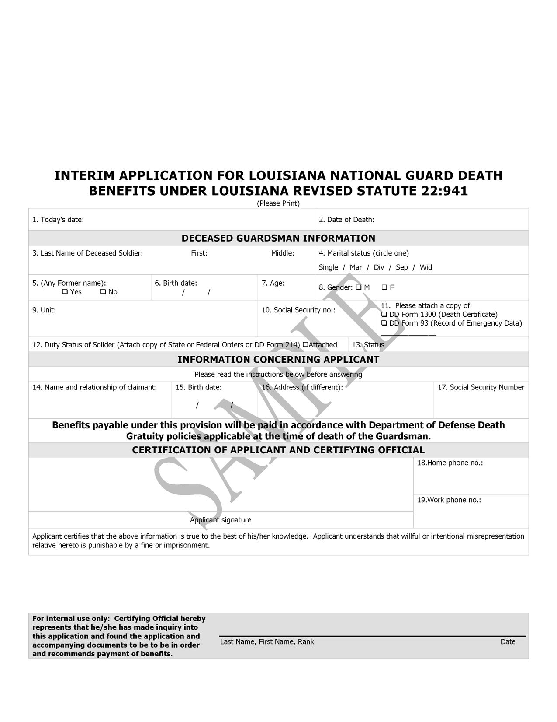

4. All claims for disability benefits must include the following:

a. a copy of the guardsman’s state or federal orders or copy of DD Form 214;

b. a rating decision by the U.S. Department of Veterans Affairs or in accordance with the worker’s compensation law of this state;

c. disability benefit claim form signed by claimant and certified by the Secretary of the Louisiana Department of Veterans Affairs or his designee.

E. Death and Disability Benefit Payment Eligibility

1. Benefits under R.S. 22:941(A)(5) will be paid to the beneficiary of guardsmen who die while on state active duty or federal active duty. Benefits will also be paid in the event of death while a guardsman is ordered to active duty by the governor pursuant to R.S. 29:7 and in a federal pay status pursuant to 32 U.S.C 502(f)(1).

2. Benefits under R.S. 22:941(A)(5) will be paid to guardsmen who are disabled due to injuries suffered while on state active duty or federal active duty. Benefits will also be paid in the event of disability due to injuries suffered while a guardsman is ordered to active duty by the governor pursuant to R.S. 29:7 and in a federal pay status pursuant to 32 U.S.C 502(f)(1).

3. Benefits under this Part will not be paid to guardsmen who die or become disabled while in any training status pursuant to Title 29 of the Louisiana Revised Statutes or Title 32 of the U.S. Code.

4. Members of the Active Guard Reserve (AGR) program, federal technicians and state employees are not eligible for benefits under R.S. 22:941(A)(5) unless otherwise qualified as set forth in Paragraph E.1 or E.2 of this regulation.

5. Guardsmen who die or become disabled while on state active duty or federal active duty, but are not in the course of business at the time of their death or injury may not be eligible for benefits under R.S. 22:941(A)(5). If an investigation determines that the Guardsman was not in the line of duty as defined by Army Regulation 600-8-4 at the time of his death or injury, that Guardsman may be determined to be ineligible for this benefit.

6. Guardsmen who are declared 100 percent disabled by the U.S. Veterans Administration for injuries suffered during a Period of Activation are eligible for the disability benefit under R.S. 22:941(A)(5). Eligibility for guardsmen who become disabled due to injuries suffered while on state active duty will be determined in accordance with the worker’s compensation law of this state.

F. Determination of Eligibility and Payment of Benefits

1. Death benefit eligibility and certification will be determined by The Adjutant General or his designee.

2. Disability benefit eligibility and certification will be determined by the Secretary of the Louisiana Department of Veterans Affairs or his designee.

3. Payment to eligible recipients of qualified claims will be made by the Louisiana Office of Risk Management after certification of eligibility and request for payment is made as set forth herein above.

G. Beneficiary Designation by Guardsmen

1. All members of LANG shall complete and execute a “Death Benefit Beneficiary Designation Form” which will contain the name of the beneficiary of the guardsman’s death benefit under R.S. 22:941(A)(5) to whom this benefit will be paid in a lump sum.

2. The designation form will be signed by the guardsman before a witness in the grade of E-7 or above.

3. The designation form will be kept in the personnel files of the LANG in the regular course of business.

Figure G Sample Beneficiary Designation Form

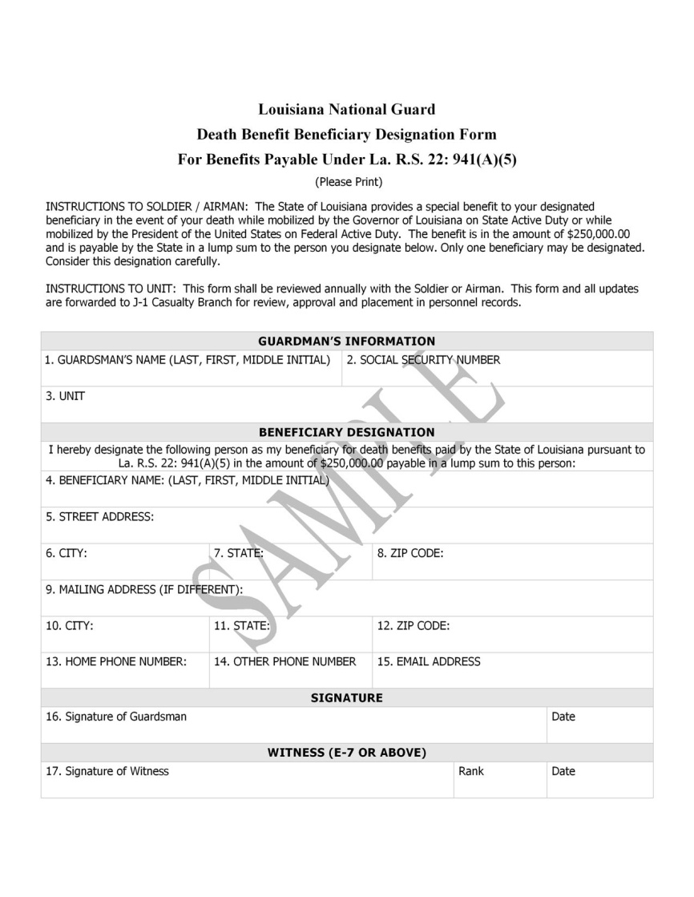

AUTHORITY NOTE: Promulgated in accordance with R.S. 29:11(F).

HISTORICAL NOTE: Promulgated in accordance with the Office of the Governor, State Military Department, LR 36:316 (February 2010).