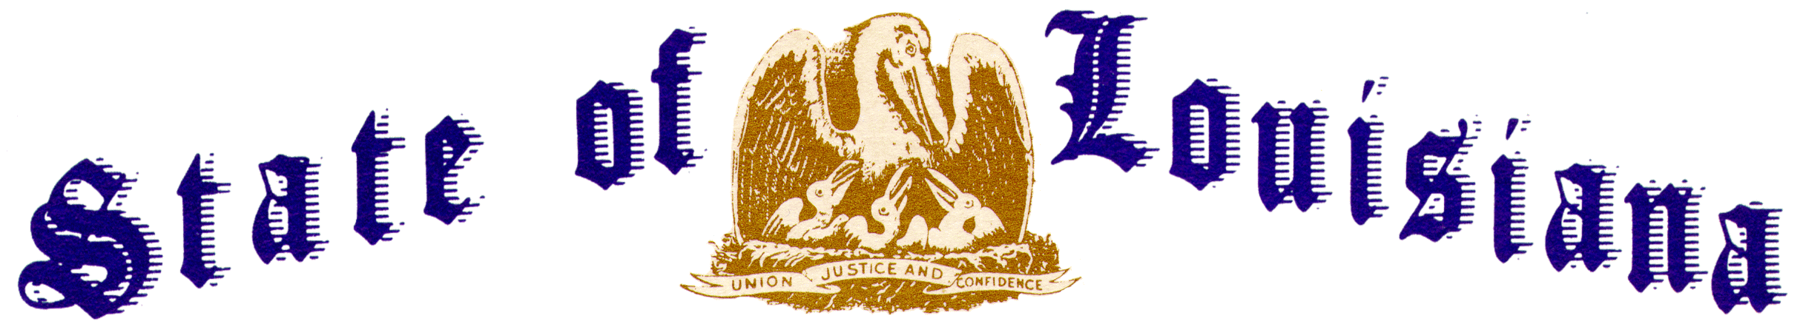
Executive Department
Office of the Governor
Executive Order Number JML 26-041

FLAGS AT HALF-STAFF – PERIOD OF MOURNING FOR JAYLA ELKINS, SHAYLA ELKINS, KAYLA PUGH, LAYLA PUGH, MARKAYDON PUGH, BRAYLON SNOW, KHEDARRION SNOW, AND SARIAHH SNOW

WHEREAS, on April 19, 2026, Jayla Elkins, 3; Shayla Elkins, 5; Kayla Pugh, 6; Layla Pugh, 7; Markaydon Pugh, 10; Braylon Snow, 5; Khedarrion Snow, 6; and Sariahh Snow, 11; tragically lost their lives in an act of senseless violence in Shreveport, Louisiana;
WHEREAS, these children were the light of their homes and the heart of their classrooms;
WHEREAS, they were full of promise and found joy in the simplest things, such as dancing, playing outside, and sharing laughter with family and friends;
WHEREAS, their futures were bright and held great promise, whether they had just begun their journey at Johnnie L. Cochran Head Start or were progressing through their studies at Summer Grove Elementary and Linwood Public Charter School;
WHEREAS, the people of Louisiana mourn alongside the loved ones of these children, especially their mothers Christina Snow, Shaneiqua Pugh Elkins, and Keosha Pugh, whose strength in the face of such unimaginable loss is beyond measure;
WHEREAS, these tragedies remind us of the importance of unity, resilience, and compassion in the face of unspeakable evil and hatred;
WHEREAS, such acts of violence and depravity erode the principles of peace and safety that bind our communities, and it is incumbent upon us to honor the memory of those lost by standing together against such senseless violence;
WHEREAS, the people of Louisiana must stand united against acts of violence directed at our children, who are entitled to our fullest protection and support;
WHEREAS, we are called upon to support one another during times of need, especially those affected by this horrific event;

WHEREAS, it is fitting and proper for the entire State of Louisiana to lower the flags of the United States and the State of Louisiana as a solemn tribute for these children, whose lives were taken far too soon.
NOW THEREFORE, I, JEFF LANDRY, Governor of the State of Louisiana, by virtue of the authority vested by the Constitution and the laws of the State of Louisiana, do hereby order and direct as follows:
Section 1: In honor and remembrance of the victims of this tragedy, the flags of the United States and the State of Louisiana shall be flown at half-staff over the State Capitol and all state buildings from sunrise to sunset on the following days to commemorate each of the victims whose lives were taken:
- On Saturday, May 9, 2026: In remembrance of Jayla Elkins;
- On Sunday, May 10, 2026: In remembrance of Shayla Elkins;
- On Monday, May 11, 2026: In remembrance of Kayla Pugh;
- On Tuesday, May 12, 2026: In remembrance of Layla Pugh;
- On Wednesday, May 13, 2026: In remembrance of Markaydon Pugh;
- On Thursday, May 14, 2026: In remembrance of Braylon Snow;
- On Saturday, May 16, 2026: In remembrance of Khedarrion Snow; and
- On Sunday, May 17, 2026: In remembrance of Sariahh Snow.
Section 2: All political subdivisions, private entities, and educational institutions, including public, private, parochial, and post-secondary institutions, are encouraged to lower the flags of the United States and the State of Louisiana to half-staff during this period.
Section 3: This Order is effective upon signature and shall remain in effect until sunset, May 17, 2026.
IN WITNESS WHEREOF, I have set my hand officially and caused to be affixed the Great Seal of the State of Louisiana in the City of Baton Rouge, on this 7th day of May 2026.

Jeff Landry
GOVERNOR OF LOUISIANA

ATTEST BY THE
SECRETARY OF STATE

Nancy Landry
SECRETARY OF STATE

