RFP attachments (RFP only)

This tab is used to attach supporting documentation related to the RFP process.

When submitting an RFP for initial review, the following attachments will be required. They will also need to be selected for review under the bundle tab.

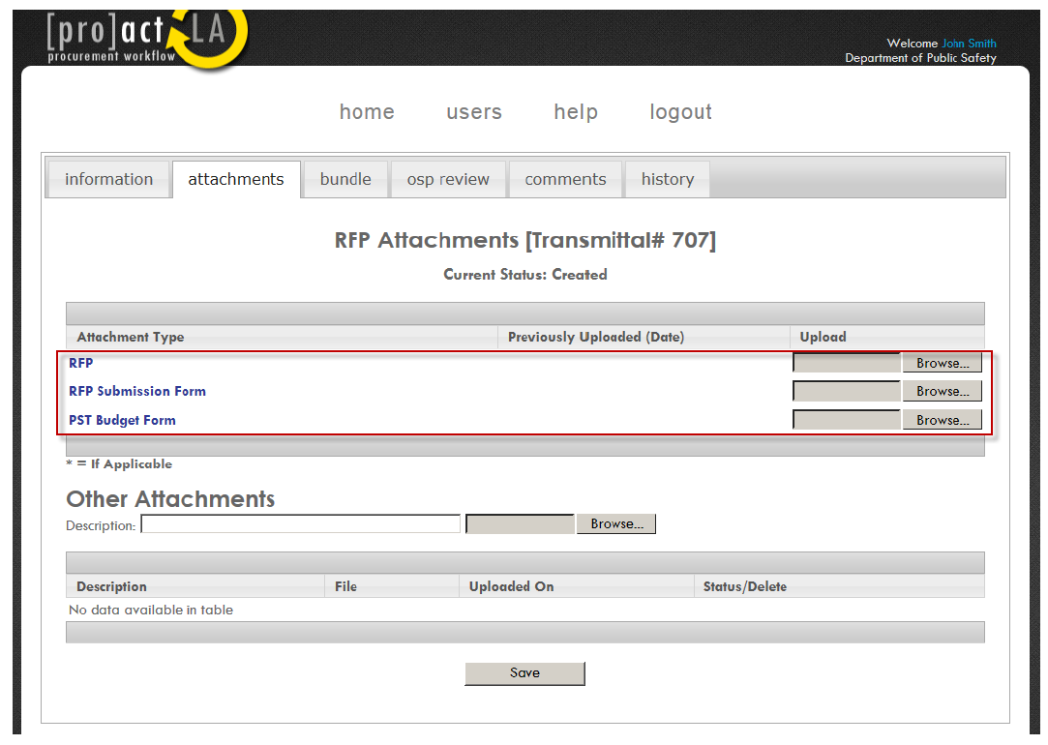

When review and approval is complete, the transmittal will be moved to Approved to Publish status and an RFP Certificate will be issued.

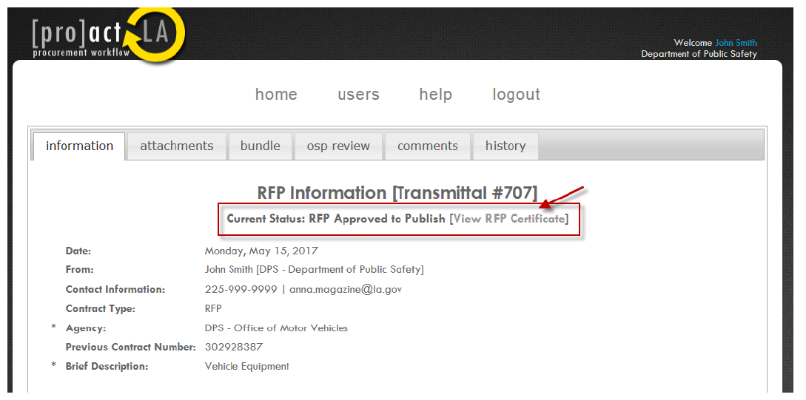

When the RFP is in Approved to Publish status, the list of attachments related to the RFP process will appear. These attachments do not need to be bundled to submit for final review and approval.

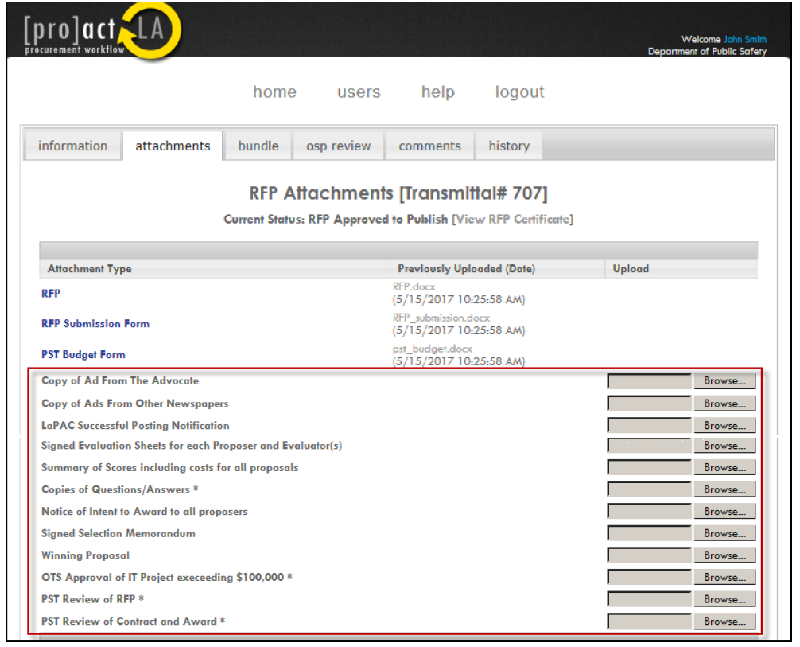

When the RFP evaluation process is complete and the winning proposal has been determined, the transmittal can be submitted to the Office of State Procurement for final review and approval. To submit for final review, go to the information tab and click on Submit for Review. When the transmittal receives final approval by the Office of State Procurement, it will be moved to Approved status and a Concurrence Certificate will be issued. This certificate will serve as confirmation that the Office of State of Procurement has reviewed and concurred with the award recommendations(s).

