INSTRUCTIONS FOR EMERGENCY PROFESSIONAL SERVICES CONTRACTS - COVID-19

Governor John Bel Edwards Proclamations JBE 2020-30, 2020-27 and 2020-25, declaring a Public Health Emergency, provide authority for agencies to contract for emergency PPCS services needed in response to the COVID-19 pandemic, without receiving the approval of OSP.

The proclamations advise that for procurement and contracting, strict compliance with the Louisiana Procurement Code (La. R.S. 39:1551, et seq.), Telecommunications Procurement (La. R.S. 39:1751-1755) and Information Technology Procurement (La. R.S. 39:196-200), shall not be required.
However, all state agencies should comply with the conditions listed in the Proclamation. They include:
- An appointed official within the agency, or the equivalent for officials in higher education, must determine that the failure to strictly comply with the statutory restriction is necessary due to the emergency;
- A centralized point of contact for each agency must monitor all transactions conducted without strict statutory compliance, maintaining copies of all documentation. Documentation should specify whether the purchase falls into the "emergency" or "permanent" category and whether the purchase relates to the COVID-19 event referenced in Proclamation Number 25 JBE 2020 and all documentation must be maintained and available for audit and FEMA reimbursement purposes;
- Written competitive quotes and/or offers must be obtained whenever possible and agencies must take the necessary steps to assess that fair and equitable pricing is being offered;
- Performance-based contracting should be used where practical;
- Statewide contracts should be used where practical;
- To the maximum extent possible, such emergency contracts should be only for the duration of the emergency or to allow the agency time to comply with normal competitive bidding requirements if the goods or services will be required for an extended period of time;
- Copies of contracts which would otherwise require approval by the Office of State Procurement and the supporting documentation discussed above must be provided to the Office of State Procurement within thirty (30) days or sooner, if practical. Additionally, LaGov agencies should enter small purchases into the LaGov system as soon as practical. The Office of State Procurement shall review the contracts and documentation to determine compliance with this Executive Order; and
- Payments to contractors should be made only after verification that all goods and services meet contract requirements.
- All Public Bid Openings shall be suspended. Bid openings will continue, however public openings will not occur in order to limit the potential for exposure. Bid openings will be made available via phone conference or web conference.
- All required Procurement Support Team meetings will be held via phone conference or web conference.

HOW TO ENTER EMERGENCY PC CONTRACTS IN LaGOV:

- Since OSP-PC approval of an OSP-PC relevant LaGov Service Type PO greater than the agency’s DPA is not required only for COVID-19 contracts, the agency can use a “CEMR Emergency” type Purchase Order.

- Agencies must begin with a shopping cart that has the OSP-PC relevant LaGov Service Type on it. (for example: PRO, PER, SOC, CON, AGY, GOV)

- The shopping cart will require agency approvals (Cost Center, Fiscal & Signature Authority) and should be marked with LaGov Process Type “Emergency”.

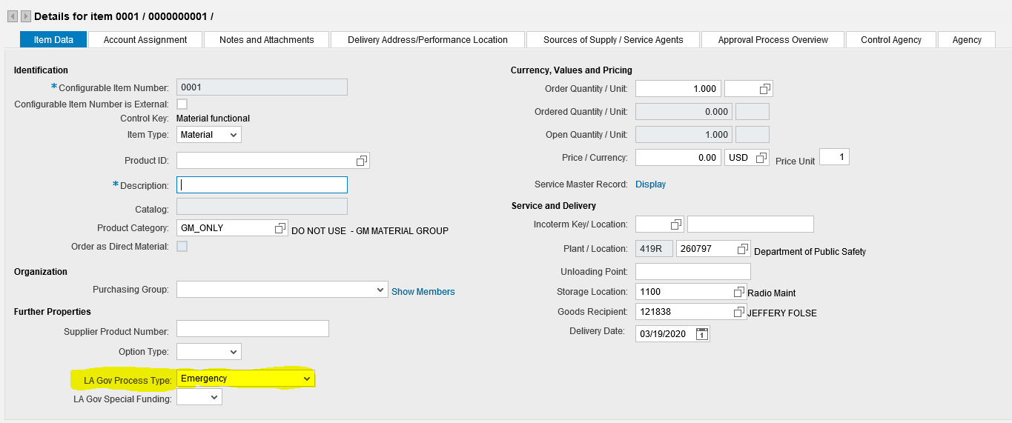

- The Emergency Pre-approval checkbox on the agency tab should not be checked for pre-approval for COVID-19 emergencies, since OSP-PC pre-approval is not required.

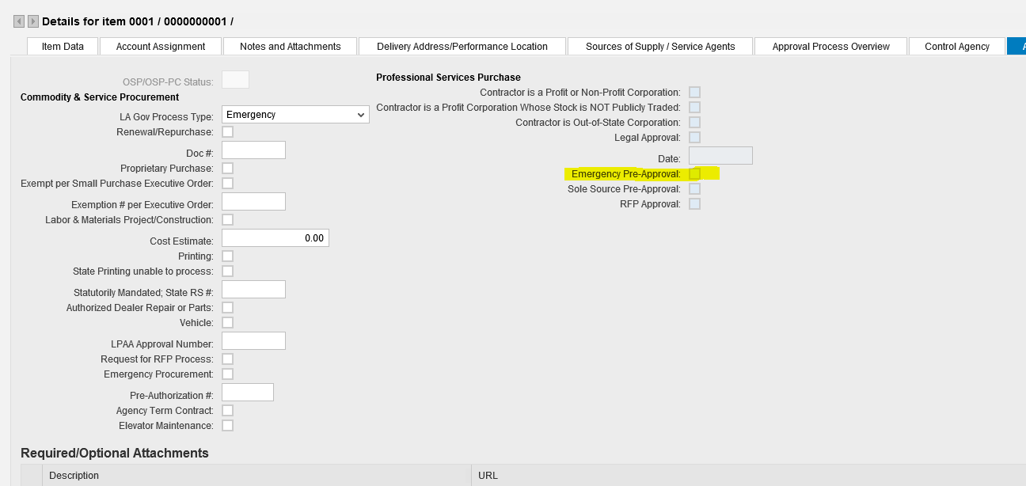

- The shopping cart, once fully approved by agency approvers, can be turned into a CEMR type Purchase Order through Perform Sourcing. The Purchase Order will not build approval to OSP-PC, even if greater than the agency’s Delegated Authority.

See below for instructions.

In the Perform Sourcing Function:

- Enter shopping cart # in “Number of Requisition”, click “Search”
- When cart pulls up, click “Select All”.
- Click “Next” at top. Step 2: Assign Sources of Supply
- Click “Create Draft” – select “Purchase Order”
- Click dropdown on Transaction Type (far right). Choose type – CEMR Emergency

- The agency should use the Notes & Attachments utility to upload the contract and supporting documents to the Purchase Order. Approval notes should be annotated with “COVID-19 emergency.”

- Agencies should notify OSP of their emergency contracts, in accordance with Section 8.G of Proclamation 20-30, by emailing the PO number, name of contractor, and subject line: “COVID-19 Agency-approved emergency” to OSP-PC Helpdesk: DOA-PCHelpdesk@la.gov. (The email address is not provided by the system).

- OSP-PC will be able to view the documents to determine compliance with the Proclamation.

