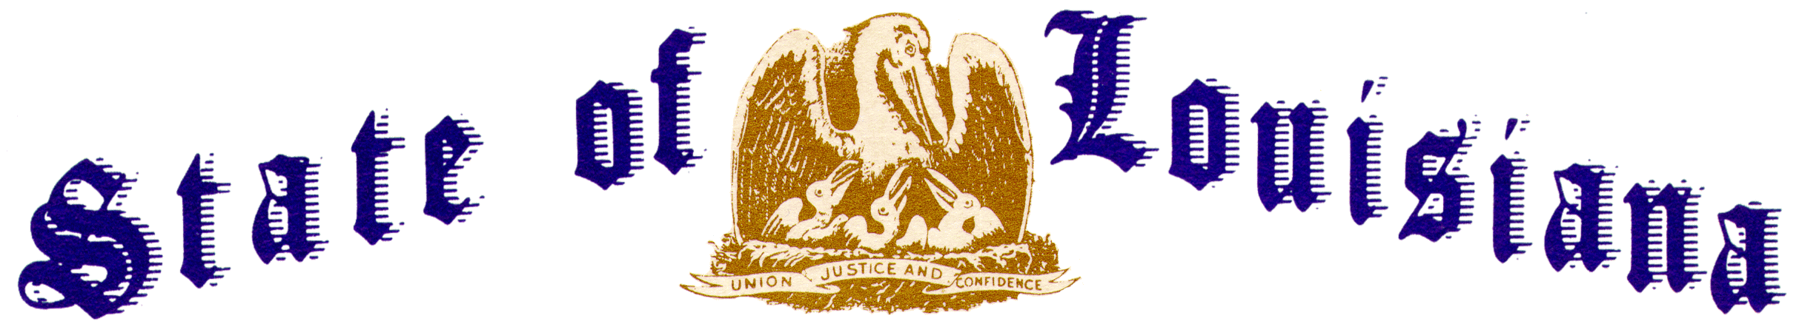

Executive Department
Office of the Governor
Executive Order Number JML 26-039
______________________________________________________________________________

FLAGS AT HALF-STAFF –
PEACE OFFICERS MEMORIAL DAY AND POLICE WEEK
______________________________________________________________________________

WHEREAS, on October 1, 1962, President John F. Kennedy signed Public Law 87-726, designating May 15th as Peace Officers Memorial Day and the week in which that date falls as Police Week;
WHEREAS, there are more than 800,000 law enforcement officers serving in communities across the United States, including the dedicated law enforcement officers serving the State of Louisiana and parishes and municipalities throughout Louisiana;
WHEREAS, since the first recorded death in 1786, there are 27,355 law enforcement officers in the United States who have made the ultimate sacrifice and been killed in the line of duty, including 589 officers who served the State of Louisiana;
WHEREAS, 363 new names of fallen heroes have been added to the National Law Enforcement Officers Memorial, including 109 officers killed in 2025 and 254 officers killed in previous years;
WHEREAS, in 2026 the names of the following Louisiana officers were added to the National Law Enforcement Officers Memorial in Washington D.C.:
Sergeant Caleb M. Eisworth
Deputy Sheriff Charles W. Riley
Officer Joseph J. Lyons
Lieutenant Allen J. Credeur, Jr.
Sergeant Grant J. Candies
Officer Marc T. Brock

WHEREAS, the State of Louisiana and the Nation owe an enduring debt of gratitude to the peace officers who have given their lives in service to their fellow citizens, and to the families who bear the weight of that sacrifice;

WHEREAS, the service and sacrifice of all officers killed in the line of duty will be honored during the National Law Enforcement Officers Memorial Fund’s 38th Candlelight Vigil on the evening of May 13, 2026;
WHEREAS, the Candlelight Vigil is part of National Police Week, which will be observed this year May 11th-16th;
WHEREAS, the people of the State of Louisiana join in prayer in remembrance of the peace officers who have given their lives in the service of our communities and offer ongoing prayer and support for those who stand watch in their place.
NOW THEREFORE, I, JEFF LANDRY, Governor of the State of Louisiana, by virtue of the authority vested by the Constitution and laws of the State of Louisiana, do hereby order and direct as follows:
Section 1: The State of Louisiana shall publicly salute the service of law enforcement officers in our community and communities across the Nation.
Section 2: The week of May 11th-16th shall be observed in the State of Louisiana as Police Week.
Section 3: Friday, May 15, 2026 is hereby proclaimed as Peace Officers Memorial Day.
Section 4: The flags of the United States and the State of Louisiana shall be flown at half-staff over the State Capitol and all public buildings throughout the state until sunset on Friday, May 15, 2026, in honor of the peace officers who have made the ultimate sacrifice in service of our people.
IN WITNESS WHEREOF, I have set my hand officially and caused to be affixed the Great Seal of Louisiana, at the Capitol, in the City of Baton Rouge, on this 5th day of May 2026.

__________________________________________
Jeff Landry
GOVERNOR OF LOUISIANA

ATTEST BY THE SECRETARY
OF STATE

_____________________________________
Nancy Landry
SECRETARY OF STATE

