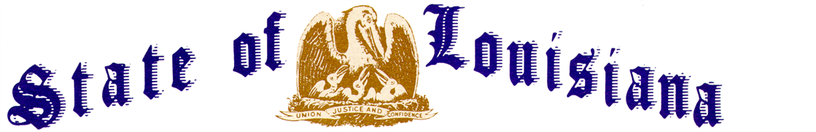
Executive Department
Office of the Governor
Executive Order Number JML 26-081
________________________________________________________________________________

EMERGENCY DECLARATION
LA 384 BLACK BAYOU PONTOON BRIDGE, CALCASIEU PARISH
________________________________________________________________________________

WHEREAS, the Louisiana Homeland Security and Emergency Assistance and Disaster Act, R.S. 29:721, et seq., confers upon the Governor of the State of Louisiana emergency powers to deal with emergencies and disasters;
WHEREAS, the Governor is responsible for meeting the dangers to the State and its people presented by emergencies;
WHEREAS, when the Governor determines that a disaster or emergency has occurred, or the threat thereof is imminent, R.S. 29:724(B)(1) empowers him to declare a state of disaster or emergency by executive order or proclamation, or both;
WHEREAS, on June 22, 2026, a vessel traveling on the Gulf Intracoastal Waterway struck the Black Bayou Pontoon Bridge located on Louisiana Highway 384 in Calcasieu Parish;
WHEREAS, preliminary assessments have identified extensive damage to the bridge, including its pontoon, apron, spans, and fender systems, operator house and machinery, rendering the bridge unsafe for public travel and requiring its closure to both vehicular and marine traffic for as long as twenty-four months while necessary repairs are completed;
WHEREAS, the closure requires motorists to use the Grand Lake Pontoon Bridge as an alternate route and leaves residents south of the bridge with only one available route heading north, requiring additional emergency and hurricane evacuation planning in Calcasieu and Cameron Parishes;
NOW THEREFORE, I, JEFF LANDRY, Governor of the State of Louisiana, by virtue of the authority vested by the Constitution and laws of the State of Louisiana, order and direct as follows:
Section 1: Pursuant to the Louisiana Homeland Security and Emergency Assistance and Disaster Act, R.S. 29:721, et seq., a state of emergency is declared to exist in Calcasieu Parish, Louisiana, as pertains to the Black Bayou Pontoon Bridge on Louisiana Highway 384.
Section 2: All departments, commissions, boards, agencies, and officers of the State, or any political subdivision thereof, are authorized and directed to cooperate in actions the State may take in response to this event.
Section 3: This Order is effective upon signature and shall remain in effect through Sunday September 20, 2026, unless extended accordance with applicable law or terminated sooner.
IN WITNESS WHEREOF, I have set my hand officially and caused to be affixed the Great Seal of Louisiana in the City of Baton Rouge, on this 21st day of August 2026.

__________________________________________
JEFF LANDRY
GOVERNOR OF LOUISIANA

ATTEST BY THE
SECRETARY OF STATE

_____________________________________
Nancy Landry
SECRETARY OF STATE

