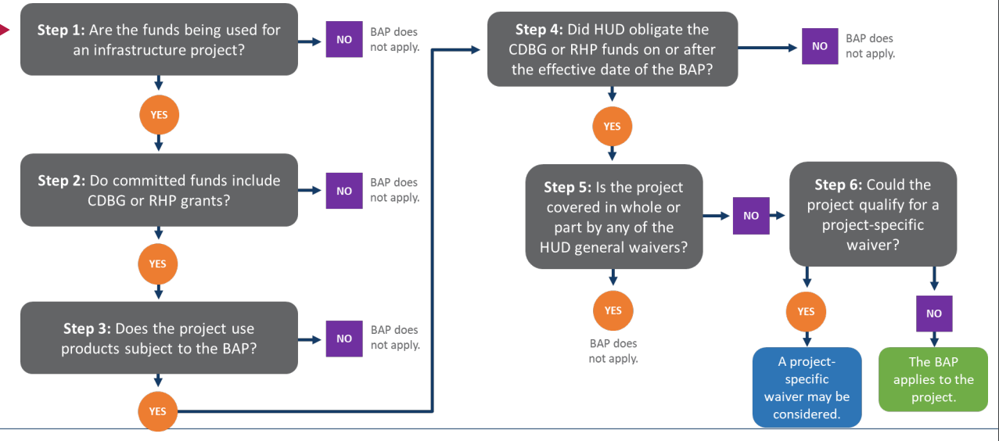
BUILD AMERICA BUY AMERICA(BABA) GUIDE

