Manage Company Data

- Log in to the vendor portal with your ID (11 digit vendor number that begins with a “V”) and your personal password.
- Click on Manage Company Data under Detailed Navigation on the left.
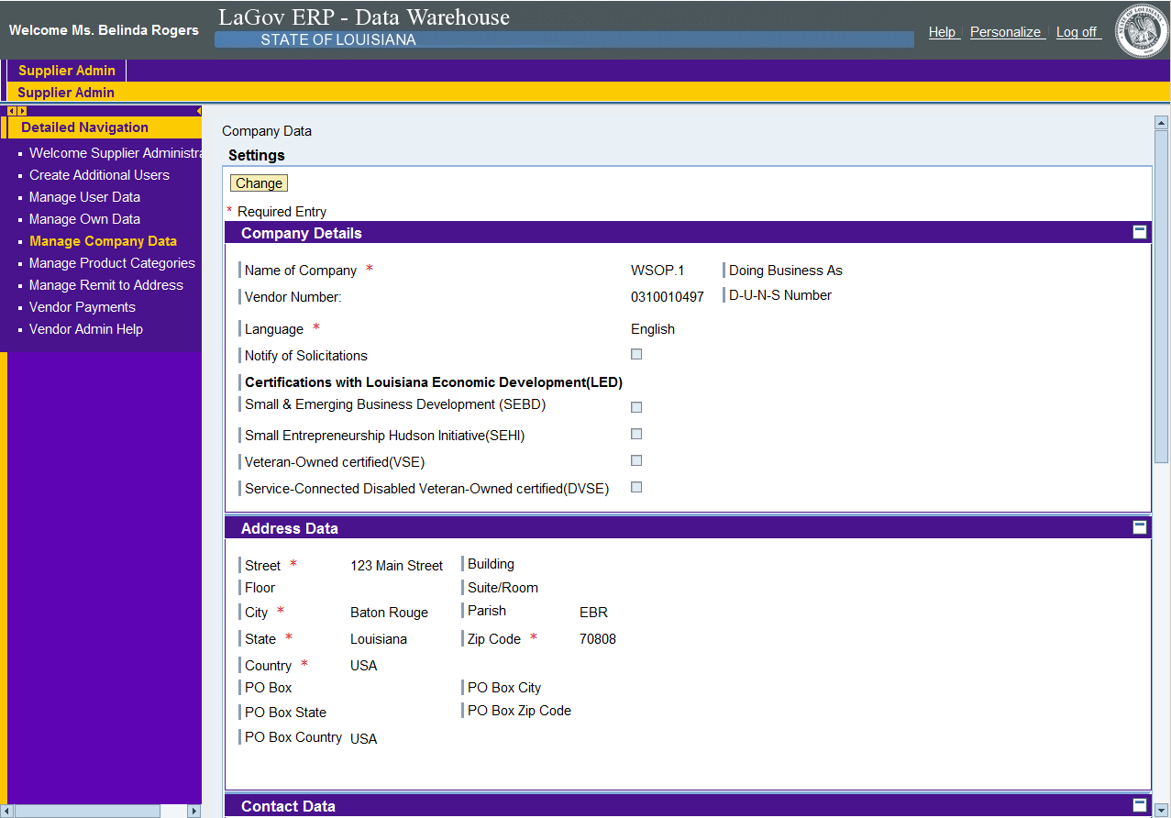

- To make changes, click the Change button at the top of the screen
Make any required changes to the company details by clicking the field, deleting unwanted text, and adding the updated information. Before saving, scroll down to the bottom and select “vendor currency” from the drop down box. Failure to do this will create an error message. NOTES:
  - The “Name of the Company” and “Doing Business As Name” cannot be changed in LaGov without following the appropriate business process. If the name of your company or DBA changes, please contact State purchasing for assistance at telephone number
(225) 342-8010.
  - The certification(s) with Louisiana Economic Development (LED) cannot be changed. This information is populated by an interface from LED.

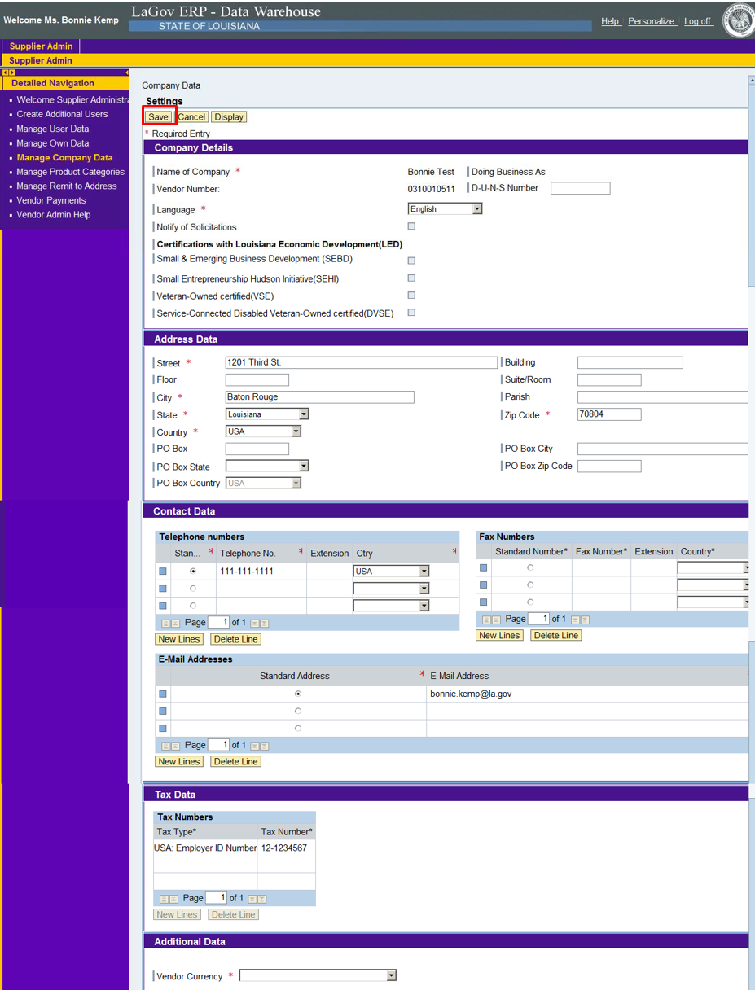

After changes are made, scroll to the top and click Save. You should receive the following message:
