# DOA STANDARDS FOR ARCHIVAL

## Archive Exception

To qualify for an archival exception to the web accessibility regulations, web content must meet all four of the following points:

1. Created before April 24, 2026; and
2. Kept only for reference, research or recordkeeping; and
3. Kept in a special area for archived content; and
4. The content has not been changed since it was archived.

Web content that qualifies for archival does not have to be compliant with WCAG 2.1, Level AA, unless specifically requested by a web user.

## Archive Standards

Any DOA Office with web content that qualifies for the archival exception must comply with the following:

1. **Navigation**: The Archive must be the last option in the left navigation panel

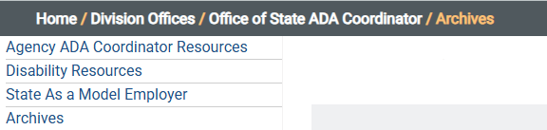

1. **Page Name and Title**: In Umbraco, the Name field and Page Title must be “Archives.”

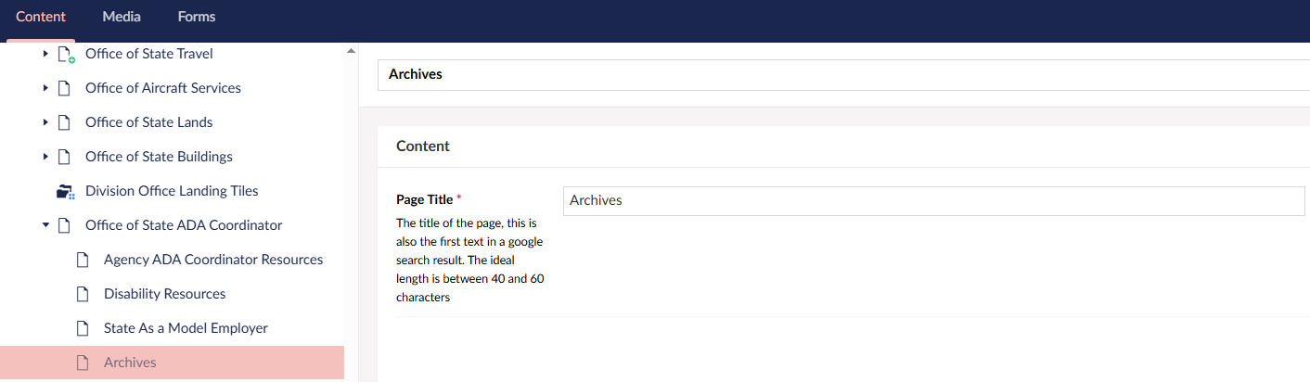

1. **Landing page**: The Archives landing page must include the following standard language. It must link to the Accessibility Statement at <https://www.doa.la.gov/accessibility-statement/>



1. **Content Organization**: Organize archived web content in a manner appropriate for the nature and volume of archived materials. If archived content is limited, it should all be included on the initial Archives landing page (example a. below). For larger archives, it can be broken down into subpages under the initial landing page (example b. below).
   1. **One Comprehensive Page**:

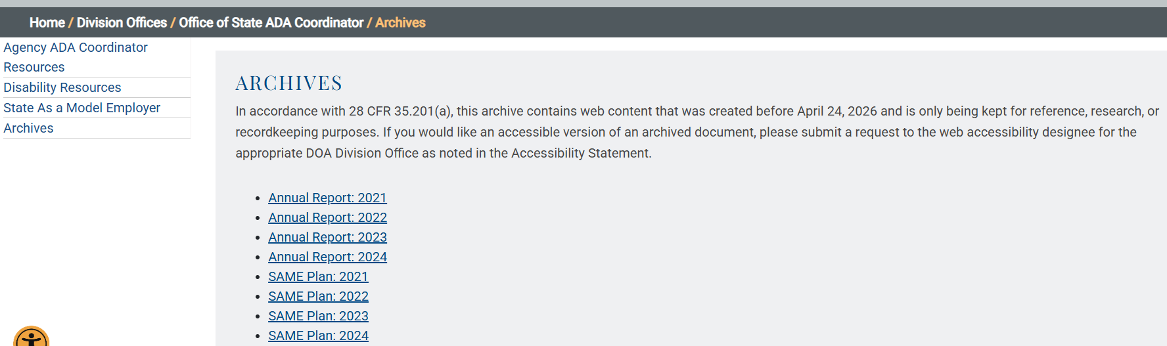

* 1. **Subpages**: If subpages are created under the Archive landing page, they must identify the type of web content followed by [Archived].

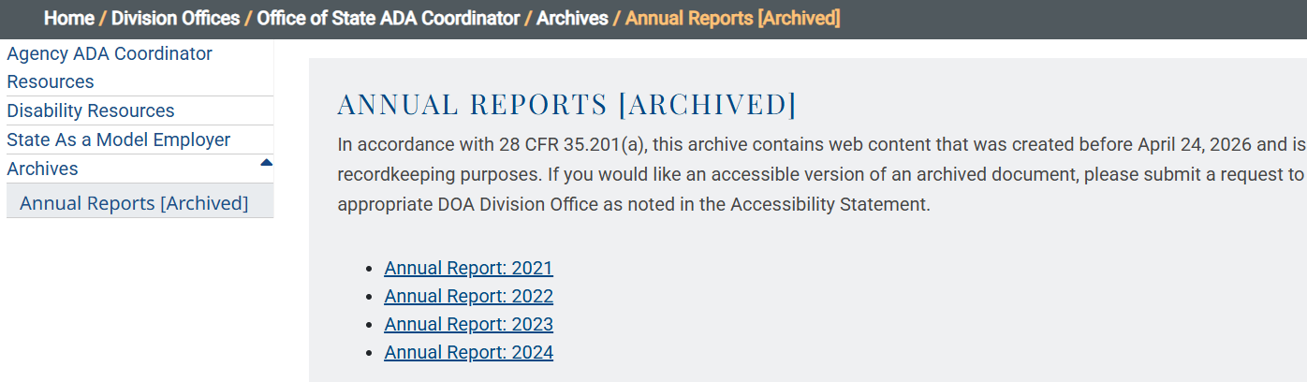

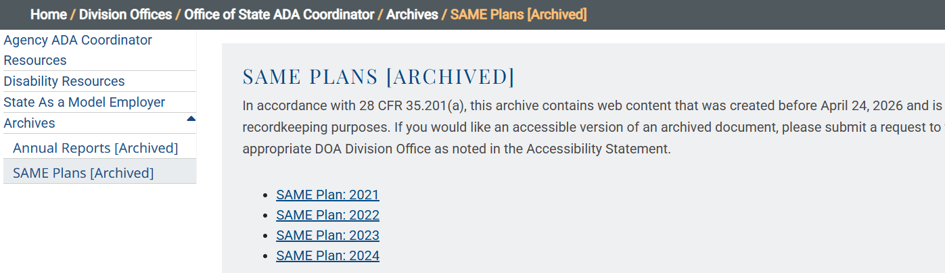

* 1. **Lists instead of Tables**: Avoid using tables to format/display web content, as they are not generally web-accessible. Instead, consider using bulleted or numbered lists.

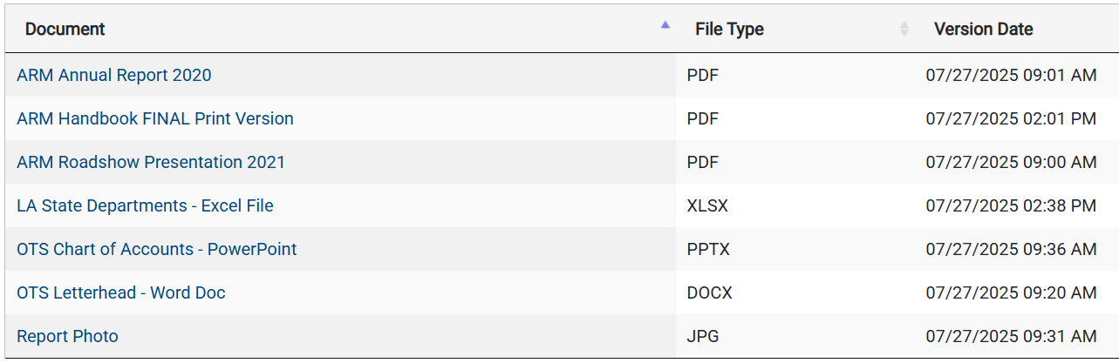

## Actions to Take

For your convenience, an Archive landing page has been created for each Office on the DOA.la.gov website. The Archive landing page is currently “hidden” in Umbraco, meaning it is not published at this time. This is why the Archives landing page appears to be shaded lighter in the list of webpages in Umbraco.

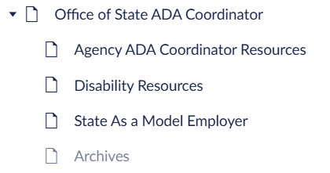

If your Office has web content that qualifies for the archive exception, simply:

1. Add/move the qualifying content in Umbraco to the Archive landing page (or any subpages that you wish to create for the Archive).
2. Once all content has been added and properly organized, click on the Hide Navigation button to change it from Umbraco Hide Navigation button marked with an X toUmbraco Hide Navigation button marked with a check.