Welcome Supplier Administrator

- Log into the vendor portal with your ID (11 digit vendor number that begins with a “V”) and your personal password.

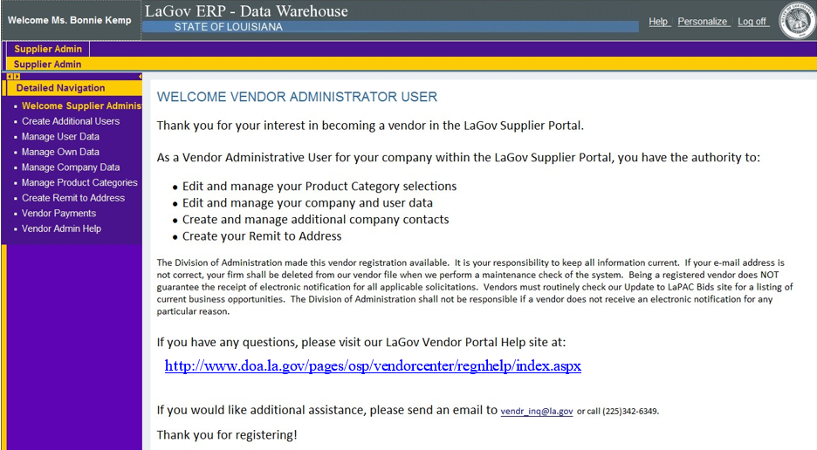

- Once you have registered, you can click on the left navigation pane to perform administrator functions. Help scripts exist for each of the topics on the Vendor Resources > Registration Information page.

