State of Louisiana FY 2021 Annual Action Plan

Executive Summary

AP-05 Executive Summary - 24 CFR 91.200(c), 91.220(b)
1. Introduction
As set forth in 24 CFR Part 91, the U.S. Department of Housing and Urban Development (HUD) requires state agencies which administer certain HUD programs to incorporate their planning and application requirements into one master plan called the Consolidated Plan. In Louisiana, the three state agencies participating in this consolidated planning process and the HUD-funded programs administered by each agency include the Division of Administration/Office of Community Development (Community Development Block Grant), the Louisiana Housing Corporation (HOME Investment Partnerships Program, National Housing Trust Fund and Emergency Solutions Grants Program), and the Louisiana Department of Health, Office of Public Health, STD/HIV Program (Housing Opportunities for Persons With AIDS [HOPWA] Program).
FY 2021 is the second year associated with the 5-year FY 2020 - 2024 Consolidated Plan for the use of U. S. Department of Housing and Development (HUD) entitlement grant funds allocated to the State. The Consolidated Plan is designed to help states and local jurisdictions to assess their affordable housing and community development needs and market conditions, and to make data-driven, place-based investment decisions. The consolidated planning process serves as the framework for identifying housing and community development priorities that focus funding from five (5) formula block grant programs including: Community Development Block Grant (CDBG) Program, HOME Investment Partnerships (HOME) Program, National Housing Trust Fund (NHTF), Emergency Solutions Grants (ESG) Program, and the Housing Opportunities for Persons With AIDS (HOPWA) Program. The Consolidated Plan is carried out through Annual Action Plans, which provide a summary of the actions, activities, and the specific federal and non-federal resources that will be used each year to address the priority needs and specific goals identified by the Consolidated Plan. The State Consolidated Plan includes 5 main parts:

• The Executive Summary
• A Needs Assessment: A Housing, Homeless, and Non-Housing Community needs assessment;
• A Market Analysis: An analysis of housing market conditions;
• A Strategic Plan: Identifies general priorities for the allocation of resources;
• Action Plan: Specific activities planned to be undertaken during the program year to address the community and housing development needs identified.
The first year of the Consolidated Plan was affected by COVID-19, diverting much time, attention and resources to the prepare for, respond to and recover from the devastating toll of the virus. At the time of publication for the FY 2021 Annual Action Plan, the State of Louisiana has been focusing on vaccination efforts and economic recovery. The State is assessing the most effective use of additional funding it has received from Congress.

2. Summarize the objectives and outcomes identified in the Plan
This could be a restatement of items or a table listed elsewhere in the plan or a reference to another location. It may also contain any essential items from the housing and homeless needs assessment, the housing market analysis or the strategic plan.
There were 14 Priority Needs identified in the 2020-2024 Strategic Plan. All but two were given a “High” priority including:
1. Affordable Housing Development -High
2. Homebuyer Assistance -High
3. Homeowner Housing Rehabilitation -High
4. Rental Assistance -High
5. Homeless Prevention and Rapid Re-housing -High
6. Homeless Shelters -High
7. Homeless Street Outreach -High
8. CHDO Capacity Building -Low
9. Homeless Data Collection -Low
10. Public Facilities and Infrastructure Projects -High
11. Planning -High
12. Demonstrated Needs –Unforseen Infrastructure Needs -High
13. LaSTEP –The Small Towns Environmental Program (STEP) -High
14. Economic Development -High
As the CPS-Market Analysis showed, conditions in the housing market continue to decline especially for the lowest income households. The need for elderly and special need housing is also increasing as their population rises while the housing market attempts to keep up.
3. Evaluation of past performance
This is an evaluation of past performance that helped lead the grantee to choose its goals or projects.
HOME: The State affordable housing goals and funding priorities were based on housing needs that are supported by Census data and current market condition data. The State continues monitoring the progress of projects that have been funded but not closed and those underway but delayed due to various plausible reasons. The "CR -20 Affordable Housing 91.520 (b) section of the FY 2020 Consolidated Annual Performance and Evaluation Report (CAPER) provides a complete summary of the goals and accomplishments. The referenced section may be viewed at: https://www.doa.la.gov/ocd/About%20LCDBG/Submitted%202017%20CAPER.pdf.
HOPWA: The overall housing goal of the State Formula HOPWA Program is to increase the availability and accessibility of appropriate and affordable housing options for persons who are HIV-infected in order to prevent homelessness. This goal is achieved through a mix of community based initiatives in the largely rural areas outside of the New Orleans and Baton Rouge metropolitan areas. A total of 746 persons living with HIV and 248 family members (overall total = 1001) persons were assisted with HOPWA funding during the 2019 reporting period. As in previous years, the majority of program households (n=403) sought assistance for Short Term Rent, Mortgage and/or Utility assistance (STRMU). There were 205 households that accessed Tenant Based Rental Assistance (TBRA), 22 persons placed in transitional/short term units, 37 in permanent housing facilities and 230 received Permanent Housing Placement Services (PHPS).
National Housing Trust Fund: The State coordinated the leveraging of nearly 80% of NHTF program funds in conjunction with other resources (private lending, HOME, MRB and LIHTC) exclusively for rental housing development.
CDBG - Program regulations require that no less than seventy percent of the aggregate of the fund expenditures shall be for activities that meet the national objective of benefiting low and moderate income persons. The State exceeded this percentage as 100% of the non-administrative funds awarded were used for activities that benefited low and moderate income persons. Overall, the FY 2019 LCDBG monies awarded as of March 31, 2020, benefited 35,040 persons of which 22,284 or 63.60% were of low and moderate income. HUD requests that states annually request funds on their letters of credit in an amount at least equal to its annual grant, and to eventually reach a ratio of the unexpended grant balance (just prior to the receipt of the next grant award) to the most recent annual grant amount of not more than 2.5 and to try to achieve 2.0 or less. The State's ratio of unexpended funds to its grant amount was 2.05 as of January 31, 2020. The Office of Community Development met and will continue to strive to maintain the expenditure goals established by HUD. It is required that each state obligate and award 95% of the non-administrative annual allocation within twelve months of the grant award. Within the twelve-month period, the State had obligated and announced 109.80% of its non-administrative funds. The percentage exceeded 100 percent due to the award program income and returned funds.
4. Summary of Citizen Participation Process and consultation process
Summary from citizen participation section of plan.
The State held two public hearings for the purpose of receiving comments on housing and community development needs throughout the State in preparation of the FY 2021 Action Plan. One of these hearings was held in person on October 20, 2020, at the Claiborne Building in Baton Rouge, Louisiana. Due to the COVID-19 pandemic, a second public hearing was held via Zoom on October 21, 2020. A notice of the hearing was published in the October 5, 2020, issue of The Advocate. Invitations were sent to all interested parties via mail or email. No comments were received. Following the public hearings, the proposed FY 2021 Annual Action Plan was drafted.
CDBG - The Office of Community Development surveyed all potential applicants for LCDBG throughout the State. The survey gathered information regarding community and parish priorities and perceived needs. The anticipated outcomes of the survey are: a) prioritization of LCDBG basic eligible activities, b) prioritization of public facilities (infrastructure) projects, c) prioritization of fund distribution by program category, d) maximum grant amounts needed by type of project, e) amount to be allowed for local administrative costs, and f) suggestions for improving the LCDBG program. Also, a public hearing was held and followed by a comment period to receive additional input.
Upon completion of the draft of the FY 2021 Annual Action Plan, a notice was published in the April 5, 2021 issue of The Advocate. Additionally, a memorandum was emailed/mailed out to all units of general local government and the list of administrative consulting firms and engineering firms maintained by the Office of Community Development. These notifications are attached to the Citizen Participation Addendum Section of this Action Plan. A 30-day comment period was allowed, but no comments were received.
5. Summary of public comments
This could be a brief narrative summary or reference an attached document from the Citizen Participation section of the Con Plan.
In addition to the efforts to obtain public comments, a statewide needs assessment survey was administered to low income persons living with HIV during the summer of 2019 to document the needs (met and unmet) of this population in order to assist with planning for both State Formula HOPWA- and Ryan White-funded services to be available in 2020 and 2021. A copy of this final report is attached for review.
No comments were received for CDBG, HOME, HTF, HOPWA or ESG.
6. Summary of comments or views not accepted and the reasons for not accepting them
There were no comments specific to State Formula CDBG, HOME, HTF, HOPWA or ESG.
7. Summary
Based on the State's past performance, experience of staff, citizen participation and consultation input from all interested parties, the State of Louisiana has drafted the proposed FY 2021 Annual Action Plan.

PR-05 Lead & Responsible Agencies - 91.300(b)
1. Agency/entity responsible for preparing/administering the Consolidated Plan
The following are the agencies/entities responsible for preparing the Consolidated Plan and those responsible for administration of each grant program and funding source.
Agency Role | Name | Department/Agency
Lead Agency | LOUISIANA

CDBG Administrator | LOUISIANA | DOA, Office of Community Development
HOPWA Administrator |  | LDH, OPH, STD/HIV/Hepatitis Program
HOME Administrator | LOUISIANA | Louisiana Housing Corporation
ESG Administrator | LOUISIANA | Louisiana Housing Corporation
HOPWA-C Administrator
 | LOUISIANA | Louisiana Housing Corporation
Table 1 – Responsible Agencies

Narrative
The three state agencies participating in the consolidated planning process and the HUD-funded programs administered by each include the Division of Administration/Office of Community Development (CDBG), the Louisiana Housing Corporation (HOME Investment Partnerships, National Housing Trust Fund and Emergency Solutions Grant Programs), and the Louisiana Department of Health (LDH)/Office of Public Health (OPH) STD/HIV Program (SHP) Housing Opportunities for Persons With AIDS (HOPWA) program. The lead agency for the Consolidated Planning Process and the Consolidated Plan is the State of Louisiana's Division of Administration/Office of Community Development. The primary objective of the Louisiana Community Development Block Grant (LCDBG) Program is to provide assistance to units of general local government in non-entitlement areas for the development of viable communities by providing a suitable living environment and expanding economic opportunities, principally for persons of low and moderate income. The HOME Program objectives are: to expand the supply of decent and affordable housing for low and very low income persons, to stabilize the existing deteriorating homeowner occupied and rental housing stock through rehabilitation, to provide financial and technical assistance to recipients/sub-recipients (including the development of model programs for affordable low income housing), to extend and strengthen partnerships among all levels of government and the private sector (including for-profit and nonprofit organizations) in the production and operation of affordable housing). The intent of the National Housing Trust Fund is to increase and preserve the supply of decent, safe, sanitary, and affordable housing, primarily rental housing, for extremely low income and very low-income households. The purpose of the Emergency Solutions Grants (ESG) Program is to help local governments and community organizations to improve and expand shelter facilities serving homeless individuals and families, to meet the costs of operating homeless shelters, to provide essential services, and to perform homeless prevention and rapid re-housing activities. The purpose of the Housing Opportunities for Persons with AIDS (HOPWA) Program is to provide localities with the resources and incentives to devise and implement long term comprehensive strategies to provide housing assistance and related supportive services for low income people living with HIV/AIDS and their families. Unstable housing and homelessness decrease the ability of persons living with HIV to achieve or maintain viral suppression, and leads to suboptimal health outcomes for the client as well as increased opportunities for HIV transmission to potential partners.

Consolidated Plan Public Contact Information
CDBG:
Division of Administration, Office of Community Development (Lead Agency)
Traci Watts
P.O. Box 94095
Baton Rouge, LA 70804-9095
traci.watts@la.gov
HOME and NHTF:
Louisiana Housing Corporation
Robert McNeese
2415 Quail Dr.
Baton Rouge, LA 70808
rmcneese@lhc.gov
ESG: Louisiana Housing Corporation
Winona Connor
2415 Quail Dr.
Baton Rouge, LA 70808
wconnor@lhc.la.gov
HOPWA:
Louisiana Department of Health (LDH), Office of Public Health (OPH) - STD/HIV Program (SHP)
Erika Sugimori, Services Manager
1450 Poydras Street, Suite 2136
New Orleans, LA 70112
erika.sugimori@la.gov

AP-10 Consultation - 91.110, 91.300(b); 91.315(l)
1. Introduction
CDBG - The Office of Community Development surveyed all potential applicants for LCDBG throughout the State for FY 2020-2021. The survey gathered information regarding community and parish priorities and perceived needs. The anticipated outcomes of the survey are: a) prioritization of LCDBG basic eligible activities, b) prioritization of public facilities (infrastructure) projects, c) prioritization of fund distribution by program category, d) maximum grant amounts needed by type of project, e) amount to be allowed for local administrative costs, and f) suggestions for improving the LCDBG program. Also, a public hearing was held, followed by a comment period to receive additional input. OCD has also been in consultation with the Louisiana Department of Health, Office of Behavioral Health trying to identify the communities in which Support Act funds could be used to meet the greatest need.
State Formula HOPWA - The Office of Public Health within the Louisiana Department of Health (LDH) partners with community-based organizations and clinical providers that offer medical care and supportive services to persons living with, or at risk of acquiring HIV disease. These groups assist in the development of the Statewide Coordinated Statement of Need (SCSN) and the Louisiana HIV Strategy for Integrated Prevention and Care, which allows input regarding the allocation of all resources of funding. Additionally, the State conducts a Needs Assessment survey of people living with HIV every two years to assess their met and unmet needs related to housing, medical care, and supportive services.
Provide a concise summary of the state's activities to enhance coordination between public and assisted housing providers and private and governmental health, mental health and service agencies
State Formula HOPWA - The Office of Public Health STD/HIV/Hepatitis Program does not work with units of local government. Instead, project sponsors demonstrating an ability to address the housing needs of low income persons living with HIV are selected during a competitive Request for Proposals (RFP) process. The successful proposers (i.e., project sponsors) are contractually required to develop both formal and informal collaborations with other housing providers in their jurisdiction, as well as private and government-funded community partners that provide medical, housing, mental health and supportive services to address the clients' needs and assist the eligible program participants to access and be maintained in HIV-related medical care.
Describe coordination with the Continuum of Care and efforts to address the needs of homeless persons (particularly chronically homeless individuals and families, families with children, veterans, and unaccompanied youth) and persons at risk of homelessness

Describe consultation with the Continuum(s) of Care that serves the State in determining how to allocate ESG funds, develop performance standards for and evaluate outcomes of projects and activities assisted by ESG funds, and develop funding, policies and procedures for the operation and administration of HMIS

2. Agencies, groups, organizations and others who participated in the process and consultations

Table 2 – Agencies, groups, organizations who participated
1 | Agency/Group/Organization | SLAC
 | Agency/Group/Organization Type | Services - Housing  Services-Persons with HIV/AIDS  Services-Health
 | What section of the Plan was addressed by Consultation? | Housing Need Assessment  HOPWA Strategy
 | Briefly describe how the Agency/Group/Organization was consulted. What are the anticipated outcomes of the consultation or areas for improved coordination? | The agency was involved in data collection for the housing needs assessment for people living with HIV.
2 | Agency/Group/Organization | ACADIANA CARES
 | Agency/Group/Organization Type | Services - Housing  Services-Persons with HIV/AIDS  Services-Health
 | What section of the Plan was addressed by Consultation? | Housing Need Assessment  HOPWA Strategy
 | Briefly describe how the Agency/Group/Organization was consulted. What are the anticipated outcomes of the consultation or areas for improved coordination? | The agency was involved in data collection for the housing needs assessment for people living with HIV.
3 | Agency/Group/Organization | Crescent Care Health
 | Agency/Group/Organization Type | Services - Housing  Services-Persons with HIV/AIDS  Services-Health
 | What section of the Plan was addressed by Consultation? | Housing Need Assessment  HOPWA Strategy
 | Briefly describe how the Agency/Group/Organization was consulted. What are the anticipated outcomes of the consultation or areas for improved coordination? | The agency was involved in data collection for the housing needs assessment for people living with HIV.
4 | Agency/Group/Organization | CLASS
 | Agency/Group/Organization Type | Services - Housing  Services-Persons with HIV/AIDS  Services-Health
 | What section of the Plan was addressed by Consultation? | Housing Need Assessment  HOPWA Strategy
 | Briefly describe how the Agency/Group/Organization was consulted. What are the anticipated outcomes of the consultation or areas for improved coordination? | The agency was involved in data collection for the housing needs assessment for people living with HIV.
5 | Agency/Group/Organization | GO CARE
 | Agency/Group/Organization Type | Services - Housing  Services-Persons with HIV/AIDS  Services-Health
 | What section of the Plan was addressed by Consultation? | Housing Need Assessment  HOPWA Strategy
 | Briefly describe how the Agency/Group/Organization was consulted. What are the anticipated outcomes of the consultation or areas for improved coordination? | The agency was involved in data collection for the housing needs assessment for people living with HIV.
6 | Agency/Group/Organization | The Philadelphia Center
 | Agency/Group/Organization Type | Services - Housing  Services-Persons with HIV/AIDS  Services-Health
 | What section of the Plan was addressed by Consultation? | Housing Need Assessment  HOPWA Strategy
 | Briefly describe how the Agency/Group/Organization was consulted. What are the anticipated outcomes of the consultation or areas for improved coordination? | The agency was involved in data collection for the housing needs assessment for people living with HIV.
7 | Agency/Group/Organization | Region IX - Bogalusa/Mandeville Volunteers of America IX
 | Agency/Group/Organization Type | Services - Housing  Services-Persons with HIV/AIDS  Services-Health
 | What section of the Plan was addressed by Consultation? | Housing Need Assessment  HOPWA Strategy
 | Briefly describe how the Agency/Group/Organization was consulted. What are the anticipated outcomes of the consultation or areas for improved coordination? | The agency was involved in data collection for the housing needs assessment for people living with HIV.
8 | Agency/Group/Organization | Non-Entitlement Cities, Towns, & Villages
 | Agency/Group/Organization Type | Other government - Local
 | What section of the Plan was addressed by Consultation? | Economic Development  Community Development
 | Briefly describe how the Agency/Group/Organization was consulted. What are the anticipated outcomes of the consultation or areas for improved coordination?
9 | Agency/Group/Organization | Non-Entitlement Parishes
 | Agency/Group/Organization Type | Other government - County
 | What section of the Plan was addressed by Consultation? | Economic Development  Community Development
 | Briefly describe how the Agency/Group/Organization was consulted. What are the anticipated outcomes of the consultation or areas for improved coordination?

Identify any Agency Types not consulted and provide rationale for not consulting
CDBG - Because entitlements are not eligible for LCDBG funding, they were not contacted. LCDBG focused on the priorities and perceived needs of those local units of government eligible to receive its funding.

Other local/regional/state/federal planning efforts considered when preparing the Plan
Name of Plan | Lead Organization | How do the goals of your Strategic Plan overlap with the goals of each plan?
Continuum of Care
Table 3 - Other local / regional / federal planning efforts

Narrative

AP-12 Participation - 91.115, 91.300(c)
1. Summary of citizen participation process/Efforts made to broaden citizen participation
Summarize citizen participation process and how it impacted goal-setting

The Consolidated Plan for the FY 2021 Annual Action Plan were developed using an effective citizen participation process which is in compliance with the regulations set forth in 24 CFR Part 91.
The State held two public hearing for the purpose of obtaining views on community development and housing needs throughout the State. The in-person public hearing was held on October 20, 2020 at the Claiborne building in Baton Rouge. One person was in attendance. A second virtual public hearing was held via Zoom where 32 people were in attendance. A notice of the public hearings was published in the October 5, 2020, issue of The Advocate newspaper.
Written invitations to attend the public hearings were also emailed or mailed to local governing bodies, public, private, and nonprofit agencies, and other interested parties the Office of Community Development includes on its list all non-entitlement local governments. Examples of the type of organizations that the Louisiana Housing Corporation made efforts to receive comments from include nonprofit organizations and nonprofit developers such as state-certified community housing development organizations; advocacy groups such as the Advocacy Center (an advocacy organization for people with disabilities in Louisiana); and for-profit developers such as members of the Louisiana Association of Affordable Housing Providers. The mailing list represented a compilation of mailing lists utilized by the three state agencies administering the five programs involved in the consolidated planning process. In addition to accepting comments at the public hearing, written comments could be submitted during the period of October 20, 2020 to November 5, 2020. No comments were received.

Citizen Participation Outreach
Sort Order | Mode of Outreach | Target of Outreach | Summary of  response/attendance | Summary of  comments received | Summary of comments not accepted and reasons | URL (If applicable)
1 | Public Hearing | Non-targeted/broad community | One person attended the meeting that was held in person at the Claiborne Building. 32 people attended the Zoom meeting. | No comments were received pertaining to the Plan. | Not applicable.
2 | Newspaper Ad | Non-targeted/broad community | One person attended the meeting that was held in person at the Claiborne Building. 32 people attended the Zoom meeting. | No comments were received pertaining to the Plan. | Not applicable.
3 | Memorandum | Non-Entitlement Units of General Local Government | One person attended the meeting that was held in person at the Claiborne Building. 32 people attended the Zoom meeting. | No comments were received pertaining to the Plan. | Not applicable.
4 | Newspaper Ad | Non-targeted/broad community | No comments were received. | No comments were received. | Not applicable.
5 | Memorandum | Non-Entitlement Units of General Local Government
Table 4 – Citizen Participation Outreach

Expected Resources

AP-15 Expected Resources – 91.320(c)(1,2)
Introduction
Due to State of Louisiana early program year, HUD allocations have not been released for the CPS 2021 program year at the time of this writing. Consequently, the State has been instructed to use program year 2020 allocations as a basis for allocating resources for program year 2021 and amending this 2021 Action Plan once final PY 2021 are available. Note that actual program income received from the most recent completed program year (2020) is being used a basis for estimating expected program income to be received during program year 2021.
Anticipated Resources
Program | Source of Funds | Uses of Funds | Expected Amount Available Year 1 |  |  |  | Expected Amount Available Remainder of ConPlan  $ | Narrative Description
 |  |  | Annual Allocation: $ | Program Income: $ | Prior Year Resources: $ | Total:  $
CDBG | public - federal | Acquisition  Admin and Planning  Economic Development  Housing  Public Improvements  Public Services | 23,582,784 | 30,000 | 0 | 23,612,784 | 0 | LCDBG funds are leveraged by the use of other federal funds, state funds and local funds. To encourage leverage through the use of local funds, the LCDBG competitive grant program offers rating points to those local governments providing administration and/or engineering funds.
HOME | public - federal | Acquisition  Homebuyer assistance  Homeowner rehab  Multifamily rental new construction  Multifamily rental rehab  New construction for ownership  TBRA | 10,594,775 | 4,384,835 | 0 | 14,979,610 | 0 | HOME funds may be allocated according to uses of funds and may be combined or leveraged with other sources of funds to make housing more affordable for low-income households. Unexpended funds from completed activities may be allocated to other eligible priorities.
HOPWA | public - federal | Permanent housing in facilities  Permanent housing placement  Short term or transitional housing facilities  STRMU  Supportive services  TBRA | 2,490,593 | 0 | 0 | 2,490,593 | 0 | State Formula HOPWA funds will be allocated in accordance with federal requirements, based on documented needs of low income persons living with HIV, current client service utilization of HOPWA programs, and the goals of the Louisiana HIV Strategy for Integrated Prevention and Care. 3% will be utilized for administrative costs.
ESG | public - federal | Conversion and rehab for transitional housing  Financial Assistance  Overnight shelter  Rapid re-housing (rental assistance)  Rental Assistance  Services  Transitional housing | 2,530,742 | 0 | 0 | 2,530,742 | 0 | The ESG funding will be allocated statewide in accordance with local, state, and federal guidelines.
HTF | public - federal | Acquisition  Admin and Planning  Homebuyer assistance  Multifamily rental new construction  Multifamily rental rehab  New construction for ownership | 8,124,196 | 0 | 0 | 8,124,196 | 0 | The minimum funding amount of National Housing Trust Fund(NHTF)is $3,000,000 annually. NTHF funds may be allocated according to uses of funds and may be combined or leveraged with other sources of funds to make housing more affordable for extremely low-income households. Unexpended funds from completed activities may be allocated to other eligible priorities..
Table 1 - Expected Resources – Priority Table

Explain how federal funds will leverage those additional resources (private, state and local funds), including a description of how matching requirements will be satisfied
CDBG: While a match is not required for LCDBG, funds available through LCDBG are leveraged with other federal, state and local government funds. The additional funds are primarily used for administration and planning of projects, property acquisition and a portion of project construction costs. CDBG has also been allocated $854,429 in Support Act funds and is working with LDH to determine the best path forward utilizing these funds.
ESG: The LHC shall require all ESGP funded programs to secure matching funds in an amount at least equal to its ESGP grant amount.
HOME: Funds available through these programs are usually leveraged with the resources from commercial lenders, cooperative, or other private lenders. HOME funds may be combined or leveraged with other sources of funds to make housing more affordable for low-income households. Specifically, the Louisiana Housing Corporation is able to leverage HOME Funds with the Department of Energy Weatherization funds, Mortgage Revenue Bonds, and Low-Income Housing Tax-Credits. Other leverage resources come from the support of private nonprofit organizations through the integration of supportive services with housing development activities. The State will support funding applications by any other entity which will assist in the delivery of housing and housing support services. The Louisiana Housing Corporation will fulfill the HOME Program requirement of a matching contribution relative to its drawn amount of HOME Program funds through the following sources:
- Cash or cash equivalents from a non-federal source;
- Value of waived taxes, fees or charges associated with HOME projects;
- The present value of interest reductions of below-market-rate loans, where a project also receives HOME assistance;
- State general revenue funds that are contributed to housing projects assisted with HOME funds and meet the HOME affordability requirements;
- Value of donated land and real property;
- Cost of infrastructure improvements associated with HOME projects;
- A percentage of the proceeds of single- or multi-family housing bonds issued by state, state instrumentality or local government;
- Value of donated materials, equipment, labor and professional services;
- Sweat equity;
- Direct costs of supportive services to residents of HOME projects;
- Direct cost of homebuyer counseling to families purchasing homes with HOME assistance; and
Any other match contribution as specified in 24 CFR 92.220.
HOPWA: Although a match is not required for State Formula HOPWA funds, federal Ryan White Part B and ADAP Earmark resources will be leveraged to increase the impact of HOPWA activities, as well as local dollars that have been garnered by the project sponsors to increase the depth and breadth of HOPWA services.

If appropriate, describe publically owned land or property located within the jurisdiction that may be used to address the needs identified in the plan
Due to the COVID 19 pandemic in 2020, the Louisiana Housing Corporation (LHC) cancelled the 2020 Community Connections Housing Conference annually held in the month of April. However, the LHC’s “Community Connections” conference in April, 2019 brought together housing professionals from all over the state to discuss various issues related to the provision of affordable housing. A popular topic was the blight that remained throughout Louisiana following the “Great Floods” of 2016. Many of these properties were acquired through local tax adjudication processes. LHC is committed to assisting local governments in returning these parcels back to the market as affordable housing.
CDBG: Local government properties may be used for certain infrastructure improvements for items such as utility lines, water wells, booster stations, pump stations, etc.
Discussion

Annual Goals and Objectives
AP-20 Annual Goals and Objectives – 91.320(c)(3)&(e)
Goals Summary Information
Sort Order | Goal Name | Start Year | End Year | Category | Geographic Area | Needs Addressed | Funding | Goal Outcome Indicator
1 | Affordable Housing Development | 2020 | 2024 | Affordable Housing | HOPWA-State of Louisiana  HOME-State of Louisiana  National Housing Trust Fund - State of Louisiana | Affordable Housing Development  Homeless Prevention and Rapid Rehousing | HOPWA: $56,038  HOME: $13,481,649  HTF: $7,311,776 | Public service activities for Low/Moderate Income Housing Benefit: 45 Households Assisted  Rental units constructed: 24 Household Housing Unit  Rental units rehabilitated: 40 Household Housing Unit  Homeowner Housing Added: 6 Household Housing Unit  Homeowner Housing Rehabilitated: 4 Household Housing Unit  Tenant-based rental assistance / Rapid Rehousing: 50 Households Assisted
2 | Homeowner Housing Rehabilitation | 2020 | 2024 | Affordable Housing | HOME-State of Louisiana | Affordable Housing Development  Homeowner Housing Rehabilitation | HOME: $1,000,000 | Homeowner Housing Rehabilitated: 20 Household Housing Unit
3 | Homebuyer Assistance | 2020 | 2024 | Affordable Housing | HOME-State of Louisiana | Homebuyer Assistance | HOME: $1,750,000 | Direct Financial Assistance to Homebuyers: 10 Households Assisted
4 | Rental Assistance | 2020 | 2024 | Affordable Housing  Homeless  Non-Homeless Special Needs | HOPWA-State of Louisiana  HOME-State of Louisiana | Homeless Prevention and Rapid Rehousing  Rental Assistance | HOPWA: $1,811,907  HOME: $600,000 | Tenant-based rental assistance / Rapid Rehousing: 600 Households Assisted  Homelessness Prevention: 150 Persons Assisted  HIV/AIDS Housing Operations: 40 Household Housing Unit
5 | Homeless Shelters | 2020 | 2024 | Homeless | ESG-State of Louisiana | Homeless Prevention and Rapid Rehousing  Rental Assistance | ESG: $692,746 | Homeless Person Overnight Shelter: 2500 Persons Assisted
6 | Homeless Prevention and Rapid Rehousing | 2020 | 2024 | Homeless  Non-Homeless Special Needs | ESG-State of Louisiana | Homeless Prevention and Rapid Rehousing  Rental Assistance | ESG: $1,385,495 | Tenant-based rental assistance / Rapid Rehousing: 400 Households Assisted  Homelessness Prevention: 300 Persons Assisted
7 | Street Outreach | 2020 | 2024 | Homeless | ESG-State of Louisiana | Homeless Street Outreach  Homeless Data Collection | ESG: $115,457 | Other: 200 Other
8 | HMIS Reporting | 2020 | 2024 | Homeless | ESG-State of Louisiana | Homeless Data Collection | ESG: $125,000 | Other: 2000 Other
9 | Public Facilities-New Infrastructure | 2020 | 2024 | Non-Housing Community Development | CDBG-State of Louisiana | Public Facilities Infrastructure Projects  LaSTEP | CDBG: $1,988,859 | Public Facility or Infrastructure Activities other than Low/Moderate Income Housing Benefit: 6000 Persons Assisted
10 | PF - Existing Infrastructure/Service Connections | 2020 | 2024 | Non-Homeless Special Needs  Non-Housing Community Development | CDBG-State of Louisiana | Public Facilities Infrastructure Projects  Demonstrated Needs | CDBG: $16,394,808 | Public Facility or Infrastructure Activities other than Low/Moderate Income Housing Benefit: 50000 Persons Assisted  Public Facility or Infrastructure Activities for Low/Moderate Income Housing Benefit: 60 Households Assisted
11 | ED - Local Government Loan to Business | 2020 | 2024 | Non-Housing Community Development | CDBG-State of Louisiana | Economic Development | CDBG: $883,937 | Businesses assisted: 3 Businesses Assisted
12 | ED - New Business | 2020 | 2024 | Non-Housing Community Development | CDBG-State of Louisiana | Economic Development | CDBG: $1,104,921 | Jobs created/retained: 100 Jobs  Businesses assisted: 5 Businesses Assisted
13 | ED - Existing Business | 2020 | 2024 | Non-Housing Community Development | CDBG-State of Louisiana | Economic Development | CDBG: $1,104,921 | Jobs created/retained: 100 Jobs  Businesses assisted: 5 Businesses Assisted
14 | PF - New Service Connections | 2020 | 2024 | Non-Housing Community Development | CDBG-State of Louisiana | Public Facilities Infrastructure Projects  LaSTEP | CDBG: $220,984 | Public Facility or Infrastructure Activities for Low/Moderate Income Housing Benefit: 12 Households Assisted
15 | Planning | 2020 | 2024 | Non-Housing Community Development | CDBG-State of Louisiana | Planning | CDBG: $400,000 | Other: 10 Other
Table 2 – Goals Summary

Goal Descriptions

1 | Goal Name | Affordable Housing Development
 | Goal Description
2 | Goal Name | Homeowner Housing Rehabilitation
 | Goal Description
3 | Goal Name | Homebuyer Assistance
 | Goal Description
4 | Goal Name | Rental Assistance
 | Goal Description
5 | Goal Name | Homeless Shelters
 | Goal Description
6 | Goal Name | Homeless Prevention and Rapid Rehousing
 | Goal Description
7 | Goal Name | Street Outreach
 | Goal Description
8 | Goal Name | HMIS Reporting
 | Goal Description | ESG funds will be used to recorded client level data for reporting purposes. Additionally the funding may be used for training and equipment to support the data collection work as its related to the homeless population and services.
9 | Goal Name | Public Facilities-New Infrastructure
 | Goal Description
10 | Goal Name | PF - Existing Infrastructure/Service Connections
 | Goal Description
11 | Goal Name | ED - Local Government Loan to Business
 | Goal Description
12 | Goal Name | ED - New Business
 | Goal Description
13 | Goal Name | ED - Existing Business
 | Goal Description
14 | Goal Name | PF - New Service Connections
 | Goal Description
15 | Goal Name | Planning
 | Goal Description

AP-25 Allocation Priorities – 91.320(d)
Introduction:
The primary needs of the State which are addressed by these HUD-funded programs are infrastructure and housing. The majority of the CDBG funds address infrastructure needs; however, CDBG funds are also allocated to address other community development needs. The primary focus of the other programs is in the area of housing. The State of Louisiana seeks to improve the lives of its residents by:
- Increasing the number of affordable housing units
- Increasing the number of affordable units for special needs populations
- Decreasing the numbers of individuals and families experiencing homelessness
- Decreasing the number of owner occupied units with housing problems
- Creating competitive and sustainable communities
The State will work to achieve these goals through:
- Leveraging of resources to support effective community programs working toward these goals
- Developing strategic partnerships to address barriers to achieving these goals
- Providing planning, coordination, and management of strategies to meet these goals
CDBG
The LCDBG program has established the following programs: 1) Public Facilities - To improve existing or construct new potable water systems, sewer systems, and streets. This funding is available through a competitive application process which is described in detail in section AP-30. For the 2020 program year, a minimum of $14 dollars of the total allocation will be used to fund eligible sewer and water applications. Once that threshold is met, the remaining funds will be used to fund the next-highest-scoring eligible applications until no additional funds remain. 2) Demonstrated Needs - To alleviate critical/urgent community needs. This program addresses critical needs of existing water, sewer, or gas systems. A portion of the state's program year funds is allocated to this program, and applications are funded based on availability of funds, degree of urgency of need, and feasibility of solution. 3) Sustainable Water Management Consolidation (SWMC) - To provide local governments with funding to develop viable, fundable water projects consisting of consolidation of non-profit/municipal water systems. 5.) Economic Development - To assist units of local government in the creation and/or retention of jobs and/or businesses within their jurisdiction.

Funding Allocation Priorities
 | Affordable Housing Development (%) | Homeowner Housing Rehabilitation (%) | Homebuyer Assistance (%) | Rental Assistance (%) | Homeless Shelters (%) | Homeless Prevention and Rapid Rehousing (%) | Street Outreach (%) | HMIS Reporting (%) | Public Facilities-New Infrastructure (%) | PF - Existing Infrastructure/Service Connections (%) | ED - Local Government Loan to Business (%) | ED - New Business (%) | ED - Existing Business (%) | PF - New Service Connections (%) | Planning (%) | Total (%)
CDBG | 0 | 0 | 0 | 0 | 0 | 0 | 0 | 0 | 9 | 74 | 4 | 5 | 5 | 1 | 2 | 100
HOME | 73 | 8 | 14 | 5 | 0 | 0 | 0 | 0 | 0 | 0 | 0 | 0 | 0 | 0 | 0 | 100
HOPWA | 0 | 0 | 0 | 100 | 0 | 0 | 0 | 0 | 0 | 0 | 0 | 0 | 0 | 0 | 0 | 100
ESG | 0 | 0 | 0 | 30 | 40 | 20 | 5 | 5 | 0 | 0 | 0 | 0 | 0 | 0 | 0 | 100
HTF | 100 | 0 | 0 | 0 | 0 | 0 | 0 | 0 | 0 | 0 | 0 | 0 | 0 | 0 | 0 | 100
Table 3 – Funding Allocation Priorities

Reason for Allocation Priorities
ESGP- The State continues to provide funding to homeless programs statewide. In an effort to reduce homelessness statewide the State's priority is to rapidly re-house homeless individuals and families and to reduce the amount of time an individual or family is homeless. The funding is utilized to support homeless shelters in effort to immediately house individuals and families that are literally homeless.
State Formula HOPWA: In order to promote housing stability and prevent homelessness of low income persons living with HIV, the STD/HIV/Hepatitis Program has allocated all of the program resources to Tenant Based Rental Assistance (TBRA), Short Term Rent/Mortgage/Utility (STRMU) assistance, Transitional/Short Term Facilities/Units, Permanent Housing Placement Services (PHPS) and Resource Identification (RI) in order to place eligible clients in appropriate and affordable rental housing.
In order to determine the non-housing community development needs of the non-entitlement units of general local government, the state conducts a Needs Assessment in the form of a survey every two years. The survey forms are distributed by mail, email, and in-person to local governments eligible for funding under the CDBG program. The last survey was conducted in August 2018. In the State's August 2018 LCDBG Survey, the respondents were asked to identify the priorities of their jurisdictions regarding the following specific activities: Sewer treatment, sewer collection, potable water, streets/drainage, water for fire protection, natural gas, drainage, parks, bridges, and solid waste. For the SWMC program specifically, OCD's ongoing involvement with the State's Rural Water Infrastructure Committee has indicated a pointed need for the consolidation of water systems in rural communities where local governments often struggle to produce the financial resources and human capital needed to adequately operate and maintain sustainable, stable water systems. Through the survey and conducting listening sessions throughout the state, it has been determined that Public Facilities ranks as a higher priority than Public Services. Due to limited resources and the threat posed to the health, safety, and well-being of the public by inadequate, substandard water and sewer systems, the LCDBG program remains focused on addressing those critical needs. OCD will continue to reassess the priorities and needs of local governments through its biennial LCDBG Survey.
HOME and National Housing Trust Funds: The Louisiana Housing Corporation (LHC) conducted a statewide housing need assessment through a cooperative endeavor agreement with the Louisiana State University Public Administration Institute. The housing need assessment may be viewed at: https://www.lhc.la.gov/2019-louisiana-housing-needs-assessment. The assessment and comments from public hearings with regards to the planned use of HOME and NHTF funds are used to assist the state in the prioritization of the distribution of HOME and NHTF funds among eligible program activities. It is anticipated that 10% of the allocation from the HOME and NHTF will be used for administrative purposes.

How will the proposed distribution of funds will address the priority needs and specific objectives described in the Consolidated Plan?
State Formula HOPWA: All resources from this award will go toward 1) decreasing the number of individuals living with HIV and their families that experience homelessness, 2) increasing the number of affordable units, and 3) increasing the number of affordable housing units for special needs populations.
State Formula HOPWA funds will continue to support the operational costs of group living facilities that are dedicated to persons living with HIV who are unable to live independently or to live alone—or would simply prefer increased social support and interaction with others. Annual awards will be made to community based organizations for Resource Identification efforts to assist their staff develop or increase rental agreements with landlords and identify newly available housing that is affordable and appropriate for their clients. These community project sponsors will also receive funding for Short Term Rent Utility and Mortgage (STRMU) assistance in order to prevent eviction and/or a lack of essential utilities and Tenant Based Rental Assistance (TBRA) to help maintain housing stability while supporting client choice and independence. Additionally, State Formula HOPWA resources will be dedicated to Permanent Housing Placement Services (PHPS) to assist low income persons living with HIV make deposits for essential utilities and/or first month’s/last month’s rent in order to increase independent living in units that are appropriate for the clients’ needs.
HOME and National Housing Trust Funds:
The proposed distribution of HOME and NHTF funds address the affordable housing needs of the state as identified in the Housing Needs Assessment and the Market Analysis sections of the Consolidated Plan. HOME and NHTF funds are equitably distributed through a competitive and non-competitive funding application method to address the priority of needs as identified in the Consolidated Plan that are supported by an assessment of neighborhood market demands during the application process. The objective is the production and preservation of decent affordable housing.
The specific objectives are as follow:
- Increase the number of affordable housing units,
- Increase the number of affordable units for special needs populations,
- Decrease the numbers of individuals and families experiencing homelessness,
- Decrease the number of owner occupied units with housing problems and
- Creating competitive and sustainable communities

AP-30 Methods of Distribution – 91.320(d)&(k)
Introduction:
The State of Louisiana's FY 2021 CPS Annual Action Plan includes a separate method of distribution description for the HUD programs administered by three state agencies. These methods of distribution are described below.
Distribution Methods
Table 4 - Distribution Methods by State Program
1 | State Program Name: | State of Louisiana Community Development Block Grant Program
 | Funding Sources: | CDBG
 | Describe the state program addressed by the Method of Distribution. | The State of Louisiana's Community Development Block Grant Program is designed to serve all non-entitlement areas throughout the state. The program is administered by the Division of Administration's Office of Community Development. Most of the State's allocation is distributed to small units of local government (Villages, Towns, and Cities) and rural parishes for public infrastructure projects and other community development needs as identified by the State. The distribution for most of the funds is based on a competitive process with some funds being distributed on an as-needed basis for projects of an emergency nature and other funds being distributed for communities that can accomplish a project using self-help methods.
 | Describe all of the criteria that will be used to select applications and the relative importance of these criteria. | The State of Louisiana's Community Development Block Grant Program is designed to serve all non-entitlement areas throughout the state. The program is administered by the Division of Administration's Office of Community Development. Most of the State's allocation is distributed to small units of local government (Villages, Towns, and Cities) and rural parishes for public infrastructure projects and other community development needs as identified by the State. The distribution for most of the funds is based on a competitive process with some funds being distributed on an as-needed basis for projects of an emergency nature and other funds being distributed for communities that can accomplish a project using self-help methods.  Applications are rated on a point scale. Criteria include: 1) Benefit to Low-to-Moderate-Income persons – 1 point; 2) Cost Effectiveness – 10 points; 3) Project Severity – 50 points; 4) Engineering Costs Paid with Non-CDBG Funds – 2 points; 5) Pre-Agreement and Administrative Costs Paid with Non-CDBG Funds – 2 points; 6) Consolidation of Systems – 4 points; 7) Application Completeness (2 points total), as follows: a) All Application Forms and Required Documents/Information Included in the Application – 1 point; b) No Revisions to Application Needed – 1 point.
 | If only summary criteria were described, how can potential applicants access application manuals or other  state publications describing the application criteria? (CDBG only) | Potential applicants can access the FY 2020 – 2021 Project Severity Package and Public Facilities Application Package and the FY 2021 Method of Distribution document on the Office of Community Development's website at http://www.louisiana.gov/cdbg/cdbghome.htm. The application package and Method of Distribution document can also be obtained from the office's physical location at 1201 N. 3rd Street, Claiborne Building, Suite 3-150, Baton Rouge, LA, 70802, or a copy can be requested by mail from the Office of Community Development, P.O. Box 94095, Baton Rouge, LA, 70804-9095. Additionally, an email requesting the package may be sent to heather.paul@la.gov.
Describe the process for awarding funds to state recipients and how the state will make its allocation available
to units of general local government, and non-profit organizations, including community and faith-based
organizations. (ESG only)
Identify the method of selecting project sponsors (including providing full access to grassroots faith-based and other
community-based organizations). (HOPWA only)
 | Describe how resources will be allocated among funding categories. | CDBG Funds will be allocated as follows: • Demonstrated Needs – $1,200,000 will be allocated for projects that are emergency in nature. • LaSTEP – $500,000 will be allocated to projects that will be accomplished with self-help methods. • Economic Development – $3,000,000 will be allocated for projects that assist local units of government in the creation and/or retention of jobs and/or businesses within their jurisdictions. • Sustainable Water Management Consolidation (SWMC) - $400,000 will be allocated to a pilot planning grant program to provide local governments with funding in order to develop viable, fundable water projects consisting of consolidation of non-profit/municipal water systems. • Public Facilities – The remaining available grant funds from the annual allocation will be utilized for public facilities projects.
 | Describe threshold factors and grant size limits. | Demonstrated Needs – The grant ceiling for critical/urgent infrastructure needs is $300,000, with a minimum of $50,000 in construction costs. There is no ceiling for projects for other community needs identified by the State. • Public Infrastructure – The following ceilings and thresholds apply: • Sewer Treatment – $1,200,000 • Sewer Rehabilitation – $1,000,000 • New Sewer Systems – $1,000,000 • Potable Water – $1,000,000 • Residential Streets – $800,000 • Multi-Jurisdictional Projects – The lesser of the combined ceiling amount for each local government participating, or $2,200,000. • Municipalities with a population of more than 12,000 and parishes with an unincorporated population of more than 25,000 – The funding ceiling is $2,000,000 for water and sewer grants and $1,600,000 for street grants. • SWMC - The grant ceiling for consolidation planning grants is $40,000 • Economic Development – The following ceilings and thresholds apply: • New Business -$639,000 • Existing Business -$1,039,000
 | What are the outcome measures expected as a result of the method of distribution? | CDBG Outcome measures expected include: • Improving existing public infrastructure – To assist local governments in providing suitable living environments by making sewer, water, and street systems sustainable. • New public infrastructure – To assist local governments in creating suitable living environments by making sewer, water, and street systems available. • New service connections – To assist local governments in creating suitable living environments by making the connection to water and sewer systems affordable. • Improving existing service connections – To assist local governments in providing suitable living environments by rehabilitating sewer or water service connections for sustainability. • Sustainable Water Management Consolidation – To assist local governments in planning for the consolidation of water systems to create systems that are sustainable, financially solvent, and stable. • Economic Development – To assist local units of government in the creation and/or retention of jobs and/or businesses within their jurisdictions.
2 | State Program Name: | State of Louisiana ESG Program
 | Funding Sources: | ESG
 | Describe the state program addressed by the Method of Distribution. | The LHC will continue to use the geographic allocation formula in the distribution of the State's ESG Funding, to ensure that each region of the State is allotted a specified minimum of State ESG grant assistance for eligible ESGP projects. The population figures outlined in the 2016 census will be used for the 2019 funding. Based on national and state studies linking homelessness to conditions of poverty, regional ESG allocations are formulated based on factors for poverty (very low income) populations in the parishes of each region according to U.S. Census Bureau data. Within each region, grant distribution shall be conducted through a competitive grant award process previously described.
 | Describe all of the criteria that will be used to select applications and the relative importance of these criteria. | Proposals accepted for review will be rated on a competitive basis according to information outlined in the grant applications. To be eligible for funding each applicants proposal must score a 75 points or higher on the evaluation. The grant amounts awarded among competing applicants will be based on the criteria as identified:  - Organizational Capacity  - Project Proposal Narrative  - Approach  - Performance Measurement  - Budget Justification
If only summary criteria were described, how can potential applicants access application manuals or other
state publications describing the application criteria? (CDBG only)
 | Describe the process for awarding funds to state recipients and how the state will make its allocation available  to units of general local government, and non-profit organizations, including community and faith-based  organizations. (ESG only) | The LHC will continue to use the geographic allocation formula in the distribution of the State's ESG Funding, to ensure that each region of the State is allotted a specified minimum of State ESG grant assistance for eligible ESGP projects. The population figures for 2010 census will be utilized for the 2018 funding. Based on national and state studies linking homelessness to conditions of poverty, regional ESG allocations are formulated based on factors for poverty (very low income) populations in the parishes of each region according to U.S. Census Bureau data. Within each region, grant distribution shall be conducted through a competitive grant award process previously described. All prospective applicants are encouraged to submit an application.
Identify the method of selecting project sponsors (including providing full access to grassroots faith-based and other
community-based organizations). (HOPWA only)
 | Describe how resources will be allocated among funding categories. | ESG funds may be used for six program components:  - Street Outreach  - Emergency Shelter  - Homelessness Prevention  - Rapid Re-housing assistance  - Homeless Management Information System (HMIS)  - Administrative Activities  All applicants are required to allocate at least 40% of their award to homeless prevention or rapid re-housing activities.
 | Describe threshold factors and grant size limits. | All qualified applications will be ranked based on the scoring criteria identified in the notice of funding availability (NOFA). The highest scoring applicants will receive a funding commitment from the LHC based on project needs, up to the availabe amount of funding for that fiscal year.
 | What are the outcome measures expected as a result of the method of distribution? | The ESG expected outcomes:  - Decent affordable housing  - Create suitable living environments
3 | State Program Name: | State of Louisiana HOME Program
 | Funding Sources: | HOME  HTF
 | Describe the state program addressed by the Method of Distribution. | Each year, the U.S. Department of Housing and Urban Development (HUD) allocates HOME program funds to state governments as well as to local participating jurisdictions (PJs). State governments may use their HOME allocations to establish programs and to fund eligible activities throughout the state. The State of Louisiana Home Program is administered by the Louisiana Housing Corporation (LHC). The LHC designs various housing programs and awards funds to local governments (referred to as state recipients), Community Housing Development Organizations (CHDOs) and non-profits (both referred to as sub-recipients), and to for-profit developers on an annual basis through a competitive application process. If awards are made more frequently, a notice will be published. HOME funds are used to provide flexible, below-market-rate loans to projects that create or preserve affordable housing for lower-income households. Eligible activity types include homeownership development, homebuyer assistance, rental development (acquisition and/or rehabilitation and new construction), homeowner rehabilitation, and rental assistance. Funds are distributed statewide.
 | Describe all of the criteria that will be used to select applications and the relative importance of these criteria. | HOME PROGRAM GUIDELINES/ELIGIBILITY CRITERIA:  - Proposals will be evaluated in accordance with the established evaluation criteria for each type of project;  - Priority will be given to projects located in non-HOME entitlement localities, CHDO projects, and special needs projects in accordance with the housing needs assessment and market analysis;  - The eligibility of projects/ households for HOME assistance varies with the type of funded activity;  - Rental housing and rental assistance: at least 90% of benefiting families must have incomes that are no more than 60% of the HUD-adjusted area median income (AMI);  - Rental projects with five or more assisted units: at least 20% of the units must be occupied by families with incomes that do not exceed 50% of the HUD-adjusted AMI;  - HOME assisted households income must not exceed 80 percent of the AMI;  - HOME income limits are published each year by HUD.  Applicants that have outstanding audits or monitoring findings, unresolved IRS findings, and/or applicants not in compliance with previous LHC agreements are ineligible for funding. Eligible applicants must be qualified developers of affordable housing, including certified CHDOs undertaking CHDO-eligible activities throughout the State of Louisiana. All HOME funds must leverage other types of funding sources including, but not limited to, low income housing tax credits, bond financing, and other public and private funds. Please note that HOME compliance requirements apply. Other funding source requirements must be compatible with HOME program requirements.
If only summary criteria were described, how can potential applicants access application manuals or other
state publications describing the application criteria? (CDBG only)
Describe the process for awarding funds to state recipients and how the state will make its allocation available
to units of general local government, and non-profit organizations, including community and faith-based
organizations. (ESG only)
Identify the method of selecting project sponsors (including providing full access to grassroots faith-based and other
community-based organizations). (HOPWA only)
 | Describe how resources will be allocated among funding categories. | Resources will be allocated in accordance with the funding priorities per the housing and community development needs assessment, citizen participation, NOFAs or RFPs, applications and the availability of funds.
 | Describe threshold factors and grant size limits. | All qualified applications will be ranked based on the scoring criteria published in the request for proposals (RFP) or notice of funding availability (NOFA). The highest scoring applicants will receive a funding commitment from the LHC based on project needs, up to the amount of funds available for the funding round. Per-project funding limitations are published in the applicable RFP or NOFA.
 | What are the outcome measures expected as a result of the method of distribution? | The expected outcome measures are affordability and decent affordable housing.
4 | State Program Name: | State of Louisiana HOPWA Program
 | Funding Sources: | HOPWA
 | Describe the state program addressed by the Method of Distribution. | The State of Louisiana receives State Formula HOPWA funding annually to promote housing stability and prevent homelessness among low income persons living with HIV who reside in the parishes outside of the New Orleans and Baton Rouge Metropolitan Statistical Areas (MSAs). These two metropolitan areas are qualifying cities and receive an annual HOPWA award specifically for the parishes that comprise the MSA. The State Formula HOPWA program is administered by the Louisiana Department of Health (LDH), Office of Public Health (OPH), STD/HIV/Hepatitis Program. Most of the State's allocation is distributed to small, community-based organizations that provide comprehensive support services and referrals to low income clients living with HIV and are able to assess client need on an individual basis. A smaller percentage of the annual award is dedicated to the operational support of existing community homes for people living with HIV. The distribution for most of the funds is based on a competitive Request for Proposal (RFP) application process, and is informed by client service utilization, information reported through the bi-annual client needs assessments and a variety of on-going performance monitoring.
 | Describe all of the criteria that will be used to select applications and the relative importance of these criteria. | A majority of the evaluation criteria utilized during the review of the applications received as a result of the HOPWA and Ryan White RFP process have been developed by the Louisiana Department of Health (LDH) and the Division of Administration (DoA). These have been developed based on required business procedures, as well as standard accounting and auditing practices. Additional evaluation criteria have been established by the STD/HIV/Hepatitis Program and included in the scoring instrument, such as company history and experience, approach and methodology to deliver quality services on the outlines scope of work, and staff capacity and qualifications. These criteria include the ability of the proposer to document and discuss the consumer need for various housing services in their geographic area and the resources that are currently available, the ability of the proposer to adhere to all federal and State programmatic and data reporting requirements, and the ability of the proposer to achieve stable housing outcomes at the end of each program year for a minimum of 80% of the clients assisted.
If only summary criteria were described, how can potential applicants access application manuals or other
state publications describing the application criteria? (CDBG only)
Describe the process for awarding funds to state recipients and how the state will make its allocation available
to units of general local government, and non-profit organizations, including community and faith-based
organizations. (ESG only)
 | Identify the method of selecting project sponsors (including providing full access to grassroots faith-based and other  community-based organizations). (HOPWA only) | Notices of all RFPs released by the Louisiana Department of Health, including competitive applications for HOPWA and Ryan White Part B funding, are sent to all vendors on the Pre-Qualified List (PQL) and posted on the La PAC and the LDH websites. An evaluation teams reviews each application submitted by the posted deadline and scores the proposal for both programmatic and cost integrity. In past two decades, all of the project sponsors that have been funded were community based organizations (CBOs), AIDS service organizations (ASOs) and/or grassroots community housing providers. Some of these project sponsors have been, or currently are, faith-based entities/agencies.
 | Describe how resources will be allocated among funding categories. | Although some percentages may vary based on the changing needs of persons living with HIV and the availability of complimentary resources in each geographic service area, generally 66% of the annual State Formula HOPWA award is allocated to community based organizations that provide Tenant Based Rental Assistance (TBRA), Short-Term Rent/Mortgage/Utility Assistance (STRMU), Resource Identification (RI) and Permanent Housing Placement Services (PHPS). The allocations to TBRA and STRMU typically make up the majority of those awards. An additional 31% of the annual award is allocated to support the operating costs of four transitional supportive facilities or units for low income persons living with HIV, while 3% is dedicated LDH to cover all of the Administrative Costs associated with this grant award.
 | Describe threshold factors and grant size limits. | There are no required contract thresholds or grant size limits for State Formula HOPWA; however, given the limited amount of funding (approximately $2.2 million) available for the seven LDH regions of the state no single contract typically exceeds $250,000.
 | What are the outcome measures expected as a result of the method of distribution? | At a minimum, contractors are expected to meet or exceed the federal HOPWA goal of achieving stable housing at the end of each program year for 80% or greater of the clients who accessed services. The actions taken to meet this goal should promote housing stability and reduce homelessness among low income persons living with HIV and increase the number of individuals who are connected to HIV-related medical care, medications, and other supportive services.

Discussion:
The methods of distribution for the four (4) HUD programs and the National Housing Trust Fund were designed as a result of the State's citizen participation process, and past experiences in program administration by the three agencies involved. The methods of distribution were each developed to assist state recipients and local governments in addressing basic services and housing needs of the citizens of the State of Louisiana.

AP-35 Projects – (Optional)
Introduction:
Since LCDBG grants are awarded throughout the State's Program Year, the Annual Action Plan is amended at the end of the Program Year to include all awards made.
HOME: HOME projects are awarded after the receipt of the annual HUD allocation.
HOPWA: HOPWA project sponsors are awarded after the receipt of the annual allocation from HUD.
NHTF: NHTF projects are awarded after the receipt of the annual award.
ESG: ESG projects are awarded after the receipt of the annual HUD allocation.
# | Project Name
1 | Opelousas
2 | Church Point
3 | Golden Meadow
4 | Dixie Inn
5 | LaSalle Parish
6 | Olla
7 | Union Parish
8 | Winnsboro
9 | Mermentau
10 | Mansura
11 | Vinton
12 | Greenwood
13 | Colfax
14 | Hornbeck
15 | Oak Grove
16 | Claiborne Parish
17 | New Iberia
18 | Rayne
19 | Dodson
20 | Abbeville
21 | Clarence
22 | Calvin
23 | Webster Parish
24 | Tangipahoa
25 | Carencro
26 | Campti
27 | Iberia Parish
28 | Duson
29 | Scott
30 | Crowley
31 | Converse
Table 5 – Project Information

Describe the reasons for allocation priorities and any obstacles to addressing underserved needs
ESG: The priorities for the state coordinate with those outlined in the U.S. Interagency Council on Homelessness Federal Strategic Plan to prevent and End Homelessness-Home, Together. These priorities have been implemented in the Louisiana State Plan to End Homelessness-Ma Maison.
HOME: The priority allocations of HOME funds are according to the housing and community development need assessment in the FY 2020-2024 Consolidated Plan, subsequent updates and comments from the community received during the various public input sessions.
HOPWA: The priorities for State Formula HOPWA are based primarily on the results of the bi-annual statewide Needs Assessment of low income persons living with HIV, client utilization of current HOPWA-funded programs and services, and the goals of the Louisiana HIV Strategy for Integrated Prevention and Care.
NHTF: The State of Louisiana plans to use FY 2021 NHTF program funds exclusively for rental housing to meet the priority needs identified by the states ConPlan and to be consistent with the priorities in the QAP. This is due to the amount of available resources and the extremely low income targeting requirements of the NHTF program and the need for rental housing affordable to extremely low income households in the state.
CDBG: Based on the stated priorities of Louisiana's current administration, input from local governments and citizens, and the fact that public facilities infrastructure in many communities across the state is advanced in age, deteriorating, and in some cases failing entirely, the majority of CDBG funds are prioritized to address public infrastructure needs (specifically, water, sewer, and street projects), including demonstrated needs for emergency projects.

AP-38 Project Summary
Project Summary Information

1 | Project Name | Opelousas
 | Target Area | CDBG-State of Louisiana
 | Goals Supported | PF - Existing Infrastructure/Service Connections
 | Needs Addressed | Public Facilities Infrastructure Projects
 | Funding | :
 | Description | The proposed project involves the upgrade of twenty-eight (28) existing pump stations throughout the City's wastewater collection system to reduce or eliminate overflows and bypasses currently being experienced within the system.
 | Target Date
 | Estimate the number and type of families that will benefit from the proposed activities
 | Location Description
 | Planned Activities
2 | Project Name | Church Point
 | Target Area | CDBG-State of Louisiana
 | Goals Supported | PF - Existing Infrastructure/Service Connections
 | Needs Addressed | Public Facilities Infrastructure Projects
 | Funding | :
 | Description | This project will allow the Town of Church Point to repair leaks in the Town's sewer collection system within the target area to eliminate the public health hazards and inconveniences which currently exist.
 | Target Date
 | Estimate the number and type of families that will benefit from the proposed activities
 | Location Description
 | Planned Activities
3 | Project Name | Golden Meadow
 | Target Area | CDBG-State of Louisiana
 | Goals Supported | PF - Existing Infrastructure/Service Connections
 | Needs Addressed | Public Facilities Infrastructure Projects
 | Funding | :
 | Description | This project includes installation of new sewer collection lines, manholes, a lift station, and a sewer connection program on Delgrandile and Terrebonne Lanes. The project will replace a variety of individual mechanical and septic tank treatment systems in a densely developed neighborhood.
 | Target Date
 | Estimate the number and type of families that will benefit from the proposed activities
 | Location Description
 | Planned Activities
4 | Project Name | Dixie Inn
 | Target Area | CDBG-State of Louisiana
 | Goals Supported | PF - Existing Infrastructure/Service Connections
 | Needs Addressed | Public Facilities Infrastructure Projects
 | Funding | :
 | Description | The nature of the project is to replace the existing flow equalization facility due to its deteriorated condition and to make improvements to the existing mechanical treatment plant so that each half of the existing plant can be operated independently which will facilitate much needed repairs.
 | Target Date
 | Estimate the number and type of families that will benefit from the proposed activities
 | Location Description
 | Planned Activities
5 | Project Name | LaSalle Parish
 | Target Area | CDBG-State of Louisiana
 | Goals Supported | PF - Existing Infrastructure/Service Connections
 | Needs Addressed | Public Facilities Infrastructure Projects
 | Funding | :
 | Description | The parish proposes the rehabilitation of the existing standpipe, wells and related items for the Rogers Community Water System, Inc. The project shall benefit all 160-plus connections of the Rogers' system.
 | Target Date
 | Estimate the number and type of families that will benefit from the proposed activities
 | Location Description
 | Planned Activities
6 | Project Name | Olla
 | Target Area | CDBG-State of Louisiana
 | Goals Supported | PF - Existing Infrastructure/Service Connections
 | Needs Addressed | Public Facilities Infrastructure Projects
 | Funding | :
 | Description | The Town of Olla proposes potable water improvements to correct the State Sanitary Code, Ten States Standards and EPA regulation violations of its water system. The purpose of this project is to construct additions to its water treatment components, new ground storage tank, control system improvements and related improvements.
 | Target Date
 | Estimate the number and type of families that will benefit from the proposed activities
 | Location Description
 | Planned Activities
7 | Project Name | Union Parish
 | Target Area | CDBG-State of Louisiana
 | Goals Supported | PF - Existing Infrastructure/Service Connections
 | Needs Addressed | Public Facilities Infrastructure Projects
 | Funding | :
 | Description | The Union Parish Police Jury via the Sardis Water System, Inc. proposes to construct a new water treatment facility, booster station, production water well and related improvements in an effort to correct violations of the State Sanitary Code, Ten States Standards and EPA regulations.
 | Target Date
 | Estimate the number and type of families that will benefit from the proposed activities
 | Location Description
 | Planned Activities
8 | Project Name | Winnsboro
 | Target Area | CDBG-State of Louisiana
 | Goals Supported | PF - Existing Infrastructure/Service Connections
 | Needs Addressed | Public Facilities Infrastructure Projects
 | Funding | :
 | Description | The proposed sewer rehabilitation project includes the rehabilitation of the city of Winnsboro's Delta Queen Lift Station within its existing collection system.
 | Target Date
 | Estimate the number and type of families that will benefit from the proposed activities
 | Location Description
 | Planned Activities
9 | Project Name | Mermentau
 | Target Area | CDBG-State of Louisiana
 | Goals Supported | PF - Existing Infrastructure/Service Connections
 | Needs Addressed | Public Facilities Infrastructure Projects
 | Funding | :
 | Description | The proposed project entails water improvements consisting of the replacement of 6-inch asbestos cement water mains in the Village of Mermentau's existing water distribution system in the target area generally on the east by the corporate limit line, on the south by Second St., on the west by the corporate limit line and on the north by Church St.
 | Target Date
 | Estimate the number and type of families that will benefit from the proposed activities
 | Location Description
 | Planned Activities
10 | Project Name | Mansura
 | Target Area | CDBG-State of Louisiana
 | Goals Supported | PF - Existing Infrastructure/Service Connections
 | Needs Addressed | Public Facilities Infrastructure Projects
 | Funding | :
 | Description | The proposed project is intended to provide water quality improvements for the Town of Mansura. Proposed improvements include the installation of approximately 3,500 ft. of 8-in PVC water main. The existing 6-in cast iron water main along Leglise St. is the main aqueduct providing all potable demand and all fire protection needs. The existing 6-in main is undersized, and given its age, is past it's useful design life. The existing 6-in cast iron water main will be replaced with an 8-in water main.
 | Target Date
 | Estimate the number and type of families that will benefit from the proposed activities
 | Location Description
 | Planned Activities
11 | Project Name | Vinton
 | Target Area | CDBG-State of Louisiana
 | Goals Supported | PF - Existing Infrastructure/Service Connections
 | Needs Addressed | Public Facilities Infrastructure Projects
 | Funding | :
 | Description | The objective of this project is to make improvements to the Town of Vinton wastewater treatment plant to enable the plant to meet current effluent limits.
 | Target Date
 | Estimate the number and type of families that will benefit from the proposed activities
 | Location Description
 | Planned Activities
12 | Project Name | Greenwood
 | Target Area | CDBG-State of Louisiana
 | Goals Supported | PF - Existing Infrastructure/Service Connections
 | Needs Addressed | Public Facilities Infrastructure Projects
 | Funding | :
 | Description | The Town of Greenwood proposes to construct wastewater collection system improvements at Lift Station "J" on McGee Road and at Lift Station "O" on Greenwood Heights Street to address identified physical/operational deficiencies, eliminate wastewater overflows/bypasses, and correct violations of the Louisiana State Sanitary Code, the Ten States Standards, LPDES Discharge Permit LA0093611, and Compliance Order WE-C-16-00326.
 | Target Date
 | Estimate the number and type of families that will benefit from the proposed activities
 | Location Description
 | Planned Activities
13 | Project Name | Colfax
 | Target Area | CDBG-State of Louisiana
 | Goals Supported | Planning
 | Needs Addressed | Planning
 | Funding | :
 | Description | This project will address the deficiencies in the Town of Colfax's four main lift stations in the sewer collection system. These stations are being proposed for replacement due to their severely deteriorated conditions and the fact that these lift stations are responsible for conveying all raw sewage generated by the Town's residents to the treatment facility.
 | Target Date
 | Estimate the number and type of families that will benefit from the proposed activities
 | Location Description
 | Planned Activities
14 | Project Name | Hornbeck
 | Target Area | CDBG-State of Louisiana
 | Goals Supported | PF - Existing Infrastructure/Service Connections
 | Needs Addressed | Public Facilities Infrastructure Projects
 | Funding | :
 | Description | The Town of Hornbeck proposes to correct the existing sanitary conditions of the project target area by constructing a new sanitary sewer collection system and pump station to serve the residents in the target area.
 | Target Date
 | Estimate the number and type of families that will benefit from the proposed activities
 | Location Description
 | Planned Activities
15 | Project Name | Oak Grove
 | Target Area | CDBG-State of Louisiana
 | Goals Supported | PF - Existing Infrastructure/Service Connections
 | Needs Addressed | Public Facilities Infrastructure Projects
 | Funding | :
 | Description | The Town of Oak Grove proposes to construct water system improvements at the existing water treatment plant to address problems and deficiencies and correct violations of the Louisiana State Sanitary Code.
 | Target Date
 | Estimate the number and type of families that will benefit from the proposed activities
 | Location Description
 | Planned Activities
16 | Project Name | Claiborne Parish
 | Target Area | CDBG-State of Louisiana
 | Goals Supported | PF - Existing Infrastructure/Service Connections
 | Needs Addressed | Public Facilities Infrastructure Projects
 | Funding | :
 | Description | The nature of the project is to drill a new water well and provide Norton Shop Water System with a secondary source of water. The target area for the project will be the entire service area of the Norton Shop Water System, as all of these residents will benefit from the proposed project.
 | Target Date
 | Estimate the number and type of families that will benefit from the proposed activities
 | Location Description
 | Planned Activities
17 | Project Name | New Iberia
 | Target Area | CDBG-State of Louisiana
 | Goals Supported | PF - Existing Infrastructure/Service Connections
 | Needs Addressed | Public Facilities Infrastructure Projects
 | Funding | :
 | Description
 | Target Date
 | Estimate the number and type of families that will benefit from the proposed activities
 | Location Description
 | Planned Activities
18 | Project Name | Rayne
 | Target Area | CDBG-State of Louisiana
 | Goals Supported | PF - Existing Infrastructure/Service Connections
 | Needs Addressed | Public Facilities Infrastructure Projects
 | Funding | :
 | Description | The proposed project entails the sewer rehabilitation of existing gravity clay lines and brick manholes. The project will include smoke testing all of the gravity lines in the entire target area.
 | Target Date
 | Estimate the number and type of families that will benefit from the proposed activities
 | Location Description
 | Planned Activities
19 | Project Name | Dodson
 | Target Area | CDBG-State of Louisiana
 | Goals Supported | PF - Existing Infrastructure/Service Connections
 | Needs Addressed | Public Facilities Infrastructure Projects
 | Funding | :
 | Description | The Village of Dodson proposes potable water improvements to correct the State Sanitary Code, Ten States Standards violations of its water system. The Village proposes the construction of a new chlorination enclosure with equipment for Well No. 2. The existing control system shall also be re-worked to establish automated operation of this well.
 | Target Date
 | Estimate the number and type of families that will benefit from the proposed activities
 | Location Description
 | Planned Activities
20 | Project Name | Abbeville
 | Target Area | CDBG-State of Louisiana
 | Goals Supported | PF - Existing Infrastructure/Service Connections
 | Needs Addressed | Public Facilities Infrastructure Projects
 | Funding | :
 | Description | The scope of this is a comprehensive sewer system survey and the subsequent repair of the deficiencies found in the survey throughout the entire sewer collection system (public and private property). Additional elements of this proposed rehabilitation work consist of renovating an existing pump station, extending a sewer force main to the sewer treatment plant, and constructing a new sewer force main across the Vermillion River.
 | Target Date
 | Estimate the number and type of families that will benefit from the proposed activities
 | Location Description
 | Planned Activities
21 | Project Name | Clarence
 | Target Area | CDBG-State of Louisiana
 | Goals Supported | PF - Existing Infrastructure/Service Connections
 | Needs Addressed | Public Facilities Infrastructure Projects
 | Funding | :
 | Description | The Village of Clarence proposes to construct wastewater treatment facility improvements and wastewater collection system improvements to address identified deficiencies and correct violations.
 | Target Date
 | Estimate the number and type of families that will benefit from the proposed activities
 | Location Description
 | Planned Activities
22 | Project Name | Calvin
 | Target Area | CDBG-State of Louisiana
 | Goals Supported | PF - Existing Infrastructure/Service Connections
 | Needs Addressed | Public Facilities Infrastructure Projects
 | Funding | :
 | Description | The Village of Calvin proposes potable water improvements to correct the State Sanitary Code, Ten States Standards and EPA violations of its water system. The purpose of this project is to construct a new water treatment facility, booster station, TTHM removal systems and improvements.
 | Target Date
 | Estimate the number and type of families that will benefit from the proposed activities
 | Location Description
 | Planned Activities
23 | Project Name | Webster Parish
 | Target Area | CDBG-State of Louisiana
 | Goals Supported | PF - Existing Infrastructure/Service Connections
 | Needs Addressed | Public Facilities Infrastructure Projects
 | Funding | :
 | Description | Two new water wells and a ground storage tank shall be constructed for Salt Works Water System to help prevent water outages. The Salt Works Water System is a non-profit corporation formed to provide water to approximately 200 customers in Webster Parish.
 | Target Date
 | Estimate the number and type of families that will benefit from the proposed activities
 | Location Description
 | Planned Activities
24 | Project Name | Tangipahoa
 | Target Area | CDBG-State of Louisiana
 | Goals Supported | PF - Existing Infrastructure/Service Connections
 | Needs Addressed | Public Facilities Infrastructure Projects
 | Funding | :
 | Description | This project entails the design and construction of well site improvements to the existing well site located on D.A. Alexander Street in the Village of Tangipahoa.
 | Target Date
 | Estimate the number and type of families that will benefit from the proposed activities
 | Location Description
 | Planned Activities
25 | Project Name | Carencro
 | Target Area | CDBG-State of Louisiana
 | Goals Supported | PF - Existing Infrastructure/Service Connections
 | Needs Addressed | Public Facilities Infrastructure Projects
 | Funding | :
 | Description | This project consists of corrective actions to rehabilitate the City of Carencro's sewer collection system within a specific target area to address sewerage backups and pumping capacity problems which occur from inflow and infiltration (I/I) of storm water which enters into the collection system during rain events.
 | Target Date
 | Estimate the number and type of families that will benefit from the proposed activities
 | Location Description
 | Planned Activities
26 | Project Name | Campti
 | Target Area | CDBG-State of Louisiana
 | Goals Supported | PF - Existing Infrastructure/Service Connections
 | Needs Addressed | Public Facilities Infrastructure Projects
 | Funding | :
 | Description | The Town of Campti proposes to rehabilitate existing gravity sewer mains and manholes which have been identified as major contributors of infiltration and inflow (I&I) to the sewer system. The municipality will also rehabilitate seven (7) lift stations to restore and/or increase pumping capacity to accommodate existing wastewater flows.
 | Target Date
 | Estimate the number and type of families that will benefit from the proposed activities
 | Location Description
 | Planned Activities
27 | Project Name | Iberia Parish
 | Target Area | CDBG-State of Louisiana
 | Goals Supported | PF - Existing Infrastructure/Service Connections
 | Needs Addressed | Public Facilities Infrastructure Projects
 | Funding | :
 | Description | This project would involve the identification of inflow and infiltration (I&I) sources, repair of main line and service line breaks, manhole rehabilitation and individual service line replacements and repairs.
 | Target Date
 | Estimate the number and type of families that will benefit from the proposed activities
 | Location Description
 | Planned Activities
28 | Project Name | Duson
 | Target Area | CDBG-State of Louisiana
 | Goals Supported | PF - Existing Infrastructure/Service Connections
 | Needs Addressed | Public Facilities Infrastructure Projects
 | Funding | :
 | Description | The Town of Duson is applying for funding to address excessive inflow and infiltration within the Town's sewer collection system, rehabilitate an existing pump station, and relocate an existing force main discharge.
 | Target Date
 | Estimate the number and type of families that will benefit from the proposed activities
 | Location Description
 | Planned Activities
29 | Project Name | Scott
 | Target Area | CDBG-State of Louisiana
 | Goals Supported | PF - Existing Infrastructure/Service Connections
 | Needs Addressed | Public Facilities Infrastructure Projects
 | Funding | :
 | Description | This project consists of corrective actions to rehabilitate the City of Scott's sewer collection system within a specific target area to address sewerage backups and pumping capacity problems which occur from inflow and infiltration (I/I) of storm water which enters into the collection system during rain events.
 | Target Date
 | Estimate the number and type of families that will benefit from the proposed activities
 | Location Description
 | Planned Activities
30 | Project Name | Crowley
 | Target Area | CDBG-State of Louisiana
 | Goals Supported | PF - Existing Infrastructure/Service Connections
 | Needs Addressed | Public Facilities Infrastructure Projects
 | Funding | :
 | Description | The proposed project entails the rehabilitation of the City of Crowley's existing sewerage collection system which is primarily composed of gravity clay lines and brick manholes. The project will include smoke testing all of the gravity lines in the entire target area.
 | Target Date
 | Estimate the number and type of families that will benefit from the proposed activities
 | Location Description
 | Planned Activities
31 | Project Name | Converse
 | Target Area | CDBG-State of Louisiana
 | Goals Supported | PF - Existing Infrastructure/Service Connections
 | Needs Addressed | Public Facilities Infrastructure Projects
 | Funding | :
 | Description | The Village of Converse proposes to construct water system improvements to address disinfection by-product problems and deficiencies and to correct violations of the Louisiana State Sanitary Code.
 | Target Date
 | Estimate the number and type of families that will benefit from the proposed activities
 | Location Description
 | Planned Activities

AP-40 Section 108 Loan Guarantee – 91.320(k)(1)(ii)
Will the state help non-entitlement units of general local government to apply for Section 108 loan funds?
No
Available Grant Amounts
N/A
Acceptance process of applications
N/A

AP-45 Community Revitalization Strategies – 91.320(k)(1)(ii)
Will the state allow units of general local government to carry out community revitalization strategies?
Yes
State’s Process and Criteria for approving local government revitalization strategies
The State supports local government community revitalization efforts by awarding bonus points to projects for affordable housing development located in designated community revitalization strategy areas in its Qualified Allocation Plan. See Appendix “E”, “2019 QAP Selection Criteria”.
However, the LCDBG program specifically will not allow units of general local government to carry out community revitalization strategies.

AP-50 Geographic Distribution – 91.320(f)
Description of the geographic areas of the state (including areas of low-income and minority concentration) where assistance will be directed
ESG: The state's ESGP funding will be awarded statewide utilizing a geographic formula for distribution. Based on national and state studies linking homelessness to conditions of poverty, regional ESGP allocations are formulated based on factors for poverty (very low income) populations in the parishes of each region according to U.S. Census Bureau data. Within each region, grant distribution is determined through a competitive grant award process.
HOME and NHTF: HOME funds administered by the Louisiana Housing Corporation will be used statewide for all activities undertaken during this program year. Activities to increase first time home ownership opportunities with down payment and closing cost assistance through HOME funds will be promoted statewide in metropolitan and non-metropolitan areas through local and statewide media mediums. The Single Family Mortgage Revenue Bond Program is administered through a network of participating financial institutions that are accessible statewide. LHC will seek to expand the number of participating financial institutions in order to increase the number of branch locations accepting mortgage applications throughout the State.
All multi-family rental new construction, acquisition and/ or rehabilitation and homeowner rehabilitation activities engaged in by the State for extremely low, very low and low income households through the use of HOME and NHTF Program funds will be geographically dispersed throughout the State, with special focus given to non-entitlement rural areas. The State’s plan does not target any specific area of the State in connection with its overall investment plan for these priorities. However, with regards to homeowner rehabilitation, priority is given to households at or below 60% of the HUD adjusted AMI and households with special need households. NHTF program funds will be used for projects that target extremely low-income and very low-income households. Tenant Based Rental Assistance will be offered on a statewide basis.
HOPWA: These resources will be dedicated to promoting housing stability and preventing homelessness among low income persons living with HIV who reside in the parishes of the state outside of the New Orleans and Baton Rouge MSAs. These parishes are predominantly rural, with high rates of poverty and limited affordable or appropriate housing stock. African Americans bear a disproportionate burden of HIV in Louisiana and continue to be the majority (greater than 70%) of the recipients of services and assistance through State Formula HOPWA funding.
LCDBG: The State's CDBG Program serves all of the non-entitlement areas of the state through a competitive grant process. The low-moderate income populations and minority populations are distributed throughout that service area. Therefore, Louisiana does not set geographic priority areas for its CDBG Program.
Geographic Distribution
Target Area | Percentage of Funds
CDBG-State of Louisiana | 97
HOPWA-State of Louisiana | 97
ESG-State of Louisiana | 100
HOME-State of Louisiana | 100
National Housing Trust Fund - State of Louisiana | 100
Table 6 - Geographic Distribution

Rationale for the priorities for allocating investments geographically
ESG: The LHC intends to continue the use of a geographic formula in the distribution of ESGP funding. This ensures each region of the State receives a specified minimum of State ESGP grant assistance for eligible ESGP projects. Determining factors for allocations will include population figures, rate of poverty, performance history, and available funding.
HOME: An assessment of the housing and homeless needs of the State of Louisiana is included in the FY 2020 – FY 2024 Consolidated Plan; the needs are substantial and complex. The State of Louisiana is extremely diverse in its racial and ethnic composition, and there are numerous areas across the state with concentrated populations, including African American, Hispanic, Asian, and others. In addition the state has multiple and varying housing and non-housing challenges. These challenges vary substantially from region to region. Therefore, the State’s plan for FY 2021 does not target any specific area of the State in connection with its overall investment plan for these priorities. Funds will be geographically dispersed throughout the State, with special focus given to non-entitlement rural areas.
HOPWA: Resources are allocated geographically in accordance with the overall HIV burden reported for each of the seven LDH regions. Within each region, allocations to various activities are based on documented client need, the goals in the Louisiana HIV Strategy for Integrated Prevention and Care, and client responses to the bi-annual Statewide Needs Assessment.
NHTF: NHTF funds will be distributed statewide primarily with Low Income Housing Tax Credits (LIHTC). Funds will be awarded on a competitive basis to projects that address the priority housing needs as identified in the state’s Consolidated Plan, and the priorities established in the QAP in force at the time of application. During the 2021 program year, the State will give preferences to projects located in: a) Qualified Census Tract, and b) rural area (as defined by the QAP).
LCDBG: The State determined that combined data regarding population density, existence of lowmoderate households, and racial concentrations in the non-entitlement areas revealed a distribution of
need with no significant concentrations. Additionally, approximately 90% of the available funds are
awarded through a competitive grant application process which requires that the applicant met at least
one of the three HUD national objectives in order to be considered for funding.
Discussion
HOME and NHTF: There are concentrations of poverty in every region of the state. The concentration varies based on local factors. Maps of the areas of poverty and minority concentration are identified in this plan as Areas of Poverty Concentration Map (Attachment B) and Areas of Minority Concentration Map (Attachment C). The State of Louisiana’s method of distribution will select projects and proposals that are supported by a current market analysis as part of the application for funding process which identifies the need for each project within the context of local and regional needs.

Affordable Housing

AP-55 Affordable Housing – 24 CFR 91.320(g)
Introduction:
The following table present Action Plan 2021 affordable housing goals by household type.
One Year Goals for the Number of Households to be Supported
Homeless | 20
Non-Homeless | 238
Special-Needs | 45
Total | 303
Table 8 - One Year Goals for Affordable Housing by Support Requirement

One Year Goals for the Number of Households Supported Through
Rental Assistance | 200
The Production of New Units | 24
Rehab of Existing Units | 40
Acquisition of Existing Units | 0
Total | 264
Table 9 - One Year Goals for Affordable Housing by Support Type

Discussion:
The State will use its 2021 HOME and National Housing Trust Fund (NHTF) allocations for the provision of affordable housing. Both funding sources will be distributed competitively through Request for Proposals (RFP) processes. RFP’s may cover a combination of funding sources and include Low Income Housing Tax Credits (LIHTC). Project selection are based on scoring criteria which gives preferences to those projects which leverage non-federal funds and those providing additional special need units. It is estimated that the state will assist a minimum of four (6) projects resulting in approximately 16 units of affordable housing for extremely low income (ELI) households based on the maximum subsidy limits with its National Housing Trust Fund allocation. It is estimated that twelve (12) will be new construction rental and twelve (12) will be rehabilitation of rental units. The estimated number of NHTF units is included in the one year goals.

AP-60 Public Housing - 24 CFR 91.320(j)
Introduction:
The State of Louisiana does not manage public housing authorities, as each have their own charter with HUD.
Actions planned during the next year to address the needs to public housing
The State of Louisiana does not manage public housing authorities, as each have their own charter with HUD. However, the state assist public housing authorities through providing to all PHAs a Certification of Consistency with the Consolidated and Annual Action Plan for their agency plan. Specific requirements of the certification will address the following topics:
- Compliance to Section 504
- Participation in the Continuum of Care
- Activity to alleviate homelessness
The state will continue to provide appropriate resources to public housing authorities to modernize their public housing units or build new units through their Tax Credit Program, and HOME allocations.
Actions to encourage public housing residents to become more involved in management and participate in homeownership
The local PHAs must adhere to this requirement; therefore, the state has no input.
If the PHA is designated as troubled, describe the manner in which financial assistance will be provided or other assistance
If HUD identifies a troubled public housing agency, the state will assess the need and consider viable options regarding the provision of available assistance and resources. The state will continue to provide appropriate resources to public housing authorities to modernize their public housing units or build new units through their Tax Credit Program or HOME allocation.
Discussion:

AP-65 Homeless and Other Special Needs Activities – 91.320(h)
Introduction
The state has taken an active approach in addressing the needs of the homeless and is working toward eradicating homelessness in Louisiana. The LHC has worked to establish the Louisiana Housing and Transportation Planning Commission to address the needs of the state’s most vulnerable citizens. This commission has adopted Louisiana’s Ten Year Plan to End Homelessness-known as Ma Maison (My Home). This plan was modeled after the federal plan designed by the United States Interagency Council “Home Together” sets the following goals:
- Prevent and end homelessness among veterans
- Prevent and end chronic homelessness among people with disabilities
- Prevent and end homelessness for families, children, and unaccompanied youth
- Set a path to ending all types of homelessness
The LHC, in partnership with the Governor’s Council to End Homelessness and other state agencies will work with the Continuums of Care, nonprofit agencies and other identified stakeholders to achieve the goals of ending homelessness in Louisiana. Ending homelessness means that every community has a system in place to quickly respond to those experiencing homelessness and to quickly rehouse them.
Describe the jurisdictions one-year goals and actions for reducing and ending homelessness including
Reaching out to homeless persons (especially unsheltered persons) and assessing their individual needs
Throughout the state each CoC works to coordinate homeless services within their communities. All CoC’s have adopted a Vulnerability Index and Service Prioritization utilizing the Decision Assistance Tool (VI-SPDAT) assessment tool and a statewide defination of “Houisng First” to provide a coordinated assessment which identifys and addresses the individual's needs.
Addressing the emergency shelter and transitional housing needs of homeless persons
Emergency Shelters provide a vital need in our communities, providing immediate housing options for individuals and families. LHC continues to allocate a large portion of ESGP funding to the emergency shelter component. While there is a priority to allocate ESGP funding for RRH activities, the state recognizes the need to continue to fund homeless shelters statewide. LHC will continue to work closely with the homeless shelters statewide to address the needs of the homeless population.
Helping homeless persons (especially chronically homeless individuals and families, families with children, veterans and their families, and unaccompanied youth) make the transition to permanent housing and independent living, including shortening the period of time that individuals and families experience homelessness, facilitating access for homeless individuals and families to affordable housing units, and preventing individuals and families who were recently homeless from becoming homeless again
The LHC has worked to align the resources by prioritizing the use of “Rapid Re-housing” (RRH) with ESGP funding. The focus of RRH is to decrease the length of time an individual or family spends in homelessness, as well as giving them access to sustainable affordable housing options. The LHC will continue to work with the CoC’s and service providers to align resources in their communities to maximize the services made available to homeless and at risk of homelessness populations.
Rapid re-housing has become a tool utilized to provide services that allow for a family or individual to exit homelessness and not return. This model has help communities to decrease the number of homelessness. The goal of rapid re-housing is to assist those that are already homeless: either sleeping in places not meant for human habitation or a homeless shelter. Rapid re-housing places a priority on moving a homeless family or individual experiencing homelessness into permanent housing as quickly as possible. The participants are assisted with housing search and placement, rental and utility assistance and case management services, the services are individualized; however, assistance is usually for a period of 4-6 months.
Helping low-income individuals and families avoid becoming homeless, especially extremely low-income individuals and families and those who are: being discharged from publicly funded institutions and systems of care (such as health care facilities, mental health facilities, foster care and other youth facilities, and corrections programs and institutions); or, receiving assistance from public or private agencies that address housing, health, social services, employment, education, or youth needs
The state continues to make provisions for agencies to utilize ESGP funding to provide homeless prevention assistance when it is necessary to prevent a family from losing its housing and becoming homeless.
Discussion

AP-70 HOPWA Goals – 91.320(k)(4)
One year goals for the number of households to be provided housing through the use of HOPWA for:
Short-term rent, mortgage, and utility assistance to prevent homelessness of the individual or family | 400
Tenant-based rental assistance | 195
Units provided in permanent housing facilities developed, leased, or operated with HOPWA funds | 0
Units provided in transitional short-term housing facilities developed, leased, or operated with HOPWA funds | 40
Total | 635

AP-75 Barriers to affordable housing – 91.320(i)
Introduction:
The effects of public policies on affordable housing and residential investment can cause increases to the cost of housing or be a disincentive to develop, maintain, or improve affordable housing. The cost of affordable housing development in Louisiana are affected by its policies, including tax policies affecting land and other property, land use controls, zoning ordinances, building codes, fees and charges, growth limits, and policies that affect the return on residential investment. In Louisiana, the Fair Market Rent (FMR) for a two-bedroom apartment is $909. According to the a study by the National Low Income Housing Coalition (NLIHC) entitled Out of Reach: 2020 in order to afford this level of rent and utilities — without paying more than 30% of income on housing — a household must earn $3,030 monthly or $36,356 annually. Assuming a 40-hour work week, 52 weeks per year. This level of income translates into an hourly “Housing Wage” of: $17.48 while the minimum wage remains $7.25/hour and average renter wage is $14.64/hour. Some of the most common barriers to affordable housing include:
- Local zoning barriers – including a lack of multi-family zones, and difficult rezoning as apprehensive property owners resist efforts to rezone because of fear of increased traffic, building scale and design, noise and overall devaluation of their own property;
- A lack of support for mass transportation and an unwillingness to use resources to promote greater access between affordable housing and needed services;
- The general lack of an existing affordable housing inventory;
- The refusal of many property owners to accept Section 8 subsidies;
- The building industry’s preference for market rate single family housing production, rather than government assisted affordable housing, as well as the demand for low density single-family housing developments as values for homes with larger lots have remained high and not very affordable;
- A tendency toward making “high-end” mortgages;
- Reluctance to engage in any portfolio lending rather than selling all homes on the secondary market;
- The high costs associated with developing affordable housing, and the lack of provision for social services;
- Lack of affordable rental units, particularly over three bedrooms in suburban and rural communities;
- Property tax rollback policies that decreases the percent of tax revenues a city can collect, thus limiting funds that could otherwise be applied to development and/or providing incentives for low-income housing and supportive services;
- Deed restrictions, including minimum home square footage requirements, the type of construction materials or design to be used, requirements for amenities, such as stone fences, landscaping, etc., are used to protect neighborhood property values by ensuring that certain minimum standards are met; and environmental regulations, passed at the national or state level, and designed to protect the environment, increases the cost of development.
Actions it planned to remove or ameliorate the negative effects of public policies that serve as barriers to affordable housing such as land use controls, tax policies affecting land, zoning ordinances, building codes, fees and charges, growth limitations, and policies affecting the return on residential investment
All agencies administering HUD programs in the state encourage, but cannot mandate, local governments to adopt policies, procedures, and processes that will reduce barriers to affordable housing. These include land use controls, tax policies affecting land, zoning ordinances, building codes, fees and charges, growth limitations, and policies affecting the return on residential investment. The state, through the Louisiana Housing Corporation encourages partnerships between for-profit developers, non-profit organizations, local governmental units, commercial lending institutions and State and federal agencies in an effort to reduce barriers and garner community support for affordable housing.
The State continues to develop strategies that will remove or ameliorate negative effects that its policies may have that serve as barriers to affordable housing. LHC’s “Community Connections" Housing Conference in held in April, 2019 brought together housing professionals from all over the state and nation to discuss various issues related to the provision of affordable housing. The Community Connections housing conference was held neither in 2020 nor in 2021 due to the Covid 19 pandemic concerns. LHC plans to resume its Community Connections housing conference in 2022 making it an annual event to broaden relationships with local governments and affordable housing partners to identify and ameliorate policies that have a negative effect on affordable housing.
Discussion:

AP-85 Other Actions – 91.320(j)
Introduction:

Actions planned to address obstacles to meeting underserved needs
All of the activities which will be funded under the State’s Community Development Block Grant Program (CDBG), HOME Investments Partnerships Program (HOME), National Housing Trust Fund (NHTF), Emergency Solutions Grants Program (ESG), and State Formula Housing Opportunities for Persons With AIDS Program (HOPWA) will address the goal of improving the living conditions of the State’s extremely low, very low, low and moderate income citizens in all regions of the State including underserved small cities and rural areas. The NHTF is statutorily targeted to primarily assist extremely low income and very low income households. NHTF will reduce the housing costs of extremely low and very low income families and increase the resources available to meet other consumer needs. The State Formula HOPWA is specifically dedicated to preventing homelessness among low income persons who are living with HIV. These individuals struggle with the stigma of their medical condition when seeking medical care, housing, employment and supportive services, in addition to the challenges that come with poverty. State Formula HOPWA is an integral component of preventing homelessness in this target population.
The HOME, NHTF, ESG, and State Formula HOPWA programs will assist in the provision of decent housing by improving existing housing units as well as expanding the availability of decent and attractive affordable housing. The Louisiana Community Development Block Grant (LCDBG) Program will provide funding for infrastructure improvements which will improve the quality of life and raise the living standards of all of the citizens being served. The LCDBG Program also allocates monies for the expansion of economic opportunities with the primary purpose of creating jobs which are accessible to low and moderate income persons. Funds are available for local governments to use to make public improvements which support a private industrial expansion effort.
Formula HOPWA is specifically dedicated to promoting housing stability and preventing homelessness among low income persons who are living with HIV. Individuals struggle with the stigma of their medical condition when seeking medical care, housing, employment and supportive services, in addition to the challenges that come with poverty. State Formula HOPWA is an integral component of programming to promote housing stability, prevent homelessness, and facilitate access to care and support for this priority population.
Actions planned to foster and maintain affordable housing
The state allows all types of housing initiatives, so as to provide opportunities to units of local government to use housing funding in the manner most conducive to their needs. HOME and CDBG funds may be used to provide grants to local governments to eliminate hazards that pose a threat to the health and safety of very low income and/or elderly/handicapped families who own and occupy substandard housing. NHTF will be used in combination with other available resources to increase the number of affordable and available housing units for extremely low and very low income households (including homeless individuals and families) statewide.
The state will continue to offer funding initiatives to for-profit developers, units of local government, experienced non-profit organizations and CHDOs interested in undertaking homeownership and rental development across the state. The goal is to use soft funds to expand the supply of affordable housing throughout the state; especially in non-entitlement areas. Selection criteria points are awarded to projects evidencing the leverage of soft funds and local governmental funding and support.
Community living facilities supported by State Formula HOPWA funding assess a rental charge of 30% of the tenant's income in order to provide both affordable and appropriate housing for low income individuals living with HIV.
Actions planned to reduce lead-based paint hazards
The lead-based paint regulations described in 24 CFR Part 35 require that the lead hazard evaluation and reduction activities be carried out for all proposed NHTF and HOME-assisted projects constructed before 1978. Applications for rehabilitation funds for existing buildings constructed before 1978 must include a lead hazard evaluation by appropriate lead-certified personnel. In addition, if necessary, developers must provide relocation of any occupants from units or buildings where rehabilitation has the potential to create or disturb lead paint hazards. For owner-occupied rehabilitation projects using HOME assistance, a lead paint inspection will be required on pre-1978 homes. If lead paint is found, mitigation measures are required when the cost of mitigation and rehabilitation are within the per project limits established for the program. The HOME program requires lead screening in housing built before 1978 for their Owner Occupied Rehabilitation Assistance Program.
All State Formula HOPWA project sponsors must get a signed certificate from the landlord certifying that there is a working smoke detector and no lead based paint in a rental unit before a client's rent may be paid. The ESG funded homeless shelters are required to meet the Shelter and Housing Standards outlined in 24 CFR 576.403. Lead-based paint remediation and disclosure applies to all ESG-funded shelters and all rental units occupied by ESG participants. In 2019 LHC applied for and won a second Lead-Based Paint Hazzard Control Grant from HUD under a partnership with the Louisiana Department of Health and Hospitals (LDHH). The grant program provides for lead testing of children and remediation for a proposed 160 housing units.
Actions planned to reduce the number of poverty-level families
The state CDBG, HOME, NHTF, ESG, SF HOPWA and other federal grants will continue to support programs and organizations that provide assistance and economic opportunities for homeless, extremely low, very low, low and moderate income persons and for populations with special needs. Funds will continue to be used to support subsidized housing, food and healthcare programs, and emergency services.
The state will continue to use Weatherization Assistance Program and Low-Income Home Energy Assistance Program funds to assist low-income households to reduce energy costs; particularly the elderly, persons with a disability and households with children. Increasing the energy efficiency of homes has been an effective mean to reduce the number of poverty-level families by increasing the amount of funds that may be used for other household needs
Actions planned to develop institutional structure
The State and the Louisiana Housing Corporation plan to continue to promote coorporation efforts with local governments and housing authorities in the state. LHC will continue to promote the development and capacity of Community Housing Development Organizations (CHDOs) to develop, own and sponsor affordable housing projects. Both the State and LHC will continue to coordinate its efforts with local banks, mortgage lenders, and financial institutions in the development of affordable housing and economic development projects.
The State Formula HOPWA grantee will continue to work with all project sponsors to promote strengths based case management and the development of care plans that are truly goal focused. This will be done in order to increase the degree to which clients are able to achieve optimal health outcomes, increase the functions of daily living and even live independently. Staff will also assure that all clients are referred to other community resources (Section 8, senior living, 1115i waiver programs, local housing authority initiatives, etc.) for appropriate housing assistance and affordable units. These efforts will assure that State Formula HOPWA resources support those persons who are most in need and preserve resources for those clients newly entering the program and in need of the greatest number of resources.
Actions planned to enhance coordination between public and private housing and social service agencies
LHC’s “Community Connections” housing conference held in April, 2019 brought together housing professionals from all over the state and nation to discuss various issues related to the provision of affordable housing. LHC plans to make its “Community Connections” housing conference an annual event to broaden relationships with local governments, affordable housing partners, and service provider agencise to identify and ameliorate policys that have a negative effect on affordable housing and enhance coordination. The State has also executed a Memorandum of Understanding (MOU) with the U.S. Department of Agriculture Rural Development to coordinate efforts promoting affordable housing efforts. All affordable rental housing applications utilizing HOME funds are required to submit a certification that the local offices of HUD and Rural Development were contacted concerning the construction of the proposed project. Developers must hold public hearings to get feed back on development plans and acknowledge in writing that the construction of the proposed project will not have an adverse impact on existing developments. All projects seeking points for providing special need services are required to have agreements with service providers in place prior to commitment agreements are executed.
Discussion:
The selection criteria under the HOME, NHTF and Low Income Housing Tax Credits Programs have been and will continue to be structured to address Louisiana’s identified housing priorities and to provide for coordination with the Louisiana Department of Economic Development, U. S. Department of Agriculture Rural Development, and local housing authorities.

Program Specific Requirements
AP-90 Program Specific Requirements – 91.320(k)(1,2,3)
Introduction:

Community Development Block Grant Program (CDBG)
Reference 24 CFR 91.320(k)(1)
Projects planned with all CDBG funds expected to be available during the year are identified in the Projects Table. The following identifies program income that is available for use that is included in projects to be carried out.

1. The total amount of program income that will have been received before the start of the next program year and that has not yet been reprogrammed | 0
2. The amount of proceeds from section 108 loan guarantees that will be used during the year to address the priority needs and specific objectives identified in the grantee's strategic plan. | 0
3. The amount of surplus funds from urban renewal settlements | 0
4. The amount of any grant funds returned to the line of credit for which the planned use has not been included in a prior statement or plan | 0
5. The amount of income from float-funded activities | 0
Total Program Income: | 0

Other CDBG Requirements
1. The amount of urgent need activities | 6,700,000

2. The estimated percentage of CDBG funds that will be used for activities that benefit persons of low and moderate income.Overall Benefit - A consecutive period of one, two or three years may be used to determine that a minimum overall benefit of 70% of CDBG funds is used to benefit persons of low and moderate income. Specify the years covered that include this Annual Action Plan. | 70.00%

HOME Investment Partnership Program (HOME)
Reference 24 CFR 91.320(k)(2)
- A description of other forms of investment being used beyond those identified in Section 92.205 is as follows:
The State of Louisiana utilizes only forms of investment that are included in Section 92.205 (b).

- A description of the guidelines that will be used for resale or recapture of HOME funds when used for homebuyer activities as required in 92.254, is as follows:
Resale/or Recapture Provisions- Federal regulations for the HOME Program specify certain requirements for resale restrictions or recapture provisions when HOME funds are used to assist with a homeownership purchase, whether the purchase is with or without rehabilitation. These provisions are imposed for the duration of the period of affordability on all HOME assisted homebuyer projects through a written agreement with the homebuyer. Enforcement mechanisms are liens, deed restrictions, or covenants running with the land. The HOME written agreement shall accurately disclose the resale or recapture provisions and the enforcement mechanism with the homebuyer before or at the time of sale. The HOME assisted unit must be the principal residence of the homebuyer throughout the period of affordability. The “Resale or Recapture Provisions” (see Appendix D) are triggered by the non-owner occupancy (either voluntary or involuntary) of the HOME assisted unit or any transfer of title, during the HOME period of affordability. (See Appendix D)

- A description of the guidelines for resale or recapture that ensures the affordability of units acquired with HOME funds? See 24 CFR 92.254(a)(4) are as follows:
The period of affordability is determined by the amount of the HOME fund investment in accordance with 24 CFR 92.254(a) (4); (see Appendix D). To ensure affordability, the State will, at its option, impose either resale or recapture requirements conforming to the standards of 24 CFR 92.254. The minimum amount of HOME Funds authorized to be recaptured by the State shall be the principal amount of the blended first mortgage times the percentage of the principal amount of such loans representing HOME Funds, as specified in the Agency’s Arbitrage Certificate for the series of bonds which financed such loan. In cases where the homebuyer assistance is provided through a CHDO or State Recipient or other non-profit directly using HOME funds that are not part of a bond issue, the State will apply the recapture provision during the period of affordability to HOME funds that are used to enable the homebuyer to purchase the unit. The Recapture period shall be that which is required by the federal regulations at the time the assistance was provided. Prior to the funding of homebuyer assistance, a written loan agreement will be required between the State (LHC) or its administrating sub-recipient (CHDO, State Recipient, etc.) and the homebuyer. The written agreement will specify all recapture provisions as well as all other applicable requirements of the program (see Appendix D).
It shall be the policy of the State to prohibit the subordination of its lien interest on a property subsidized with HOME Funds unless the residual equity available after the new debt is placed on the property is sufficient to allow recapture of the HOME subsidy. If the residual equity available is sufficient to allow for recapture, the State shall give written permission to the homeowner to allow for the refinancing. During the period of affordability, no such homeowner will be permitted to refinance the property without the prior written approval of the State. It shall be the policy of the State to use its authority to forgive a portion or all of a HOME-funded loan made through the Single Family Homebuyer Program with good reason, consistent with the HOME rules and regulations, and with the approval of the Executive Director of the Louisiana Housing Corporation.

- Plans for using HOME funds to refinance existing debt secured by multifamily housing that is rehabilitated with HOME funds along with a description of the refinancing guidelines required that will be used under 24 CFR 92.206(b), are as follows:
If the State of Louisiana uses HOME funds to refinance existing debt secured by multifamily housing, it will only be provided in accordance with 24 CFR 92.206 (b). The State will not use FY 2021 HOME funds to refinance existing debt secured by multifamily housings.

Emergency Solutions Grant (ESG)
Reference 91.320(k)(3)

- Include written standards for providing ESG assistance (may include as attachment)

- If the Continuum of Care has established centralized or coordinated assessment system that meets HUD requirements, describe that centralized or coordinated assessment system.

- Identify the process for making sub-awards and describe how the ESG allocation available to private nonprofit organizations (including community and faith-based organizations).

- If the jurisdiction is unable to meet the homeless participation requirement in 24 CFR 576.405(a), the jurisdiction must specify its plan for reaching out to and consulting with homeless or formerly homeless individuals in considering policies and funding decisions regarding facilities and services funded under ESG.

- Describe performance standards for evaluating ESG.

Housing Trust Fund (HTF)
Reference 24 CFR 91.320(k)(5)
1. How will the grantee distribute its HTF funds? Select all that apply:

Applications submitted by eligible recipients

2. If distributing HTF funds through grants to subgrantees, describe the method for distributing HTF funds through grants to subgrantees and how those funds will be made available to state agencies and/or units of general local government. If not distributing funds through grants to subgrantees, enter “N/A”.
N/A

3. If distributing HTF funds by selecting applications submitted by eligible recipients,
a. Describe the eligibility requirements for recipients of HTF funds (as defined in 24 CFR § 93.2). If not distributing funds by selecting applications submitted by eligible recipients, enter “N/A”.
Eligibility to apply for NHTF funds will generally be the same as required by NHTF regulations with modifications, where allowed, to conform to the adopted QAP and general LHC policies. Eligible applicants/recipients of NHTF funds include nonprofit and for-profit developers, public housing agencies, and municipalities. In accordance with the definition at 24 CFR 93.2, recipients must:
(1) Make acceptable assurances to the grantee (LHC) that it will comply with the requirements of the NHTF program during the entire period that begins upon selection of the recipient to receive NHTF funds, and ending upon the conclusion of all NHTF-funded activities; (2) Demonstrate the ability and financial capacity to undertake, comply, and manage the eligible activity; (3) Demonstrate its familiarity with the requirements of other Federal, State, or local housing programs that may be used in conjunction with NHTF funds to ensure compliance with all applicable requirements and regulations of such programs; and (4) Have demonstrated experience and capacity to develop an eligible NHTF activity as evidenced by its ability to own, construct, rehabilitate, manage and operate an affordable multifamily rental housing development.

b. Describe the grantee’s application requirements for eligible recipients to apply for HTF funds. If not distributing funds by selecting applications submitted by eligible recipients, enter “N/A”.
(1) Program funds allocated annually to the State by HUD shall be awarded to eligible applicants through a formal NOFA application process. Submission requirements for project applications will be developed annually by LHC for a joint Application for both National Housing Trust Fund and Low Income Housing Tax Credits funding. (2) Program funds will be awarded according to the Housing and Economic Recovery Act of 2008, federal regulations and guidelines, and the final approved QAP. The Selection Criteria for the final approved FY 2021 QAP are included in this annual plan as Appendix E. In addition to the specific requirements of the QAP, the following threshold criteria must exist in any Application to be considered for a NHTF award: 1) the project must include the creation or preservation of permanent rental housing (transitional housing and shelters are not eligible); 2) the housing must remain affordable via deed restrictions for at least 30 years; 3) at least one of the State’s Consolidated Plan housing priorities must be addressed and 4) there must be a reasonable expectation that the project will be ready to proceed within 12 months.

c. Describe the selection criteria that the grantee will use to select applications submitted by eligible recipients. If not distributing funds by selecting applications submitted by eligible recipients, enter “N/A”.
The Selection Criteria for the final approval 2021 QAP are included in this plan as Appendix E. Under the selection criteria points will be awarded to the degree that the applicaiton meets or exceeds the minimum requirements that are established. Scores are reflective of the priorities established for hte current year. Projects will be awarded based on their scores after satisfying threshold requirements. The highest scoring project will be funded first and each successive score wil be funded until the available funds are exhausted. The annual application packet shall be made available to eligible applicants and interested parties upon request at the same time and manner as applications for low income housing tax credits.

d. Describe the grantee’s required priority for funding based on geographic diversity (as defined by the grantee in the consolidated plan). If not distributing funds by selecting applications submitted by eligible recipients, enter “N/A”.
Projects that conform to a governmental priority will receive preference when:
- Project Located in Difficult Development Area (DDA), or Choice Neighborhood Initiative (CNI);
- Rural Area Project (as defined in the QAP glossary) (NHTF Priority: Geographic Diversity); and
- Area of Demonstrated Needs (as defines in NOFA of RFP)

e. Describe the grantee’s required priority for funding based on the applicant's ability to obligate HTF funds and undertake eligible activities in a timely manner. If not distributing funds by selecting applications submitted by eligible recipients, enter “N/A”.
The State considers readiness to proceed in a timely manner to be a threshold matter. Therefore no preference will be given to projects based on the readiness to proceed. LHC will not fund any project that does not indicate in its application the ability to start construction within 12 months of the date of contract between the recipient and the State. Furthermore, the State will continue to follow its established practice of putting benchmarks in written agreements and imposing sanctions up to and including canceling the project if they are not met.

f. Describe the grantee’s required priority for funding based on the extent to which the rental project has Federal, State, or local project-based rental assistance so that rents are affordable to extremely low-income families. If not distributing funds by selecting applications submitted by eligible recipients, enter “N/A”.
For the 2021 program year, the State is considering project based rental assistance as a threshold item. The State may award project based vouchers through the Louisiana Housing Authority (LHA) to all recipients of HTF funding. Louisiana Housing Authority is the State Public Housing Authority (PHA) entity. If all available LHA project based vouchers are exhausted, the State may revise this item to require that applicants have firm commitments from another PHA or HUD to provide project based vouchers or the State may revise its plan so as to provide operating cost assistance that is designed to make up the difference in operating income lost by the project making units available to extremely low-income families.

g. Describe the grantee’s required priority for funding based on the financial feasibility of the project beyond the required 30-year period. If not distributing funds by selecting applications submitted by eligible recipients, enter “N/A”.
The State will prioritize projects that are located in Difficult Development Area (DDA) or Choice Neighborhood Initiative (CNI) Development and/or which have characteristics that support long term affordability (such as green building). The priority will be exhibited through the awarding of points during the application process. The following areas will be considered:
Neighborhood Features: Points in this section are capped by the applicant's selection and verified through the commissioned market study. Points will be awarded for services located within the specified distance of the site inclusive of but not limited to accessibility to grocery, public library, hospital/doctor office or clinic, bank/credit union (must have live tellers), elementary school, post office, pharmacy/drug store, public transportation (shuttle services excluded), etc.

h. Describe the grantee’s required priority for funding based on the merits of the application in meeting the priority housing needs of the grantee (such as housing that is accessible to transit or employment centers, housing that includes green building and sustainable development features, or housing that serves special needs populations). If not distributing funds by selecting applications submitted by eligible recipients, enter “N/A”.
NHTF priority preference will be evidenced by the State awarding the following points to project applicants:
Extended Affordability Agreement (Lease to own projects ineligible*) (Only one selection allowed - Maximum 4 points allowed)
Project will execute agreement in which Owner irrevocably waives its rights under the provisions of I.R.C. §42(h)(6)(E) and (F) until after the:
- (i) 35th year 5 Points
- (ii) 40th year 6 Points
- (iii) 45th year 7 Points
Lease to own projects ineligible; not eligible if executing Corporation's Option to Purchase and Right of First Refusal Agreement.

i. Describe the grantee’s required priority for funding based on the extent to which the application makes use of non-federal funding sources. If not distributing funds by selecting applications submitted by eligible recipients, enter “N/A”.
The State will give priority to projects that have non-federal funding. This will be exhibited through the awarding of the following points to applicants: A. Leverage for Disability Funding (Non-Governmental Support) with support documentation from the funding entity and calculations supporting the selection must be included in the application submission. Leverage must consist of a specified amount of non-governmental funds used for persons with disabilities throughout the project’s compliance period. B. Project’s TDC per unit is at least 15% below the maximum TDC/unit. Calculations supporting the selection must be included in the application submission.
Local governmental support that is evidenced by a signed commitment of the award of funds to the project such as the following will receive a preference for NHTF funds:
- Waiving water and sewer tap fees;
- Waiving building permit fees;
- Foregoing real property taxes during construction;
- Contributing land for project development;
- Providing below market rate construction and/or permanent financing;
- Providing an abatement of real estate taxes, PHA contributions or other governmental contributions.

4. Does the grantee’s application require the applicant to include a description of the eligible activities to be conducted with HTF funds? If not distributing funds by selecting applications submitted by eligible recipients, select “N/A”.
Yes
5. Does the grantee’s application require that each eligible recipient certify that housing units assisted with HTF funds will comply with HTF requirements? If not distributing funds by selecting applications submitted by eligible recipients, select “N/A”.
Yes
6. Performance Goals and Benchmarks. The grantee has met the requirement to provide for performance goals and benchmarks against which the grantee will measure its progress, consistent with the grantee’s goals established under 24 CFR 91.315(b)(2), by including HTF in its housing goals in the housing table on the SP-45 Goals and AP-20 Annual Goals and Objectives screens.
Yes
7. Maximum Per-unit Development Subsidy Amount for Housing Assisted with HTF Funds. Enter or attach the grantee’s maximum per-unit development subsidy limits for housing assisted with HTF funds.
The limits must be adjusted for the number of bedrooms and the geographic location of the project. The limits must also be reasonable and based on actual costs of developing non-luxury housing in the area.
If the grantee will use existing limits developed for other federal programs such as the Low Income Housing Tax Credit (LIHTC) per unit cost limits, HOME’s maximum per-unit subsidy amounts, and/or Public Housing Development Cost Limits (TDCs), it must include a description of how the HTF maximum per-unit development subsidy limits were established or a description of how existing limits developed for another program and being adopted for HTF meet the HTF requirements specified above.
Maximum Per-Unit Development Subsidy for housing assisted with HTF funds as of 7/1/2020 is included in this submission as "Attachment G" (Maximum HOME and HTF Per Unit Investment); please see the attachment below. Maximum HOME and HTF Per Unit Investment Limits for FY 2021 has not been published.

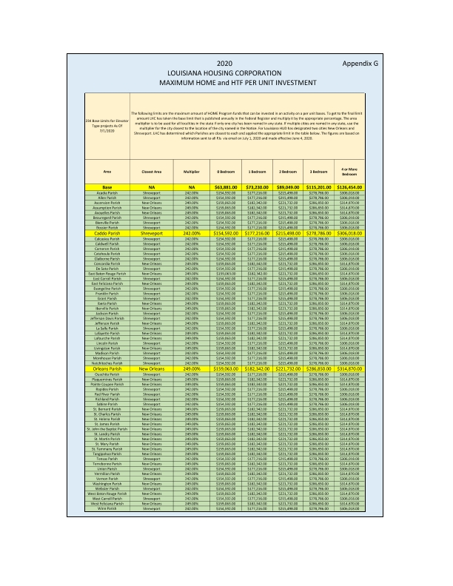

8. Rehabilitation Standards. The grantee must establish rehabilitation standards for all HTF-assisted housing rehabilitation activities that set forth the requirements that the housing must meet upon project completion. The grantee’s description of its standards must be in sufficient detail to determine the required rehabilitation work including methods and materials. The standards may refer to applicable codes or they may establish requirements that exceed the minimum requirements of the codes. The grantee must attach its rehabilitation standards below.
In addition, the rehabilitation standards must address each of the following: health and safety; major systems; lead-based paint; accessibility; disaster mitigation (where relevant); state and local codes, ordinances, and zoning requirements; Uniform Physical Condition Standards; and Capital Needs Assessments (if applicable).

Written Rehabilitation Standards are included in this submission as "Attachment F"; please see the attachment below.

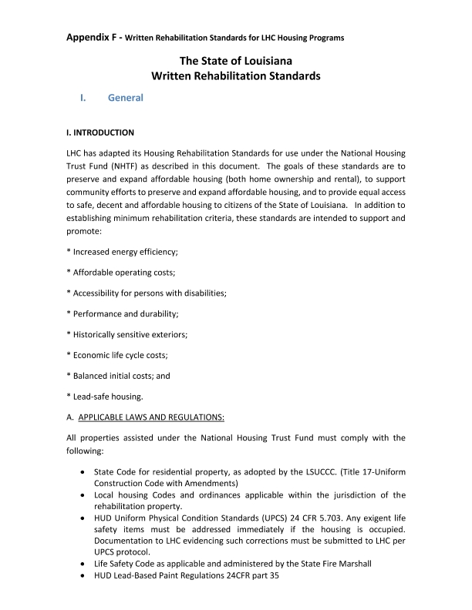
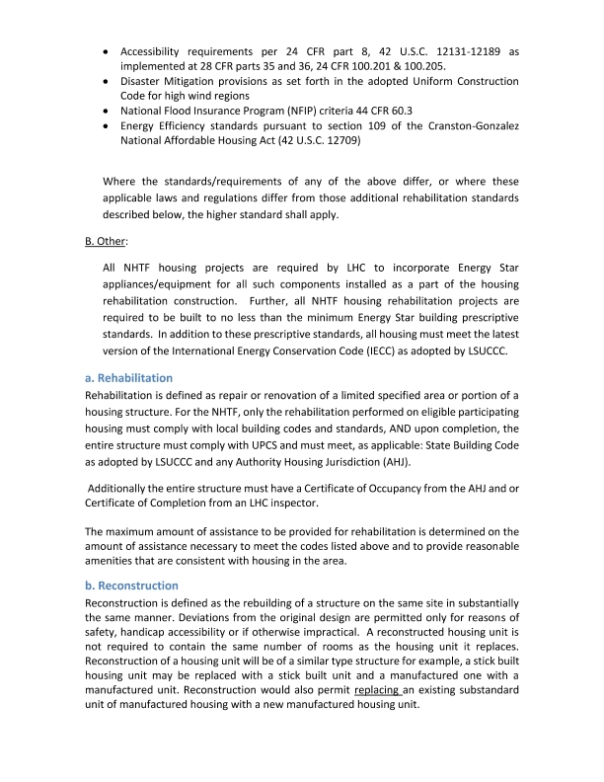
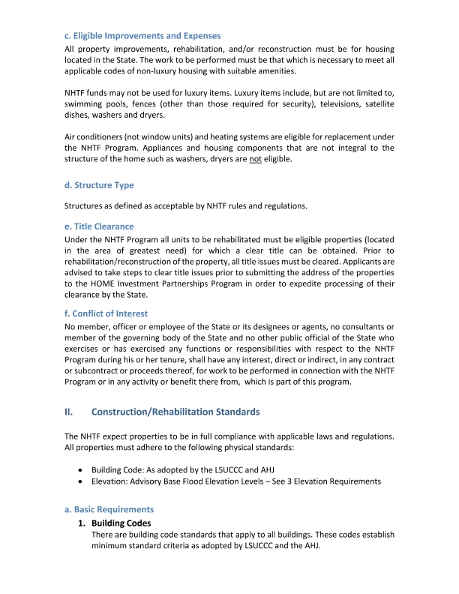
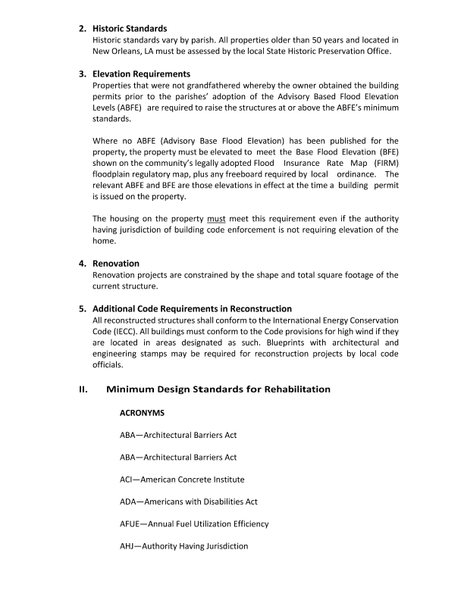
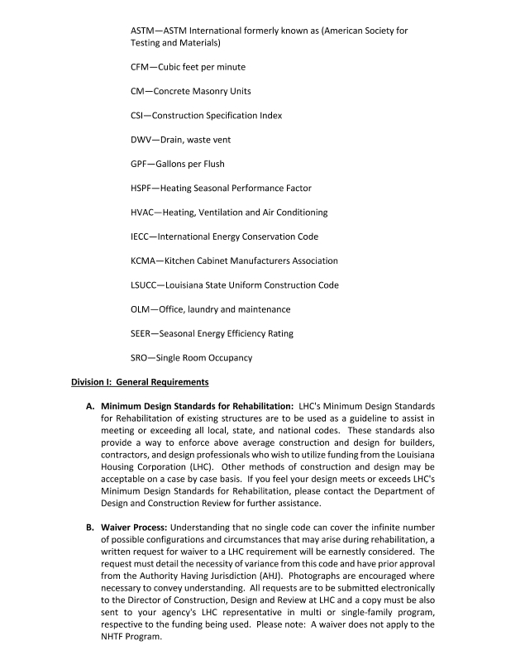
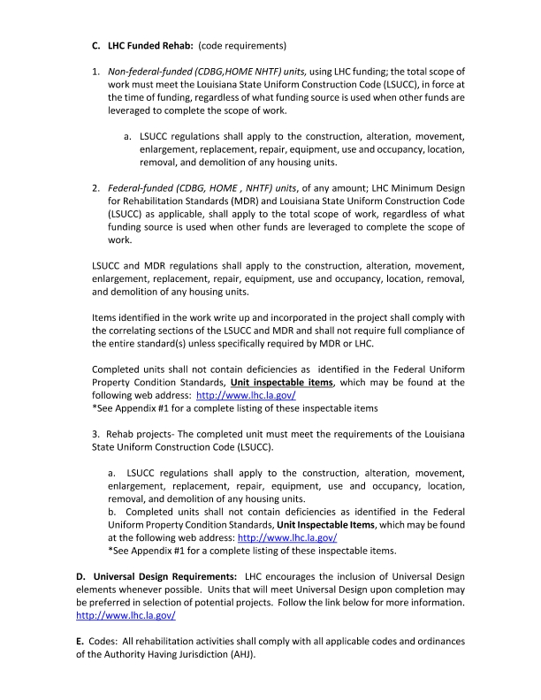
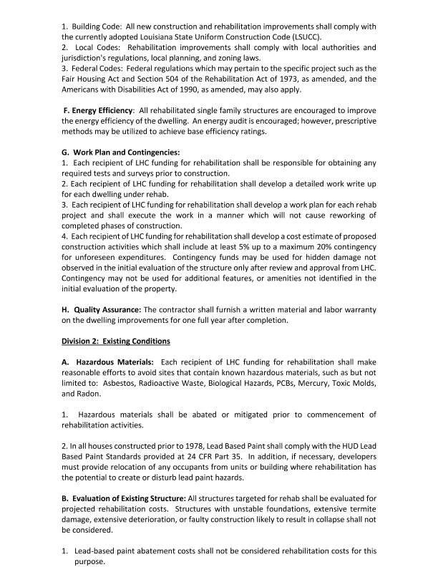
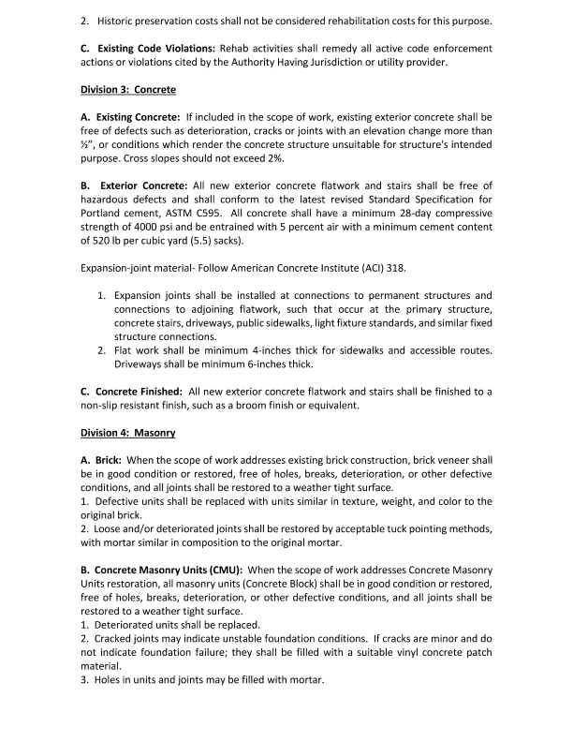
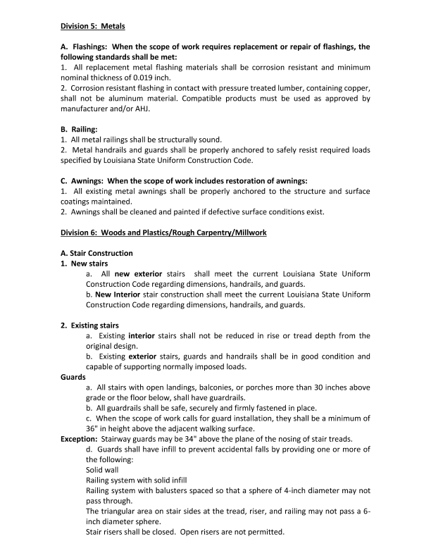
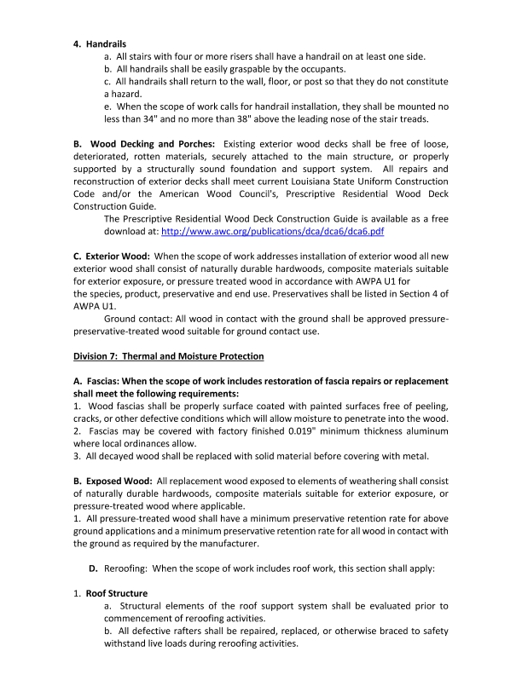
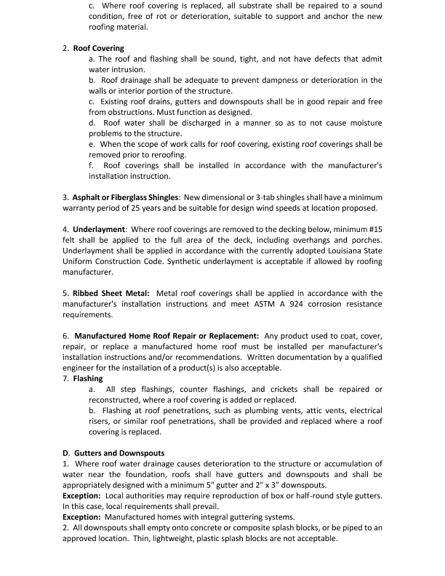
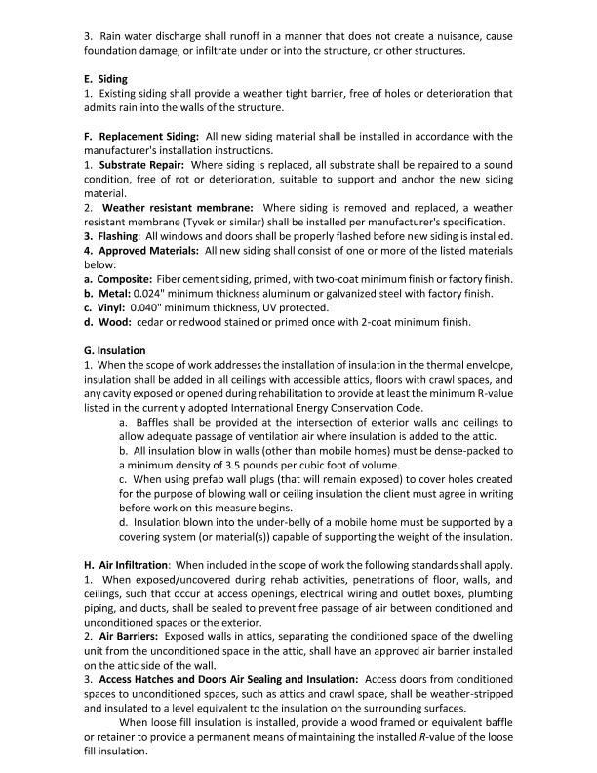
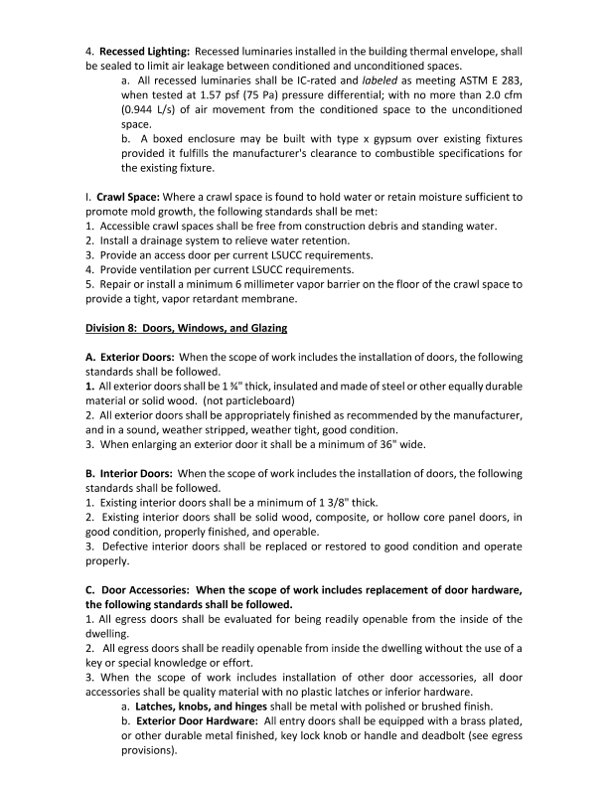
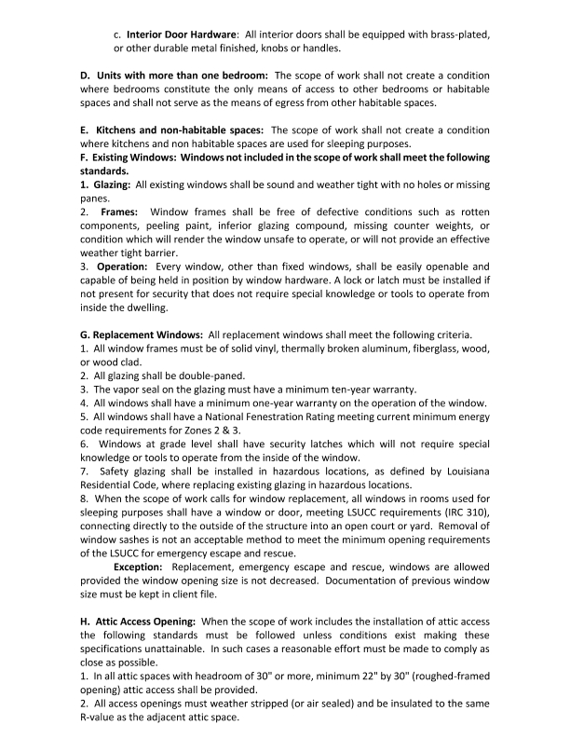
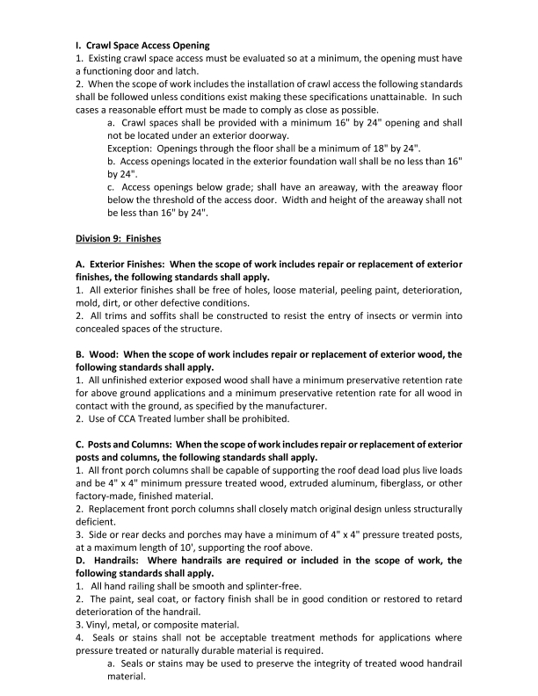
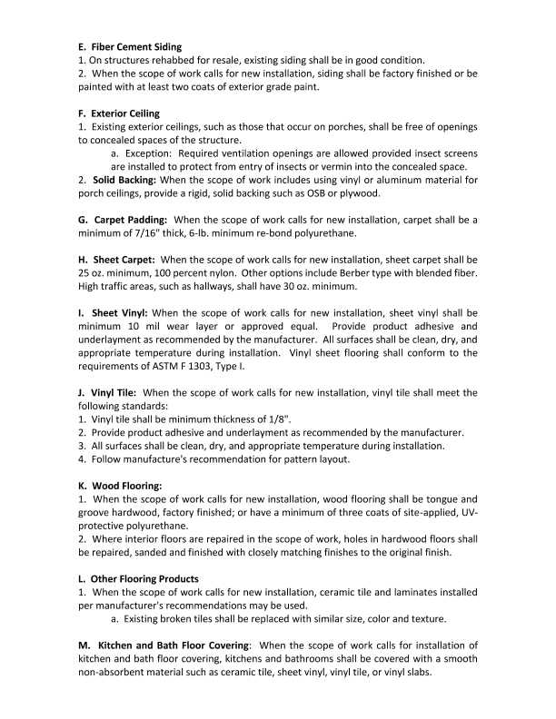
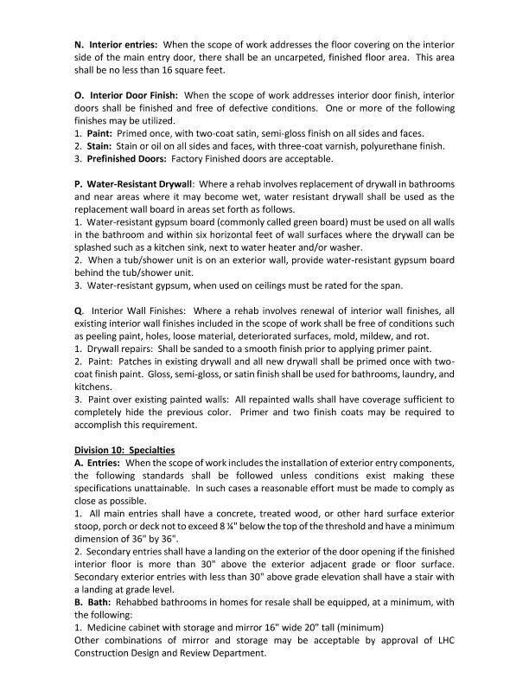
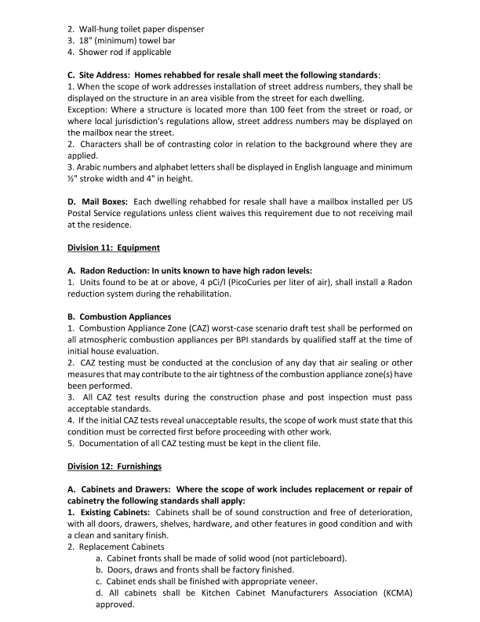
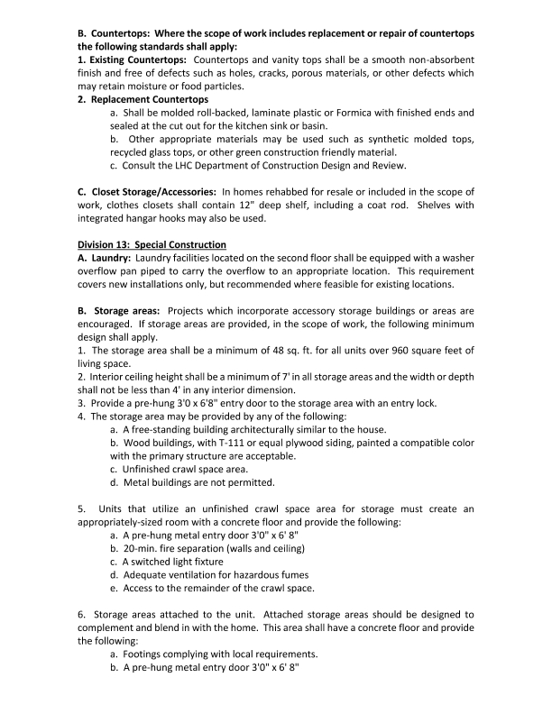
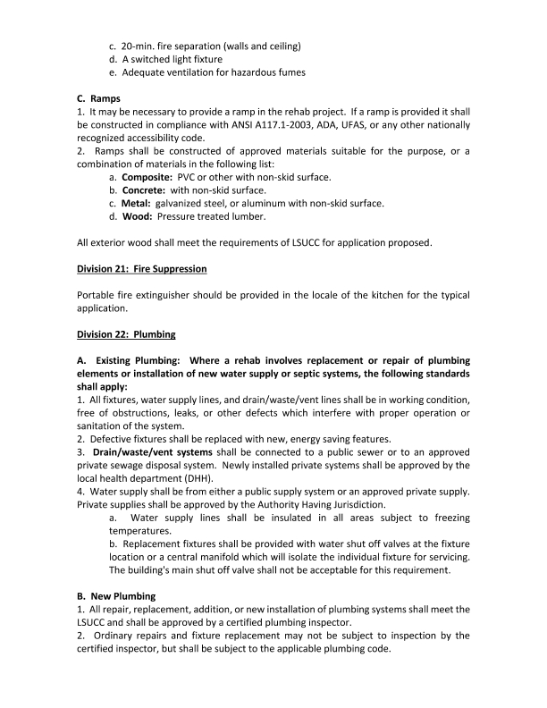
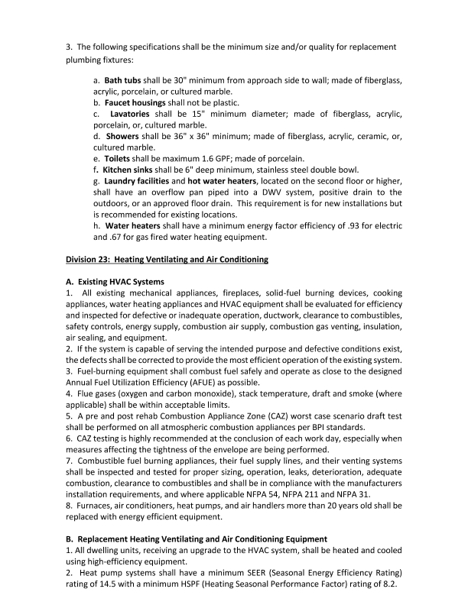
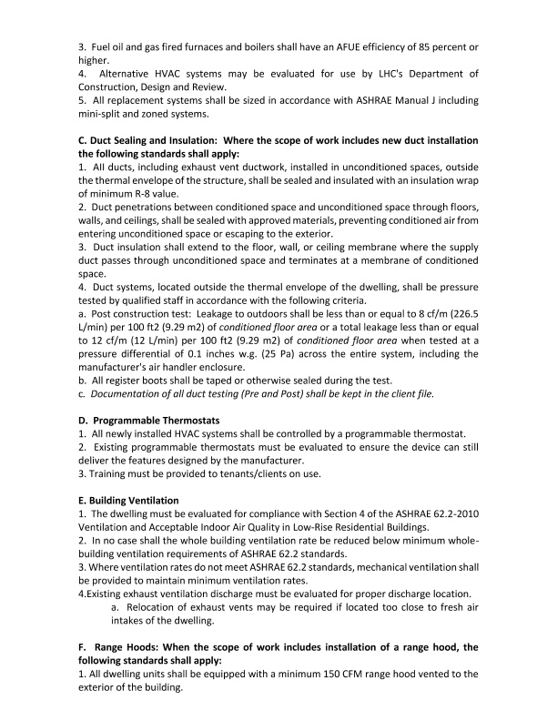
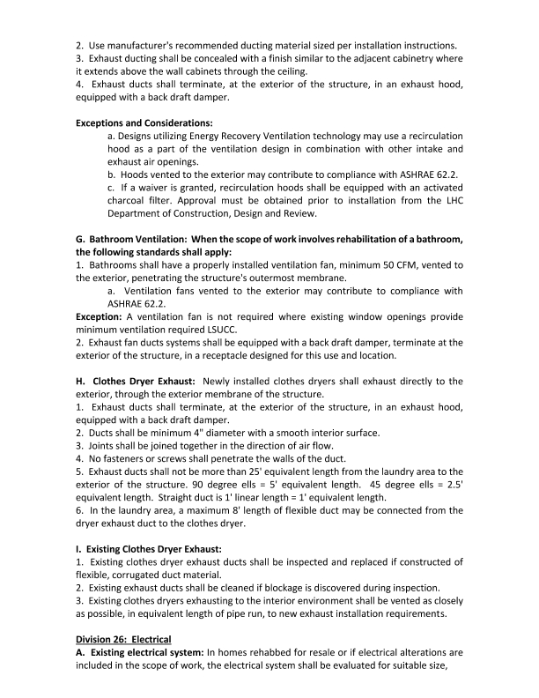
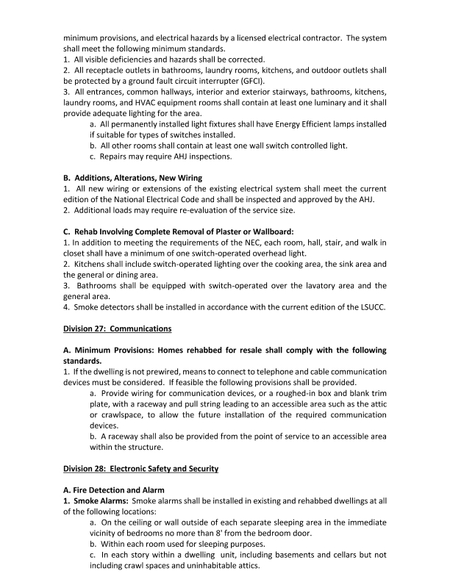
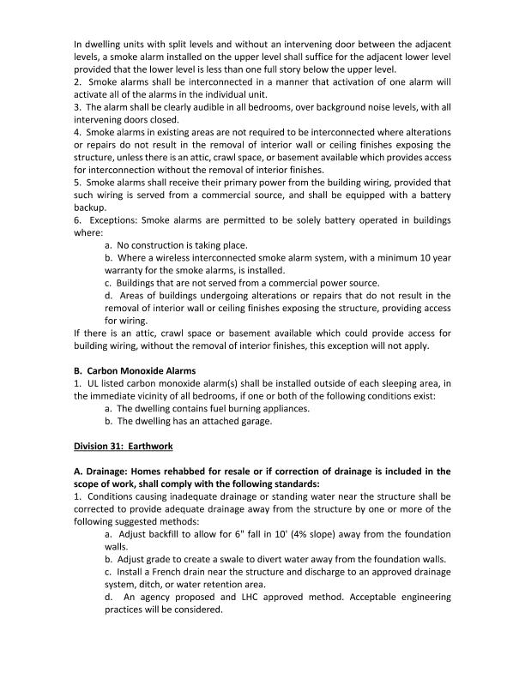
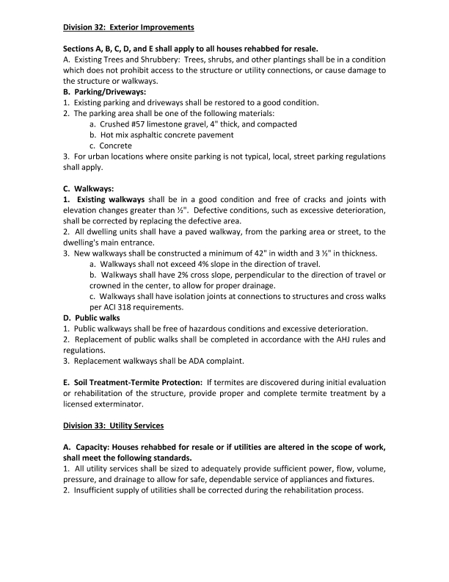
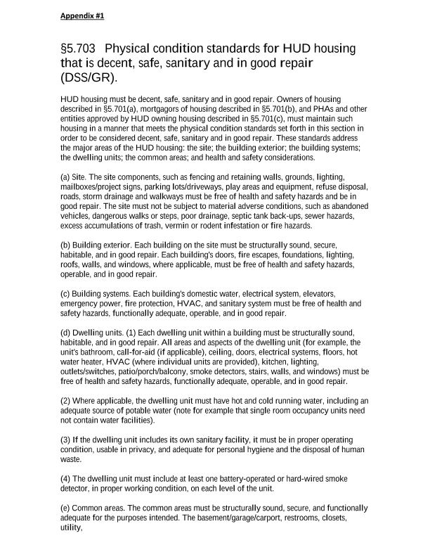
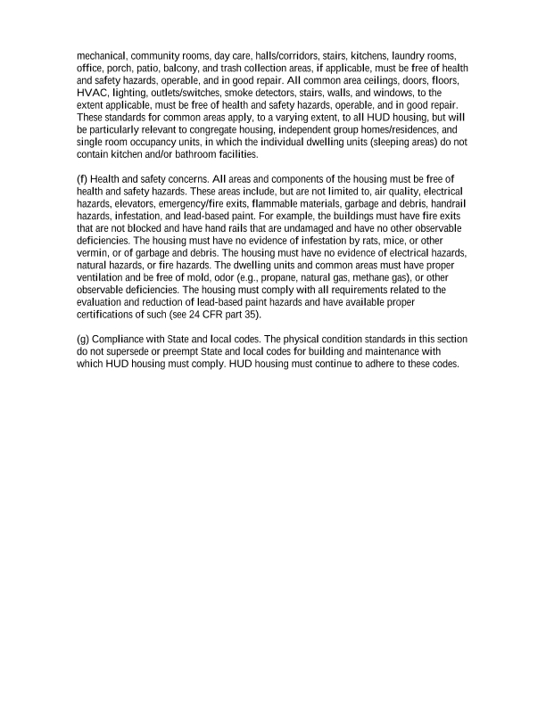
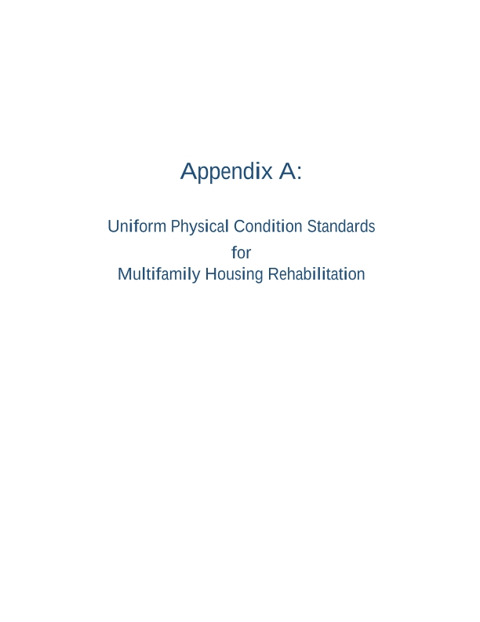
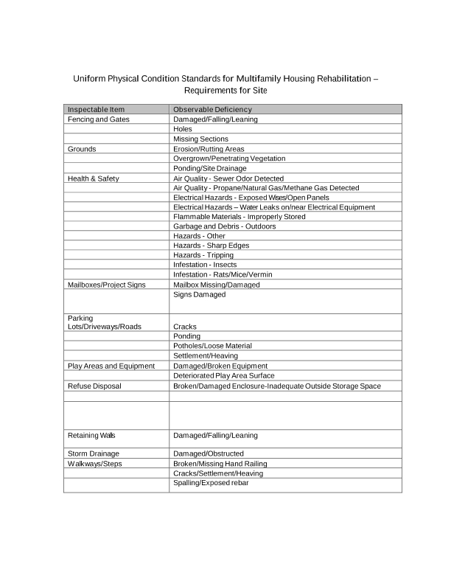
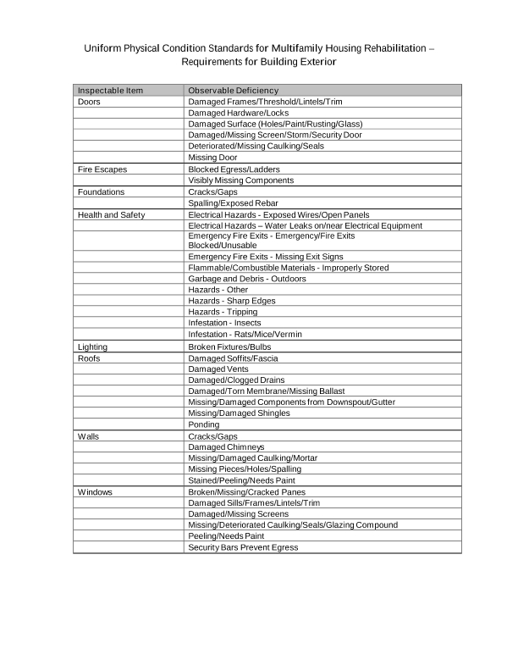
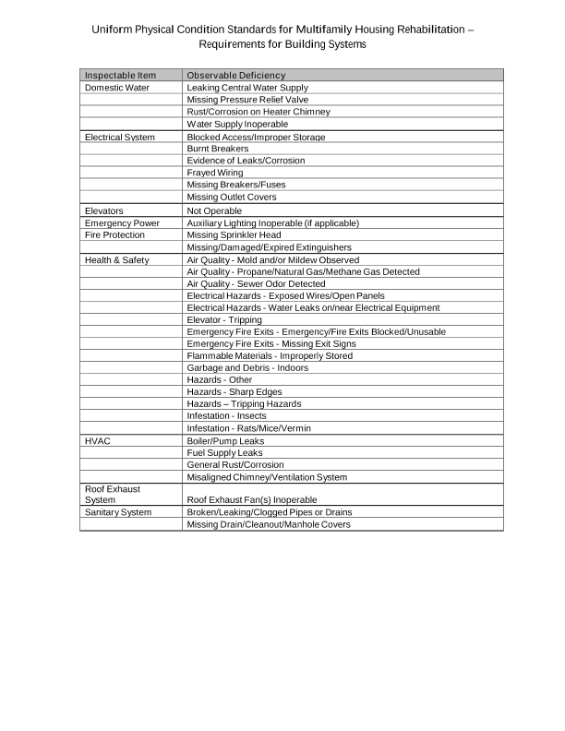
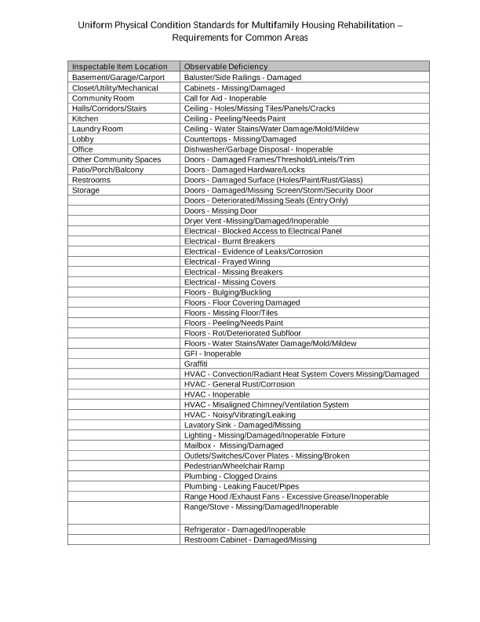
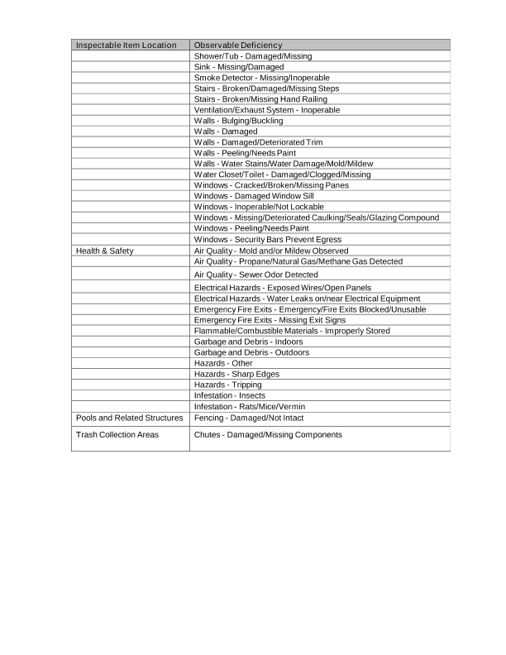
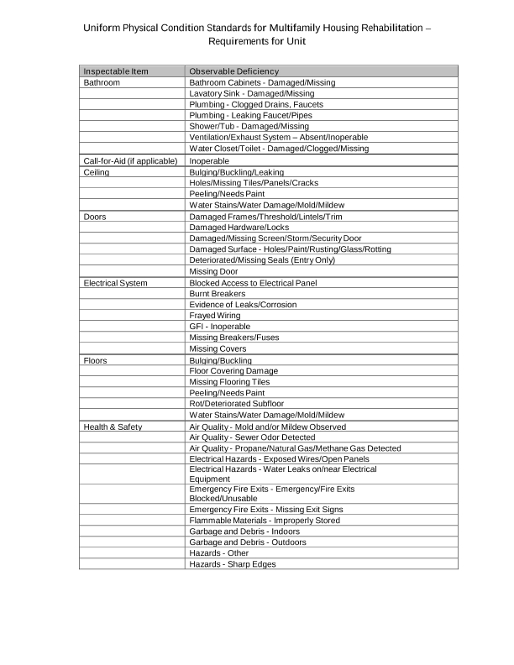
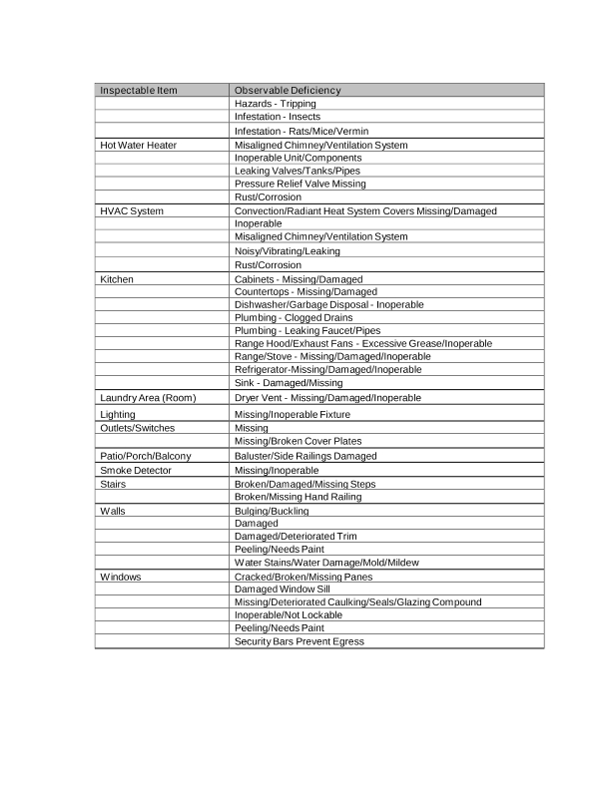
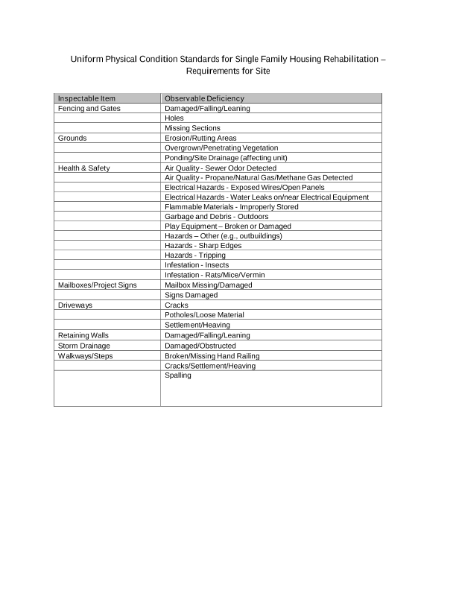
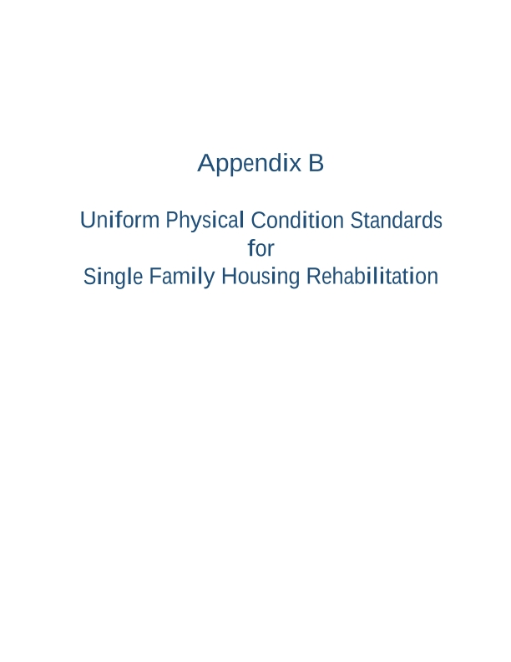
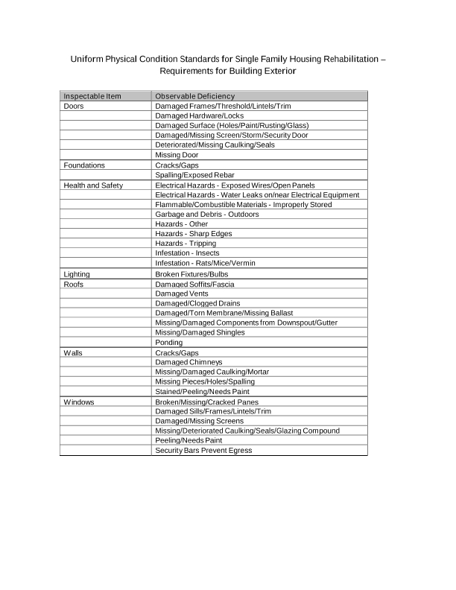
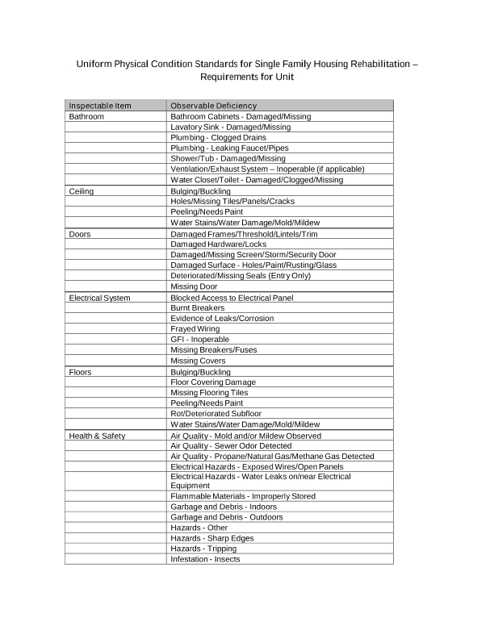
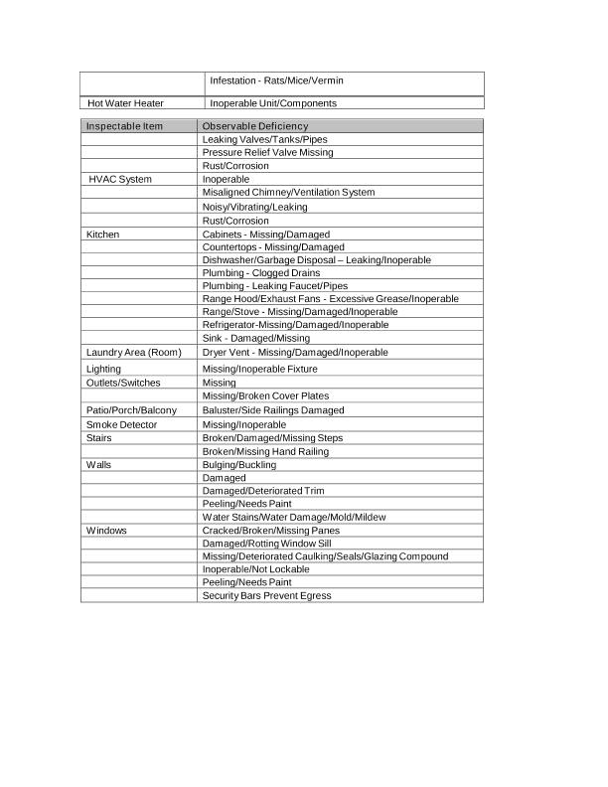
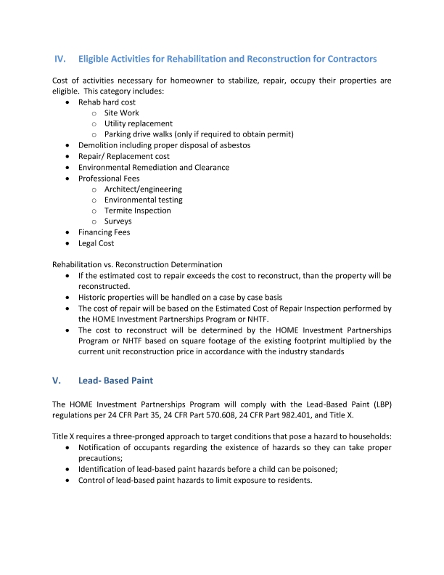
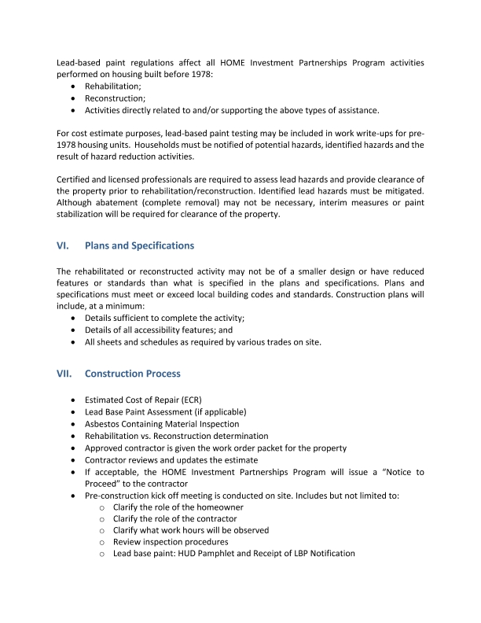
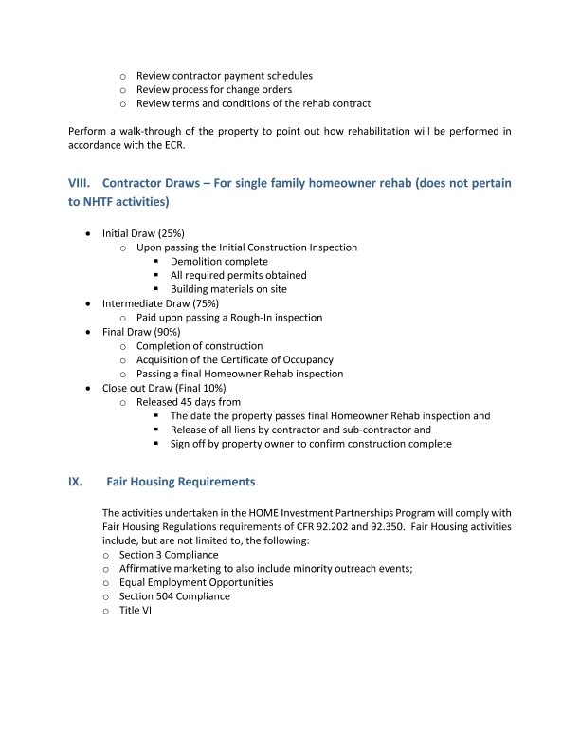
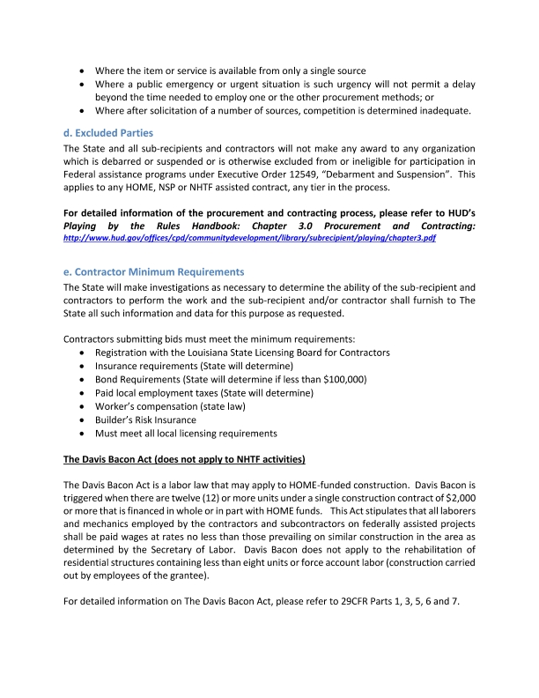
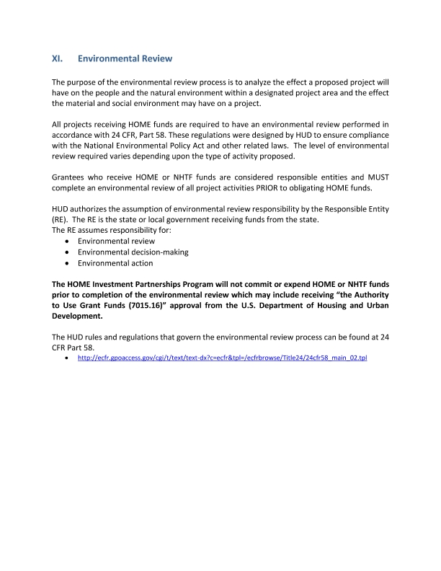

9. Resale or Recapture Guidelines. Below, the grantee must enter (or attach) a description of the guidelines that will be used for resale or recapture of HTF funds when used to assist first-time homebuyers. If the grantee will not use HTF funds to assist first-time homebuyers, enter “N/A”.
Resale or Recapture Guidelines are included in this submission as "Attachment D"; please see the attachment below.

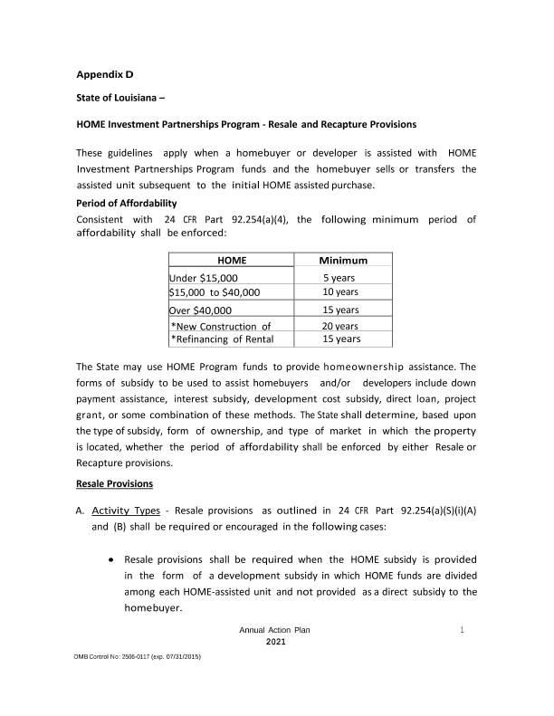
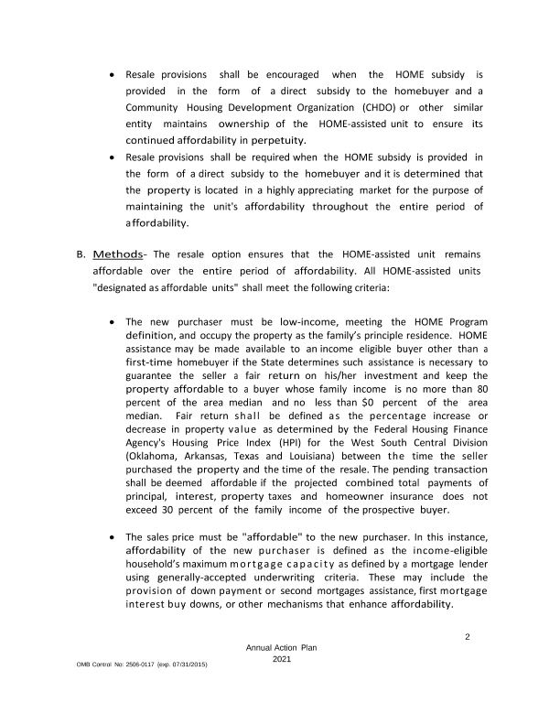
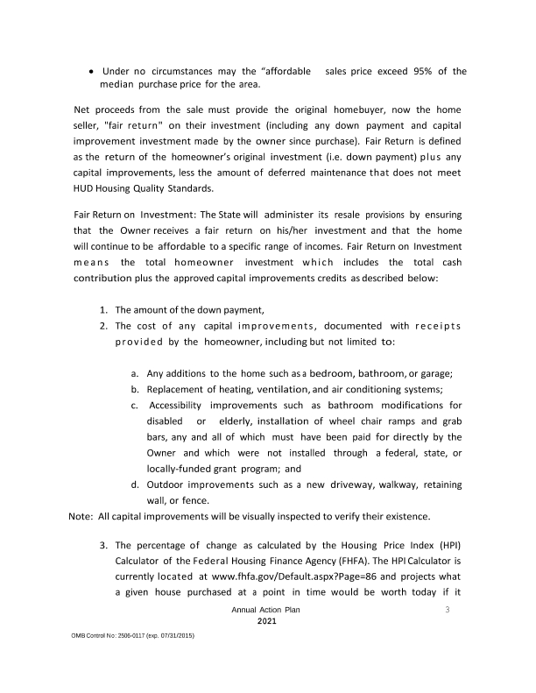
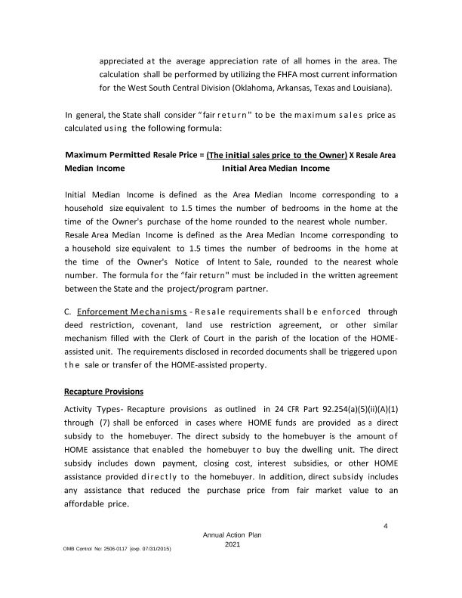
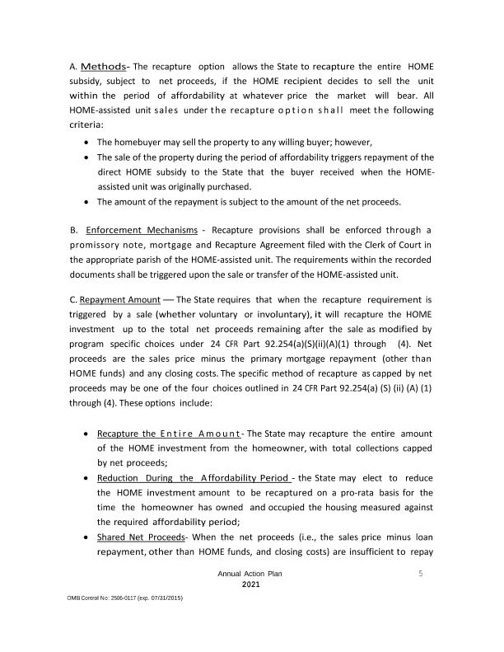
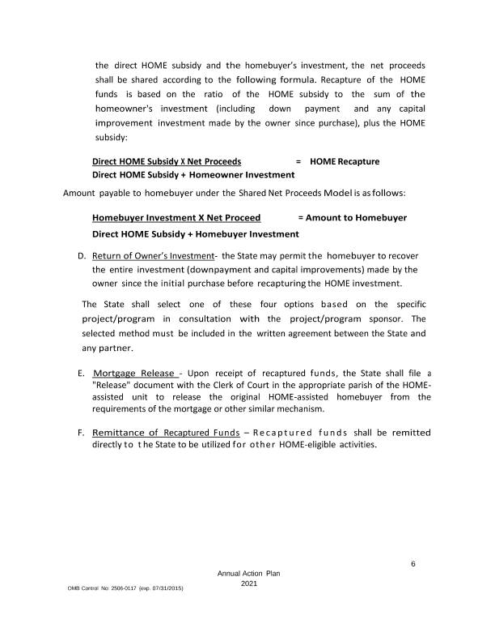

10. HTF Affordable Homeownership Limits. If the grantee intends to use HTF funds for homebuyer assistance and does not use the HTF affordable homeownership limits for the area provided by HUD, it must determine 95 percent of the median area purchase price and set forth the information in accordance with §93.305. If the grantee will not use HTF funds to assist first-time homebuyers, enter “N/A”.
The grantee will use the HUD issued affordable homeownership limits.

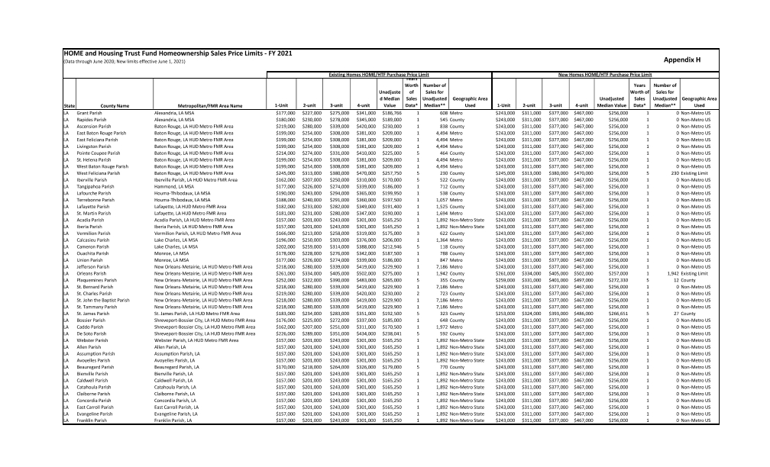
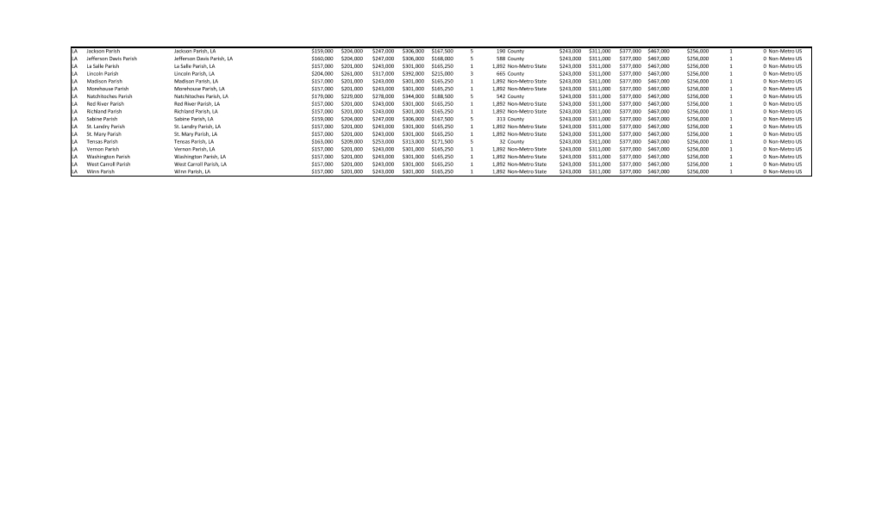
11. Grantee Limited Beneficiaries or Preferences. Describe how the grantee will limit the beneficiaries or give preferences to a particular segment of the extremely low- or very low-income population to serve unmet needs identified in its consolidated plan or annual action plan. If the grantee will not limit the beneficiaries or give preferences to a particular segment of the extremely low- or very low-income population, enter “N/A.”
Any limitation or preference must not violate nondiscrimination requirements in § 93.350, and the grantee must not limit or give preferences to students. The grantee may permit rental housing owners to limit tenants or give a preference in accordance with § 93.303(d)(3) only if such limitation or preference is described in the action plan.
N/A
12. Refinancing of Existing Debt. Enter or attach the grantee’s refinancing guidelines below. The guidelines describe the conditions under which the grantee will refinance existing debt. The grantee’s refinancing guidelines must, at minimum, demonstrate that rehabilitation is the primary eligible activity and ensure that this requirement is met by establishing a minimum level of rehabilitation per unit or a required ratio between rehabilitation and refinancing. If the grantee will not refinance existing debt, enter “N/A.”
Multifamily projects that receive NHTF funds for rehabilitation may utilize those funds to refinance existing debt consistent with 24 CFR 93.201(b) if they meet the following guidelines: 1. Refinancing is necessary to reduce the overall housing costs and to make the housing more affordable and proportional to the number of HTF- assisted units in the rental project. 2. Rehabilitation is the primary eligible activity (at a minimum, greater than 51% of the rehabilitation acitivity). A minimum of $7,500 of rehabilitation per unit is required. The proportional rehabilitation cost must be greater than the proportional amount of debt that is refinanced. 3. The grantee must demonstrate management capacity and practices that ensure that the long term needs of the project can be met and the targeted population can be served over an extended affordability period. 4. The grantee must demonstrate that the new investment is being made to maintain current affordable units, to create greater affordability in current affordable units, to create additional affordable units, or to continue the affordability of units that could be lost. 5. Refinancing will be limited to projects that have previously received an investment of public funds. 6. The minimum NHTF affordability period shall be thirty (30) years. 7. NHTF funds cannot be used to refinance multifamily loans made or insured by any Federal program, including CDBG. 8. Refinancing will only be allowed for projects that can produce estoppel letters from all current debt or lien holders. The estoppel letters must state clearly that there is not currently an instance of default or any condition that, if persisting, would lead to an instance of default over the next two years. Also, the letter must state that the current debt/ lien holders have no plans to seek remedy for any existing condition by means of foreclosure, deed in lieu of foreclosure or a dation en paiement.

Discussion:

Attachments

Citizen Participation Comments
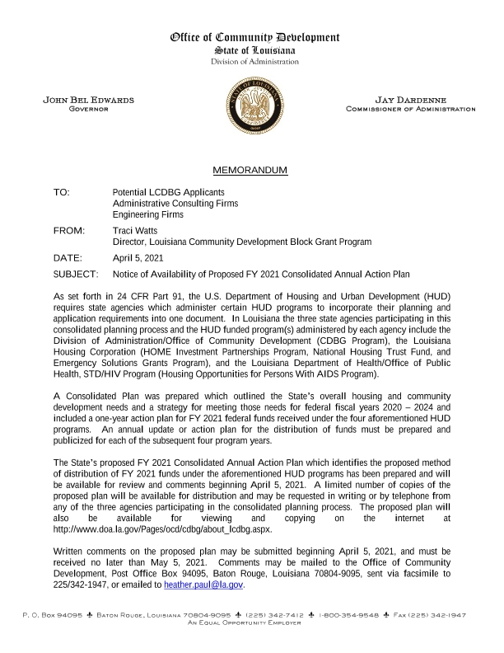
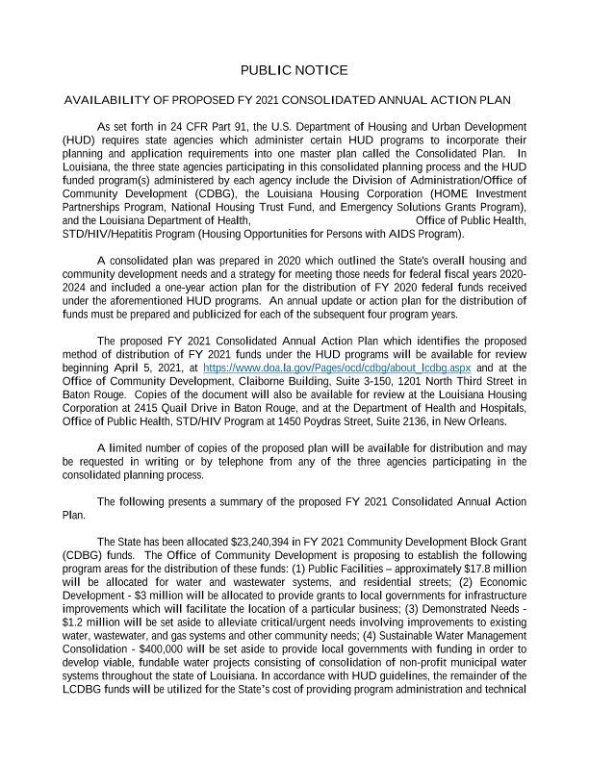
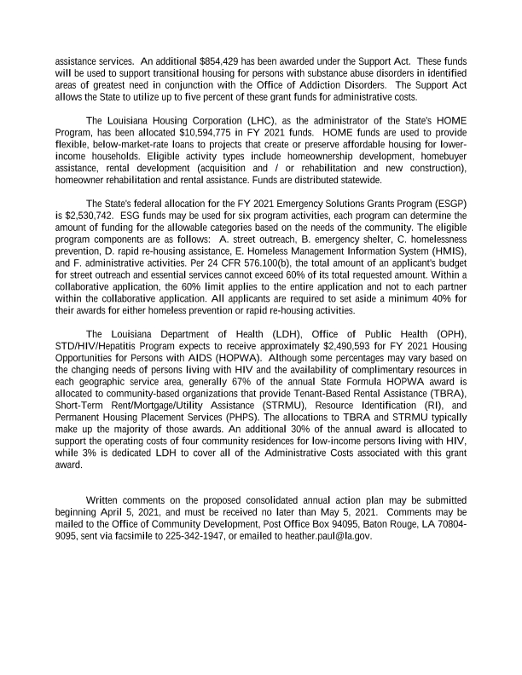
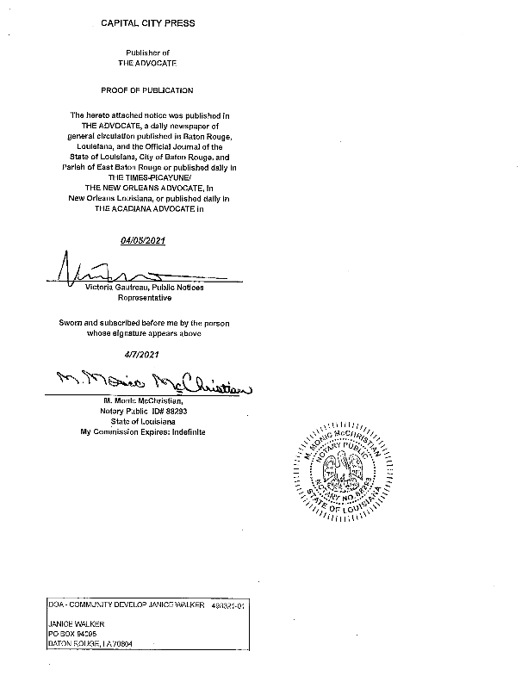
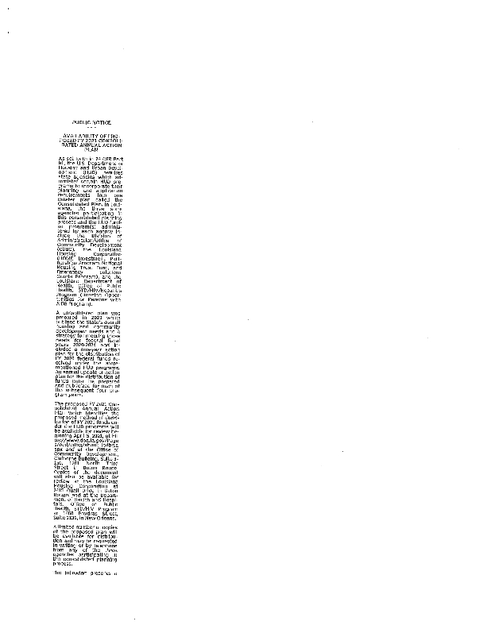
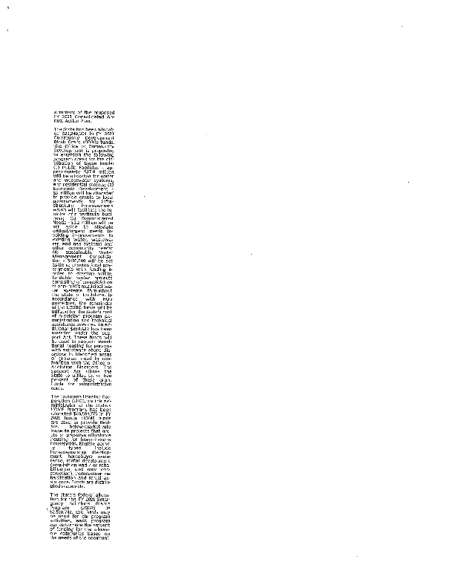
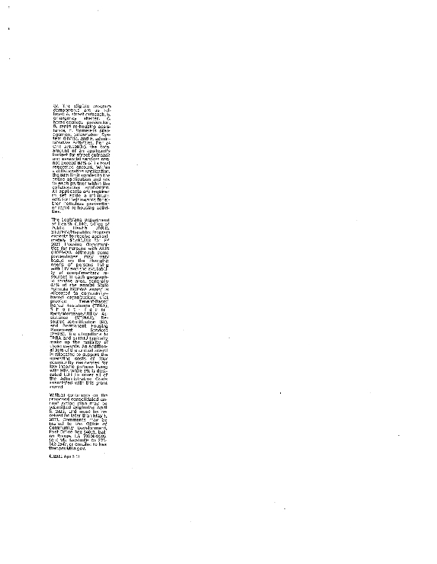

Grantee Unique Appendices
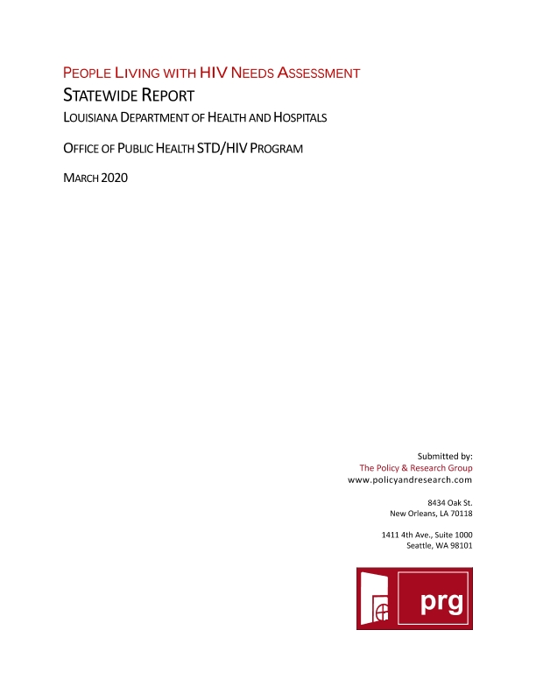
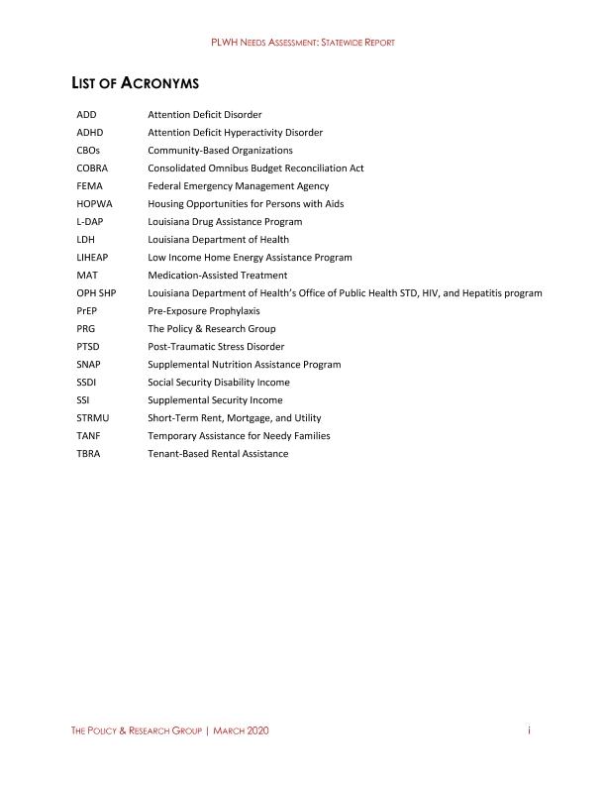
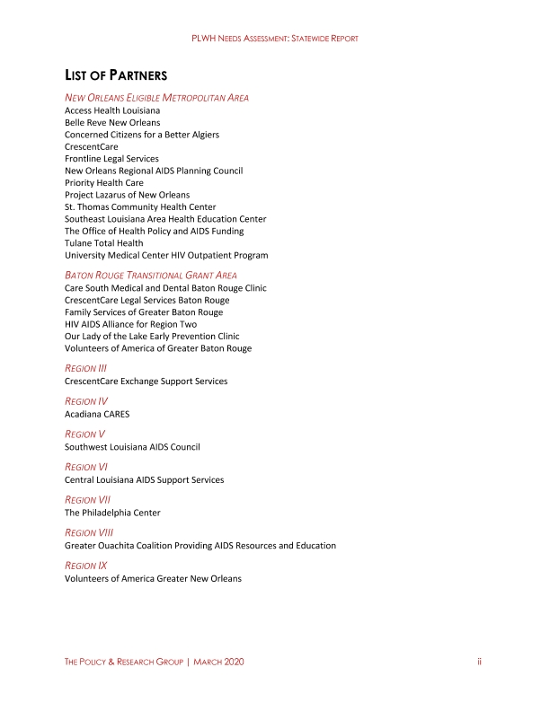
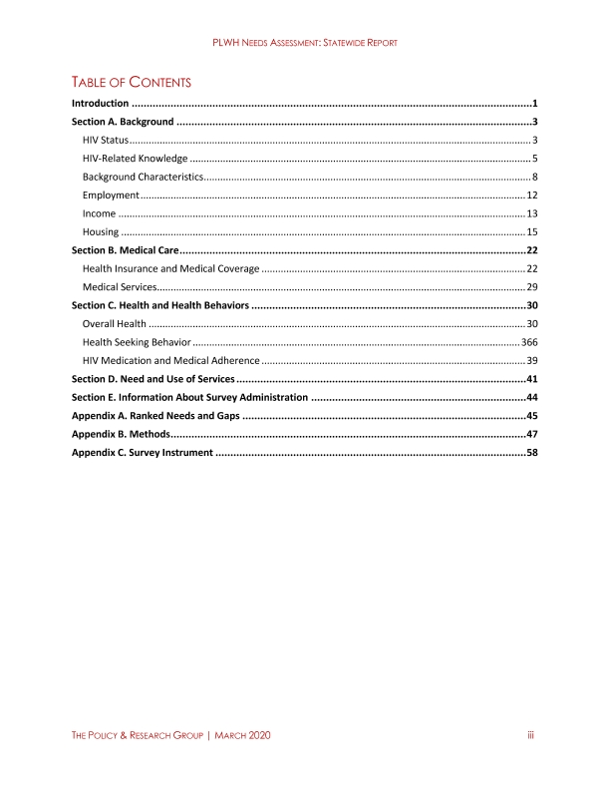
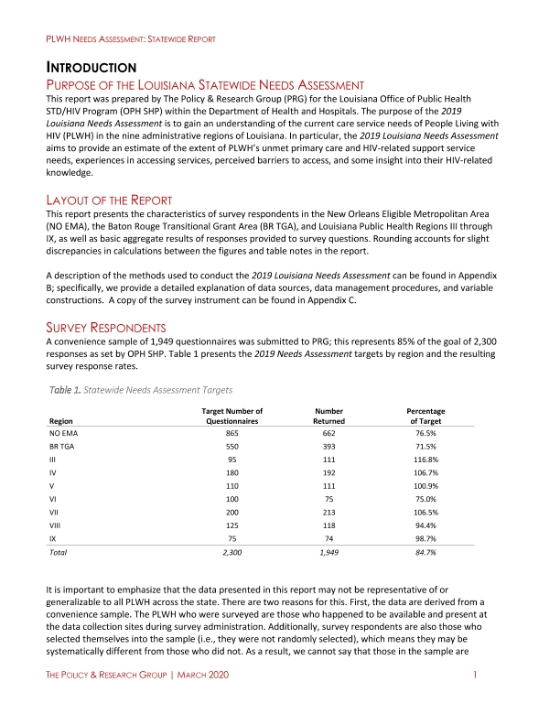
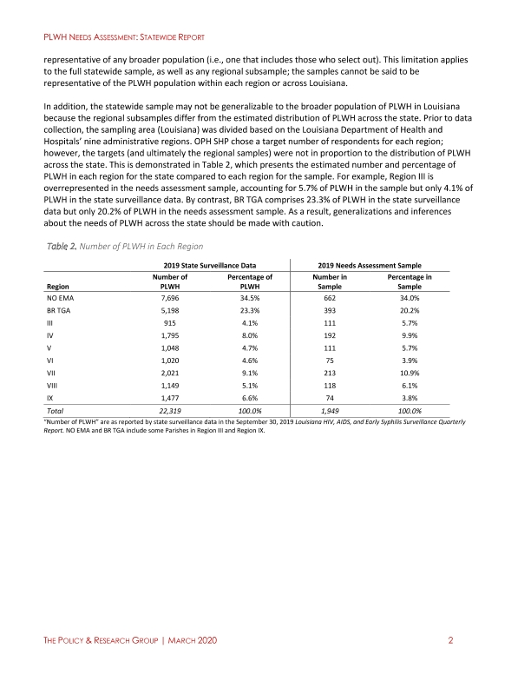
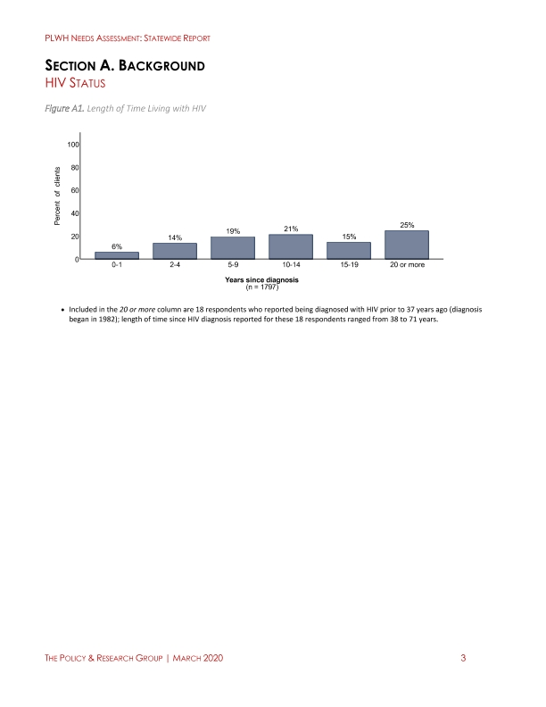
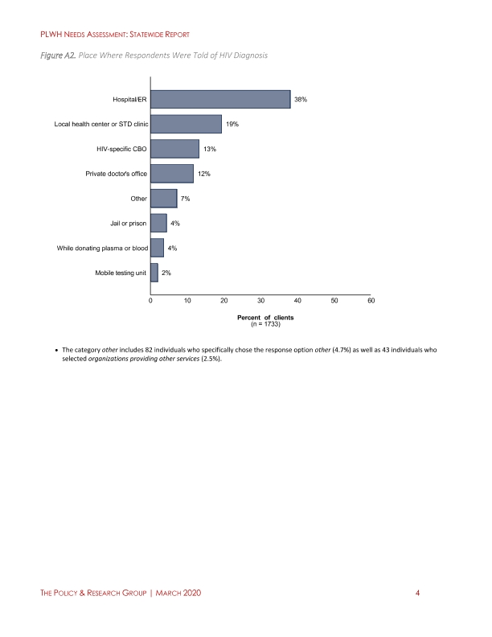
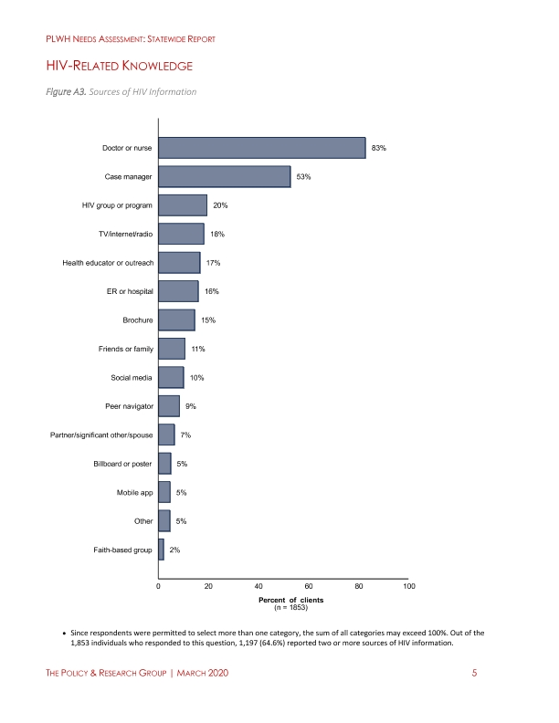
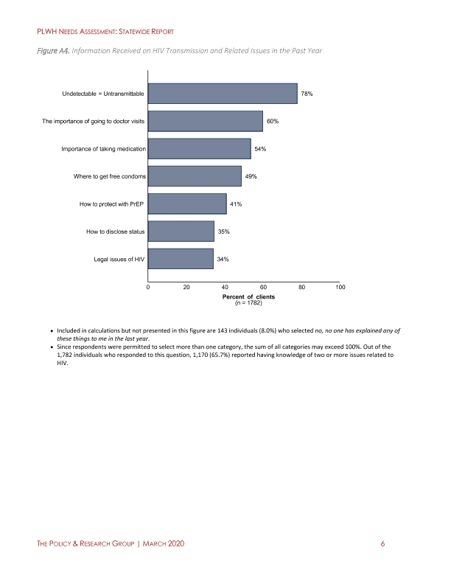
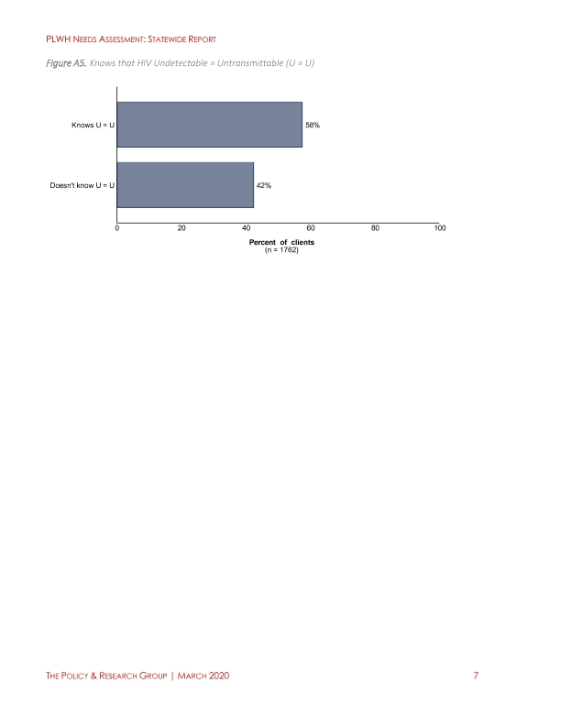
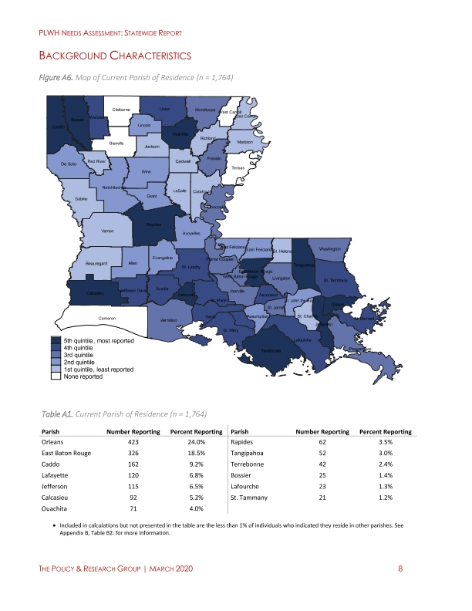
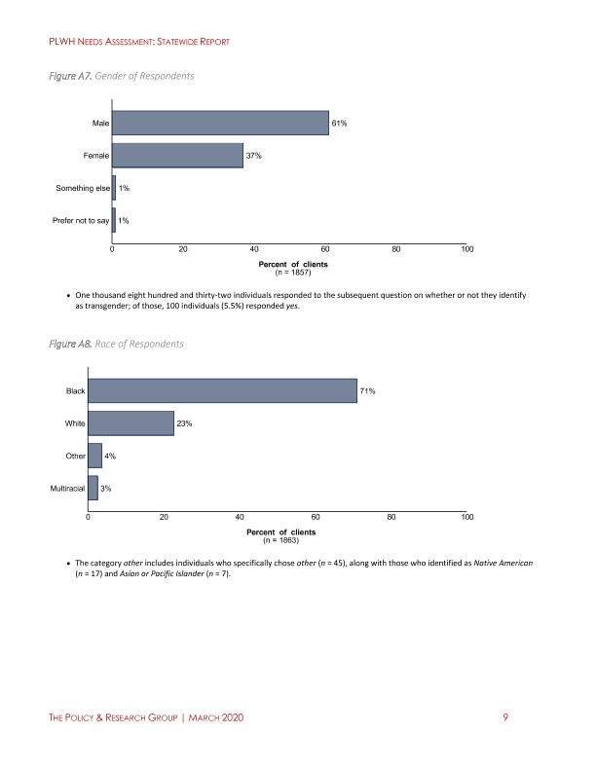
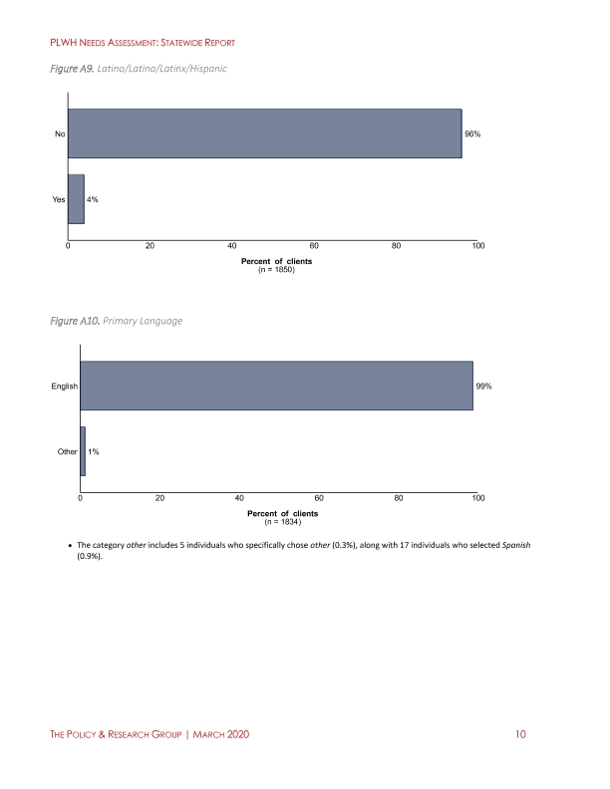
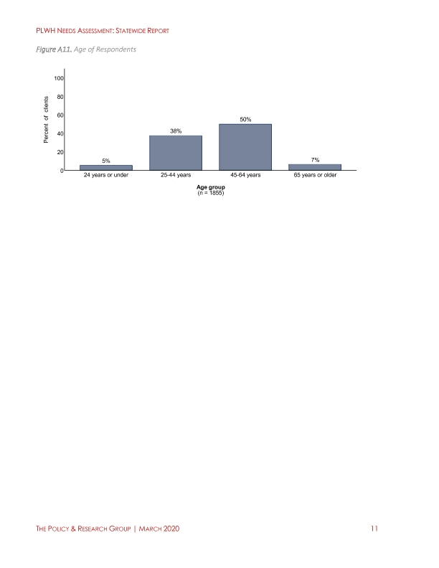
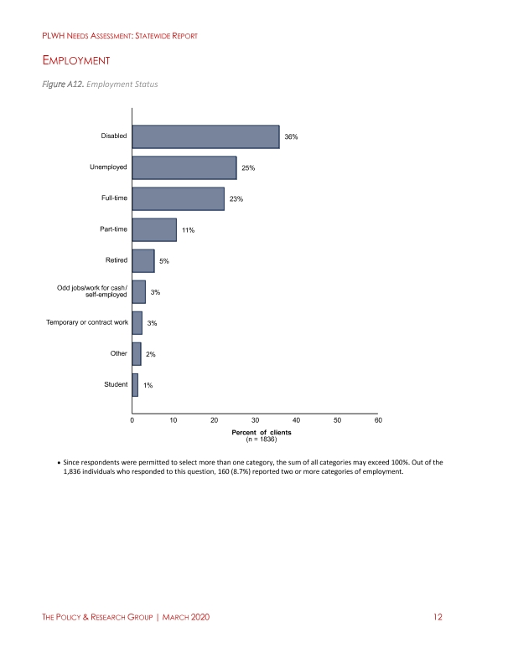
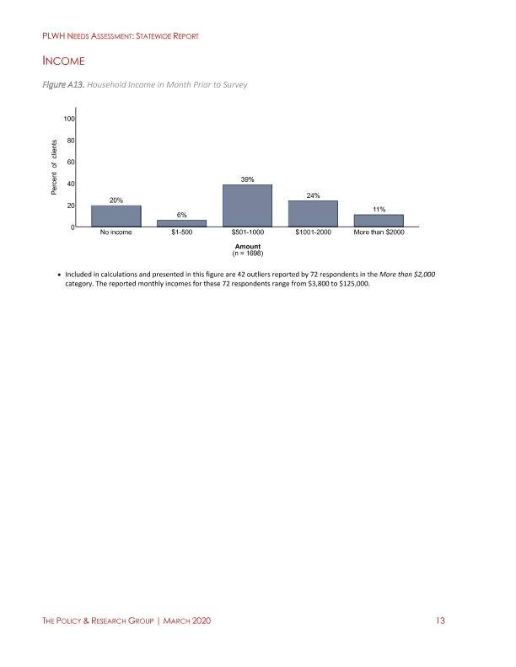
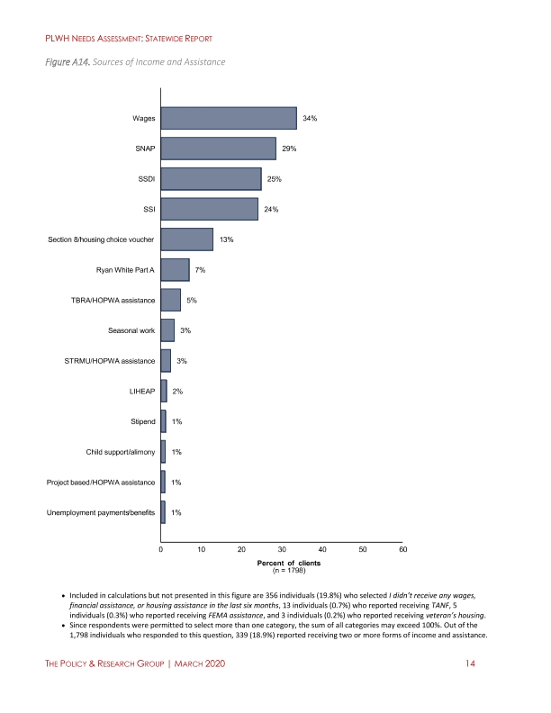
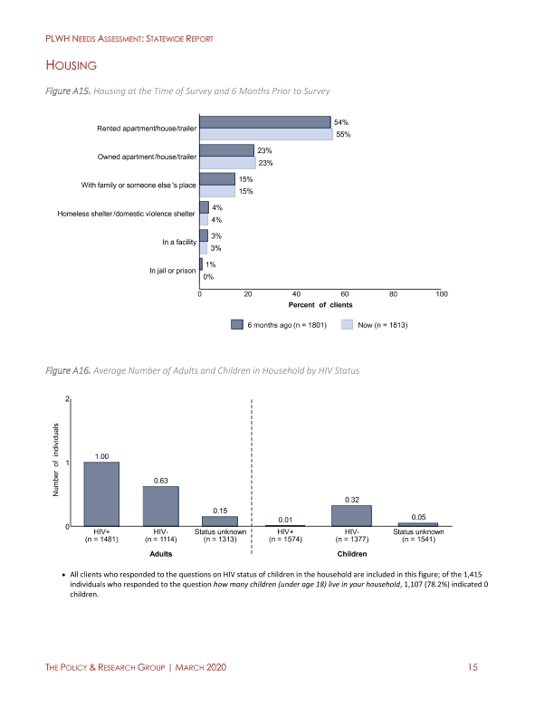
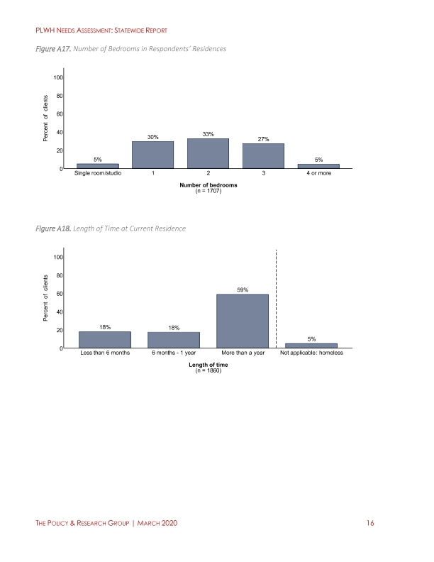
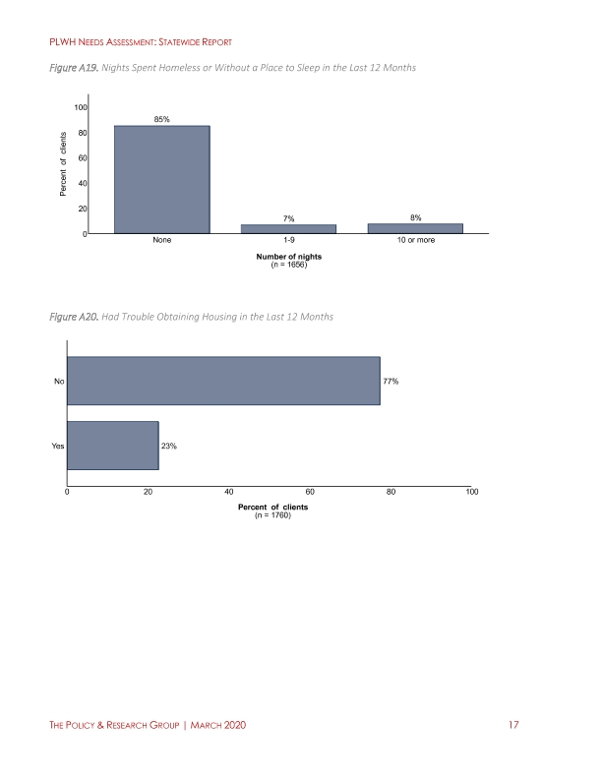
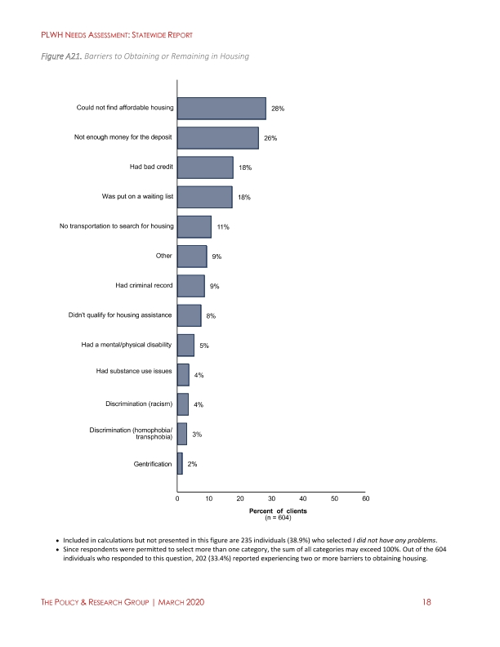
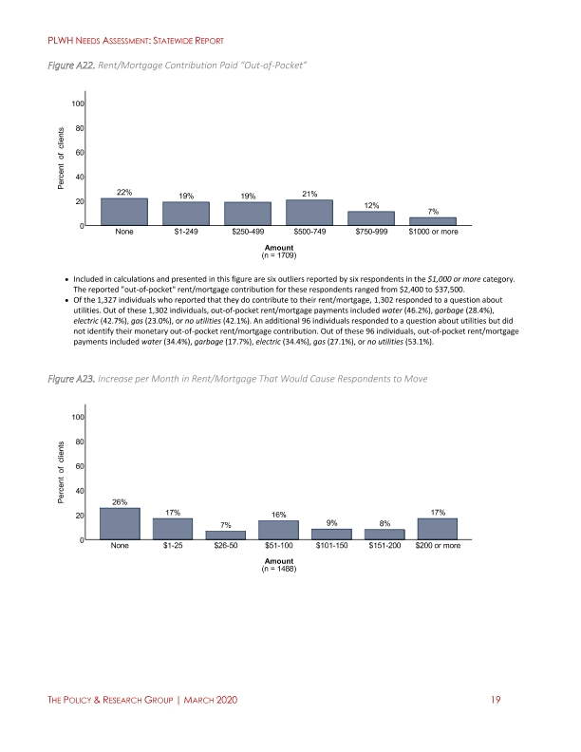
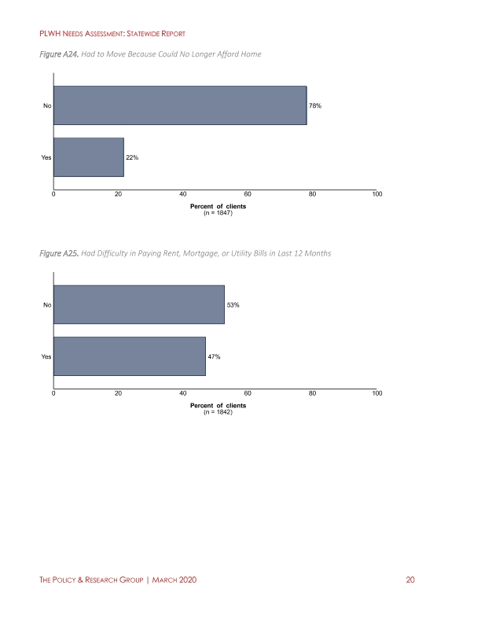
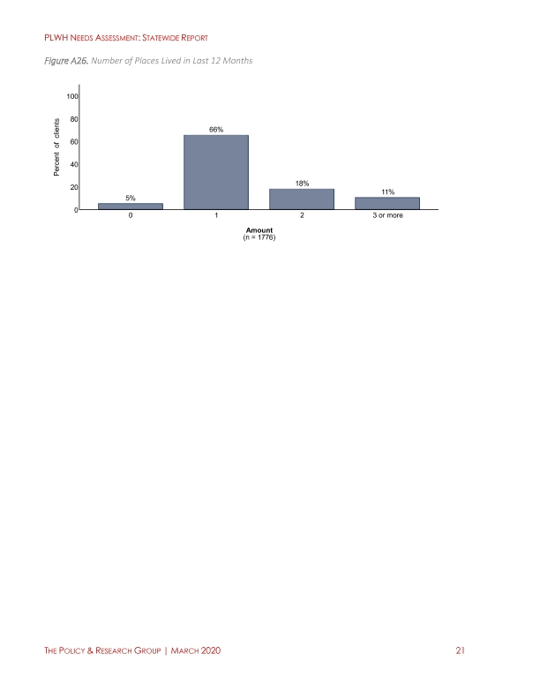
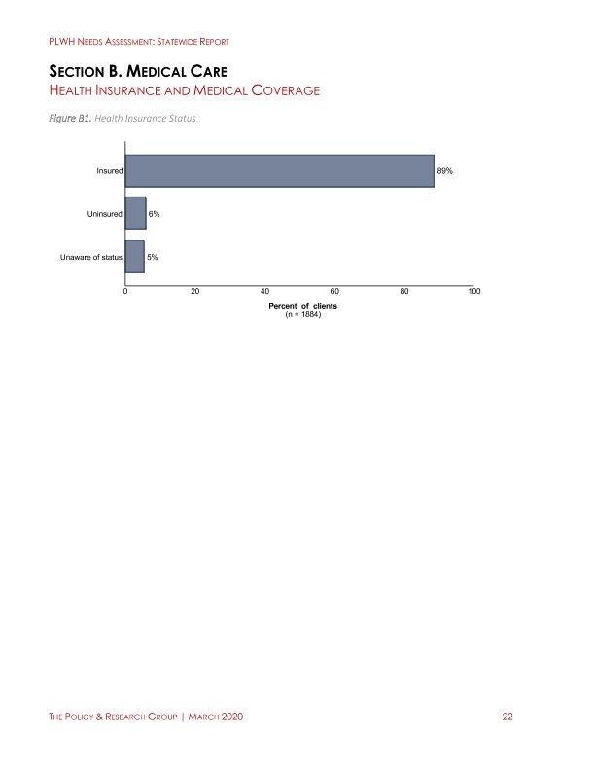
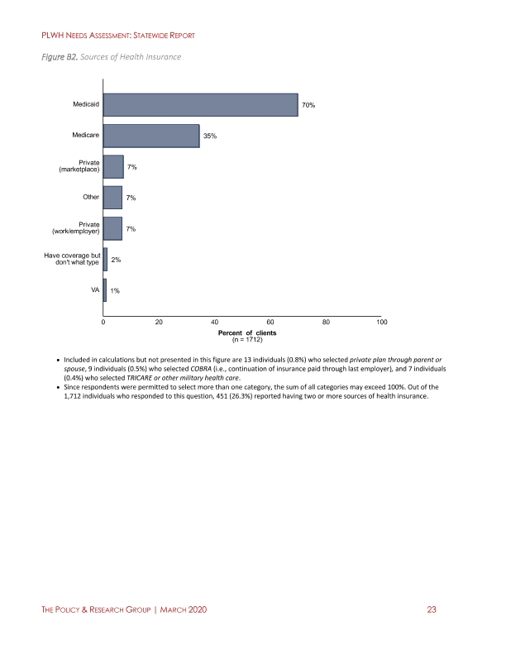
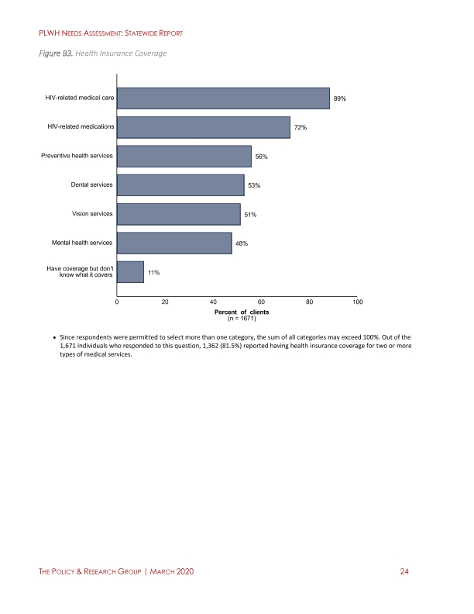
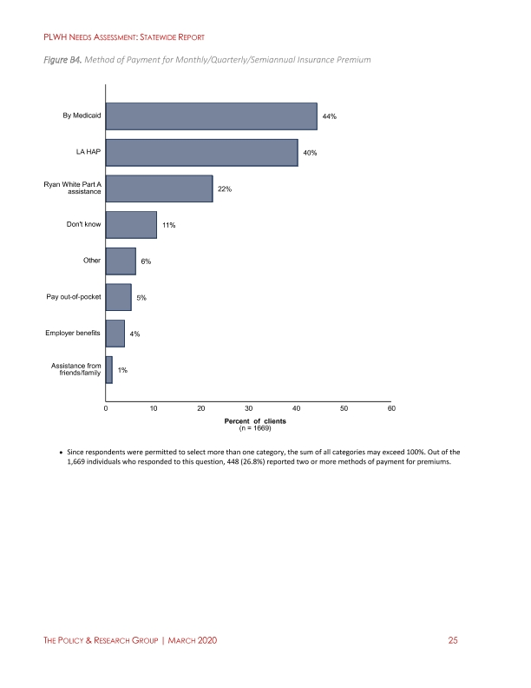
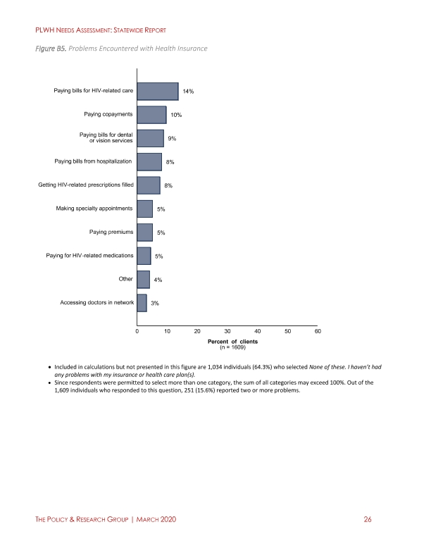
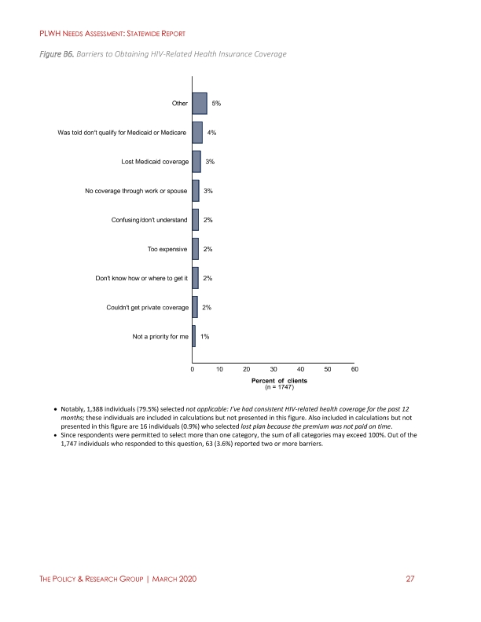
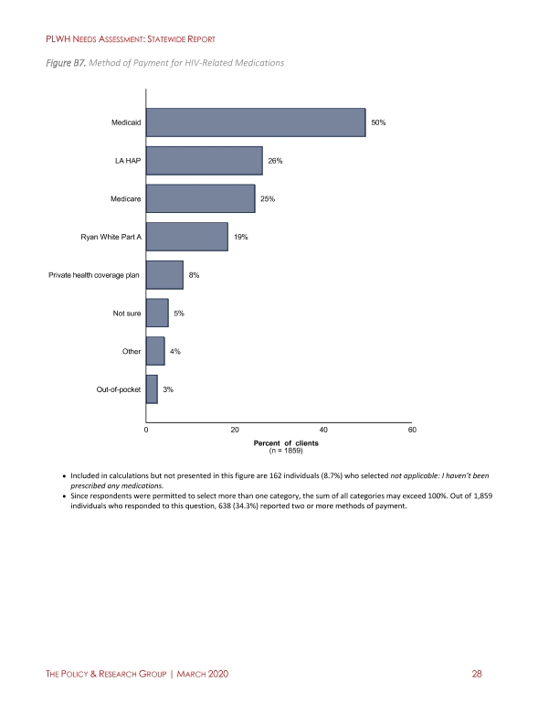
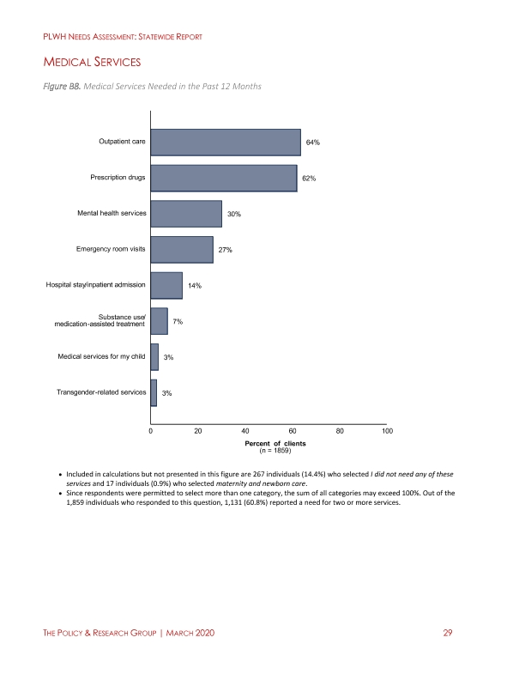
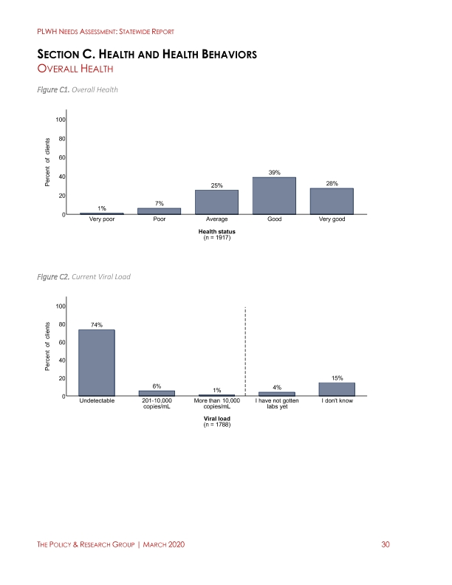
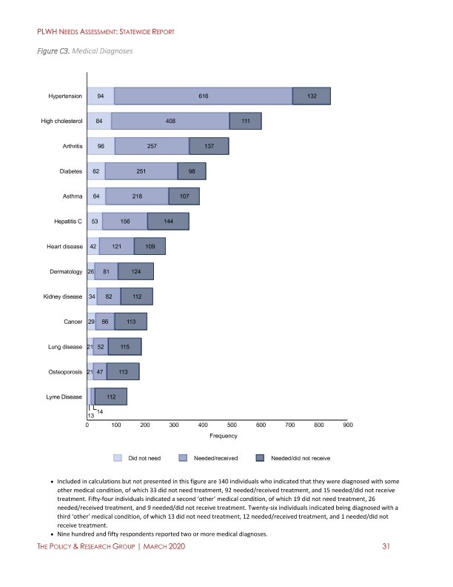
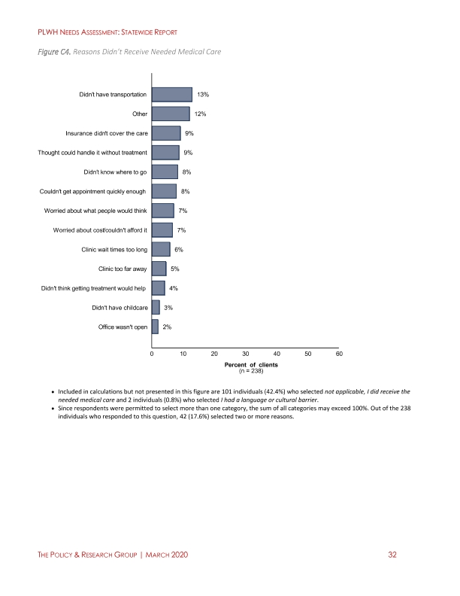
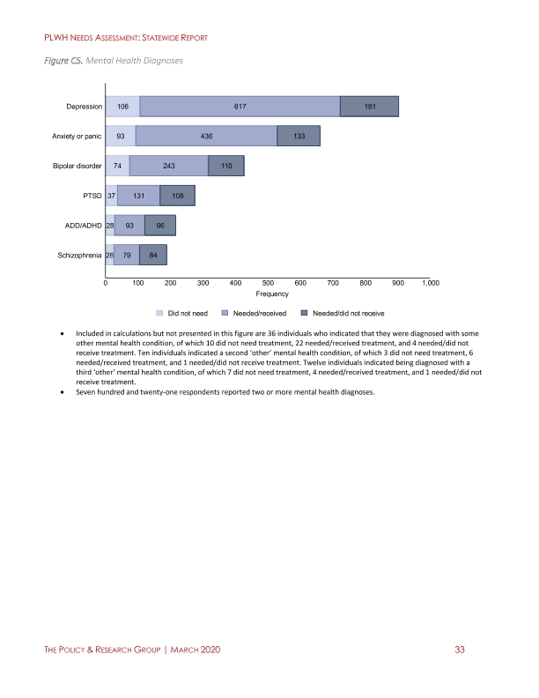
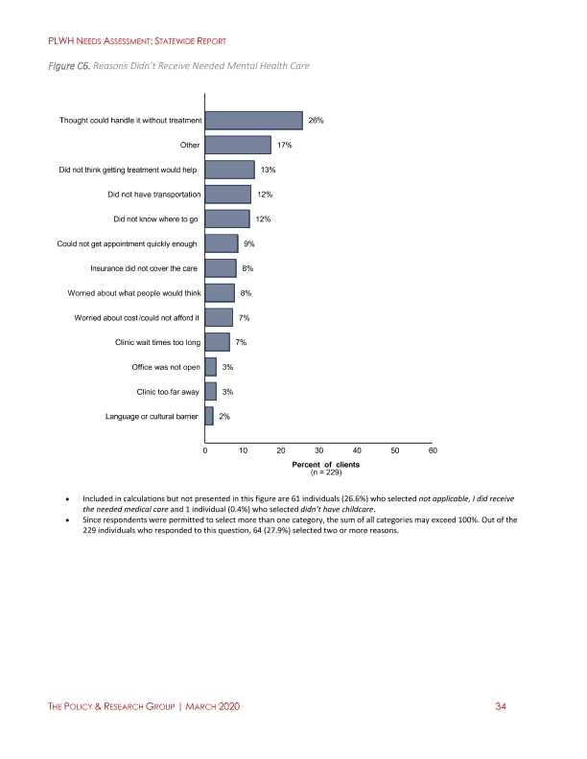
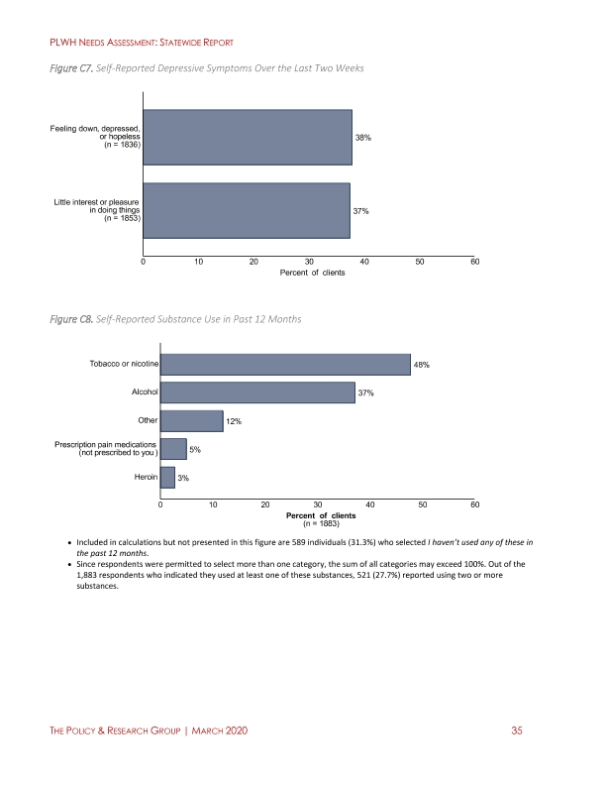
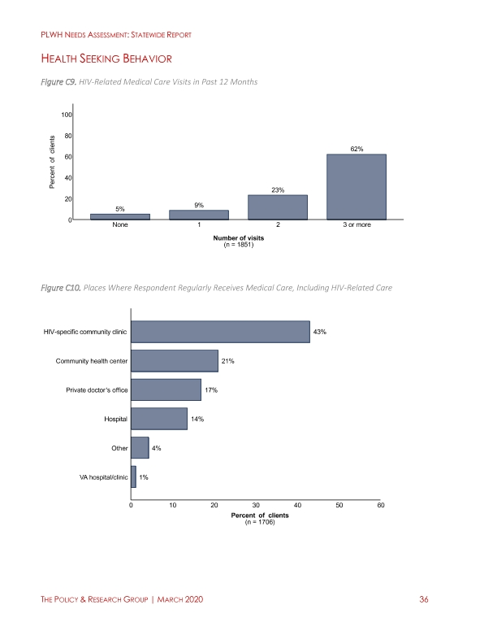
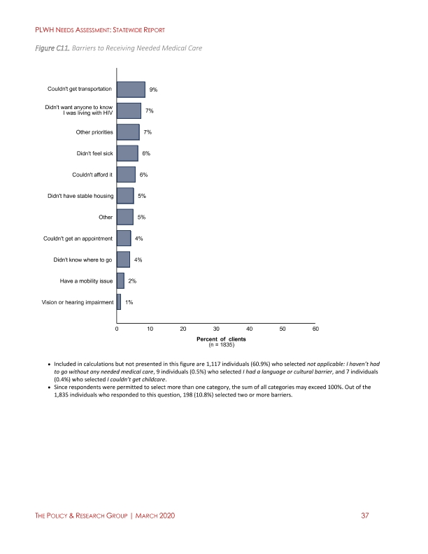
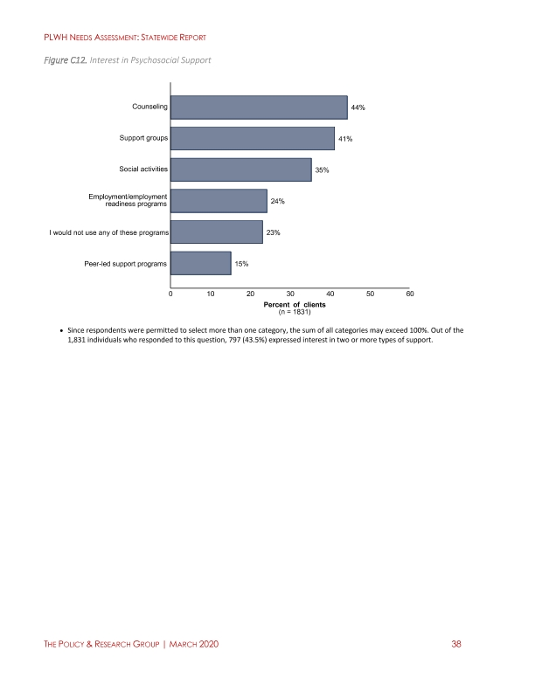
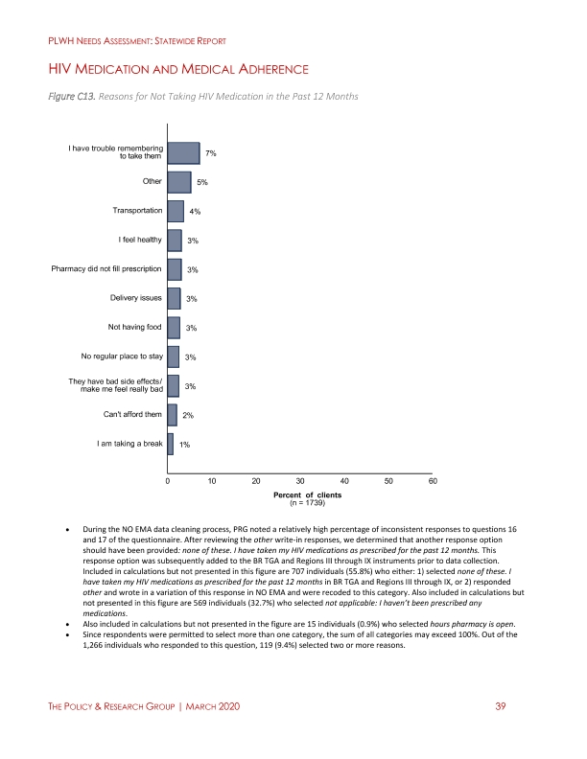
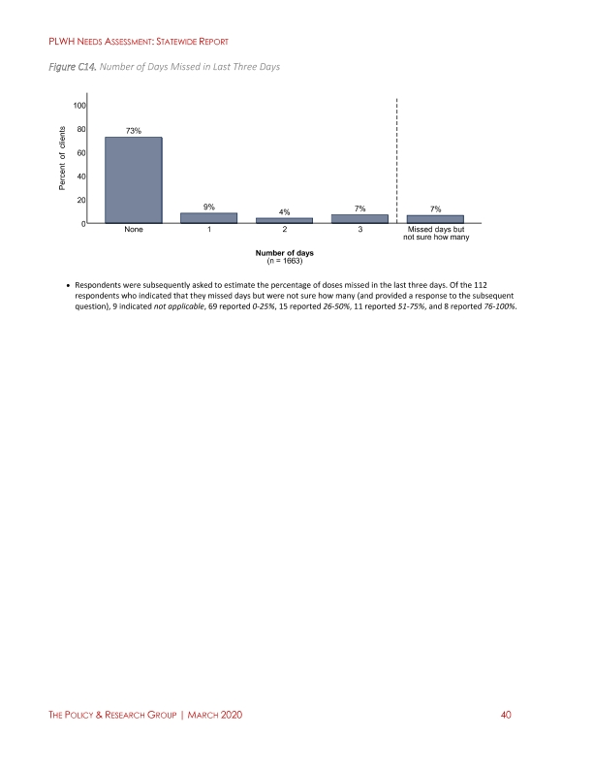
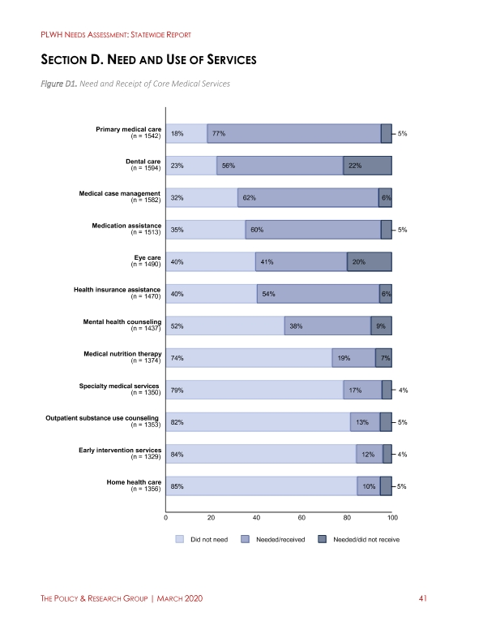
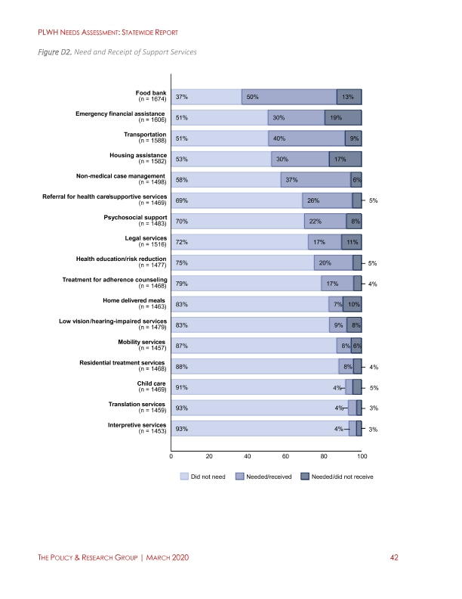
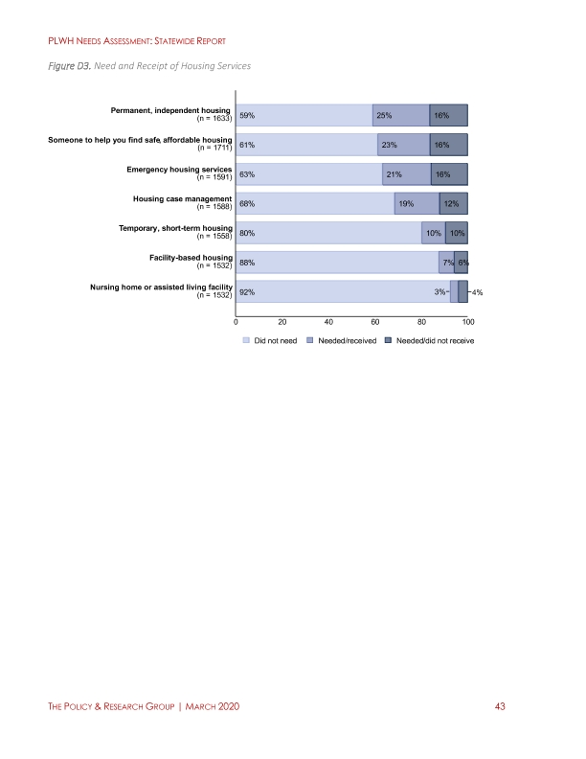
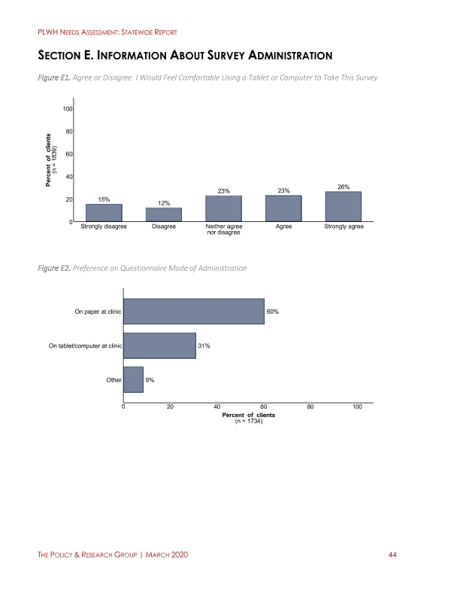
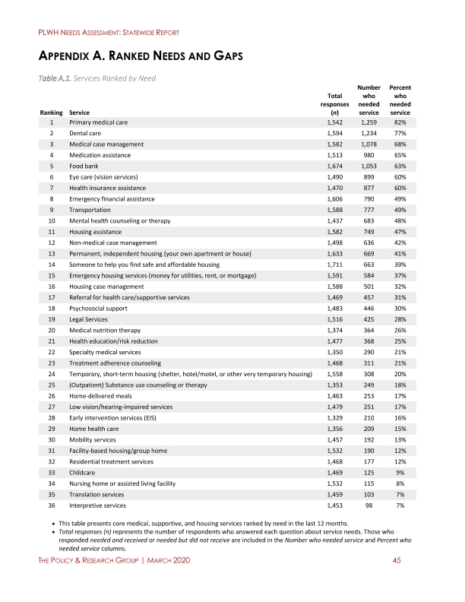
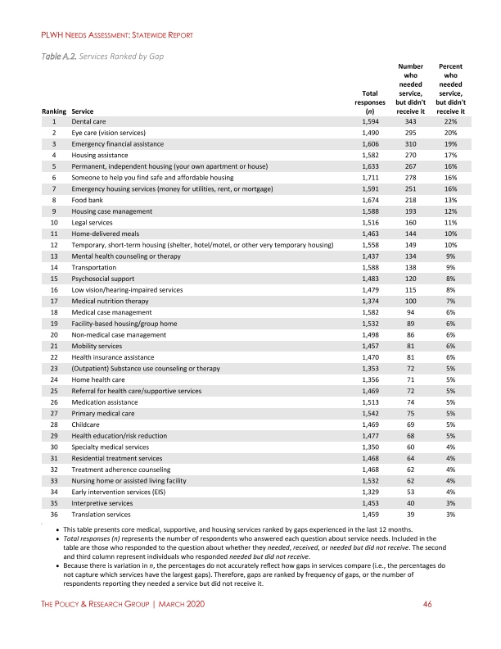
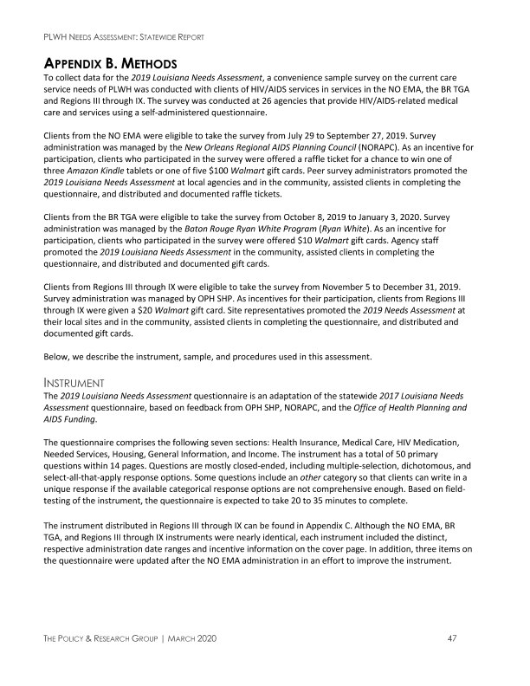
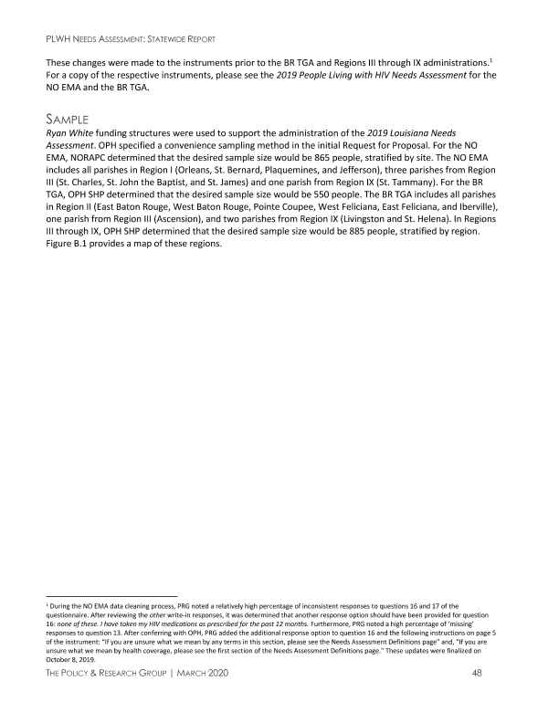
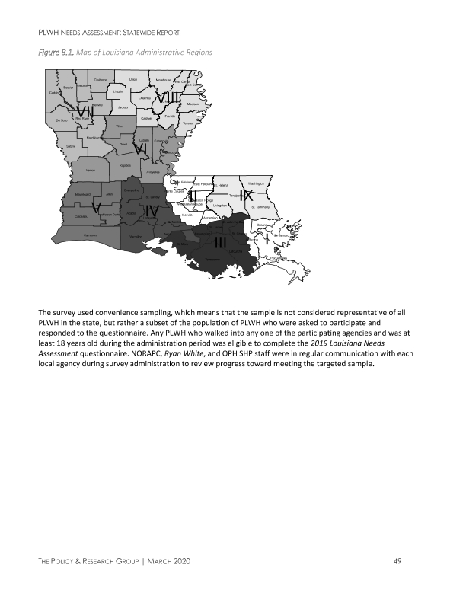
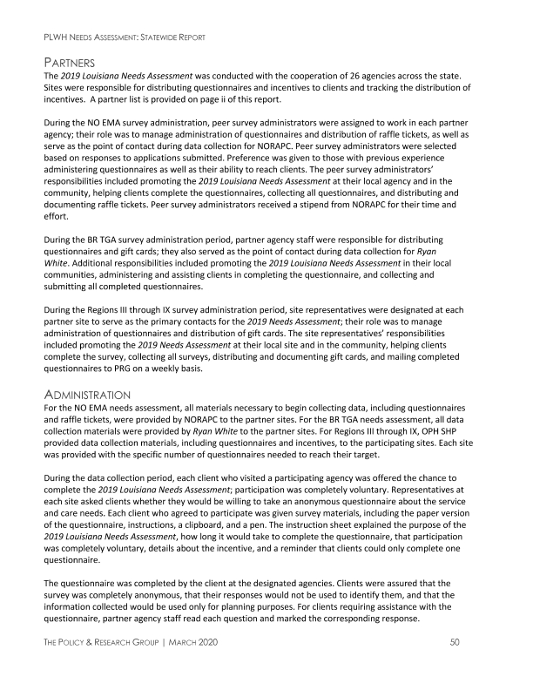
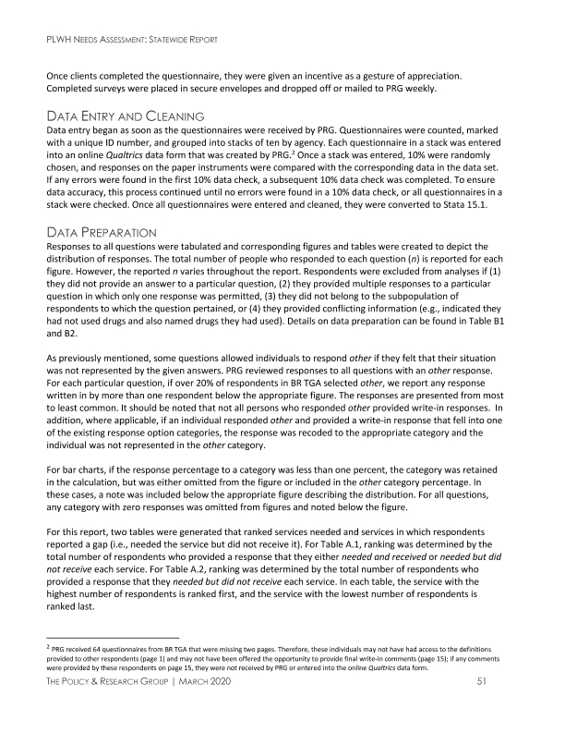
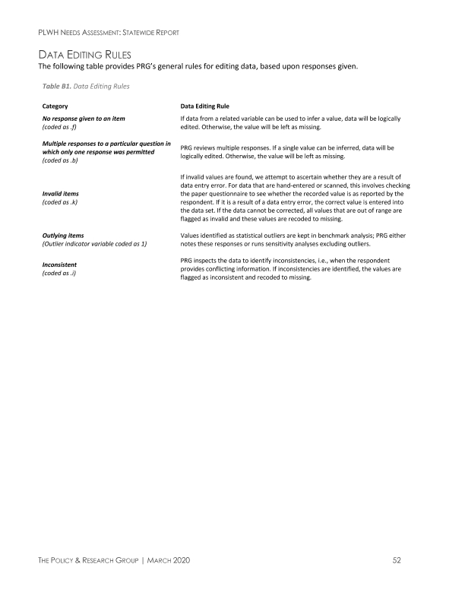
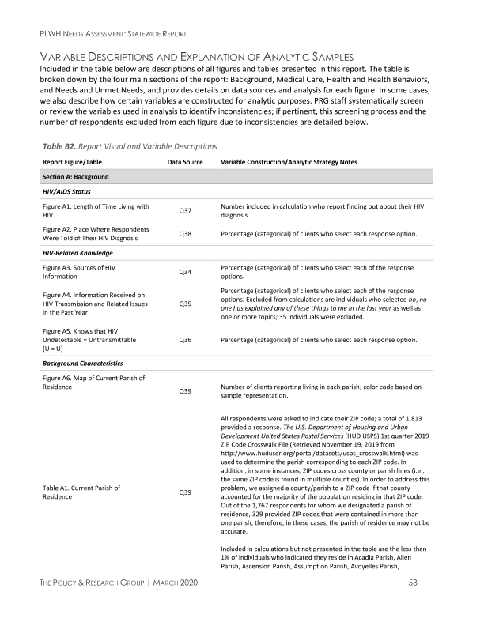
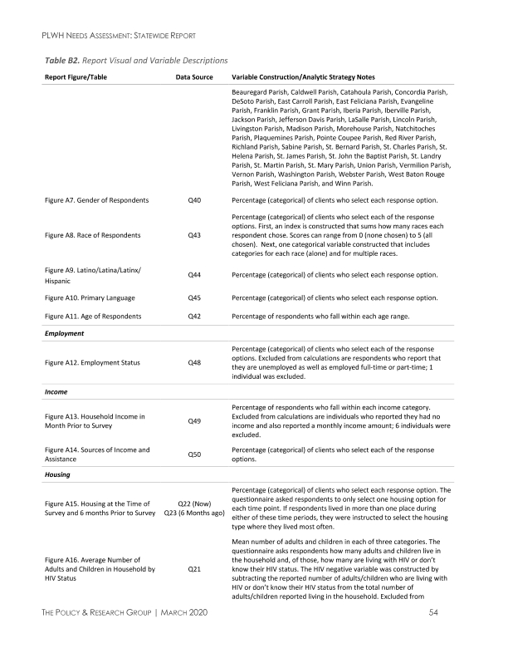
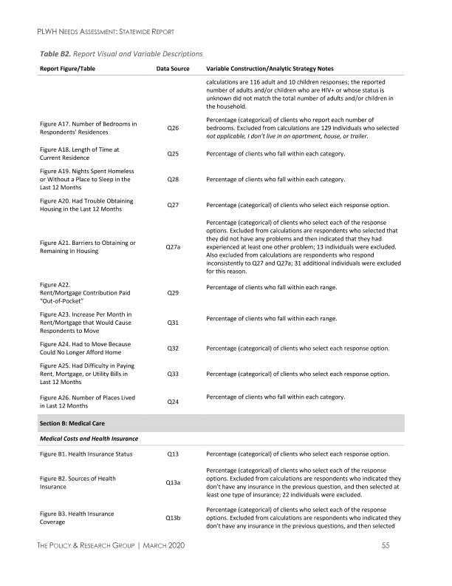
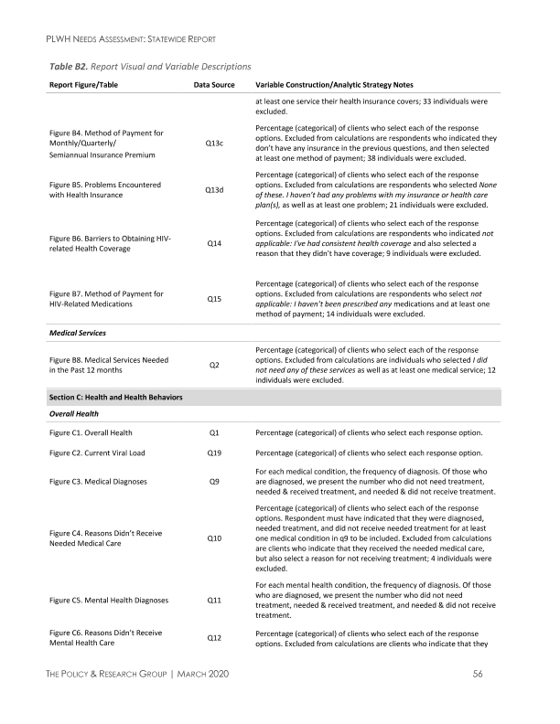
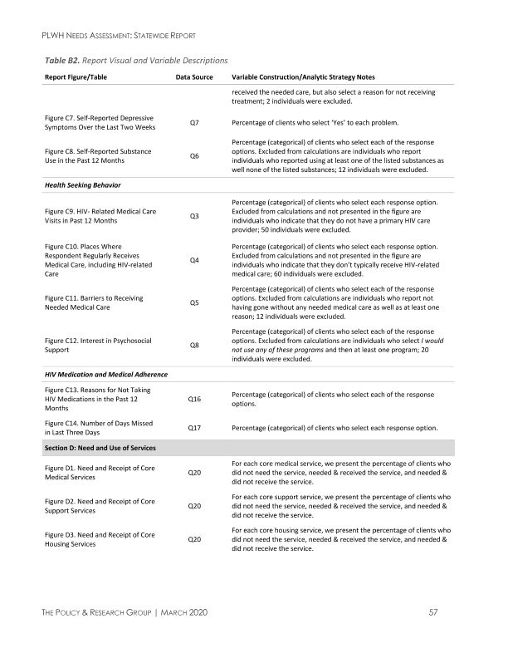
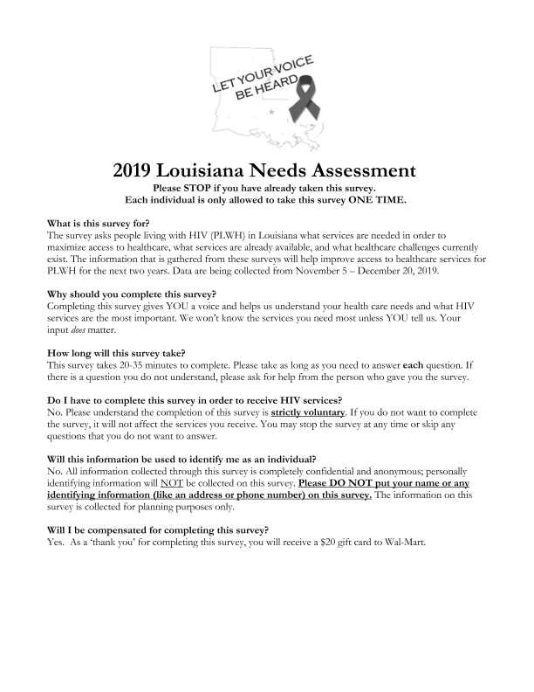
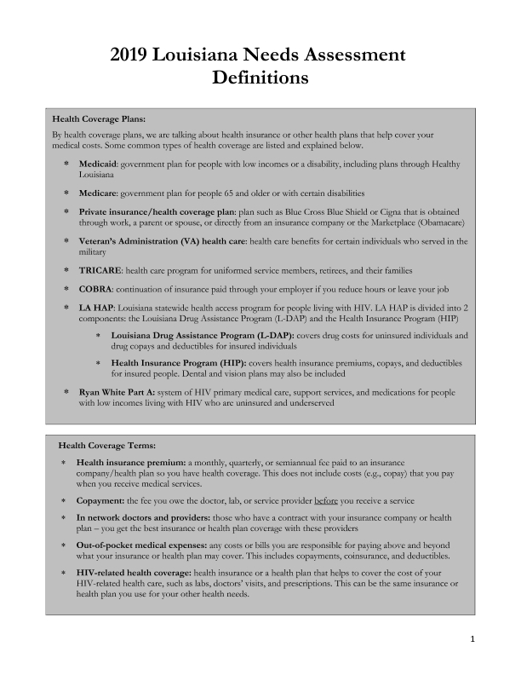
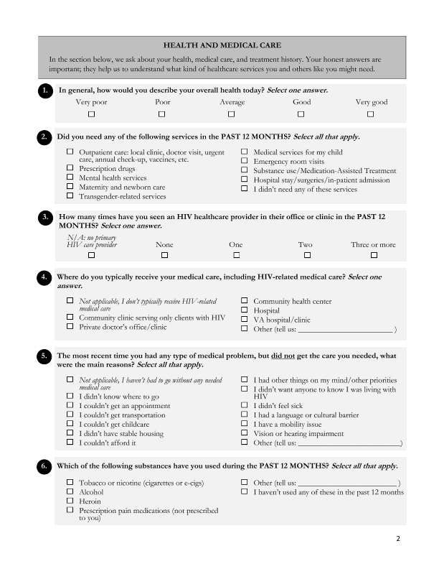
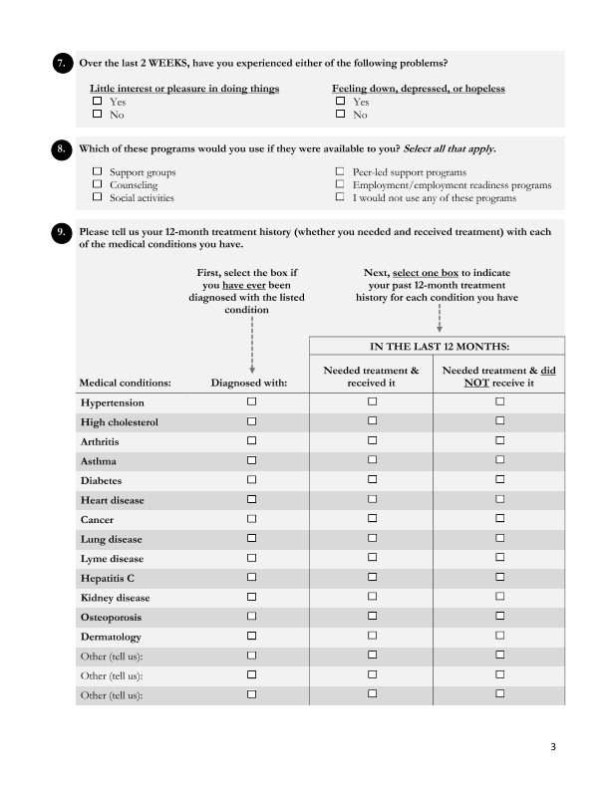
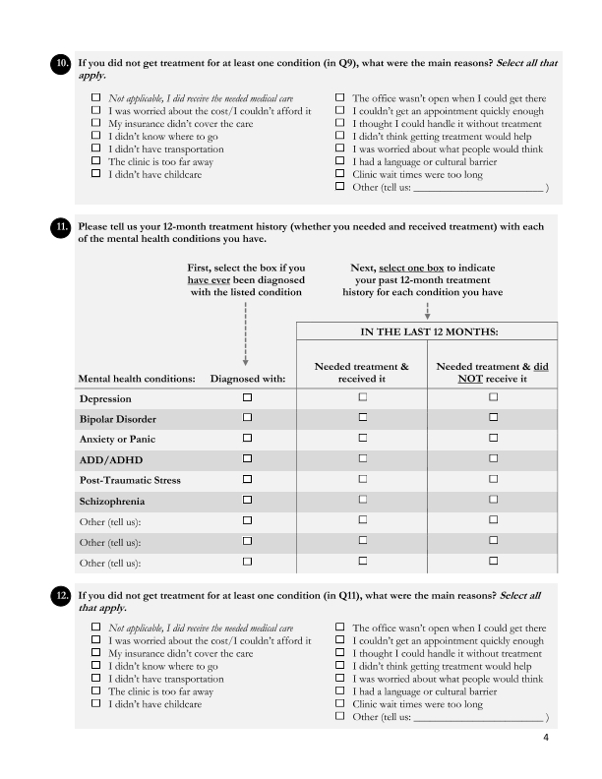
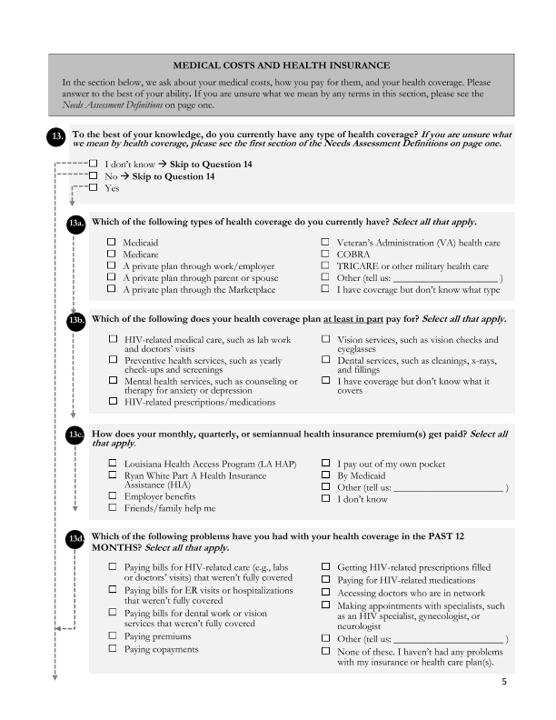
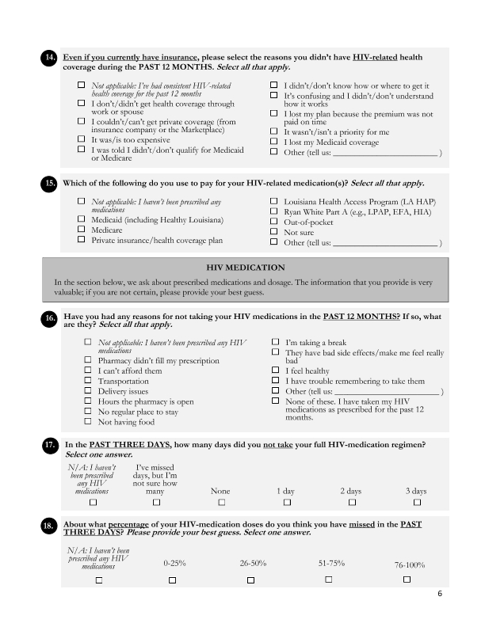
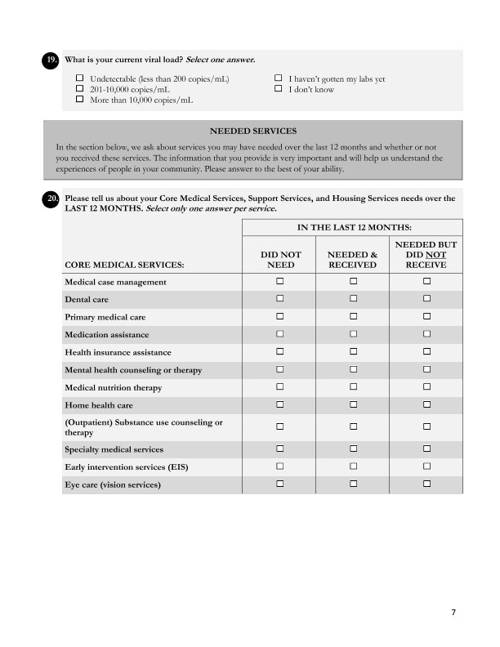
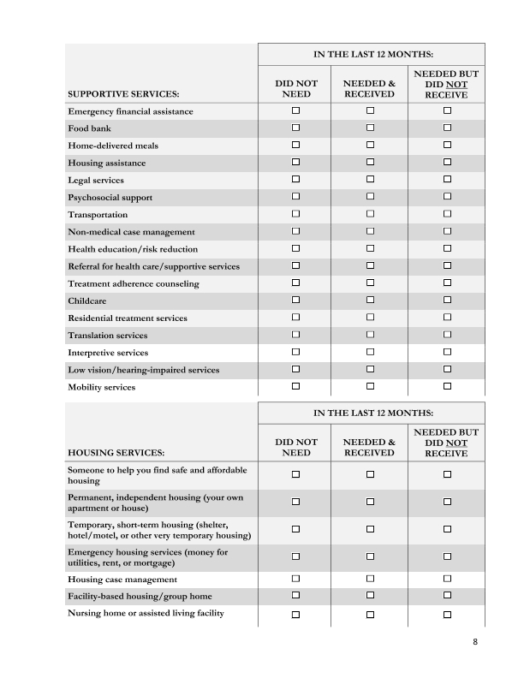
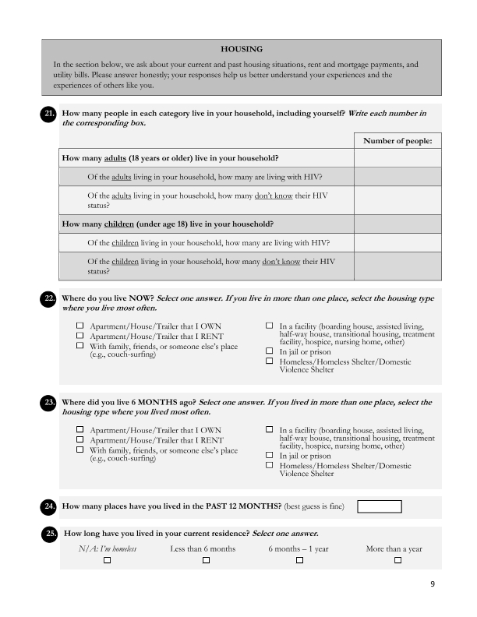
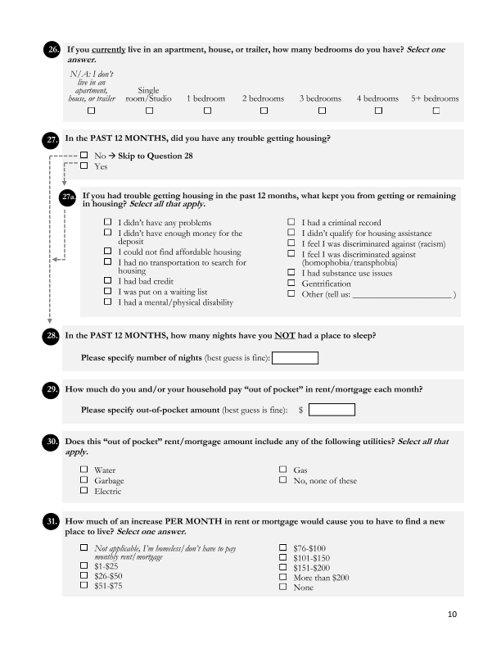
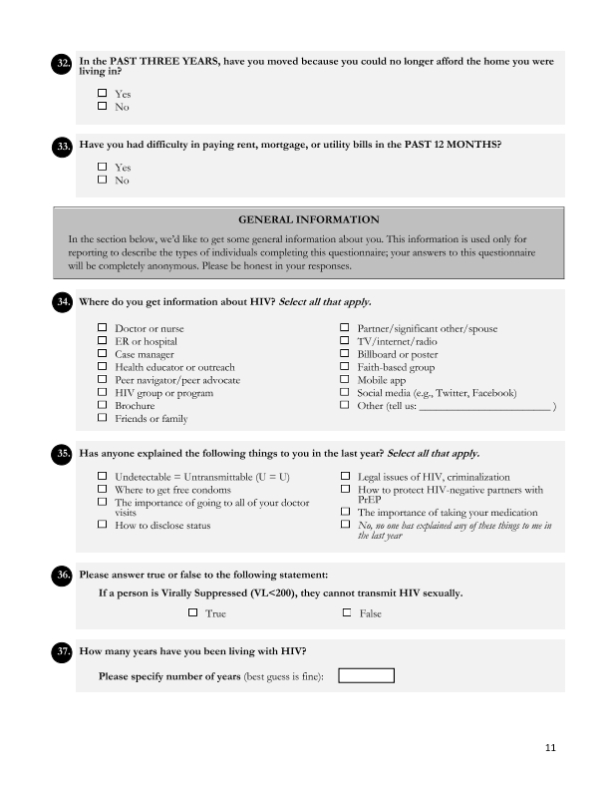
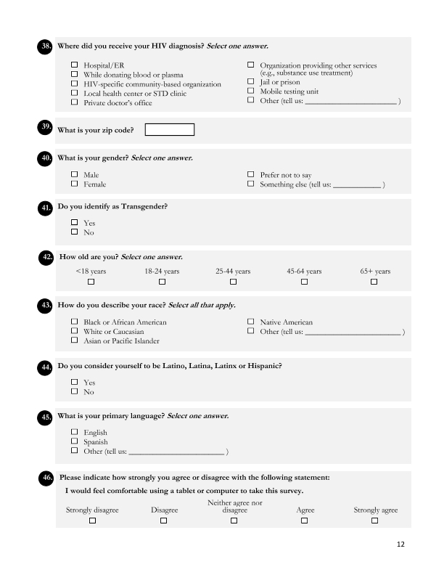
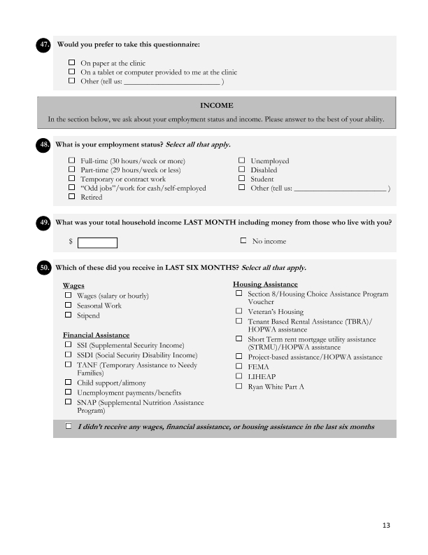

Grantee SF-424's and Certification(s)
